**Generalities on Dimensions Ethics and deontology**

**https://youtu.be/Rr7U49RPpTs**

**• Introduction**

**•Students environment in the university**

**• Origin of the words ethics and deontology**

**• Meaning of words dimension ethics and deontology**

**• Objectives in the university**

**• Fundamental notions of ethics and deontology**

**• Repositories ( referentials)**

**• The University Franchise**

**• University Values**

**• Rights and duties**

**• University relations**

**• Practices**

1. **Introduction**

* Morals, ethics and deontology are fundamental subjects for practice and university life.

*We incorporate these buzzwords like ethics, morals or deontology, without always knowing what is behind these words which, in some cases, can seem synonymous.

*In order to clarify these expressions, we must go through the definitions stage.

*At the end of this chapter, students will be able to:

• Define the different notions of ethics and deontology

• Know the distinction between these concepts

• Integrate these notions within the university

1. Students environment in the university

Pedagogy and

Social services (accommodation, entertainment; transport , restoration)

1. Origin of the words
2. Dimension

The term dimension, from the Latin dimensio "action of measuring",

We say for a person having dimension—which means **the quality or character or stature proper to a person**.

Dimension of words deep, nature, and actions, usefullness

Morality comes from the Greek word moralus which means the good conduct of an individual in society.

1. . Ethics comes from the Greek word ETHOS which means the behavior of an individual in a professional company.
2. Deontology comes from the Greek word deontos which means the duty of an individual in society

There are two key dimensions of deontological theory:

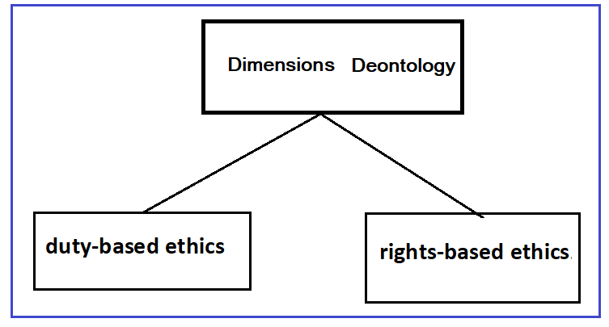

1. **Objectives of words moral ethics and deontology in the university**

**Moral:**

Morality is the science of good and evil, it is considered as a theory relating to human conduct. It also refers to morals, habits and rules of conduct accepted and practiced by society as being good. It also refers to the institutions that enable a society to achieve its objectives, more particularly to legal or quasi-legal institutions.

**Morality has several sources, among which we can cite:**

• Religion: Texts of the Holy Book (Quran);

• • Conscience: It is my conscience that tells me what is good or bad.

• • The sense of duty: Accomplishing good or seeking it is, above all, a duty.

• • Reason: Philosophical meaning;

• • The meaning of respect: Interpersonal relationships should be governed by respect;

• • Justice: We are all born equal in rights, in other words, there is only one rule that applies to everyone. But these rules are not necessarily legislative in nature.

• • Virtue: Virtue is specific to the character of the person, to his identity. A good person, a virtuous person will accomplish good things.

**•2. Ethics:**

Ethics can be distinguished from morality understood as the activity of choosing and deciding, judging, justifying, and defending conduct, In our present age, ethics has an important place in all areas of life. Ethics has also become important in education, because education is a fundamental process of human life. Therefore, ethics is very important

subject in education. We can easily reach all knowledge by technology. In education using technology reveals some ethical problems such as plagiarism. In order to understand the importance of

ethics, ethics should be placed as a course in educational system. Before discussing this issue, it is necessary to define what ethics is and what education is.

Ethics is the most important and functioning branch of philosophy in today. In general, ethics is moral philosophy. It is related to our values and virtues. Therefore, our actions and our experiences in everyday life are the subjects of ethics. We have the capacity to think about our choices, so we are responsible for all our decisions and actions. In addition to this, it can be said that ethics is the study of what is wrong and what is right. Good-evil, right-wrong, virtue- vice, justice and injustice are some ethical concepts.

” **Description of ethics:**

• Art of directing human conduct while consciously taking into account the values of professional company.

• It also refers to the product of a reflection on values in order to criticize them, to renew them, and this to the extent of the changes that daily life reveals.

• Ethics is an approach aimed, when faced with a given problem, at adopting the best solution by relying on learned, accepted and integrated values and taking into account the context in which the problem currently arises. Which relates to morality. Discipline of philosophy whose subject is the moral principles guiding the conduct of an individual or a professional group.

• Currently ethics designates a sectoral morality specialized in a field:

• Ecological ethics (respect for nature);

• Biomedical and medicine ethics; • •

• The ethics of war;

• Business ethics.

• Applied ethics affects different areas of life:

• Professional Ethics ;

• Organizational ethics;

• Environmental ethics;

• Social ethics;

• Political ethics.

**Here are the different branch of ethics**

We give the table the more components of ethics in our daily life:

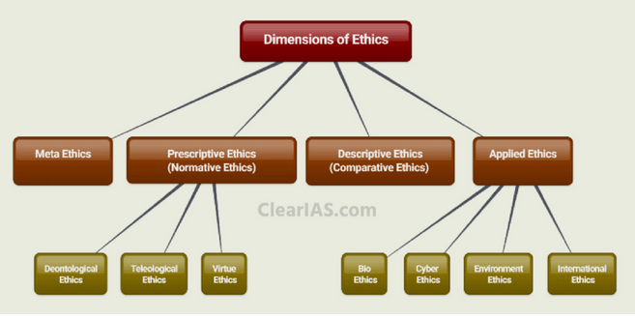

An example Education & ethics of education

EDUCATION

In general sense, education is any act or experience that has a formative effect on the mind, character or physical ability of an individual. Etymologically, the word education is derived from the Latin Educe which means educate, train. Education is a process of

learning and acquiring information. It means teaching and learning. Education affects on human mind, character and physical abilities. The history of education begins with the human history itself. Education is also a way to become civilized human individuals and it maximizes human potential. Culture and cultural heritage can be transmitted by education, because the main occupation of man is to

pass knowledge, skills and attitude from one generation to other.

In ancient Greece some philosopher’s views of education such as Socrates, Plato and Aristotle contribute to the development of our present educational system. In general, they all believe that the purpose of education is that improve humankind.

Socratic Method is still used modern educational practices. In this method, teachers ask some questions to improve the intellectual abilities of students and students try to answer these questions by

using their reasons.

Today’s educational theories are based on the philosophies of these philosophers. Plato, who was the founder of Idealism, claimed that the aim of education was to develop individual’s abilities to better serve society. He also was the founder of Academy, the first university of the world. For him both men and women had the right to have education. He claimed that there were different stages of education. According to him, education was a key element for a society.

On the other hand, Aristotle who was the father of realism believed that only citizens could be educated. He believed heat educated person was fulfilled person. He defended theoretical, practical and technical

education. Education helps development of bodily and mental faculties.

In ancient Greece, education was seen as a function of the state and the aim of it is to serve the ends of state.

Today, education also serves both the needs of state or society and citizens. Therefore, education is important for us. It builds character, gives knowledge and helps progressing of state. Education makes a man complete and it also plays an important role in developing society and state. Schools are basic frameworks of education. School helps children to become a good citizen and human being. This is possible only by ethical education, so teaching ethics in school is important.

THE ROLE OF ETHICAL EDUCATION

Why Ethics is important and why ethics should be taught in schools? What kind of ethics should be taught in schools? In this chapter I will try to discuss this issue.

Ethics education can be divided into four stages:

1-Ethics education in family

2-Ethics education in school

3-Ethics education in university

4-Ethics education in business

In family, ethics education should focus on descriptive facts. Children observe their parents’ (role models) ethical behaviour and they learn social facts about ethical behaviour.

In school, students learn what is right and what is wrong. This is a value education or character education. In educational systems, generally ethics is associated with religion. Therefore, instead of ethics

course students take religious course. However, students should learn values clarification, and making ethical decision. In addition, school fosters to students become trustful, responsible, and just person. Ethics in school can benefit to this.

In university, ethics should be professional ethics.

Only some students can take ethics course related to their professions in universities, because in universities ethics does not give as a course in all departments. This kind of ethical education provides

students to realize what is right, make good decisions/

3. Deontology “Theory of Duty”:

Deontology (this word comes from the Greek deon, deontos duty and logos speech), is the theory of moral duties and the set of rules of conduct that human must respect with regard to society in general. In a less technical sense, and more widespread today, it designates the set of duties imposed on professionals by the exercise of their profession. This set of duties can be formalized by the governing or representative bodies of a profession in the form of a code. (Code of deontology)

• • We must differentiate between morality, which refers to morals as they are practiced, and the notion of ethics, which is the concern to found a morality, which rather refers to theory, rules and principles.

• • While morality defines principles or general laws, ethics is an individual disposition to act according to the virtues, in order to seek (chercher) the right decision in a given situation. Morality does not integrate the constraints of the situation. Morality ignores nuance, it is binary. Ethics admits discussion, argumentation, paradoxes.