**Series number 3**

**Exercise No 1:**

Establish the Lagrangian of the system and Determine the equation of motion (**Fig.1**)

X m1

l

m2

**Exercise No 2**

Let a point mass m move without friction along a circular wire of radius a. The motion takes place in the horizontal plane (Oxy), and the particle is subject to the force =-kv2, where k is a constant and is the unit vector in the direction of velocity .

* Determine the position of thepoint θ(t) at time t such that at t=0, θ=0and ​ v=v0.

**Exercise No 3**

Consider a hollow sphere (S) of radius a in a Galilean reference frame R(O,xyz). A small ball, assumed to be a point mass m, is constrained to move without friction inside the sphere (see **Fig. 2**).

1. What are the constraints on the motion of the mass m? Deduce the number of degrees of freedom of the ball.

The components of the generalized forces are given as:

Qθ= m g a sinθ, Qϕ=0.

1. Deduce the equations of motion.
2. Calculate the kinetic energy of the ball and derive the Lagrange equations. 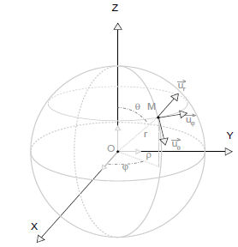

**(Fig. 2**).

**Exercise No4**

The Atwood machine setup is described by the adjacent figure. The mass m1is connected to pulley 1 of mass M via an inextensible string of length L and negligible mass. The mass m2 is connected to mass m3​ by an inextensible string of length L and negligible mass.

Pulleys 1 and 2 have respective radii R1 and R2​. Pulley 1 is suspended by an inextensible string of negligible mass and length l0​. The strings slide over the pulleys without friction, and the moments of inertia of the pulleys are negligible.

​ (see (**Fig.3**).

M2

m2

m1

M1

- Deduce the equations of motion.