**READING 01**

# BASIC: Can the Earth Be Saved by Turning CO2 to Stone?

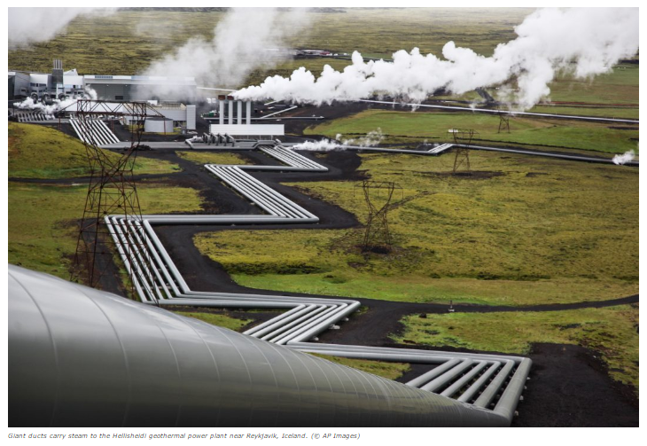

https://d3c33hcgiwev3.cloudfront.net/imageAssetProxy.v1/B9ppYCXXEeeErgpOFanBSA_273fb2aa5f93c08a602910a8260c3fbd_Newsela.jpg?expiry=1731974400000&hmac=aGPW2jjKypal1WJzscaeMIzqDSl1XOyf0NLr7bJSR3c

Scientists around the world are teaming up to solve a big problem. They are pioneering a new and promising way to capture and store carbon dioxide. Carbon dioxide is a greenhouse gas that contributes to global warming. Their idea? Turn it into stone.

Scientists on the CarbFix team first tested this idea in Iceland in 2014. They pumped atmospheric CO2 into a type of volcanic rock called basalt. The results surprised and encouraged the scientists. Within two years, nearly 250 tons of CO2 changed into carbonate crystal stones.

“Our results show that between 95 and 98 percent" of the CO2 turned into stones, said Juerg Matter of the University of Southampton in the United Kingdom. He is the lead author of the report. He said it happened "amazingly fast."

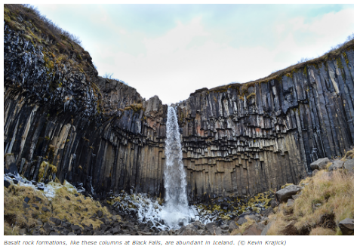

A large power station in Iceland supplied the CO2 for the test. The experiment ended, but the power plant continues to pump CO2 out of the air. There are plans to inject 10,000 tons of CO2 into stone this summer. The plant eventually wants to capture its entire CO2 output in stone.

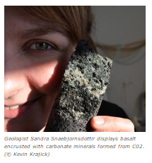

They have not had any trouble yet. "That is a good sign," Martin Stute said. He is a Columbia University environmental scientist. He was part of the team that came up with the experiment.

## Field results are "promising"

It could be an important step. Carbon dioxide from human activity is contributing to climate change. Each day, huge amounts of CO2 are released from burning coal, oil and natural gas.

There are plenty of places where you can put CO2, Stute said. He gave one example in the Middle East. “That one rock formation in Oman could take all human CO2 emissions for hundreds of years,” he said.

Basalt rocks are found all over the world, even under the ocean floor. Brazil, India, South Africa and the United States have huge amounts of basalt.

Scientists have other ideas about taking CO2 out of the atmosphere. Rather than capturing CO2 from power plants alone, remove the gas from the air anywhere. Stute said the field results are "promising."

CO2 can be captured anywhere. It exists in the air in similar amounts all over the world. If captured near volcanic rock and water, the CO2 could be injected and crystallized on the spot.

## Getting the price down

Grabbing CO2 from the air where there is a lot of basalt and water is fairly affordable. It could cost $20 to $30 per ton. Capturing and transporting carbon can cost five times as much, or even more. It depends on how far the carbon must be moved.

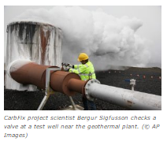

Another thing that could make it more expensive is how the carbon is made. The gases given off from the Iceland plant were mostly CO2 and hydrogen sulfide. Coal, oil, and natural gas plants release more kinds of gases. They must be separated from the CO2.

## Now is the time

The CarbFix scientists agree: capturing and storing carbon is a good short-term fix. Eventually, however, we need to focus on renewable energy, like solar power and wind.

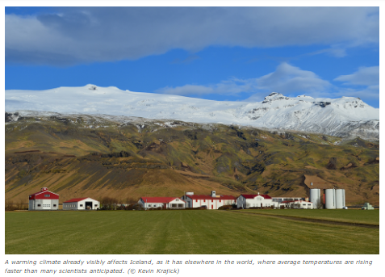

Scientists say renewables alone are not enough. Using more renewable energy cannot offset all the problems with greenhouse gases. We need to do everything we can to stop global temperature rise.

It comes down to money, Stute added. There needs to be a money-related incentive, or reason, "to do something about CO2 emissions. If the incentive is there it can be done. We need to take it seriously.”

The CarbFix project is funded by the U.S. Department of Energy and the European Union. It includes scientists from Australia, Britain, Denmark, France, Iceland, Netherlands and the United States.

____________

Terhune, L. (2016, July 7). Saving Earth by Turning Co2 to Stone. (Ed. by Newsela staff). Retrieved from <https://share.america.gov/saving-earth-by-turning-co2-to-stone/>