**Chapter 3**

**Reading: Lubrication of Bearings**

The machine tools in a workshop sometimes have their own electric motors, or they may take the power they need from a motor which feeds several machines. The shafts which carry the power from the motor to the machines need some kind of support to ***keep them steady***. We call these supports bearings. There are different types of bearings for different purposes. We can classify them according to whether they take the load on the shaft or the thrust along the axis of the shaft. The former type is known as a journal bearing, and the letter type as a thrust bearing.

The rotating shaft bears on a stationary bush or tube. We therefore have two metal surfaces in close contact with each other, and sliding over each other often at high speed. This will cause friction and the bearing will become heated. So we have to ***protect*** the metal surface ***from*** overheating and damage.

First of all, we ***avoid*** making the shaft and the bush of the same material. The shafting itself is generally of steel, but we use another metal such as cast-iron or white metal or bush. At a certain temperature, the metal in the bush will seize or run, and this will ***prevent*** damage to the shaft. But of course it will not ***prevent*** overheating ***from*** occurring.

However, we can ***reduce*** the danger of overheating by lubrication. We have a thin film of oil between the two metallic surfaces to ***keep them apart***. The internal friction of oil is much less than the friction between two solids, and generates less heat. Lubrication also offers another advantage. A film of oil on the metal surfaces will ***prevent*** them from corroding by ***protecting*** them ***from*** the air.

The sort of lubricant which we use depends largely on the running speed of bearing. We can use grease in low-speed bearings, but grease offers more resistance to the turning movement of the shaft. A lighter oil causes less friction, and so an oily lubricant is better for high speed bearings. The rotation of the shaft carries the film of oil round the inside of the bearing and ***keeps*** the shaft ***from*** contact with the bush which houses it. We can feed oil into the bearing in several **ways**. Sometimes we allow it to drip down under the influence of gravity. More commonly, a pump or gun feeds it in under pressure. In motor-car and other engines, we half cover the bearing in an oil-bath, and oil splashes up into it.

We can reduce the amount of friction even more with rolling bearing. The hardened steel balls in this type of bearing roll round in a finely-ground ball race, and make little more than point contact with the race.

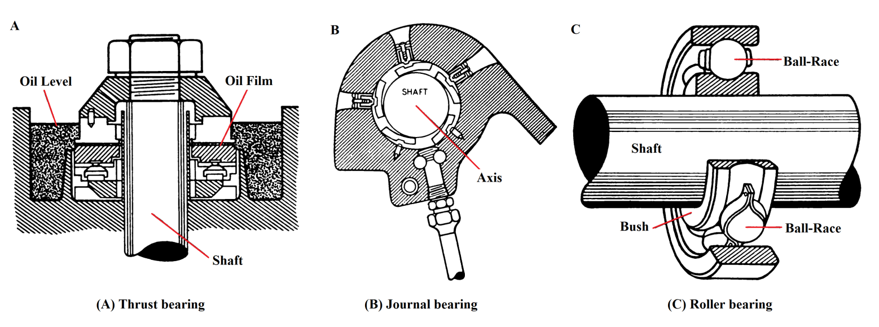

**Word study**

|  |  |  |  |  |  |  |  |
| --- | --- | --- | --- | --- | --- | --- | --- |
| ***Contact*** (= touch) | | | | | | | |
| When the platinum point | | | ***are in contact with*** | | | each other, a current flows. | |
| ***make contact with*** | | |
| The two moving surfaces are ***in*** contact ***with*** each other as little as possible.  The piston does not come ***in contact with*** the cylinder cover.  The water which is ***in close contact with*** the steam will evaporate first.  The various departments are ***in close touch*** with each other all the time. | | | | | | | |
| The leaves of the spring are ***not in contact with*** each other. They are ***separated*** or ***kept apart*** by strips of rubber. | | | | | | | |
| ***House, Accommodate*** | | | | | | |
| 1. | The university | ***houses***  ***accommodates*** | | | most of its students in hostels. | |
| 2. | An aluminum bush ***houses*** the bearing. | | | | | |
| 3.  4. | The cylinders  The air cannot | accommodate  hold | | a certain volume of steam.  any more steam without a rise in temperature | | |

|  |  |  |  |  |  |
| --- | --- | --- | --- | --- | --- |
| ***Resist, Withstand*** | | | | | |
| 1.  2. | High-speed aircraft need metals which can  Turbine blades must be able to | | | ***resist***  ***withstand*** | very high temperatures.  creep and corrosion. |
| 3.  4.  5. | Curved rails  Some materials  Silicones | offer resistance to | the movement of the train.  the passage of electric current.  moisture and heat | | |
| 6.  7. | Thick grease ***offers more*** resistance ***to*** motion than thin oils.  Silicones are ***resistant to*** moisture and heat. | | | | |

|  |  |  |  |  |
| --- | --- | --- | --- | --- |
| ***Advantages*** | | | | |
| The ***advantage*** ***of*** rolling bearings ***is that*** they cause less friction. | | | | |
| This type of bearing | ***has***  ***offers***  ***possesses*** | | several ***advantages over*** the sliding bearing. | |
| Its low cost ***confers*** a great ***advantage*** ***on*** this type of engine. | | | | |
| The earlier type of engine | | ***has***  ***suffers from*** | | ***the disadvantage of*** being expensive to run. |

**Patterns**

|  |  |  |  |  |  |  |  |  |  |
| --- | --- | --- | --- | --- | --- | --- | --- | --- | --- |
| **1. The use of Will, Can and May** | | | | | | | | | |
| There are the most important uses of these three words: | | | | | | | | | |
| ***1.*** | ***Futurity (Will)*** | | | | | | | | |
|  | **Note:** | | We do not often use the form ***is going to*** in technical writing or speech to show the future. | | | | | | |
|  | | Production of the new machine ***will*** commence next year  Work ***will*** shortly begin on the new motorway.  The new aircraft ***will*** fly for the first time on Monday. | | | | | | | |
| ***2.*** | | ***Capability (Will, Can, Capable, Are able to)*** | | | | | | | |
|  | | These planes | | ***will fly***  ***can fly***  ***are capable of flying***  ***are able to fly*** | | | | | at 800 miles per hour. |
| ***3.*** | | ***What always happens (Will)*** | | | | | | | |
|  | | This solid ***will*** vaporize when we heat it.  Friction ***will*** cause the bearing to become heated.  Good lubrication ***will*** reduce the friction. | | | | | | | |
| ***4.*** | | ***What sometimes happens (May, Can)*** | | | | | | | |
|  | | Metal which cools rapidly  Unguarded belts or chains  The testing of new planes | | | | ***may***  ***can*** | | fracture.  cause accidents.  take a long time. | |
| ***5.*** | | ***Ability (Can)*** | | | | | | | |
|  | | Work on the new engine ***can*** start in a few weeks.  We ***can*** easily calculate the frictional losses. | | | | | | | |
|  | |  | | | | | | | |
| ***6.*** | | ***Possibility (Can, May)*** | | | | | | | |
|  | | Low-speed bearings  This problem  The steel  Thermo-couples | | | ***can be***  ***may be*** | | lubricated with grease.  approached in several ways.  quenched in either water or oil.  used to measure high temperatures. | | |

|  |  |  |  |  |  |  |  |  |  |  |  |  |  |  |  |
| --- | --- | --- | --- | --- | --- | --- | --- | --- | --- | --- | --- | --- | --- | --- | --- |
| **2. Prevention, Protection, etc** | | | | | | | | | | | | | | | |
| Good  lubrication | ***Prevents*** | | overheating.  damage to the bearings. | | | | | | | | | | | | |
| ***prevents***  ***keeps*** | | the bearings from | | | | | | becoming overheated.  being damaged. | | | | | | |
| This ***keeps*** the | water | in. | | | = | This | | ***prevents***  ***keeps*** | | | the | | water from | escaping. | |
| out. | | | entering. | |
| pressure | up. | | | pressure from | falling. | |
| down. | | | rising. | |
| screws tight.  air clean. | | | | screws from working loose.  air from getting dirty. | | |
| A thin film of oil ***protects*** the bearing from corrosion.  A guard on the machine ***protects*** the workers from injury. | | | | | | | | | | | | | | | |
| Workers should ***avoid*** | | | | wearing loose overalls in the factory.  using these materials wastefully. | | | | | | | | | | | |
| By taking precautions n the  factory we can | | | | ***reduce***  ***prevent***  ***avoid***  ***obviate***  ***eliminate*** | | | the | | | risk  danger  possibility | | of accidents. | | |

|  |  |  |  |  |  |  |  |  |  |  |
| --- | --- | --- | --- | --- | --- | --- | --- | --- | --- | --- |
| **3. Classification** | | | | | | | | | | |
| There are | two  three  several  many | | ***types***  ***kinds***  ***sorts***  ***classes***  ***varieties*** | | | of bearings. | | | | |
| Bearings are | ***of*** | two, etc. | | | ***types,*** etc. | | | | (***of*** = belonging to) | |
| We can ***classify*** | bearings | | | according to | | | their position on the shaft.  whether they take the load on the shaft or the end thrust. | | | |
| We can ***divide*** | bearings | | | into several | | | | ***classes***  ***categories***  ***groups*** | | according to … (as above). |