**Overview of the Unit**

Welcome to Unit 4 of the English for STEM! More and more governments and corporations are funding engineers to create and build new energy systems that can limit the effects of climate change. Many of these energy systems come from renewable energy sources, such as, wind, solar (sun), and hydroelectric (water) power. In this unit, you will explore the science behind these systems. You will also learn how to summarize the main ideas of readings and how to use modal verbs to make a suggestion.

**Learning Objectives**

By the end of this **unit**, you will:

* Investigate different types of renewable energy and how they work
* Summarize main ideas of a text
* Use modal verbs to make a suggestion
* Define and accurately use content-related vocabulary in course activities
* Read, watch, and listen to a variety of texts and multimedia sources.

**PART I: Going Green**

**VEDEO 01**

**The Rise of Renewable Energy**

Hello, welcome to unit four, Discovering cleaner energy sources to power the world.

Earlier in the course, we discussed how fossil fuels release greenhouse gases into the atmosphere. And that has caused the earth to get warmer at a very fast and dangerous pace. Scientists, are therefore, trying to discover new types of energy that won't have such a harmful effect on the environment.

In this unit, we will look at some examples of those new cleaner energy sources.

In this video, we're going to talk about some new technologies. We'll start by looking at the different types of renewable energy. Then we'll look at some of their advantages and challenges of each. Finally, we'll introduce some advances in technology that may help increase the use of renewable energy in the future.

Let's start by explaining what renewable energy is. ***Renewable energy is energy from a source that is not depleted when used***. Depleted means used up oremptied. Some of the most common examples are wind,water or solar power. For example,if you get your energy from a windmill, you don't have to worry that someday you'll use up all the wind the same way that fossil fuels willsomeday be used up or depleted.

The main types of renewable energysources are biomass energy, hydropower, geothermal energy,wind energy and solar energy.

***Biomass energy is energy made from non-fossilized plant materials***. In other words, plants that havenot been turned into fossil fuels.

Wood and wood waste are commonforms of biomass energy. In fact, a couple hundred years ago,before the use of coal and oil became so important, wood supplied 90% ofthe energy needed in the United States.

Another example of biomass is ethanol,which is fuel made of corn. For the most part, sources forbiomass energy similar to fossil fuels have to beburned to release the energy. But there are other forms of renewableenergy that are not burnt and do not release any greenhousegases into the atmosphere. Let's look at some typesof clean renewable energy.

***Hydropower is energy created by moving water.***

***Geothermal energy is energy taken from the hot interior of the Earth***.

***Wind energy is power from the wind, and solar energy is power created by capturing the radiation of the Sun***.

These types of energies are different, because they are cleansources of renewable energy. This means, they do not pollute ouratmosphere with greenhouse gases.

You might be asking yourself, why don't we use renewable energy fromclean sources that don't cause pollution? One challenge is these naturalsources are not always available, there may be cloudy days, or days with low winds that can decreasethe power from solar or wind energy.

Another challenge, in the pastcreating these types of energy has been more expensive than fossil fuels, so some countries that are developingquickly have chosen to use cheaper and easier methods to get fossilfuels to power their growth. But many scientists are workinghard to create new ways to help increase the use of these cleanrenewable sources of energy. For example, they are discoveringways to store the extra energy collected on extra sunny days, soit can be used later on cloudy days.

All of this research is paying off.In the United States, the amount of electricityproduced by renewable energy increased from 13% in 2012 to 22% in 2013. It's predicted by 2020,26% of the electricity in the US will be producedby renewable sources, and this increase is happeningall over the world. One great example is Denmark. In 2015, Denmark produced over 40% ofits power by wind energy.

In this video, we looked at a fewexamples of renewable energy. We learned about some of the challengesrenewable energy faces, and introduced some advances in technology that mighthelp make it more available in the future. In the rest of this unit, we will gointo more detail about a few specific, new clean energy sources. We'll start, in the nextvideo, by looking at **wind, sun, and water energy sources**.

**VEDEO 02**

**The Power of Sun, Wind, and Water**

Hello, in the previous video, you looked at the rise of renewable energy.

In this video, we're going to take a closer look at some of the most common renewable energy sources, sun, wind and water.

We'll look at the technologies, how they produce energy, and look at the advantages and disadvantages of each one.

Let's begin by looking at how we can get power from the sun.

We call this solar power. The sun gives off energy in the form of heat. We can use something called a solar panel to turn that heat into energy. **A solar panel is made up of lots of silicon cells joined together**. Silicon, which has the chemical symbol Si, is a semiconductor. This means that it sometimes conducts electricity.

The technology is quite complicated. But in simple terms, a solar panel is like a sandwich of two layers of silicon. The bottom layer does not have enough electrons, and the top layer has more than it needs. When photons, small particles of light from the sun, hit the silicon sandwich, they knock electrons from the bottom layer to the top. This creates electricity.

Solar panels have many advantages compared to fossil fuels. They produce clean energy with very little waste that harms the environment. They can be installed on the tops of houses, so each home can be responsible for creating its own energy. After the solar panels have been installed, they save people money. Most importantly, any country in the world can used the power of the sun to create energy. So countries do not have to depend on other countries for their energy.

There are two strong disadvantages, the cost of buying the solar panels and the fact that the sun does not shine all the time. Consequently, the panels either need an efficient way to store energy, or they need to be used with another power source.

Second, let's talk about the power of wind. Modern windmills are called wind turbines. And many of them are placed together to create a wind farm. **A turbine is a machine for producing power in which a wheel goes around.**

When the wind turns the blades of the wind turbine, it is connected to a shaft, which spins a generator and creates electricity.

Similar to solar power, wind power is a clean, naturally occurring energy that can be created wherever the wind blows. After the wind farm has been set up, it is easy and cheap to fix, and allows countries to create their own electricity without help from other countries.

In contrast to solar power, it can be generated 24 hours a day because winds blow at night, too. However, there are a few disadvantages to wind power. A wind farm can be expensive to create, and some people believe that wind farms are unattractive to look at. Also, the best wind sites are not usually close to cities, which use the electricity, so the power often has to be transported a long way.

Third, let's look at water power. When we refer to energy created by water, we use the word hydro from Greek, so we call it hydroelectric power.

***Hydroelectric power is created by converting falling water into electricity.*** The process is similar to wind power. The water falls onto a turbine that spins a generator, creating electricity. Similar to solar and wind power, hydroelectric power is a clean energy with no waste product.

The water is either used again or just continues flowing. The water also flows constantly, so like wind power it can produce electricity 24 hours a day. Also, since the flow of water can be controlled, more energy can be created at peak times, the times of day when people use more energy.

There are a couple of disadvantages. The water has to fall a long way to create the force to turn the turbines. Therefore, you need to build a dam on a river to stop most of the water from flowing. This can be expensive to create, and it can cause problems for the land around the river, such as flooding. Also, people often need to leave their towns or farms when the dam is built.

So in this video, we looked a little closer at three forms of renewable energy. Solar power from the sun, wind power, and hydroelectric power from water.

We looked at the way that they work, and talked about some of the advantages and disadvantages of each.

**READING 01**

**BASIC: Indian Scientists Design Solar Tree to Save Space for Solar Power Generation**

NEW DELHI, India — Scientists in India have designed what they call a “solar tree.” They hope the invention will help overcome a key problem with solar power in India. That problem is finding enough land for the solar panels.

Land is a scarce resource in India. People often lose their land to the government. It may be taken to build roads or factories. There have been frequent protests. Some have been violent.

Solar power creates electricity by capturing the energy in sunlight. The "solar tree" has steel branches. Photovoltaic panels are placed on them.

Photovoltaic panels are constructed from solar, or photovoltaic, cells. Solar cells are made of materials like silicon. They create a photoelectric effect in sunlight. They do this by shaking up electrons.

Sunlight contains energy. When it hits a solar cell, electrons are knocked loose from the atoms in the silicon. Those electrons can be captured as an electric current. That current is electricity.

## "Four-square meters of space"

Daljit Singh Bedi is the chief scientist at the Council of Scientific and Industrial Research (CSIR) in New Delhi. His laboratory in Kolkata developed the tree.

The solar tree “takes about four-square meters of space to produce energy," says Bedi. Typical solar panels require 400 square meters of space, he says. Almost 100 times the space is saved.

Scientists estimate that one solar tree could generate enough electricity to light up five homes. The tree would make it easier to bring solar power to cities. It would also help bring power to country areas. Indian farmers do not want to give up their land to install solar panels.

The solar tree will also capture more energy than rooftop solar panels do. Bedi says the tree exposes panels to more sun than other designs. He says it is “able to harness 10 to 15 percent more energy." That means an extra hour of power for a home compared to other designs.

India has pledged to reduce its greenhouse emissions. To keep that promise, the country will have to create much more solar energy.

## India's Pledge

India is the world’s third largest emitter of greenhouse gases. Greenhouse gases trap heat in the Earth's atmosphere. We release these gases when we burn coal or oil. Most scientists agree that greenhouse gases are causing climate change.

India made a pledge at the United Nations Conference on Climate Change in Paris last year. The country said it would reduce the amount of greenhouse gases being released. India says it will cut the rate by one third over 2005 levels by 2030.

This is an ambitious goal. India will have to get 40 percent of its total energy from renewable sources by 2030. Renewable energy is made from natural resources like sunlight or wind. India gets a great deal of sun. Its main focus will be on solar power.

The cost of photovoltaic panels has fallen in recent years. Still, some worry about finding enough land for them.

However, Indian officials like Bedi are hopeful. “When we talk about plantation of trees, we would now talk about plantation of solar trees,” he said.

______________

Pasricha, Anjana. (2016, August 26). Indian Scientists Design Solar Tree to Save Space for Solar Power Generation. (Ed. Newsela staff). Retrieved from <http://www.voanews.com/a/indian-scientists-design-solar-tree-to-save-space-for-solar-power-generation/3481641.html>

### ACTIVITY 01

### 1.Question 1

**Comprehension Check Instructions:**

The reading focuses on:



A new “solar tree” design that may reduce the amount of space needed to use solar energy.



India’s commitment to reduce greenhouse gases through renewable energy.



The challenges India faces in switching to solar power.

### 2.Question 2

The reading claims that “solar trees” could:



save up to 100 times the amount of space needed to gather solar energy



also be used as windmills of space



also be used by farmers to grow fruit

### 3.Question 3

Which of the following statements is true?



India is considering pledging to reduce its greenhouse gas emissions



India has pledged to reduce its greenhouse gas emissions



India has not pledged to reduce its greenhouse gas emissions

### 4.Question 4

Which statement is **false**?



India has pledged to slow the rate that it emits greenhouse gas by one third by 2030.



India has a target of generating 40% of its total capacity from renewables by 2030.



India is the world’s largest emitter of greenhouse gases

**VEDEO 03**

**Language Focus: Summarizing Main Ideas from a Text (Part 1)**

Hello. In part one of this language focus video, we're going to learn how to summarize a text. To understand how to summarize a text we first must learn what kind of information to include in a summary.

To do this, we will learn how to identify the main idea of a text and how to find key points or important details to support that main idea.

So what, exactly, is a summary? ***A summary is a short overview of a text, that highlights the main ideas and overall theme of that text.***

Summaries often are short in length, highlight the main idea, include important examples to support the main idea, do not include unnecessary information, and are written in one's own words. It's important to understand how to write a summary because it allows you to put things into your own words which helps you to be a better learner. It also helps you to explain information that you have learned from others more clearly.

To start, we should first preview the text. Do you remember what it means to preview a text? We learned about this back in unit one. As a reminder, when we preview a text we quickly look through our source before we give it a full reading. This helps us learn what the text is about and improves our understanding. We usually preview a text in four steps: by looking at the title, the pictures and captions, subheadings, and the first paragraph. Let's look at an example together.

Take a few minutes now to preview the text on the screen. Look at the title, pictures and captions, subheadings, and first paragraph, and predict what the reading will be about. Pause the video here, and start it again once you've finished previewing. Now that you've previewed the text, what do you think the main idea of the reading is? That's right. We can say that the main idea of this text is that the US is creating renewable energy sources at a faster rate than fossil fuel project development.

Now that we know the main idea of the text, we can begin to look for key points or details that support this idea. Let's take a few minutes to read through the text. If you need to, pause the video, and start it again once you've finished reading. Now that you've read the text, let's talk about two key points or details in the article that best support our main idea.

The first detail that directly supports our main idea, states: These two sources, referring to wind and solar power, accounted for two-thirds of new power generation in 2015, according to the US Department of Energy. This supports our main idea because it gives a specific example of two renewable energy sources, wind and solar power, that grew faster than fossil fuel energy projects in the US in a recent year.

A second detail from the text that directly supports our main idea, states: And for the second straight year, the US has invested more in renewable energy projects than those that rely on fossil fuel. This supports our main idea because it shows that the US is investing more money and focus on the growth of renewable energy projects, instead of fossil fuel projects.

Now that we have the main idea of our text and two supporting details, we are ready to move on to part two and write our summary.

So, in part one of this language focus you learned how to identify the main idea of a text, and how to find key points or important details to support that main idea. In the next video, part two of this language focus, you will learn how to take this information and write a summary in your own words.

**VEDEO 04**

**Language Focus: Summarizing Main Ideas from a Text (Part 2)**

Hello, in the previous video, part one of this language focus, we learned how to identify the main idea of a text. And find key points or important details to support that main idea.

In this video, we will learn how to write a summary paragraph. We will learn about the main elements of a good summary paragraph which includes a topic sentence, key supporting details, and a conclusion.

Before we get started, let's review what a summary is and why it is important. A summary is a short overview of a text that highlights the main ideas and overall theme of that text. It's important that you understand how to write a summary, because it allows you to put things into your own words, which helps you to be a better learner. It also helps you to explain information that you have learned to others more clearly.

Now, that we have reviewed the importance of a summary, let's start to develop our own summary paragraph.

Let's begin by talking about topic sentences. What is a topic sentence?

***A topic sentence is the first sentence in a paragraph that states the main idea of the paragraph***. So if we look at the example from the previous video, what would be the main idea we want to express in our summary? Yes, it would be the main idea of the text.

As a reminder, we said that the main idea of the text was the US is creating renewable energy sources at a faster rate than fossil fuel project development. So this would be our topic sentence.

Now, that we have our topic sentence, we need to include key points or details from the text that support this idea.

In the previous video, we found two main details from the text that supported this idea. Let's look at each one individually and rewrite in our own words.

The first detail we found that directly supports our main ideas states, these two sources referring to wind and solar power accounted for two-thirds of new power generation in 2015, according to the US Department of Energy. So, how can we say this in our own words?

To put it in our own words, we need to change the grammatical structure and vocabulary. For example, we could say, in 2015, the US created new wind and solar power energy sources, which contributed to two-thirds of new energy sources that year.

Now, let's move on to the next detail we found in the text, and do the same thing. The second detail states, and for the second straight year, the US has invested more in renewable energy projects than those that rely on fossil fuel.

Pause the video and try to put this in your own words like we did with the previous example.

Your sentence might look something like this. In addition, the US has given more money to renewable energy projects over fossil fuel projects for the second year in a row.

Great, we are almost finished with our summary. So far, we have a topic sentence, and two keys supporting details written in our own words. The last thing we need to do is write our conclusion.

A conclusion, reviews the main idea and leaves the reader with a final thought. So in our conclusion, we want to restate our main idea in a meaningful way.

We might say something like, the US is changing the way it powers its country, and is relying on renewable energy sources to do the job. Try rating your own conclusion.

Finally, we are ready to put it all together. To write our summary, we just need to put each of the pieces we developed into a paragraph. Therefore, our summary would look like this.

As you can see, it includes our topic sentence. Two supporting key details, and our conclusion. So let's review what we learned in this video.

In this video, we learned how to write a summary paragraph using the main idea and supporting details from a text. We also learned about the main elements of a good summary paragraph, which include a topic sentence, key supporting details, and a conclusion. Next, you will play a game to practice identifying the main ideas of a text.

# ACTIVITY 2: Matching Main Ideas to Short Paragraphs

### 1.Question 1

**Read the paragraphs below from the text “Indian Scientists Design Solar Tree to Save Space for Solar Power Generation” and identify their main idea by choosing the best answer.**

1. **It takes about four-square meters of space to produce energy which otherwise would have required 400 square meters of space. So almost 100 times the space is saved, which as you know is very valuable,” said Daljit Singh Bedi, chief scientist at the Council of Scientific and Industrial Research (CSIR) in New Delhi, whose laboratory in Kolkata developed the tree.**

1 point



The solar tree uses considerably less space than other types of power.



Daljit Sing Bedi is a chief scientist at the Council of Scientific and Industrial Research.

### 2.Question 2

**The solar tree will also harness more energy compared to rooftop panels. “This design, it facilitates placement of solar panels in a way that they are exposed more towards sun and that way they are able to harness 10 to 15 percent more energy, which is more or less equivalent to one hour more than the conventional format,” said Bedi.**



The placement of the solar tree panels are more exposed to the sun than rooftop panels.



The solar tree will be able to create more energy than rooftop panels.

### 3.Question 3

**India’s pledge to reduce its carbon emissions relies heavily on increasing the generation of solar energy. The world’s third largest emitter of greenhouse gases, India pledged at the United Nations Conference on Climate Change in Paris last year to slow the rate at which it emits greenhouse gases by one third over 2005 levels by 2030.**



India is the world’s third largest emitter of greenhouse gases.



India is focused on decreasing its greenhouse gas emissions, which will increase the need for more solar energy.

### 4.Question 4

**While the falling cost of photovoltaic panels in recent years has made solar power much more viable, and investment has been flowing into the growing sector, worries remain about acquiring large tracts of land to set up solar parks. It takes quite a bit of time which results in cost escalation and all those things,” said Amit Kumar at the Energy and Resources Institute, a research institute in New Delhi.**

Amit Kumar works at the Energy and Resources Institute in New Delhi.

While solar panels are becoming more cost efficient, some people are worried that the time to get land and build solar parks could increase costs.

**Model Summary: Preparation for Unit 4 Assessment 1**

**Below is a sample from Unit 4 videos 3 and 4 about summarizing. In the next Assessment you'll be asked to summarize an article. Please study the Model Summary before doing the assessment that follows.**

Remember that a summary

* is short
* highlights the main idea
* includes important examples to support the main idea ?
* does not include unnecessary information, and
* is written in one’s own words.

Here is an example article and summary:

*Original text: “It’s a new era: U.S. renewables outpacing fossil fuels”*

**Next time you recharge your iPad or turn on a TV in the U.S., you could tap into electricity from wind or solar. These two sources accounted for two-thirds of new power generation in 2015, according to the U.S. Department of Energy. And for the second straight year, the U.S. has invested more in renewable energy projects than those that rely on fossil fuel.**

**“We are entering the era of renewables,” former Vice President Al Gore said May 5 at the Climate Action 2016 conference in Washington. “It’s a very exciting new reality.”**

New technologies have reduced cost for renewable energy so much, they are competing with fossil fuel prices. Wind energy is now the lowest-cost energy source, even without government tax incentives that promote clean energy, the investment firm Lazard recently said. In places like Texas and the U.S. Midwest, this new environment is dotting the horizon with windmills. Around the country, 48,800 utility-scale wind turbines produce enough electricity to power 20 million homes. Wind power is expected to provide one-fifth of the country’s electricity by 2030, the Energy Department has estimated.

Republican U.S. Senator Chuck Grassley has seen phenomenal growth in his home state of Iowa, where wind now provides one-third of the state’s power. “We’ve seen the economic success story behind renewables up close and personal,” he said.

*This article draws on reports from the Associated Press.*

**Sample Summary:**

The U.S. is creating renewable energy sources at a faster rate than fossil fuel project development. In 2015 the U.S. created new wind and solar power energy sources, which attributed to two-thirds of new energy sources that year. In addition, the U.S. has given more money to renewable energy projects over fossil fuel projects for the second year in a row. The U.S. is changing the way it powers its country and relying on renewable energy sources to do the job.

**Unit 4 Assessment 1: Summary**

### 1.Question 1

Write a brief summary of the main points in the article “Indian Scientists Design Solar Tree to Save Space for Solar Power Generation.”

Remember that a summary:

1. is short
2. highlights the main idea
3. includes important examples to support the main idea
4. does not include unnecessary information, and
5. is written in one’s own words.

## Indian Scientists Design Solar Tree to Save Space for Solar Power Generation

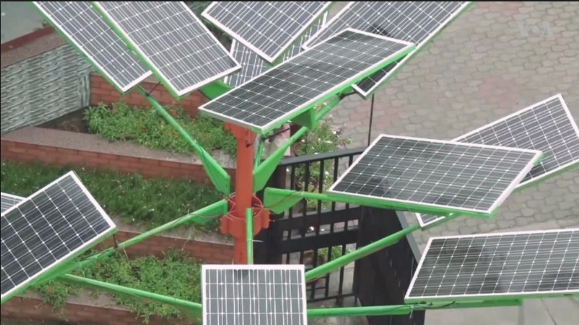

NEW DELHI —

Indian scientists have designed a “solar tree” that they hope will help overcome one of the key challenges the country faces in the generation of solar power.

With photovoltaic panels placed at different levels on branches made of steel, “solar trees” could dramatically reduce the amount of land needed to develop solar parks.

“It takes about four-square meters of space to produce energy which otherwise would have required 400 square meters of space. So almost 100 times the space is saved, which as you know is very valuable,” said Daljit Singh Bedi, chief scientist at the Council of Scientific and Industrial Research (CSIR) in New Delhi, whose laboratory in Kolkata developed the tree.

A scarce resource in India, acquisition of land to develop roads, factories and other infrastructure is a sensitive issue that has led to frequent and sometimes violent protests from displaced people.

Scientists estimate the energy generated by a solar tree would be sufficient to light up five homes. They say the space-saving tree would not only make it easier to increase solar power generation to light up homes and streets in cities, but also in rural areas where farmers are unwilling to give up large tracts of land for solar panel installations.

The solar tree will also harness more energy compared to rooftop panels. “This design, it facilitates placement of solar panels in a way that they are exposed more towards sun and that way they are able to harness 10 to 15 per cent more energy, which is more or less equivalent to one hour more than the conventional format,” said Bedi.

India’s pledge to reduce its carbon emissions relies heavily on increasing the generation of solar energy. The world’s third largest emitter of greenhouse gases, India pledged at the United Nations Conference on Climate Change in Paris last year to slow the rate at which it emits greenhouse gases by one third over 2005 levels by 2030.

To achieve this, India has set an ambitious target of generating 40 percent of its total capacity from renewables by 2030 and reducing its reliance on polluting coal-based thermal energy. In the sun-drenched country, the main focus will be on solar power.

While the falling cost of photovoltaic panels in recent years has made solar power much more viable, and investment has been flowing into the growing sector, worries remain about acquiring large tracts of land to set up solar parks.

“It takes quite a bit of time which results in cost escalation and all those things,” said Amit Kumar at the Energy and Resources Institute, a research institute in New Delhi.

But will solar trees provide a sustainable option? Kumar cautions that innovations that aim at concentration of solar power so far have not made much headway.

“Unless we put those [trees] on a large scale, [only] then will we be able to get that answer,” he said.

However Indian officials like Bedi are optimistic.

“When we talk about plantation of trees, we would now talk about plantation of solar trees,” he said.

__________________

Pasricha, A. (2016, August 26). Indian Scientists Design Solar Tree to Save Space for Solar Power Generation. Retrieved from <http://www.voanews.com/a/indian-scientists-design-solar-tree-to-save-space-for-solar-power-generation/3481641.html>

## PART II: New Technologies Create New Solutions

**VEDEO 05**

**New Discoveries in Renewable Energy**

Hello, in the last video, we learned about the rise of renewable energy. In this video, we will look at new discoveries in renewable energy from simple devices used in daily life, to the gathering of large data to make current discoveries work better. Finally, we'll talk about an exciting direction for the science of renewable energy.

In the beginning of this course, we did a warming experiment with two jars which showed us how the earth gets warmer when heat is trapped in the atmosphere. It was a simple project that helped us understand a very large idea.

Well, a few engineers at the **Massachusetts Institute of Technology**, **MIT**, have also made a big discovery using low-tech or simple tools. **An engineer is someone who designs and builds products, machines, systems, or structures**. In this case, the engineers at MIT, were trying to find a low tech, or simple way to boil water using solar power. They called their design a solar vapor generator. It used a simple device made of little more than a sponge bubble wrap and a couple of thin layers of material to use the sun to boil water. In addition to just boiling water for cooking, this design could be used as an inexpensive way to take the salt out of sea water.

Or as a simple way to **sterilize** medical tools. That means **to make doctors tools clean from live bacteria or other micro-organisms.** Scientists are not only trying to create new discoveries. They are also trying to find new ways to make old systems work cleaner and more efficiently. They can do this with data or information.

For example, scientists are using motion sensors devices that detect moving objects on off shore windmills. Windmills that are in the ocean. The sensors send data to the scientists, about how strong the wind and waves are, over a period of time. With this information, they can know when the wind is likely to be strongest, and they can make sure that the equipment is set for maximum efficiency. In some cases, this could mean they're able to get 20% more electricity from windmills that already exist.

Where might scientists look next?

**Hydropower** is one of the most common forms of renewable energy in places where there are rivers because people can build dams. But what about oceans?

As we discussed earlier, the oceans cover more than 70% of the planet Earth. They absorb the largest amount of solar energy, and they have the most predictable energy from motion due to its tides and waves.

What if we could find a way to use some of that giant and predictable energy to create power? Maybe someday, we will. Maybe you will discover the way to do it. In this video, we looked at new discoveries in renewable energy. From simple devices to the gathering of large data. And finally, we talked about an exciting direction the science of renewable energy might be heading in the future. Now let's meet a scientist who is discovering new ways to recreate renewable energy.

**VEDEO 06**

**Language Focus: Using Modal Verbs to Make a Suggestion**

In this language focus video we are going to look at **modal verbs**. Modal verbs include words like can, should, might and several more.

Using modal verbs help you to describe how you feel about a situation in a more precise way. Modal verbs can be used in different ways.

In this video we will look at the modals we use **to make a suggestion**. We'll talk about the structure of modal verbs and the meaning of different types of modals. Then we'll look at some examples.

In order to talk about modal's the very first thing you have to do is define verb.

**A verb is the word that tells an action or a state of being in a sentence. Run, walk, think and be are all verbs.**

Now we can define modal. **A modal is a special type of verb usually used with another verb that describes ideas such as making a suggestion, giving advice or talking about the probability, the chance of something happening.** We're going to look at modals for making a suggestion in four modal verbs in particular. **Should, can, and might, and must.**

First, let's look at the grammar from four modal verbs. And then, we'll talk about the differences between these four. The grammar for most modals is quite simple. Use only one modal and put the modal in front of the verb in a sentence.

Let's see an example. In the previous video you listened to an expert talking about capturing extra heat and using it as energy. In this instance, you capture extra heat for energy. We should first identify the verb. Did you find it? It's **capture**. Now, we just need to put our modal right in front of the verb. Let's try **could** for suggestion and remember we can add only one modal. That gets us this sentence, **you could capture waste heat for energy**. Because we have add a model for suggestion, could, the sentence now means that we are making a suggestion. The person we are talking to could follow our suggestion or they could not.

Let's look at another example. The government **builds** some wind farms. Can you find the verb? That's right. It's builds. Now let's imagine that we are answering the question. What can the government do with a suggestion? The government **might** build some wind farms. Notice that the **s** from builds has gone. When we use a modal verb, we use the base form of the verb, build, in this case. Okay, so now we know the structure of using modal verbs. Let's look at the different modals we can use.

When you're making a suggestion you can use different modal verbs. Use must, should, shouldn't, could or might, depending on how strong your suggestion is.

For example, if you want to make a strong suggestion, then use **should**. Countries should reduce the amount of carbon emissions. In this case we are making a strong suggestion.

We have included must in this video even though must is not really a suggestion. It is an obligation, something that you have to do. However, because climate change is such an important subject, many people use must when they are making a suggestion about what to do. You must take action to stop climate change now.

Sometimes we are not so certain about our suggestion. In these cases, **we use a weaker suggestion, like could or might**. You could open more recycling sites. You might start composting at home.

We can also use should to make negative suggestions. These are also strong suggestions but we use should not or must not to tell people not to do something. For example. You shouldn't invest more money in fossil fuels.

So in this video, we looked at the modals we use to make a suggestion. We talked about the structure of modal verbs and then the meaning of different types of modals followed by some examples.

**ACTIVITY 3: Strength (Strong Suggestion – Weak Suggestion)**

### 1.Question 1

**Imagine your friend is going to visit the Antarctic, to see for themselves the melting of the polar ice-caps. Choose the most appropriate modal verb to complete the following suggestions. To help you, the strength or weakness of each suggestion is marked on a line.**

1. You __________ take warm clothing like a hat and gloves.

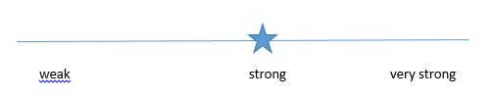

might

shouldn't

should

### 2.Question 2

You __________ pack a telescope, if you have room in your suitcase.

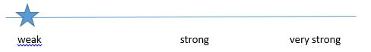

could

should

shouldn't

### 3.Question 3

You __________ try to touch a polar bear. They are beautiful, but very dangerous.

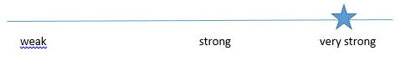

must not

might

should

### 4.Question 4

You __________ start writing a journal of your experiences, if you have time.



shouldn't

might

should

### 5.Question 5

You __________ pick up any trash that you see, to help keep the environment clean.



shouldn't

should

might

### 6.Question 6

You __________ watch the stars at night, assuming it’s not too cold.



shouldn't

should

could

# READING 02 : Salting Away Renewable Energy for Future Use

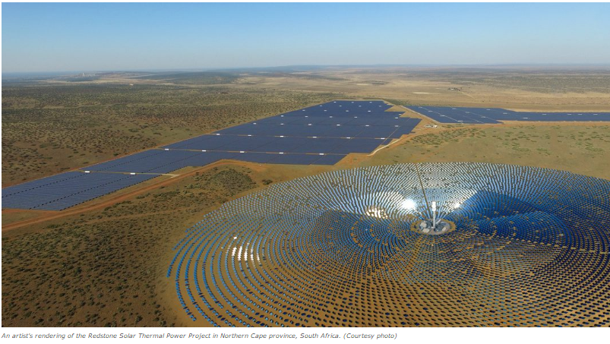

https://d3c33hcgiwev3.cloudfront.net/imageAssetProxy.v1/fcx56OjGEeaNiQ60ANFaMA_285965c32efacbb87bed37cf8b65a57e_Newsela.jpg?expiry=1726272000000&hmac=cs6vgvQ87ttEYwrerNOEqrZ4Q7Ozy-XgdnL4fRcKFt4

One problem with using solar energy is where to keep it. How do you store electricity from the sun? Scientists think salt may be the answer.

[Solar Reserve](http://www.solarreserve.com/en/) is a California company. It is figuring out how to use [melted salt](http://www.scientificamerican.com/article/new-concentrating-solar-tower-is-worth-its-salt-with-24-7-power/) to store energy for a long time.

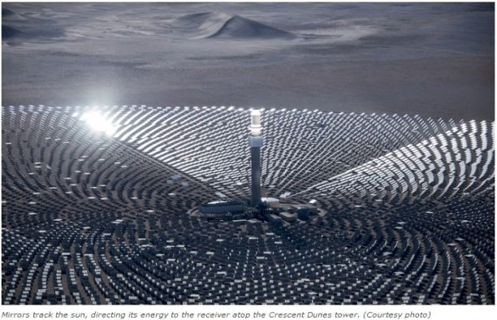

The company has a solar power plant in Tonopah, Nevada, called Crescent Dunes. It was built in 2015. Solar Reserve is the first private energy plant to use the new storage technology.

The plant can power 75,000 homes and run for 10 hours from the energy stored. This means it can keep running overnight.

Kevin Smith is in charge of SolarReserve. He said that the Paris agreement on climate change will change the way people use energy around the globe. Many nations signed the agreement. They promised to release fewer greenhouse gases.

Greenhouse gases are contributing to global warming. They are released by burning gas and coal. To cut back, more people will need to use renewable energy, like solar and wind. Countries in Africa, Latin America and Asia are using more electricity. They are very interested in renewables.

Smith added that people are already looking to Crescent Dunes as a model. The technology will change how people store energy across the globe, he said.

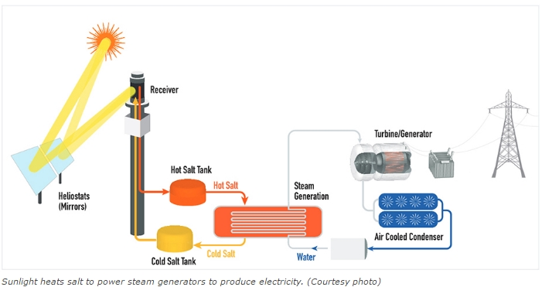

## How does it work?

Ten thousand (10,000) mirrors reflect sunlight onto a receiver that sits on top of a 195-meter tower. Liquid salt is piped through the heated receiver. The melted salt flows into hot salt tank. As electricity is needed, the hot salt moves through a steam-generation system where water is heated to produce high-pressure steam. The steam turns a turbine that produces electricity. It works whether the sun is shining or not.

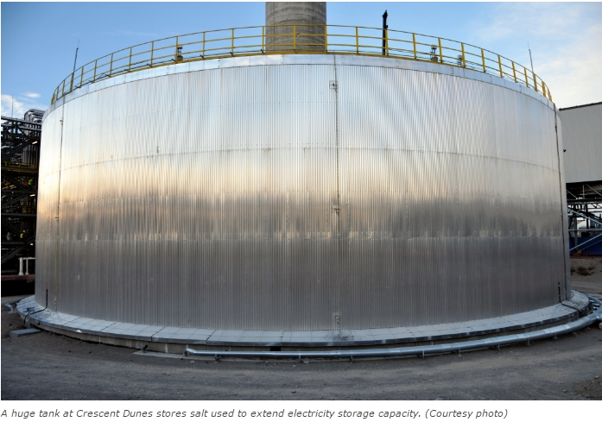

The steam-generation process is just like those used to produce electricity from gas, coal or nuclear power plants, but it is 100 percent renewable. There are no harmful greenhouse gas emissions.

“So far, in the industry, that’s the state of the art — molten salt storage,” University of South Florida solar power expert Yogi Goswami [told the Los Angeles Times](http://www.latimes.com/business/technology/la-fi-cutting-edge-solar-salt-20160320-story.html).

The molten salt storage technology was developed after decades of research design and testing by U.S. aerospace companies Rockwell International, Rocketdyne, Boeing, Pratt & Whitney and Aerojet.

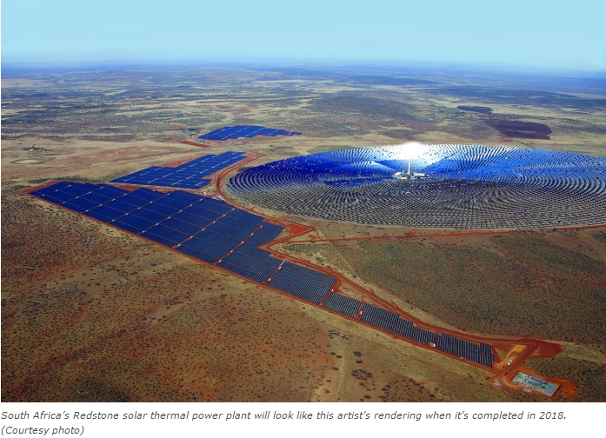

Solar Reserve has started projects that use molten salt storage in other countries, in partnership with governments and private energy providers. Its [Redstone thermal power project](http://www.solarreserve.com/en/global-projects/csp/redstone) in South Africa’s Northern Cape province is expected to be completed in 2018. Another project is being built in Chile. And the company recently signed a deal with Shenhua Group to build 1,000 megawatts of advanced solar energy installations in China.

## ___________

Terhune, L. (2016, Nov 17). Salting away renewable energy for future use. (Ed. Newsela staff). Retrieved from <https://share.america.gov/salting-away-renewable-energy-for-future-use/>

**ACTIVITY 03: Check Your Understanding: "Salting away renewable energy for future use."**

### 1.Question 1

**Comprehension Check Instructions:**

**Instructions:** All questions in this quiz refer to the reading, “Salting away renewable energy for future use." You are allowed to refer to this reading as you answer these questions. You can open the reading in a new tab by clicking one of the links:

BASIC: <https://www.coursera.org/learn/stem/supplement/f3GcR/basic-salting-away-renewable-energy-for-future-use>

What is the main idea of this reading?

exploring ways to increase government funding of solar energy

exploring ways to increase the size of solar panels

exploring ways to store solar energy using salt

### 2.Question 2

What does the number 10,000 refer to?

the number of watts of electricity generated by this process

the number of homes that will benefit from this solar energy

the number of mirrors that reflect the sun’s rays to a receiver

### 3.Question 3

The text refers to molten salt. What does the word ‘molten’ mean?

cold

liquid

hard

### 4.Question 4

According to the article, which of the following countries is NOT involved in similar projects?

China

Chile

Japan

South Africa

**VEDEO 07**

**Assessment 2 Sample, New Energy System**

Come in. Thanks for coming. Please take a seat. Now, as you know, we are looking at a new energy policy for the country, one that's better for the environment. I believe you've conducted some research on this subject. Is that correct? Excellent. Well, what we need is for you to talk about the current energy system and then to suggest a new one. Could you come in and give a brief presentation tomorrow?

Great. I'll see you then. Thank you for inviting me to talk about our nation's energy systems.

I have a suggestion. We should use solar power. At the moment, our country uses a lot of oil. The oil is pumped from the ground. It is turned into gasoline in a refinery and used to power cars and other vehicles. This source of energy creates a lot of air pollution. It is possible that our country could create solar-powered cars. The sun shines a lot in our country. So solar panels make sense. Solar panels work by using silicon to absorb energy from the sun and change it into another kind of energy that can be stored and used. This energy is clean and does not create any pollution. To conclude, I think our country should use solar-powered cars instead of gasoline-powered cars.

**Unit 4 Assessment 2: Written assessment instructions**

**Basic Instructions:** Describe the energy systems used in your country. Suggest a new energy system for your country and explain how it would be better for the environment. You can choose an example of a new energy system from our course readings or introduce a new one from your own research. Write one paragraph.

**Detailed Instructions:**

Part 1: Describe a current energy system being used in your country.

* Name the energy source.
* Explain how the energy source creates power.

Part 2: Suggest a new energy system for your country.

* Name the energy source.
* Explain how the energy source creates power and is better for the environment.
* Use appropriate modals of suggestion.