**Exercise No. 1:**

The main colors constituting the visible part of the electromagnetic spectrum are given, along with their corresponding frequency range. Deduce the wavelength range in nm and the energy range in eV.

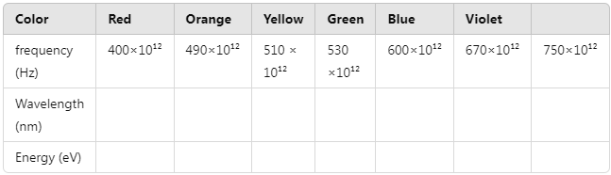

* Ultraviolet light spans a range from 400 nm to 12 nm. Calculate the maximum frequency and energy of UV radiation.
* Given that the ionization energies of atoms (C, H, O, and N) are respectively (11.24 eV, 13.54 eV, 13.57 eV, and 14.24 eV), explain why prolonged exposure to UV radiation is dangerous.

**Exercise No. 2:**

1. Find the surface temperature of the Sun, Polaris, and Sirius, knowing that their spectra exhibit a maximum at wavelengths of 0.55 µm, 0.35 µm, and 0.29 µm, respectively.
2. Assuming that the Earth and the Sun radiate as black bodies, determine the Earth's temperature in terms of the Sun's temperature, the Sun’s radius, and the Earth-Sun distance.

**Exercise No. 3:**

Classify the following radiations based on their physical properties: UV, n, p, , , X-rays.

* What is the difference between the photoelectric effect and the Compton effect?
* What is the difference between an X-ray and a Gamma-ray (same order of energy)?

**Exercise No. 4:**

A vacuum photoelectric cell is illuminated with monochromatic light, where each photon carries an energy of 2.75 eV.

1. Calculate the wavelength of this light.
2. Calculate the expulsion velocity of an electron from the cathode metal, knowing that the work function is 2.25 eV.

To increase this velocity, should one change the wavelength of the incident light or the light power? Justify your answer.

**Exercise No. 5:**

A homogeneous X-ray beam with a wavelength of Å falls on a carbon crystal. Observations show that X-rays are scattered in all directions, with different wavelengths. Assume that the electrons in the crystal are at rest relative to the photons.

* Show that an X-ray photon cannot transfer more than 40.2 keV to electrons in the crystal.
* What is the wavelength of X-rays scattered at 45°?
* What is the energy of recoil electrons in this case?

**Exercise No. 6:**

The cathode metal of a photoelectric cell is characterized by a work function eV.

1. Determine the threshold wavelength for the photoelectric effect.
2. The cell is illuminated by a beam consisting of two monochromatic radiations with wavelengths µm and µm. Does the photoelectric effect occur?
3. The cell is illuminated by a monochromatic beam emitted by a point source S, with a wavelength µm. The electric potential difference between the anode A and the cathode C is . The current through the cell is µA.
   * Draw a schematic of the setup, indicating the direction of the current.
   * Knowing that the current remains unchanged when is increased beyond 50V, deduce the number of electrons emitted per second from the cathode.

**Exercise No. 7:**

The Sun's mass is kg; its radius is m, and its surface temperature is approximately K. Assuming the Sun radiates as a black body:

* Find the mass it loses per second.
* Estimate the time required for a relative loss of 1% in mass.