**ESP Branches:**

Though there is no general agreement among scholars about what definitively the branches of ESP are, most of them seem to agree on two major categories of purposes, academic (sometimes called instructional or educational) and occupational.

Under the auspices of the British Ministry of Foreign Affairs, the British Council carried in 1975 a first attempt to classify the different types of ESP. In this first taxonomy, two branches were considered, according to their specificity and purposes: firstly, English for academic purposes (EAP) that included English for Science and Technology (EST) and secondly, English for Occupational Purposes (EOP).

In 1977, Strevens presented another classification which completed that previous one taking into consideration the chronological factor,i.e., whether the courses were followed as a simultaneous experience with students’ jobs – sandwich courses- or students followed the courses before getting their jobs.

Furthermore, Strevens (1977) identified two main branches of special purpose language teaching (SP-LT): occupational and educational languages

In terms of occupational language three sub-categories are clearly set out: pre-experience, simultaneous and post-experience.

**PRE-EXPERIENCE**

**OCCUPATIONAL** **SIMULTANEOUS**

**POST-EXPERIENCE**

**SP-LT**

**PRE-STUDY**

**EDUCATIONAL** **IN-STUDY**

**POST-STUDY**

***Figure 1: The division in SP-LT (Strevens, 1977: 155-156)***

Strevens revised, later, his model. So, he subcategorized English for Occupational Purposes ( EOP ) as Professional English , such as English for Business and Economics, and Vocational English, such as English for auto mechanics. He also broke down English for Academic - or educational – Purposes (EAP) into English for Science and Technology (EST) and English for Academic Purposes other than EST .Of all the subcategories EST has been the best developed and most frequently taught. The reasons are that many ESP students throughout the world are scientists and engineers, and because a vast number of scientific books and papers are printed in English and that science , especially at the discourse level, is more regular across languages ( Johns, 1991:71 ).

**English for Specific Purposes ( ESP )**

* 🡾

**English for Occupational Purposes English for Academic Purposes**

**(EOP) (EAP)**

🡿 🡾 🡿 🡾

**English for English for English for English for**

**Professional Vocational Science and Academic**

**Purposes Purposes Technology Purposes (EPP) (EVP) (EST) (other than EST)**

***Figure 2: Subcategories of English for Specific Purposes (*Johns, 1991:71).**

Further to this, Robinson (1991), influenced by the work of Strevens, produces the following chart

**English for Specific Purposes ( ESP )**

**English for Academic or Educational Purposes (EEP/EAP )**

**English for Occupational Purposes**

**( EOP )**

**As a School Subject**

**For Study in a Specific**

**Discipline**

**Post-Experience**

**Similtaneous/ In Service**

**Pre-Experience**

**Independent**

**Post-Study**

**In-Study**

**Pre -Study**

**Integrated**

***Figure 3: Classification of English for Specific Purposes (Robinson, 1991: 3-4)***

In her classification of ESP Robinson agrees with Strevens on the fact that EAP takes place in a tertiary educational setting where students learn English either before specializing their studies (pre-study) or as part of their studies (in-study).

Munby (1978) illuminates this point as;

“A Turkish student in the preparatory department… who is studying English is an example of pre-study discipline-based ESP. A Mexican, student in the faculty of veterinary science at the National University of Mexico, who is studying English in order to read books and articles on his subject that are written in English, is an example of in-study, disciplined-based ESP.” (Munby, 1978:57).

Another important classification of ESP is that of Carver (1983) in which he distinguishes three types of ESP:

**(a) English as a Restricted Language**

 As examples of English as a restricted language, Carver (1983) mentions the language used by air traffic controllers or by waiters. The difference between restricted language and language itself is that, as Mackay and Mountford (1978) posit,

“... the language of international air-traffic control could be regarded as 'special', in the sense that the repertoire required by the controller is strictly limited and can be accurately determined situational, as might be the linguistic needs of a dining-room waiter or air-hostess. However, such restricted repertoires are not languages, just as a tourist phrase book is not grammar. Knowing a restricted 'language' would not allow the speaker to communicate effectively in novel situation, or in contexts outside the vocational environment.” (Mackay and Mountford, 1978: 4-5)

**(b) English for Academic and Occupational Purposes**

Carver (1983) points that this type of English should be at the heart of ESP. Carver’s rationale for the division of ESP into EAP and EOP lies in the fact that the end purpose of both EAP and EOP are one in the same: employment, but the means taken to achieve it are very different . While, EAP’s focus is on cognitive academic proficiency EOP’s focus is on basic interpersonal skills. (Cummins, 1979).

Hutchinson and Waters assume that there is no clear- cut distinction between EAP and EOP since “people can work and study simultaneously; it is also likely that in many cases the languages learnt for immediate use in a study environment will be used when the student takes up, or returns to a job” (1987:16)

Additionally, Hutchinson and Waters have developed the English Language Teaching tree (ELT tree) in which English for Specific Purposes is split up into three main branches : English for Science and Technology (EST), English for Business and Economics (EBE), and English for Social Studies (ESS).

Further, each of these subject areas is broken down into two categories: English for Academic Purposes (EAP) and English for Occupational Purposes (EOP).

Examples of EAP are English for Medical Studies in EST, English for Economics in EBE and English for Psychology in ESS; whereas examples of EOP include English for Technicians in EST, English for Secretaries in EBE and English for Teaching in ESS.

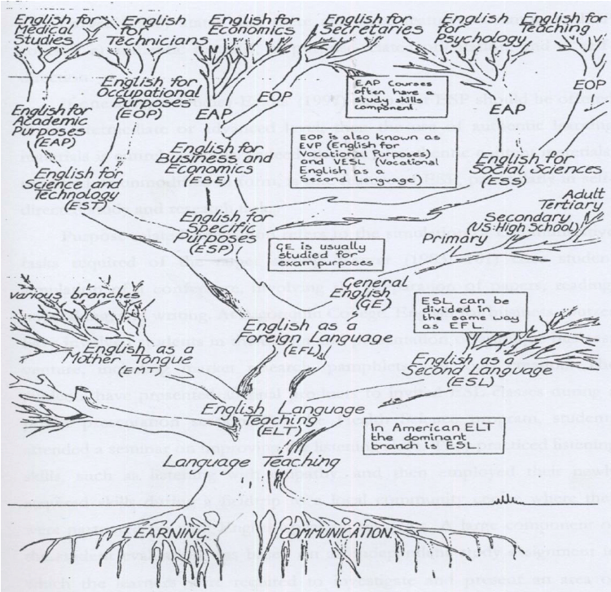

*The ELT tree according to Hutchinson and Waters (1987)*

**(c) English with Specific Topics**

Carver (1983) noted that it is only in English with specific topics where emphasis shifts from purpose to topic.

It is also assumed that this category of ESP is uniquely concerned with anticipated future needs of, for example, scientists requiring English for postgraduate reading studies, attending conferences or working in foreign institutions. However, it is argued that English with specific topics is an integral component of ESP courses or programs rather than a separate type of ESP.

In this type of ESP, the courses or programs focus on situational language based on the interpretation of results from needs analysis of authentic language used in target workplace settings.

Dudley-Evans and St John (1998) acknowledge, as a matter of fact, the division of ESP into EAP and EOP, as well as the diagram produced by Robinson .They believe that this division of ESP is a useful division of ESP courses according to when they take place since it will affect the degree of specificity that is appropriate to the course. They also argue,

“A pre-experienced or a pre-study course will probably rule out any specific work related to the actual discipline or work as students will not yet have the required familiarity with the content , while courses that run parallel to or follow the course of study in the educational institution or work place will provide the opportunity for specific or integrated work.” (Dudley-Evans and St John, 1998:6)

However, Dudley-Evans and St John advocate the following tree diagram of ESP as a typical one in which EAP and EOP are divided according to discipline and professional area

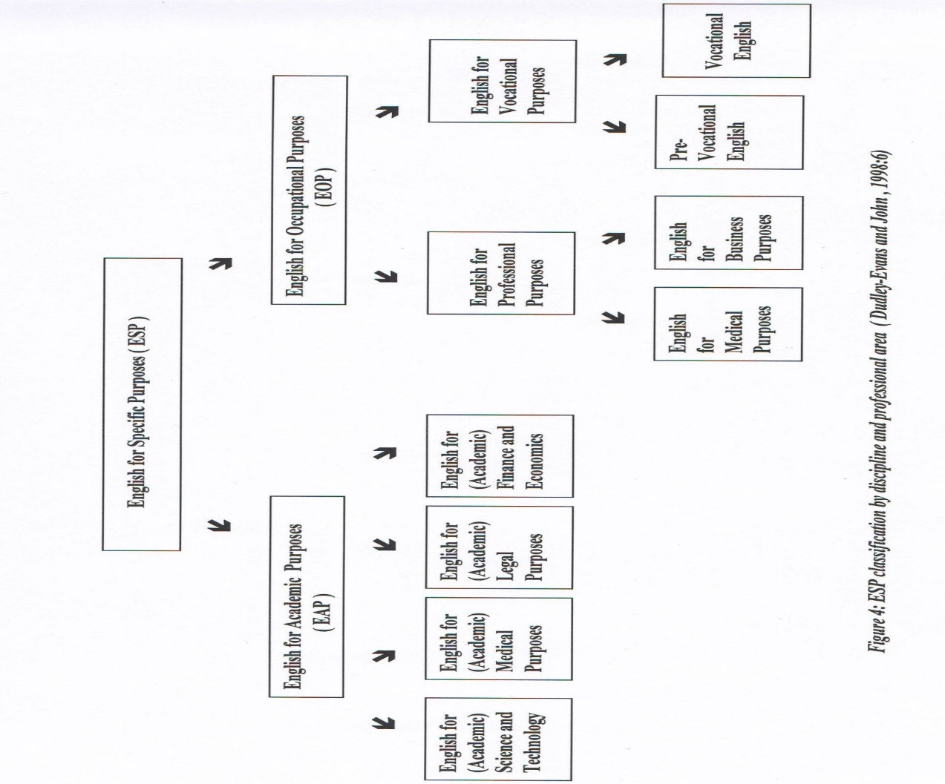

It is necessary to note that the distinction Dudley-Evans and St John make between EAP and EOP lies in the fact that EAP relates to the English needed in an educational context (university or similar institution and possibly at school ) whereas EOP is more complicated :it relates to professional purposes ,e.g. those of working doctors , engineers or business people.( Dudley-Evans , 2001: 132 )

Drawing on an idea from Blue (1988), Dudley-Evans and St John make another key distinction between more general ESP and more specific ESP. They distinguish between English for General Academic Purposes (EGAP) designed for heterogeneous groups with regard to discipline, and English for Specific Academic Purposes (ESAP) designed to meet the needs of a group from the same discipline.

Though it is often common to hear terms such as medical English, English for engineers or English for administration Dudley-Evans and St John (1998) cited in Dudley-Evans (2001 ) consider that these terms may lead to confusion as “medical English may include EAP for students following a degree course in medicine where the language of instruction is English, or a reading skills course where the subject is taught in a language other than English, but also a type of EOP for practising doctors using English to talk to patients (e.g. Cuban doctors working in South Africa) or to write up research in English. Similarly, English for engineers may be for students of engineering or for practising engineers needing, say to write reports in English.” (Dudley-Evans, 2001: 133)