**SERIES 1: Dynamics and Kinematics of a Material Point**

**Exercise No 1:**

Consider a mobile with a mass of m = 2 N moving in a force field such that:  
=24 t2+ (36t-16) -12t

At t=0, the mobile is at position = 3- + 4 and has a velocity **0** = 6- 15- 8.

Determine:

1. The velocity of the mobile.
2. The position of the mobile.
3. The acceleration of the mobile.

**ExerciseNo2:**  
The equation of motion of a projectile of mass mmm launched from the ground in the (x, y) plane and subjected to air resistance is: *m* = + *m*where α is a positive constant and ​ is the gravitational acceleration. Given (*t* = 0) = (*v*0*x , v*0*y*).

Show that the time-dependent equations of motion are: *x*(*t*) = *v*0*x* [1 − exp(−*t/* )];

*y*(*t*) = (*v*0*y* + *g* ) [1 − exp(−*t/*)] − *gt* where τ is a parameter to be identified.

1. Describe the trajectory qualitatively.
2. Calculate the total energy of the mass.
3. Calculate the work done by the friction force between two instants t1 and t2​. Derive this result again using question 2.

**ExerciseNo3:**  
Let r and θ be the polar coordinates describing the position of a material point, the unit vector directed along , and ​​ the unit vector perpendicular to and directed in the direction of increasing θ.

1. Write ​​ and ​​ in the Cartesian basis.
2. Provide the expressions for and in the polar reference frame.
3. Show that = ​​ and = .
4. Demonstrate that the velocity and acceleration can be written as:

*;*

**ExerciseNo4:**  
Express the position vector of point M in cylindrical coordinates (*, ,* ) and spherical coordinates ( *,,*) (Figure 1-2).

* Calculate the velocity vector .
* Calculate its acceleration .

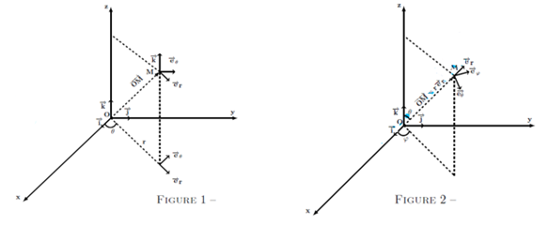

**Exercise No 5 :**

1. Show that the force field defined by:

= (y2z3-6xz2) +2xyz3  + (3xy2z2-6x2z) is a conservative force field.  
2. Calculate the work done by this force when the displacement of the mobile is from point A(−2,1,3) to point B(1,−2,−1)

**ExerciseNo6:**  
Consider the motion of a mobile subjected to the force:

=m[-w2a cos(wt )-w2b sin (wt ]

with x= a cos(wt) and y= b sin(wt)

1. Show that the applied force field is conservative.
2. Determine the potential energy at point A(r=a) and at point B(r=b).
3. Calculate the work done in moving from Ato B.

**ExerciseNo7:**  
A material point of mass mmm moves along a parabolic wire with the equation ay=x2 where a>0). The movement is subject to dynamic friction with a coefficient μ, as shown in Figure 5.

* Find the coordinates of the material point at which it is in equilibrium.