# Unit 01: Reading

# BASIC: Climate Change: How Do we Know?

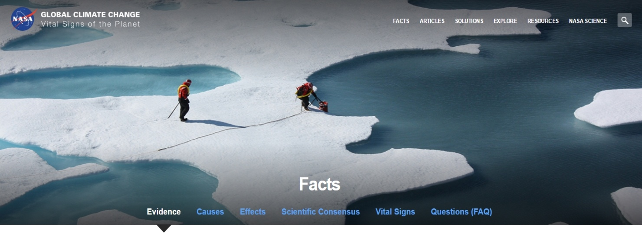

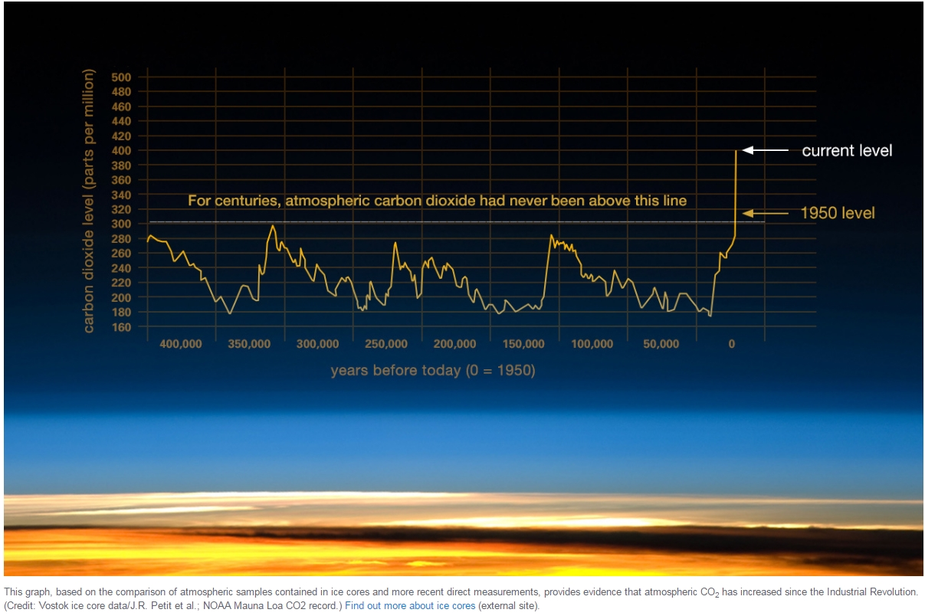

https://d3c33hcgiwev3.cloudfront.net/imageAssetProxy.v1/fbkyFOcfEeaHDBJlPgj3oA_c4978c5c3067d7f4fc029da06cc6022c_Newsela.jpg?expiry=1680566400000&hmac=hVErvIrZBA-ozgzYkqZ2225GSeXtSU9SEEl6ZgbOdBA

Earth's climate is always changing. In the last 650,000 years there have been seven ice ages (cycles of glacial advance and retreat). The last ice age ended about 7,000 years ago. That is when our current climate period began. Human civilization began then as well. Most climate changes are caused by very small changes in Earth’s orbit. A change in orbit can change the amount of energy our planet receives from the sun.

But today, the way the climate is warming is different. That's because it is almost certainly caused by humans. Also, the temperature is increasing faster than it has in the past 1,300 years.

Scientists have a lot more information than they used to. Today, scientists are able to see the big picture. That is because there is new technology. Satellites that orbit around the Earth provide a lot of information. They have been collecting information for many years. This data has revealed the signals of a changing climate.

Humans have been burning fossil fuels like coal, oil and natural gas ever since the Industrial Revolution began in the 1800s. Fossil fuels release greenhouse gases, such as carbon dioxide, into the atmosphere. They are called greenhouse gases because they trap heat from the sun in the atmosphere.

NASA (National Aeronautics and Space Administration) has flown many instruments into the atmosphere to get information. They have shown that increased levels of greenhouse gases cause the Earth to warm.

Some of the evidence is ancient. Samples of ice can be taken from deep inside glaciers. Other samples can come from trees and oceans. The evidence shows how Earth’s climate responds to changes in greenhouse gas levels. Earth is warming 10 times faster than it would without humans burning greenhouse gases.

The evidence for rapid climate change is compelling:

## Sea Level Rise

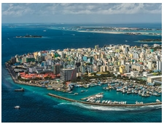

Global sea level rose about 17 centimeters (6.7 inches) in the last century. The rate in the last 10 years has been much faster. As temperatures on Earth rise, huge glaciers melt. This causes the sea levels to rise.

## Global Temperature Rise

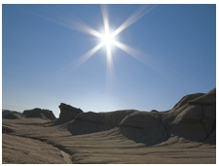

The Earth has warmed significantly since 1880. Most of the warming occurred in the past 35 years. Since 2001, we have had 15 of the 16 warmest years on record. The year 2015 was the first time the global average temperatures were 1 degree Celsius or more above the 1880-1899 average.

## Warming Oceans



Oceans absorb heat. This causes ocean temperatures to rise. Since 1969, the ocean temperature has increased by around 0.3 degree Fahrenheit.

## Shrinking Ice Sheets

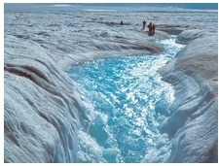

The Greenland and Antarctic ice sheets have gotten smaller. Greenland lost 150 to 250 cubic kilometers of ice each year between 2002 and 2006. Antarctica lost about 152 cubic kilometers of ice between 2002 and 2005.

## Declining Arctic Ice

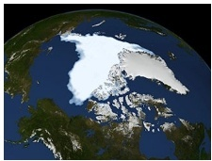

Arctic sea ice has changed quickly over the last several decades. It does not cover as much surface as it did before. It is also not as thick. Sea ice typically melts a little bit during the summer, but not completely. Recently, more sea ice has been melting all the way in the warmer months.

## Glacial Retreat

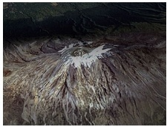

Glaciers are huge masses of ice on mountains. Around the world, glaciers are getting smaller. Glaciers in the Alps, Himalayas, Andes, Rockies, Alaska and Africa have all gotten smaller.

## Extreme Events



When a temperature is the warmest it has ever been, it is called a "record high temperature event." Since 1950, the number of record high temperature events in the United States has been increasing. The number of record low temperature events has gone down. Also, there have been more instances of very heavy rain. Other weather events like hurricanes are also happening more often.

## Ocean Acidification

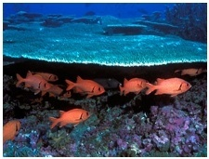

Ocean acidity has gone up by about 30 percent over the last 200 years. This is because oceans absorb carbon dioxide. There has been more carbon dioxide in the atmosphere. This puts more acid into the ocean. The amount of carbon dioxide that ends up in the oceans is increasing. It has gone up by about 2 billion tons per year.

## Decreased Snow

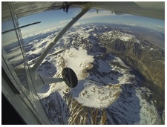

Satellite pictures show scientists how much snow falls on Earth. In the last 50 years, the amount of snow has decreased. Snow is also melting earlier in the year.

_________

NASA. (2017, January 19). Climate Change: How do we know? (Ed. Newsela Staff). Retrieved from <http://climate.nasa.gov/evidence/>