**Overview of the Unit**

**Overview of the Unit**

Welcome to Unit 5 of the English courses! In this unit, you will investigate practical advances in Nanotechnology that help slow down climate change. An example of this is turning light into heat. You will also learn how the scientific community works together to create new discoveries through expert interviews and readings. Lastly, you will develop your own research skills by learning how to choose good sources and cite them in your research.

**Learning Objectives**

By the end of this unit, you will:

* Demonstrate understanding of potential uses of Nanotechnology
* Choose good sources for research
* Understand importance of citing sources in own research
* Use future possibility and probability modals
* Read, watch, and listen to a variety of texts and multimedia sources.
* Demonstrate your understanding of these texts and key course ideas through comprehension check quizzes, a discussion board and a peer-reviewed assignment.

**PART I : The Development of Nanotechnology**

**VEDEO 01**

**What is Nanotechnology?**

In this unit, we're going to shift from studying the Earth's large atmosphere and zoom in on the tiny world of nanotechnology.

We will investigate the question "What is nanotechnology?" and learn about how it works, its uses, and how it relates to climate change.

To begin, let's answer the question "***What is nanotechnology***?"

Look at the word nanotechnology. You'll notice it consists of two parts: the prefix **nano** and the word **technology**. The prefix nano means very **small**.

In science and math, **nano** is used to describe one **billionth** the size of something. For example, a nanosecond is one billionth the time of the second.

The second part of the word technology is something you're probably familiar with. It is the creation of new things using different sciences, methods, and techniques. So what do you think nanotechnology means then? **Nanotechnology is the science of working with atoms and molecules at the nanoscale to build devices that are extremely small.**

Scientists in the nanotechnology field work in *nanometers*. Do you know how small a nanometer is? *A nanometer is one billionth the size of a meter.* To understand how small that is, think about this: a strand of human hair is approximately 80,000 to 100,000 nanometers wide and a sheet of paper is approximately 100,000 nanometers thick.

So one nanometer is much too small for any human to see. Therefore, we need special tools and microscopes in order to see and work at the nanoscale. However, don't be fooled by the size of the nanoscale. Although it is very small, it can create some very powerful materials.

At the nanoscale, there are many ways to change materials properties. Properties include things like strength, weight, durability, etc. Scientists that work in the field of nanotechnology work at the nanoscale to create new or special properties in materials. *Nanotechnology can make materials stronger, lighter, more durable, more magnetic, etc.,*

for example, **carbon** in the form of **graphite**, like **pencil** lead is soft and malleable. However, by changing it at the nanoscale, it can be made stronger than steel and is six times lighter.

Using nanotechnology, new materials can be used to improve our way of living. In **medicine**, scientists are finding ways to change nano particles, the size of molecules, so that they only treat damaged or diseased cells in the body. This would improve treatments like **chemotherapy** because healthy cells would not be hurt during treatment.

In terms of **electronics**, **batteries** are being developed using nano materials that are able to stay good for longer and be charged much faster than current batteries.

In terms of the **environment**, there are many ways nanotechnology is working to help find solutions to climate change. One example, includes using nanoscale **membranes** or screens to separate carbon dioxide from other gases so it can be stored and removed from the environment. Another is the use of nanotechnology in the production of solar panels. It is predicted by the year 2020, nanotechnology will be able to increase the output of energy of solar panels by two to three times by using nano materials in place of current solar cells.

To summarize, in this video, we learned about nanotechnology. We learned about what it is, how it works, its uses, and how it relates to climate change. Next, you're going to learn about how nanotechnology is growing and being used around the world.

**VEDEO 02**

**Nanotechnology Around the World**

Hello, in the previous video, we learned about nanotechnology. We learned what it is, how it works, its uses, and how it relates to climate change.

In this video, we will learn about the growth of nanotechnology and different countries around the world who are emerging leaders in the field. Whether you know it or not, nanotechnology is everywhere.

A recent study showed that nanoparticles can be found in our clothes, fertilizers, cosmetics and even chewing gum. Developments in electronics, medicine, health care, energy production, environmental remediation, transportation and more have all happened with the help of nanotechnology.

As countries become aware of the benefits of nanotechnology, they focus more on research and development. According to data cited by the UNESCO science report, **Switzerland** is the leader in the publication of scientific articles and Nanotechnology. Followed by the **Republic** of **Korea**, **Germany**, **France**, the **USA** and **Japan**.

These countries also have the highest rate of inventions in the field. In addition to research, nanotechnology has become a focus for industrial nations looking for better ways to make things. These options include the incorporation of new resources and systems. Such as materials that are lightweight, stronger and more durable. Clean and powerful energy sources. And databases that can store large amounts of information.

**Australia, Canada and China**, in addition to the countries already mentioned, are among the top in using nanotechnology for manufacturing. Governments in these countries hope that advanced manufacturing will help to create more affordable products for consumers and increase jobs.

Beyond these leaders, other countries, such as **Brazil, the Russian Federation and India** are all trying to become nanotechnology centers. Brazil's investment in nanotechnology research is continually growing and in 2011, the country established the Brazilian Nanotechnology National Laboratory.

The Russian Federation has been focusing its efforts on the production of nanotech products, such as **nanoceramics, nanotubes and medical materials.**

In India, the development of nanotechnology is concentrated on physical infrastructures and research, with the goal of becoming a global knowledge hub. The country has also made progress in developing nanotech products such as the **Tata Swach**, which is a water filter that uses **nano-silver particles to help purify or make water clean**.

To summarize, in this video, we learned about the growth of nanotechnology, and different countries around the world who are emerging leaders in the field. Next, you're going to read an article about how some scientists are turning carbon dioxide into stone, as a way to lessen the amount of carbon dioxide in our atmosphere.

**READING 01**

# Can the Earth Be Saved by Turning CO2 to Stone?

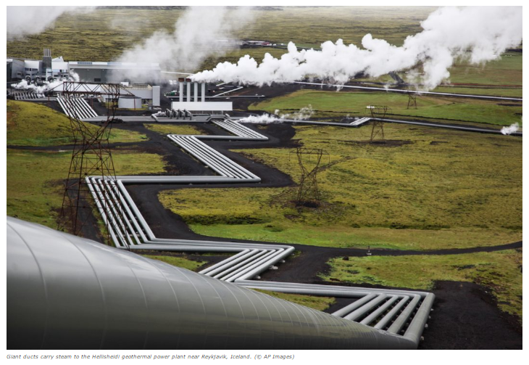

https://d3c33hcgiwev3.cloudfront.net/imageAssetProxy.v1/B9ppYCXXEeeErgpOFanBSA_273fb2aa5f93c08a602910a8260c3fbd_Newsela.jpg?expiry=1731974400000&hmac=aGPW2jjKypal1WJzscaeMIzqDSl1XOyf0NLr7bJSR3c

Scientists around the world are teaming up to solve a big problem. They are pioneering a new and promising way to capture and store carbon dioxide. Carbon dioxide is a greenhouse gas that contributes to global warming. Their idea? Turn it into stone.

Scientists on the CarbFix team first tested this idea in Iceland in 2014. They pumped atmospheric CO2 into a type of volcanic rock called basalt. The results surprised and encouraged the scientists. Within two years, nearly 250 tons of CO2 changed into carbonate crystal stones.

“Our results show that between 95 and 98 percent" of the CO2 turned into stones, said Juerg Matter of the University of Southampton in the United Kingdom. He is the lead author of the report. He said it happened "amazingly fast."

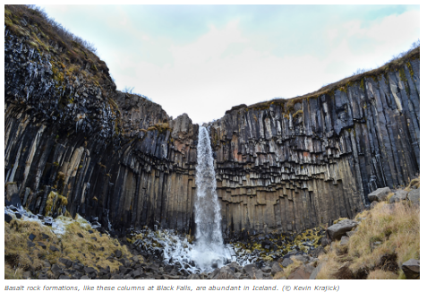

A large power station in Iceland supplied the CO2 for the test. The experiment ended, but the power plant continues to pump CO2 out of the air. There are plans to inject 10,000 tons of CO2 into stone this summer. The plant eventually wants to capture its entire CO2 output in stone.

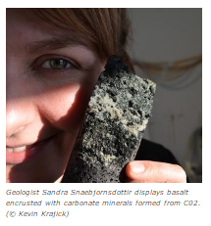

They have not had any trouble yet. "That is a good sign," Martin Stute said. He is a Columbia University environmental scientist. He was part of the team that came up with the experiment.

## Field results are "promising"

It could be an important step. Carbon dioxide from human activity is contributing to climate change. Each day, huge amounts of CO2 are released from burning coal, oil and natural gas.

There are plenty of places where you can put CO2, Stute said. He gave one example in the Middle East. “That one rock formation in Oman could take all human CO2 emissions for hundreds of years,” he said.

Basalt rocks are found all over the world, even under the ocean floor. Brazil, India, South Africa and the United States have huge amounts of basalt.

Scientists have other ideas about taking CO2 out of the atmosphere. Rather than capturing CO2 from power plants alone, remove the gas from the air anywhere. Stute said the field results are "promising."

CO2 can be captured anywhere. It exists in the air in similar amounts all over the world. If captured near volcanic rock and water, the CO2 could be injected and crystallized on the spot.

## Getting the price down

Grabbing CO2 from the air where there is a lot of basalt and water is fairly affordable. It could cost $20 to $30 per ton. Capturing and transporting carbon can cost five times as much, or even more. It depends on how far the carbon must be moved.

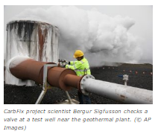

Another thing that could make it more expensive is how the carbon is made. The gases given off from the Iceland plant were mostly CO2 and hydrogen sulfide. Coal, oil, and natural gas plants release more kinds of gases. They must be separated from the CO2.

## Now is the time

The CarbFix scientists agree: capturing and storing carbon is a good short-term fix. Eventually, however, we need to focus on renewable energy, like solar power and wind.

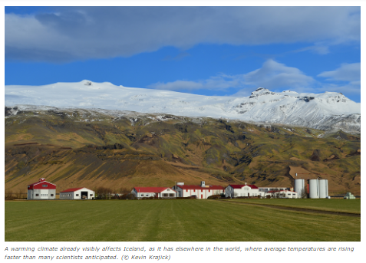

Scientists say renewables alone are not enough. Using more renewable energy cannot offset all the problems with greenhouse gases. We need to do everything we can to stop global temperature rise.

It comes down to money, Stute added. There needs to be a money-related incentive, or reason, "to do something about CO2 emissions. If the incentive is there it can be done. We need to take it seriously.”

The CarbFix project is funded by the U.S. Department of Energy and the European Union. It includes scientists from Australia, Britain, Denmark, France, Iceland, Netherlands and the United States.

____________

Terhune, L. (2016, July 7). Saving Earth by Turning Co2 to Stone. (Ed. by Newsela staff). Retrieved from <https://share.america.gov/saving-earth-by-turning-co2-to-stone/>

### 1.Question 1 **Comprehension Check Instructions:**

**Instructions:** All questions in this quiz refer to the reading, “Can the Earth Be Saved by Turning CO2 to Stone?" You are allowed to refer to this reading as you answer these questions. You can open the reading in a new tab by clicking one of the links:

**According to this article, what new strategy are scientists using to try to capture and store carbon dioxide?**

Scientists are trying to capture and store carbon dioxide in water

Scientists are trying to capture and store carbon dioxide in heat

Scientists are trying to capture and store carbon dioxide by turning it into stone

Scientists are trying to capture and store carbon dioxide by heating it in volcanoes

### 2.Question 2 What happened within two years of the CarbFix project?

90 to 95% of the carbon dioxide was released into the atmosphere

The carbon dioxide burned a hole into the rock formations

The carbon dioxide dissolved

Nearly 250 tons of carbon dioxide was turned into carbonate crystals

### 3.Question 3 Where can basalt rock formations be found?

Brazil

South Africa

The United States

All of the above

### 4.Question 4 True or False: There are no price concerns with this method of ridding of carbon dioxide.

True

False

**VEDEO 03**

**Making New Technology Practical**

Hello, in the previous video, you looked at nanotechnology around the world. In this video, we are going to talk about the practical ways that new technology like this could help to stop climate change.

We'll look at practical applications of nanotechnology for energy efficiency and environmental protection. This means how we can use nanotechnology in our everyday lives

As you know, nanotechnology is the science of working with atoms and molecules at the nanoscale to builddevices that are extremely small. At the nanoscale, the properties of a material change, such as its strength, shape, conductivity, or many other things. Let's start by looking at how that can help in energy efficiency.

One example of this is about vehicle engines. Many parts in vehicle engines rub against each other when the vehicle is moving. Nano technology can reduce, or lessen, the amount of fossil fuels that these vehicles use by decreasing friction, the resistance between two objects in the engines, when nanoparticles are added to the oil. Electrical wires containing **carbon nanotubes** could be used in the electrical grid. They will have less resistance, meaning more power will be transferred to users.

Another use of **carbon nanotubes** could be in the blades of wind turbines in wind farms. The blades could be made both lighter and stronger, increasing the amount of electricity generated.

Nano-scale materials are already available to consumers. At the moment, these nano materials can make a **shirt** either water resistant or wrinkle-free. In the future, perhaps these materials could make a shirt able to get energy from the sun, or even create energy through movement. Imagine being able to creat usable energy just by moving around in your daily life. As we have seen in other videos, reducing the amount of energy we use is an important part of fighting climate change.

Nanotechnology can create efficient, rechargeable **batteries**, so that cars and other vehicles do not need to use so much **fuel**. It could also make lighter, stronger aircrafts, that also use much less fuel.

Cleaning up environmental problems is another area where nanotechnology could be applied practically. You may remember, we talked about one of the human costs of coastal flooding-- drinking water will be contaminated by salty seawater. Nanoparticles could be put into the water to clean and desalinate, take the salt out, so that people can drink it. You might also might remember that one of the problems of placing garbage in landfills is the contamination of ground water, such as rivers and lakes. Nano particles can also create chemical reactions that clean the chemicals out of this water and make it safe for people.

Back in unit three, we talked about the problems caused by excessive heat and that air pollution gets worse in hot weather. Nanotechnology can be used in sensors to monitor air quality and make sure it is not dangerous for people. Oil spills, when a ship or pipeline leaks oil into the sea, are terrible for the environment, killing wild life and polluting the water. **Towels** made from nano fabrics can be used to clean up these spills. The towels can clean up to 20 times their own weight in oil. Of course, many of these technologies are still in development. They may need many years of research before they are ready to use. Ordinary people will still need to play an important role in stopping climate change.

So in this video, we looked at some of the practical ways in which nanotechnology could be used to help stop the problems caused by climate change. In terms of both energy efficiency, and environmental protection. Use the information that you have learned in this video to help you take the quiz that follows.

## Unit 5 Assessment 1: Making New Technology Practical and Profitable

### Question 1 **Instructions:** Use the information you gained from Video 3 "Making New Technology Practical" to choose the best answer to each of the following questions.

**At the nanoscale ________________.**

many different properties of a material change

the color of a material always changes

the weight of a material always changes

### 2.Question 2 Nanoparticles could be put into engine oil to ____________.

change the color of the oil

make the oil thinner and cheaper

reduce friction in the engine

### 3.Question 3 Carbon nanotubes increase electricity efficiency because ____________.

 electrical wires containing carbon nanotubes can be used 24 hours a day

 electrical wires containing carbon nanotubes have less resistance

electrical wires containing carbon nanotubes are cheaper than regular wires

### 4.Question 4 Carbon nanotubes could make wind turbines ____________.

lighter and stronger

heavier and stronger

longer and stronger

### 5.Question 5 Nanoscale materials in clothing could create ____________.

energy using water or wind

energy using the sun or the Earth

energy using the sun or movement

### 6.Question 6 Nanotechnology could create efficient rechargeable batteries for __________.

pens and pencils

cars and other vehicles

televisions

### 7.Question 7 Nanotechnology could help the victims of coastal flooding by ____________.

 finding them somewhere else to live

purifying drinking water that has become contaminated

evaporating the flood water into steam

### 8.Question 8 Nanoparticles could clean water that has been contaminated by ____________.

recycling

landfill

incinerating

### 9.Question 9 Nanotechnology could monitor air pollution made worse by ___________.

 excessive heat

excessive cold

excessive rain

### 10.Question 10 Towels made from nanofabrics could be used to clean up _________.

oil spills from a ship or pipeline

waste aluminum from recycling

a cup of coffee dropped on the floor

**VEDEO 04**

**Language Focus: Future Possibility and Probability Modals**

Hello. In the previous video, you looked at making new technology practical. In this language focus video, we're going to talk about how to talk about the possibility of something happening in the future. We do this by using modals of probability. We'll look at the most common modal verbs to use, talk about the differences between them, and look at some examples of each one.

In the previous unit, we looked at modals of suggestion. So we know that a modal is a special

type of verb usually used with another verb that describes ideas such as making a suggestion, giving advice, or talking about the probability, the chance of something happening. In this video, we're going to look at modals of probability. Probability means the chance of something happening in the future.

As an example, think about a weather forecast. If there is a 90% chance of rain tomorrow, that is a very high probability. If there's a 10% chance of rain tomorrow, that is a very low probability. We can use different modal verbs to indicate whether the chance of something is high or low. Today, we're going to concentrate on the modals **will**, **should**, **could** and **might**, and the negative of will, **won't**.

Here is a graph showing the probability of these modals, from high to low. High means that something has more chance of happening, and low means it has less chance. At the high end, we have the modal will. This is a very strong modal, and we only use it when the chance of something happening is almost certain.

Let's look at a couple of examples. Rising sea levels will cause more coastal flooding. As we saw in a previous video, we can be certain that rising sea levels will result in areas near the sea being flooded. Consequently, we can make a prediction with high probability and use the modal verb, will.

Another example might be, lack of rainfall over a long time will cause drought. Again, we can be certain of this happening. So, we use will.

If we want to say that something will not happen, we use the negative of will, **won't**. In this case, we are certain that something will not happen. Increased use of fossil fuels won't reduce CO2 emissions. So we know we should use will if we are certain that something will happen, and won't if we are certain that something won't happen.

If we are not quite certain of the result, we use **should**. Should is still fairly high in probability, but not as high as will. For example, scientists believe that hurricanes are going to be stronger in the future, but they are not certain of this because there are so many things to consider. Therefore, we make this sentence, as the climate gets warmer, hurricanes should get stronger.

What if the future is even more difficult to predict? In this case, we use lower probability modals like **might** or **could** to express our opinions. Climate scientists looking at data about tornadoes have found that there are more tornados now than in the past, but that does not necessarily mean there will be more in the future. They are not sure. Therefore, their prediction is climate change might cause more tornadoes. Because in this case, might and could have very similar meanings. Another way of saying this is climate change could cause more tornadoes.

So in this video, we looked at how to talk about the possibility of something happening in the future. We did this by using modals of probability. We looked at the most common modal verbs, talked about the differences between them, and looked at some examples of each one.

## Game 2: Future Possibility and Probability Modals

### 1.Question 1

**Climate scientists are certain that climate change will affect us in many ways. However, they are not always certain exactly how this will happen. Look at the following sentences and choose the most appropriate modal of probability.**  **To help you, the probability (high, low, or in the middle) is marked on a line for each sentence.**

**1. Scientists know that global climate change __________ affect agriculture and food supply.**



won't

will

could

### 2.Question 2 They think that global climate change __________ make it too hot to grow some crops.

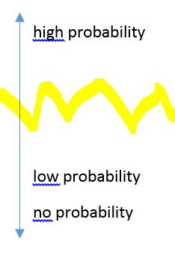

won't

might

should

### 3.Question 3 Heat waves affect everyone, but the young and the elderly __________ be most at risk.



won't

might

will

### 4.Question 4 In areas with severe drought, there __________ be enough water for hydroelectric dams.



will

won't

might

### 5.Question 5 Perhaps as many as 25% of all the plants and animals on Earth __________ become extinct within 100 years, if the Earth keeps getting warmer.



will

could

won't

**READING 02**

# BASIC: Profits From Eco-friendly Vertical Farming Stack Up

In vertical farming, plants are grown inside. They are stacked from floor to ceiling. The room is carefully controlled, so the plants have the best growing conditions. More places are starting to use vertical farming. It is changing how we think about growing and selling food.

One example is AeroFarms in Newark, N.J. It grows leafy greens and herbs in a large warehouse. The farm has more than 250 different kinds of plants. The plants are placed on tall shelves and get light from special LED lights. Mist and cloth make sure they get enough water.

Farmers have to dress carefully to enter. They wear gloves, lab coats and coverings on their heads. Their shoes are also carefully cleaned.

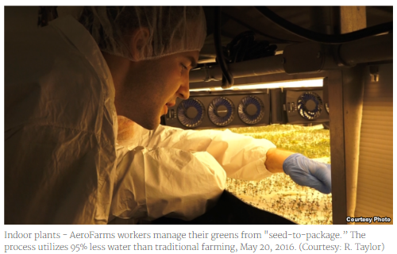

The farm manages to grow more food at lower costs. AeroFarms is now a leader in indoor farming. People think indoor farming is going to grow very quickly over the next five years. Soon, it will be worth a great deal of money, about $4 billion according to some estimates.

David Rosenberg is co-founder and CEO of AeroFarms. He said that for now the company will stick to growing leafy greens. Doing so "absorbs some of the price premiums with the new technology,” he said.

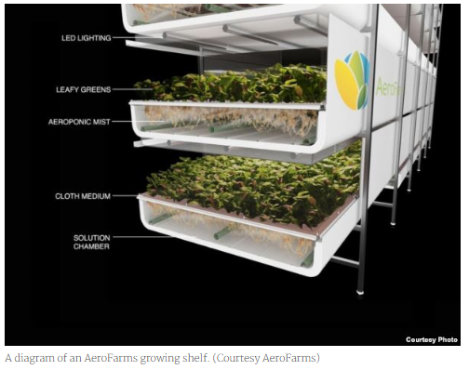

## 95 percent water reduction, zero pesticides

AeroFarms grows the same amount all year. It also does not hurt the land, unlike other types of farming. It does not use harmful chemicals. Also, the farm uses much less water and electricity than other farms. Rosenberg pointed out that indoor farming can also be done anywhere, like in a city or a desert.

New indoor farms are being planned around the world.

AeroFarms is especially interested in cities, said Marc Oshima, chief marketing officer. Cities have many people in a small area. He thinks people in cities want to eat their leafy greens.

As AeroFarms expands, it wants to grow food that is unique to each country. What are the most popular greens in a place? Oshima wants to grow the greens that people will want to eat.

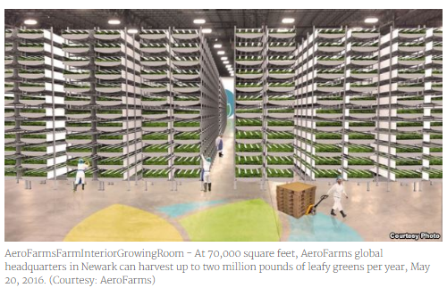

## Baby Watercress, Specialty Kale

The farm's office also serves as a tasting lab for its leafy greens. Its watercress, packaged and ready to sell, is an office favorite.

Alina Zolotareva loves food and is a registered dietitian who helps people eat healthy. She says her goal is to get people to eat more leafy greens like kale, one of the most nutritionally dense foods on the planet. To achieve this, producing the perfect taste is essential. The farm’s specialty kale, in her opinion, “melts in your mouth.” The farm made a sweeter kale by changing how it is grown. People like it more, she said.

## 6,500 square meters = 900,000-kilo harvest

Rosenberg says AeroFarms also helps deal with world hunger. People need healthy food, not just high energy food. This is where AeroFarms can help out.

By 2050, there will be 9 billion people in the world. They will need twice as much food as what is grown now. Climate change will make this harder. It will kill many crops, reducing crop yields by more than 25 percent.

AeroFarms will start growing much more food in the United States. It will also grow more worldwide. Its Newark location is the largest indoor vertical farm in the world, he says. Every year, the farm grows almost 2 million pounds of food.

Taylor, R. (2016, May 20). Profits form Eco Friendly Vertical Farming Stack Up. (Ed. by Newsela staff). Retrieved from <http://www.voanews.com/a/profits-from-eco-friendly-vertical-farming-stack-up/3337900.html>

### 1.Question 1 The reading focuses on:

a company that is growing its capacity to do more indoor farming

a company that might begin indoor farming

a company that invented indoor farming

### 2.Question 2 Over the next five years the market for indoor farming is expected to:

grow a lot

stay about the same as it is now

decrease a little

### 3.Question 3 Which of the following statements is NOT true about AeroFarms indoor farming method?

They use no pesticides

They use 95% less water

They use fewer seeds

### 4.Question 4 The World Bank believes the global population will need 50% more food. How might climate change impact that situation?

Climate change will not impact that situation.

Climate change could decrease crop yields by 25% or more.

Climate change could increase crop yields by 25% or more.

## PART II Creating a Scientific Community

**VEDEO 05**

# Biofilter Made from Peanut Shell Degrades Air Pollutants



# ****Biofilter made from peanut shell degrades air pollutants****

(Nanowerk News) In order to clean the air of pollutants such as methanol and solvents used in the industry, biotechnology expert Raul Pineda Olmedo, of the National University of Mexico (UNAM), designed a biofilter that uses microorganisms living in the shell of the peanut.

The research from the department of Environmental Technology noted that microorganisms grow naturally on peanut shell, which can be used to clean the air. Furthermore, in Mexico this material is generated in large amounts and is considered a worthless agricultural residue.

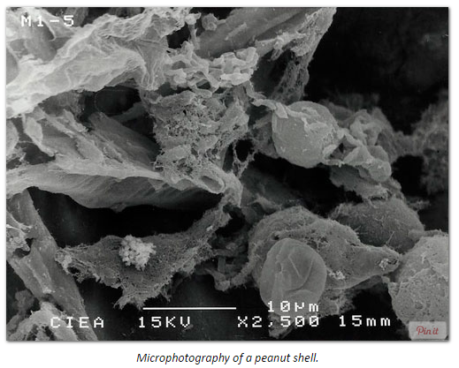

The idea is a prototype filter with peanut shells, which cultivates the microorganisms to degrade toxic pollutants into carbon dioxide and water, thereby achieving clean air.

"The peanut shell is special for these applications because it is naturally hollow and has an area of contact with air, which favors the development of microorganisms," said Pineda Olmedo.

He also said it has been observed that this organic material can be applied to biotechnology as biological filters similar to those used by cars, but instead of stopping dust it can degrade the contaminants.

Olmedo Pineda development focuses on solving the problem of air pollution in companies dedicated to handling inks or solvents, which have a contaminated workplace.

The experiment was developed in collaboration with doctors Frédéric Thalasso Sire and Fermin Perez Guevara from the Research Center of Advanced Studies (CINVESTAV) in Mexico.

The prototype is similar to a bell or kitchen extractor, but it not only absorbs and stores polluting vapors, it degrades and purifies the air.

The design consists of a filter made with peanut shells containing microorganisms, which purify the air. For optimum development it should be in a temperature controlled environment.

Olmedo Pineda explained that the filter takes on average 28 days to synthesize microorganisms such as Fusarium and Brevibacterium. Bacteria and fungi take the carbon from pollution to reproduce and breathe.

In Mexico this technology has not been exploited extensively. The researcher currently seeks to commercialize the innovation, which is a solution applicable to everyday life. They will create a demonstration prototype for schools, making it accessible to students, who can apply and replicate it.

## ____________

Nanowerk News. (2016, January 8). Biofilter made from peanut shells degrades air pollutants. Retrieved from <http://www.nanowerk.com/news2/green/newsid=42272.php>

### 1.

Question 1

**Comprehension Check Instructions:**

**Instructions:** All questions in this quiz refer to the reading, “Biofilter made from peanut shell degrades air pollutants." You are allowed to refer to this reading as you answer these questions. You can open the reading in a new tab by clicking the link below:

<https://www.coursera.org/learn/stem/supplement/dLAW8/biofilter-made-from-peanut-shell-degrades-air-pollutants>

Which of these live inside peanut shells and help to degrade air pollutants?



Peanuts



Microorganisms



Peanut shells



Molecules

Status: [object Object]

1 point

### 2.

Question 2

How is this peanut shell prototype similar to a bell or kitchen extractor?



Both cost the same amount of money.



Both were designed by Raul Pineda Olmedo.



Both use microorganisms to clean the air.



Both absorb and store polluting vapors.

Status: [object Object]

1 point

### 3.

Question 3

Where should peanut shell filters be stored for optimum development?



A temperature controlled environment



An environment with freezing temperatures



An environment with boiling temperatures



An environment with changing or fluctuating temperatures

Status: [object Object]

1 point

### 4.

Question 4

How do the microorganisms clean the air?



They eat the carbon from pollution as a food.



They store the carbon from pollution in the peanut shell.



They take the carbon from pollution to reproduce and breathe.



None of the above

### 1.

Question 1

Choose the word that best matches the definition.

1. Very small; one billionth the size of something



technology



prefix



nano

Status: [object Object]

1 point

### 2.

Question 2

The science of working with atoms and molecules at the nanoscale to build devices that are extremely small



engineering



nanotechnology



environmental science

Status: [object Object]

1 point

### 3.

Question 3

A unit of measurement that is one billionth of a meter



nanosecond



nanometer



nanotechnology

Status: [object Object]

1 point

### 4.

Question 4

The scale in which nanometers are measured.



technology scale



meter scale



nanoscale

# Major Advance in Artificial Photosynthesis Poses Win/Win for the Environment



# ****Major Advance in Artificial Photosynthesis Poses Win/Win for the Environment****

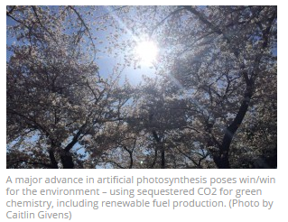

A potentially game-changing breakthrough in artificial photosynthesis has been achieved with the development of a system that can capture carbon dioxide emissions before they are vented into the atmosphere and then, powered by solar energy, convert that carbon dioxide into valuable chemical products, including biodegradable plastics, pharmaceutical drugs and even liquid fuels.

Scientists with the U.S. Department of Energy (DOE)’s Lawrence Berkeley National Laboratory (Berkeley Lab) and the University of California (UC) Berkeley have created a hybrid system of semiconducting nanowires and bacteria that mimics the natural photosynthetic process by which plants use the energy in sunlight to synthesize carbohydrates from carbon dioxide and water. However, this new artificial photosynthetic system synthesizes the combination of carbon dioxide and water into acetate, the most common building block today for biosynthesis.

“We believe our system is a revolutionary leap forward in the field of artificial photosynthesis,” says Peidong Yang, a chemist with Berkeley Lab’s Materials Sciences Division and one of the leaders of this study. “Our system has the potential to fundamentally change the chemical and oil industry in that we can produce chemicals and fuels in a totally renewable way, rather than extracting them from deep below the ground.”

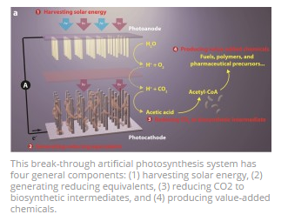

Yang, who also holds appointments with UC Berkeley and the Kavli Energy NanoSciences Institute (Kavli-ENSI) at Berkeley, is one of three corresponding authors of a paper describing this research in the journal Nano Letters.The paper is titled “[Nanowire-bacteria hybrids for unassisted solar carbon dioxide fixation to value-added chemicals](http://pubs.acs.org/doi/full/10.1021/acs.nanolett.5b01254).” The other corresponding authors and leaders of this research are chemists Christopher Chang and Michelle Chang. Both also hold joint appointments with Berkeley Lab and UC Berkeley. In addition, Chris Chang is a Howard Hughes Medical Institute (HHMI) investigator. (See below for a full list of the paper’s authors.)

The more carbon dioxide that is released into the atmosphere the warmer the atmosphere becomes. Atmospheric carbon dioxide is now at its highest level in at least three million years, primarily as a result of the burning of fossil fuels. Yet fossil fuels, especially coal, will remain a significant source of energy to meet human needs for the foreseeable future. Technologies for sequestering carbon before it escapes into the atmosphere are being pursued but all require the captured carbon to be stored, a requirement that comes with its own environmental challenges.

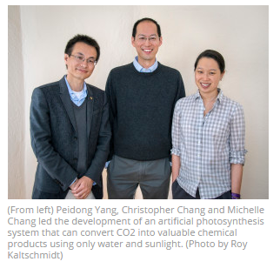

The artificial photosynthetic technique developed by the Berkeley researchers solves the storage problem by putting the captured carbon dioxide to good use.

“In natural photosynthesis, leaves harvest solar energy and carbon dioxide is reduced and combined with water for the synthesis of molecular products that form biomass,” says Chris Chang, an expert in catalysts for carbon-neutral energy conversions. “In our system, nanowires harvest solar energy and deliver electrons to bacteria, where carbon dioxide is reduced and combined with water for the synthesis of a variety of targeted, value-added chemical products.”

By combining biocompatible light-capturing nanowire arrays with select bacterial populations, the new artificial photosynthesis system offers a win/win situation for the environment: solar-powered green chemistry using sequestered carbon dioxide.

“Our system represents an emerging alliance between the fields of materials sciences and biology, where opportunities to make new functional devices can mix and match components of each discipline,” says Michelle Chang, an expert in biosynthesis. “For example, the morphology of the nanowire array protects the bacteria like Easter eggs buried in tall grass so that these usually-oxygen sensitive organisms can survive in environmental carbon-dioxide sources such as flue gases.”

The system starts with an “artificial forest” of nanowire heterostructures, consisting of silicon and titanium oxide nanowires, developed earlier by Yang and his research group.

“Our artificial forest is similar to the chloroplasts in green plants,” Yang says. “When sunlight is absorbed, photo-excited electron−hole pairs are generated in the silicon and titanium oxide nanowires, which absorb different regions of the solar spectrum. The photo-generated electrons in the silicon will be passed onto bacteria for the CO2 reduction while the photo-generated holes in the titanium oxide split water molecules to make oxygen.”

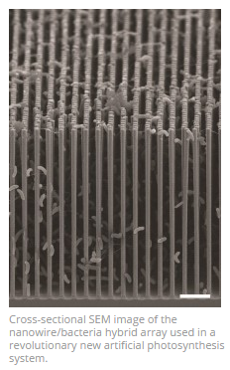

Once the forest of nanowire arrays is established, it is populated with microbial populations that produce enzymes known to selectively catalyze the reduction of carbon dioxide. For this study, the Berkeley team used Sporomusa ovata, an anaerobic bacterium that readily accepts electrons directly from the surrounding environment and uses them to reduce carbon dioxide.

“S. ovata is a great carbon dioxide catalyst as it makes acetate, a versatile chemical intermediate that can be used to manufacture a diverse array of useful chemicals,” says Michelle Chang. “We were able to uniformly populate our nanowire array with S. ovata using buffered brackish water with trace vitamins as the only organic component.”

Once the carbon dioxide has been reduced by S. ovata to acetate (or some other biosynthetic intermediate), genetically engineered E.coli are used to synthesize targeted chemical products. To improve the yields of targeted chemical products, the S. ovata and E.coli were kept separate for this study. In the future, these two activities – catalyzing and synthesizing – could be combined into a single step process.

A key to the success of their artificial photosynthesis system is the separation of the demanding requirements for light-capture efficiency and catalytic activity that is made possible by the nanowire/bacteria hybrid technology. With this approach, the Berkeley team achieved a solar energy conversion efficiency of up to 0.38-percent for about 200 hours under simulated sunlight, which is about the same as that of a leaf.

The yields of target chemical molecules produced from the acetate were also encouraging – as high as 26-percent for butanol, a fuel comparable to gasoline, 25-percent for amorphadiene, a precursor to the antimaleria drug artemisinin, and 52-percent for the renewable and biodegradable plastic PHB. Improved performances are anticipated with further refinements of the technology.

“We are currently working on our second generation system which has a solar-to-chemical conversion efficiency of three-percent,” Yang says. “Once we can reach a conversion efficiency of 10-percent in a cost effective manner, the technology should be commercially viable.”

In addition to the corresponding authors, other co-authors of the Nano Letters paper describing this research were Chong Liu, Joseph Gallagher, Kelsey Sakimoto and Eva Nichols.

This research was primarily funded by the DOE Office of Science.

## ____________

### Nanowerk News. (2015, August 7). Major Advance in Artificial Photosynthesis Poses Win/Win for the Environment. Retrieved from [http://newscenter.lbl.gov/2015/04/16/major-advance-in-artificial-photosynthesis/](http://newscenter.lbl.gov/2015/04/16/major-advance-in-artificial-photosynthesis/%C2%A0) 1.

Question 1

**Comprehension Check Instructions:**

**Instructions:** All questions in this quiz refer to the reading, "Major Advance in Artificial Photosynthesis Poses Win/Win for the Environment." You are allowed to refer to this reading as you answer these questions. You can open the reading in a new tab by clicking the link below:

<https://www.coursera.org/learn/stem/supplement/l3Crb/major-advance-in-artificial-photosynthesis-poses-win-win-for-the-environment>

What is the main idea of this reading?



Using sunlight to extract oil and gas from the ground for energy



Using sunlight to trap carbon dioxide emissions and create useful products



Using sunlight to desalinate seawater to create freshwater and minerals

Status: [object Object]

1 point

### 2.

Question 2

How are the researchers using nanotechnology in this process?



they have created nano-cells that magnify the power of the sun



They have created an artificial forest of nanowires



They have created a greenhouse composed of reflective nanomaterial

Status: [object Object]

1 point

### 3.

Question 3

What does the number 200 refer to in the article?



The number of years that global carbon levels have been rising



The number of researchers who were involved in the project



The number of hours of sunlight that the artificial material was exposed to

Status: [object Object]

1 point

### 4.

Question 4

In the researchers’ technique, what happens to the carbon dioxide after it is captured?



it is heated and separated into its component molecules



it is expanded and absorbed by natural plants



it is reduced and combined with water