**I-Introduction**

In Newtonian mechanics, the motion of a system with N material points is obtained by solving N second-order vector differential equations or 6N scalar differential equations (3 for acceleration and 3 for velocity), projecting onto the 3 Cartesian coordinate axes and involving 6N integration constants.

However, there are circumstances where the application of Newtonian mechanics is delicate, particularly when the system has internal constraints due to binding forces that limit the movement of the system, thus reducing its degrees of freedom.

Newton's laws form what can be called vector mechanics, as most of the quantities involved in this description are of a vector nature (force, acceleration, velocity, position vector). In contrast to vector mechanics, analytical mechanics uses scalar functions (kinetic and potential energies).

**II-Principle of Virtual Work**

If denotes the sum of all forces acting on the material point i of a system with N material points, the sum of the work done by the forces applied to the system in equilibrium is:



where is a virtual displacement of the system.

Some forces among the have identically zero virtual work, and others have mutually zero virtual work. These forces are called binding forces, and the remaining forces are applied forces:



By definition, for any infinitesimally small virtual displacement compatible with the constraints of the problem, we can write that the virtual work of the binding forces (this is what is called d'Alembert's principle (1743)) is:



In the case of equilibrium, we have:



**Example 1**

Consider a lever in equilibrium under the action of two forces ​ and ​. Determine the condition of equilibrium.The position vectors are written as:



Giving the lever a virtual rotation δθ, we get:





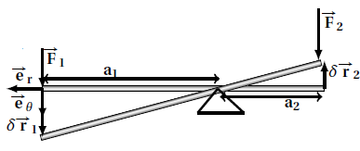

Since the reaction force R⃗ does not do work, the principle of virtual work can be written as:



Given that:

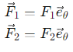

It follows that:



Calculation of the reaction force :

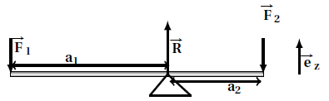

If the virtual displacement is incompatible with the binding force, we give the lever a virtual vertical translation δr⃗=δz​. The principle of virtual work then becomes:



Therefore:

​

**Example 2: Double Inclined Plane**

Let two masses m1​ and m2​ placed on a double inclined plane and a lever in equilibrium under the action of two forces et ​ and ​. Determine the condition of equilibrium

The forces acting on the system include gravitational forces ​ and ​, tension forces ​ and and reaction forces ​ and ​.

The principle of virtual work can be written as:



Since ⋅=0⃗ and ⋅δ=0⃗​ (as and are perpendicular to the virtual displacements), the virtual work of and is identically zero.

The virtual work of ​ and ​ is mutually zero:

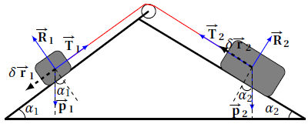

Since =, we have (−).δr=0, implying =​.

The virtual work of the weights is:



Therefore:



The equilibrium position is:



**Constraints**

A constraint is associated with a binding force that restricts or limits the possible movements of the system. The equations of constraints can be expressed either by:

* Binding forces.
* Equations of constraints containing the coordinates, their derivatives, and time.

In the simplest case, these constraints can be expressed by a number l of independent equations among the n<N positions and time t:

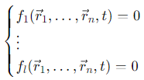

These constraints are called holonomic (from Greek: "whole law"). In these constraint relations, the velocity r⃗ does not appear.

• If time is implicit in the equation, it is called holonomic scleronomic or holonomic stationary.

• If time is explicit in the equation, it is called holonomic rheonomic or holonomic non-stationary.

If these constraint relations do not involve the velocity \( \dot{\vec{r}}_i \): - If time

**Degrees of Freedom**

A free particle in a 3-dimensional configuration space has 3 independent coordinates to determine its motion. For a system of N free material points, 3N independent coordinates are needed to fully determine its motion. If the system is subject to constraints that limit its motion, the number of necessary coordinates to describe its motion reduces. In the simplest case, these constraints can be expressed by a number l of independent equations among the N positions and time t : The minimum number of coordinates necessary to specify the position of a system, or multiple material points, is called the number of degrees of freedom (DOF): n{DOF} = 3N – l

**Generalized Coordinates**

Generalized coordinates are the necessary and independent coordinates that allow tracking the evolution of a system over time. They can take the form of a coordinate or an angle. For nd degrees of freedom, we have nd generalized coordinates. It is assumed that the position vector of material point iii is an arbitrary function of the generalized coordinates {qj,j=1,…,nd} of the form:



From this equation, the differential form of Pfaff or Pfaffian is:

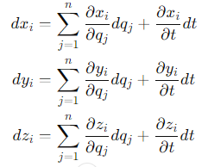

**Generalization of the Principle of Virtual Work**

To simplify, we consider holonomic constraints with n degrees of freedom. For any point in the system, we have:



A compatible displacement from {q1,…,qnd,t}is any virtual displacement that could be imposed on the system, taking into account the constraints existing at time t:

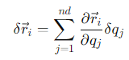

**D'Alembert's Equation**

Consider a system of material points of mass mi​, subjected to binding forces and applied forces According to the fundamental principle of dynamics, we have:



According to the virtual work condition:

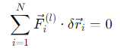

We obtain D'Alembert's equation (the sum of the virtual work of the applied forces and the inertia forces is zero for any compatible virtual displacement):

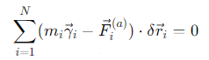

**Generalized Force**

From D'Alembert's equation and equation (2.3), we have:

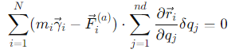

Introducing the generalized force Qj:

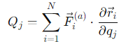

**Lagrange's Equations of the First Kind**

For a system with N material points subjected to holonomic rheonomic constraints gk(r⃗1,r⃗2,…,r⃗N,t) ( k=1,…,ℓ), defining thus nd=3N−ℓ generalized coordinates {q1,q2,…,qnd} , we can invert the ndrelations qj=qj(r⃗1,r⃗2,…,r⃗N,t) ( j=1,…,ndj  ) to express the N relations:

r⃗i=r⃗i(q1,q2,…,qnd,t)

The infinitesimal displacement is:

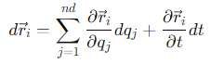

The generalized velocity is defined as:



Thus:

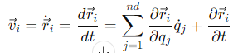

The left-hand side of D'Alembert's equation (2.5):



Then:



On the other hand:



We have:

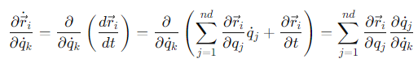

We have:

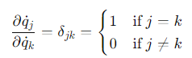​ is the Kronecker delta. Thus, we have:

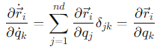

Thus:

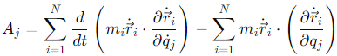

Then:

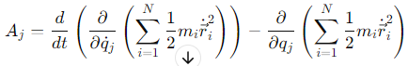

The kinetic energy of the system is defined as:

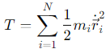

Finally, for Aj​, we have:

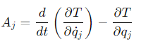

Equation (2.5) becomes:

**Lagrange's Equations of the First Kind**



This is a system with nd equations called Lagrange equations.

**Example: Simple Pendulum**

It is a system composed of an object which is a material point of mass mmm. Thus, the number of coordinates is Nc=3. The constraints are the plane xoy with equation z=0 and since the string is inextensible, the coordinates of the mass mmm satisfy the relation r==ℓ, and the mass moves along an arc of a circle. The number of constraint equations is ℓ=2, so the number of degrees of freedom is nd=1. The generalized coordinate is θ. The kinetic energy T is

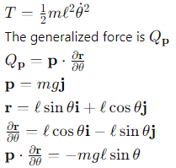

Applying equation (2.7), we have



Thus, we find

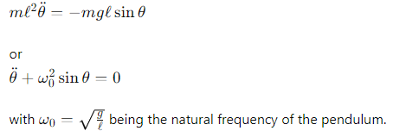​​ .

**Relation between Work and Generalized Force**

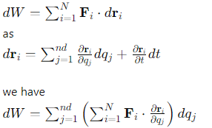

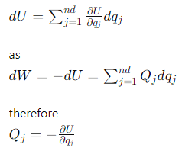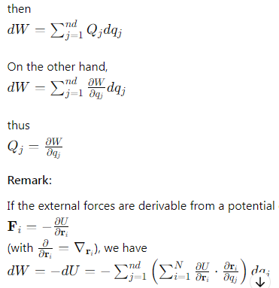

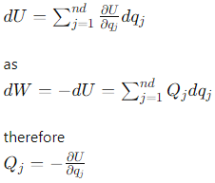

**Lagrange Equation in Presence of Conservative and Non-Conservative Forces**

Suppose the material point i of the system is subject to conservative and non-conservative forces

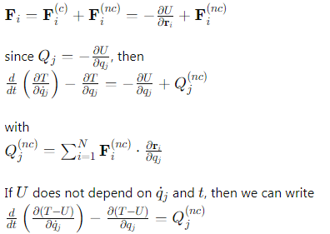

By defining the Lagrangian as



**Example:**

Let a mass m slide with friction on a plane inclined at an angle α relative to the horizontal. Determine its acceleration. This is a system with one degree of freedom and generalized coordinate x.

The kinetic energy T is

T=

The potential energy of the system is gravitational in nature 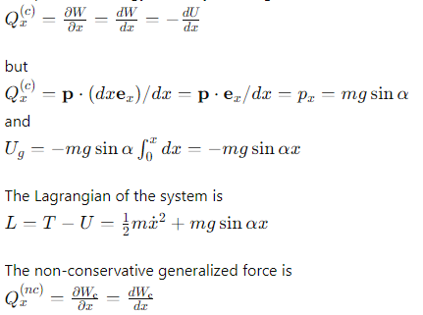

but

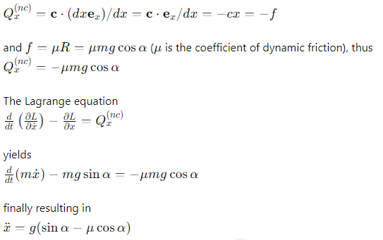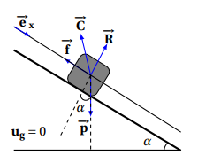

**Viscous Friction Force: Stokes Problem**

Suppose some of the forces are not derived from the potential. This is the case with viscous friction forces



where **u** is a unit vector in the direction of the motion and ki>0 is a proportionality coefficient, s the velocity of the material point i of the system with N material points. γ is a coefficient and depending on its value, we have three types of friction:

* γ=1 linear or dynamic friction
* γ=2 quadratic friction
* γ=0 Coulomb friction (solid)

The equation of motion is expressed as follows:

=

In the case of linear friction, the solution is



**Example:**

Consider a material point m falling from a certain height and subject to a quadratic friction force. Determine the acceleration of the point. The system has one degree of freedom with generalized coordinate x.

The kinetic energy T is

T=

The potential energy of the system is gravitational in nature 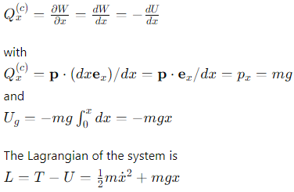

The non-conservative generalized force is

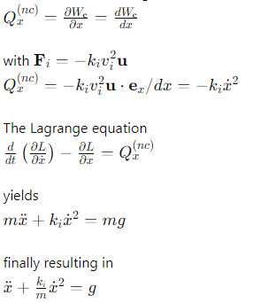

**Viscous Friction**



where is a unit vector pointing in the direction of movement, and ki>0 a proportionality coefficient. vi​ is the velocity of the material point iii in a system of N material points. γ is a positive exponent defining the friction regime, and in general, γ=γ(v); however, in the low-velocity regime, experiments show that γ=1. We are interested in the case where γ is a positive real number and independent of velocity v. From each vector, we can construct its unit vector, so

=

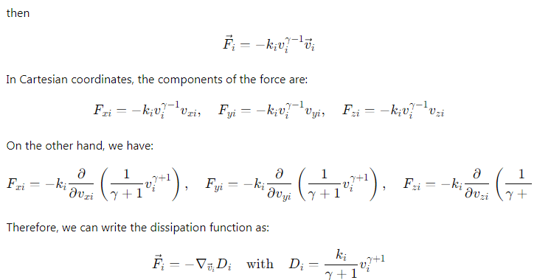

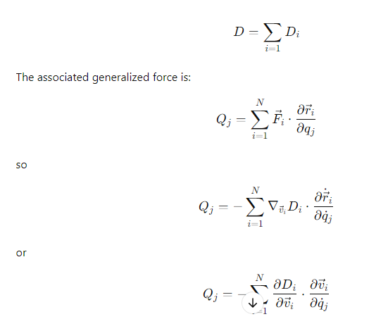

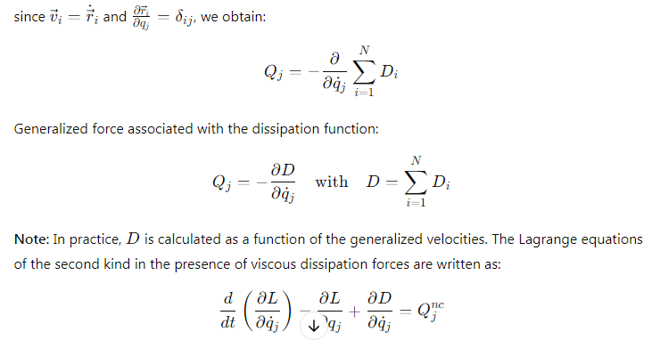

**Generalized Constraint Force**

Some constraints, including holonomic ones, are sometimes too complex to allow for the emergence of new generalized coordinates in a reduced number. Other non-holonomic constraints, such as inequalities, do not offer a way to reduce the number of degrees of freedom. In these cases, the initial coordinates, which are too numerous, are retained, and the question arises about the impact of the constraints on the system's movement and their integration into the model. The answer lies in developing a general method of extending the Lagrangian formalism. It involves constructing a constrained Lagrangian and applying the principle of least action to derive modified Euler-Lagrange equations. The introduction of an additional unknown per constraint, called a Lagrange multiplier, allows the constraint to be adapted to the formalism, giving physical meaning to the constraint equation.

We use the set of 3NC coordinates of the system, knowing that it has nd​ independent coordinates and ℓ holonomic constraint equations, hence ℓ dependent coordinates. The first nd coordinates are generalized and independent coordinates (no relations between them), so: 

Only the coordinates linked by constraint equations of the form:



Thus, we have:

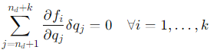

By introducing k undetermined multipliers λi​, also called Lagrange multipliers, into equation (2.13) and using the Lagrange equations of the first kind (2.7), we have:

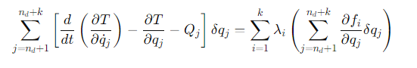Thus, we obtain:

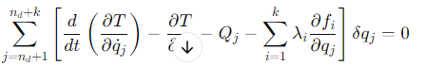

To make each of the k terms in equation (2.15) zero, the Lagrange multipliers λi_satisfy the equation of motion:

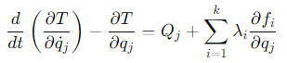

This Lagrange equation of the first kind is only used for linked coordinates. Considering all the system's coordinates, the system's equations of motion are:

Lagrange equations of the first kind in the presence of generalized constraint forces



The term homogeneous to a generalized force, it is a generalized constraint force. The use of equations (2.18) does not concern the number of degrees of freedom or the generalized coordinates to use. But, one must find the dependent coordinates and their constraint equations. The number of Lagrange multipliers λi equals the number of constraints. Each unknown is accompanied by a constraint equation.

For the N coordinates of the system with k non-holonomic constraints, we solve the system of equations given by (2.18) and the constraint equations fi. Note that equations (2.18) include k more terms than the Lagrange equations of the second kind.

pour j= 1,….,nd

+ pour j= nd +1,….,nd+k

**Example 1: Simple Pendulum**

Consider a simple pendulum with mass mmm suspended by an inextensible string of length ℓ and negligible mass, fixed at point O. The pendulum is set in motion by displacing it from its equilibrium position.

The kinetic energy T of the system is given by:

T=

The potential energy U of the system, which is gravitational, is:

U=−mgrcosθ

The Lagrangian Lis:

L=T−U =​m+)+mgrcosθ

The constraint equation is f(r,θ)=r− ℓ. The Lagrange multipliers are:

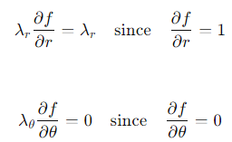

The Lagrange equations are:

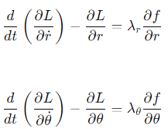

We obtain:

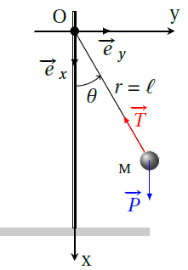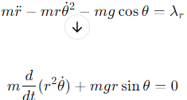

Including the constraint, we get:

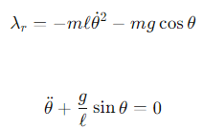

Here, λr ​ represents the tension in the string, which balances the component of the weight along the radial direction ​ and the centripetal force.

**Example 2: Particle Sliding on a Cylinder**

Consider a material point with mass m sliding without friction on the external surface of a cylinder with radius a.

The kinetic energy T of the system is:

T =​m+)

The potential energy U of the system, which is gravitational, is:

U=mgrcosθ

The Lagrangian L is:

L=T−U =​m+)+mgrcosθ

The constraint equation is f(r,θ)=r−a. The Lagrange multipliers are:

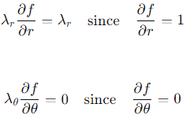

The Lagrange equations are:

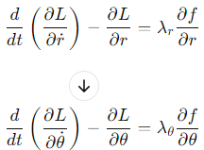

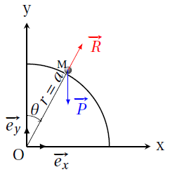

We obtain:

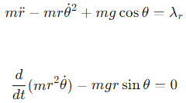

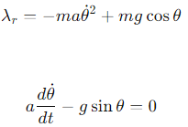

​ is the radial component along of the reaction force R⃗=R of the lateral surface of the cylinder, balancing the component along of the weight and the centripetal force.

If we consider the second differential equation:

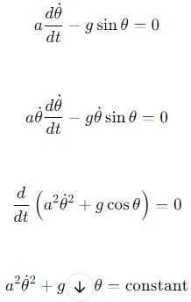

Given that at t=0, θ=0 and ˙=0, the constant is g.

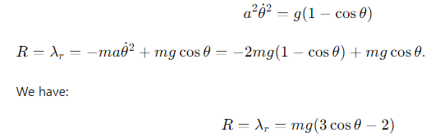.

R>0 only if cosθ>2/3. Beyond θ=arccos(2/3), the particle will no longer be on the lateral surface of the cylinder.

**Example 3: Cylinder Rolling Down an Incline**

Consider a cylinder of mass M and radius R rolling without slipping on an inclined plane with an angle α\alphaα relative to the horizontal. Determine its acceleration.

The rolling without slipping condition constitutes the only constraint, so there is only one Lagrange multiplier. The constraint equation is f(x,θ)= x−Rθ=0, with:

=1 and =−R

There is only one degree of freedom, but we use both coordinates xxx and θ\thetaθ. The kinetic energy TTT is:

T=+

The potential energy U, which is gravitational, is:

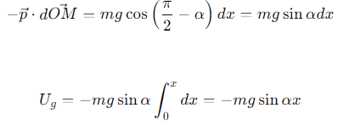

The Lagrangian L of the system is:



The Lagrange equations are:

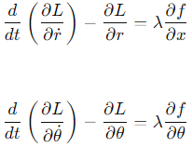

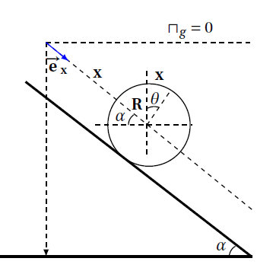

We obtain:

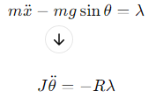

The Lagrange multiplier λ has the dimension of a force, and it can be expressed as:

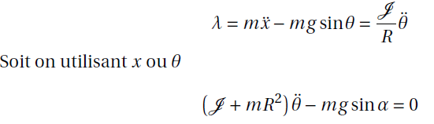

**Principle of Least Action**

The state of a physical system with n degrees of freedom is described by the generalized coordinate qi(t) at each instant t. At any given moment t, the system's state can be represented by a point in an n-dimensional Cartesian space, called the "configuration space." Each axis corresponds to a generalized coordinate qi ​. As a mechanical system evolves between two instants t1​and t2, it traces a curve in the configuration space between two points qi(t1) and qi(t2) which we (for lack of a better term) call a "trajectory". Time is considered as a parameter of the curve. The real trajectory corresponds to the actual dynamics followed by the system, while the "varied trajectory" or "fictitious trajectory," which is infinitely close, corresponds at each instant to the positions qi+δqi ​, where δq ​ is an infinitesimal increment of the position. These two trajectories must satisfy the same initial and final conditions:

The fact that qi represents the actual trajectory of the system is obtained by solving the Lagrange equation. This equation is derived by minimizing the functional S defined by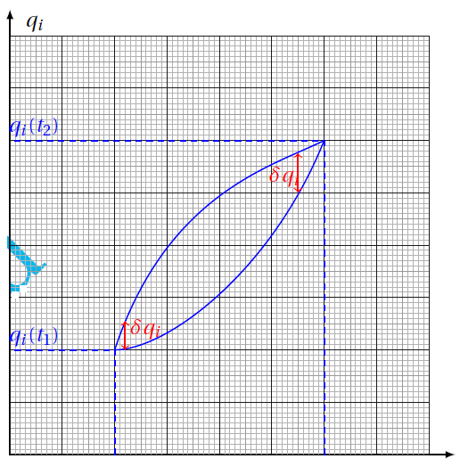

**Action and Principle of Least Action**



The physical trajectory is the path that gives a minimal value to the action S (it is generally a minimum; hence the principle of least action, but in some cases, the extremum is a maximum). The motion of a system from instant t1to t2 is such that the action S is stationary (minimal), where

δS=0

The variation of δS is written as:



Knowing that and after a first-order expansion of δqi​, we have:



The last term does not contribute since the variation is taken at constant time δt=0, so:

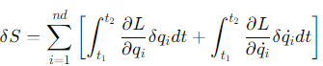.

Since δ˙=d(/dt, the second integral can be rewritten as:

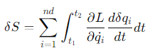

By performing an integration by parts on this integral, we obtain:

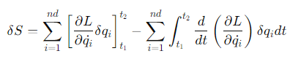

The first term in brackets is zero since δqi(t1)=δqi(t2)=0. Therefore, for all expressions of ∂L/∂i ​​, we obtain:

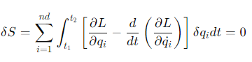

The qi ​ are generalized coordinates and thus independent. The sum can only vanish for arbitrary and independent δqi ​ if the n differential equations:

are simultaneously satisfied.

**2.2 Conjugate Momentum**

The conjugate momentum associated with the generalized coordinate qiq_iqi​ is defined by:

pi=

pi sometimes called generalized momentum.

**Example:**

For a material point of mass m immersed in a potential U, we have:



**Example:**

For a material point of mass m rotating around a force center c at a distance r, we have:



Pθ is the component of the angular momentum perpendicular to the plane of rotation.

**Example:**

For a generalized potential:

**2.3 Conservation Laws**

In the context of solving motion equations, conservation laws play a fundamental role in physics:

* They reflect certain fundamental physical properties.
* They provide important information about the system's motion.

**A. Cyclic Variable:**

If the Lagrangian L is independent of the generalized coordinate q, then:

=0

In this case, q is called a cyclic or hidden coordinate, and we have:



The conjugate momentum p associated with the generalized coordinate q is a constant of motion (time-independent) or first integral.

**B. Time Homogeneity:**

If the Lagrangian L(qi;) does not explicitly depend on time t (i.e., ∂L/∂t=0), then the quantity:

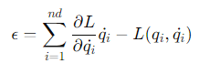

is a first integral, where:

=0

By hypothesis, we have =0 but 0, so we have:

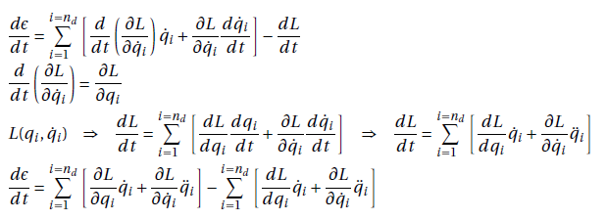



Nous supposons que le potentiel U(qi) ne dépend pas de la vitesse généralisée et que les liaisons sont holonomes scléronomes (c'est-à-dire indépendantes du temps t). L’expression de l’énergie cinétique T est alors de la forme quadratique par rapport aux vitesses généralisées qi.

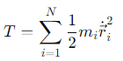

where mi is the mass of particle ii, and˙i​ is the velocity of that particle.

Since:

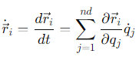

..

Then

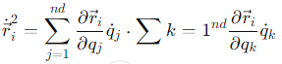

Expanding this, we obtain: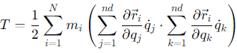

This can be rewritten as:

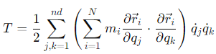

Hence:

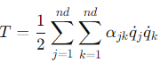  
with:

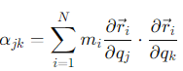

Thus:

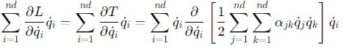

Knowing that:



then

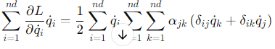

or

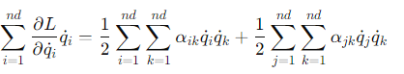

Finally, we obtain:

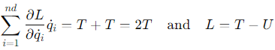

Thus, the expression for ϵ\epsilonϵ is:

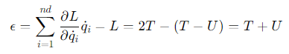

This shows that the total energy ϵ is the sum of the kinetic energy T and the potential energy U.

**Non-uniqueness of the Lagrangian**

Consider a physical system described by a Lagrangian L(qi,,t), which satisfies the Lagrange equation 2.21. The following Lagrangians:

=λL

describe the same evolution equation, where f(qi,t) is a real and differentiable scalar function.

For the first Lagrangian, this follows directly from the linear form of L in the Lagrange equation.

For the second Lagrangian, we have:





On the other hand, we have:

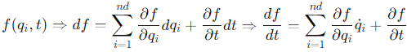

Thus:



since:



Then:



**2.5 Principle of Least Action and Holonomic Constraints**

Suppose that the physical system is subjected to ℓ constraints or holonomic constraints:

fj(r⃗1,…,r⃗N)=0 ∀1≤j≤ℓ

or, in terms of the 3N coordinates qi, for i=1,…,3N

fj(q1,…,q3N)=0 ∀1≤j≤ℓ

For a virtual displacement, we have:



Thus:

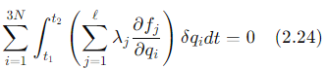

Moreover, according to the calculus of variations, if we add a virtual displacement δqi such that δqi(t1)=δqi(t2)=0 to a real trajectory qi​, the variation of the action is:

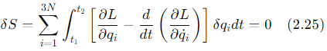

Given equations (2.24) and (2.25), we have:



The 3N unknowns qi ​ are given by the Lagrange equations:

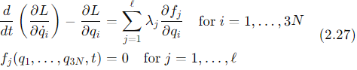

Applications

A. **Two-Body Problem:** Two particles of masses m1 and m2​ are represented by position vectors and ​. Assuming the system formed by m1 and m2​ is closed, the total external force on the system is zero. Additionally, the particles interact via the potential energy U(,​.)=U(,​).

Let be the position vector of the center of mass (CM):

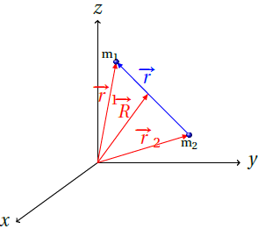

Let the new vector be defined as:

=−

The kinetic energy of the system is:

T=

After substitution and simplification:

T=(m1+m2)+

Finally, the kinetic energy can be written as:

T=M+μ

where M=m1+m2 ​ is the total mass of the system, and μ=is the reduced mass.

In the case where m1m2 ​, such as in the Earth-Sun system, M=m2 and μ=​. The Lagrangian of the system is:

L=T−U(1−2)=M+μ−U()

This Lagrangian can be written as:

L=LCM+Lμ

where:

LCM=M

is a Hidden or Cyclic Variable:

Since = ​​=,

then:

​​=

the center of mass (CM) moves at a constant velocity.

The second part of the Lagrangian is:

Lμ=μ −U)

This appears as the Lagrangian of a particle with mass μ\muμ and position vector . The Lagrangian L is the Lagrangian of the relative motion between two particles, reducing it to a problem of a single fictitious particle with reduced mass μ\muμ and position vector .

The two-body problem can be reduced to a one-body problem. However, the N-body problem (N > 2) has no analytical solution.

**Central Potential:**

We are interested in cases where the interaction depends only on the distance between two bodies (gravitational interaction, electrostatic interaction) or between the body and the origin of the force (central force) (mass-spring, sun-earth). In this case, U()=U(r).

Since the force here is purely radial, = f(r) then:

== f(r) =r f(r) =

The moment of the force applied to the mass mmm is zero. The angular momentum is:

Since ​ , the angular momentum with respect to O is:



According to the angular momentum theorem:

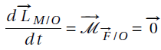

​ is constant in magnitude and direction, so the trajectory of the material point lies in the XOY plane (the plane is a constraint, reducing one degree of freedom). We can also write:

=0

The particle of mass mmm has two degrees of freedom, so two generalized coordinates rrr and θ\thetaθ. The Lagrangian is:

L=m(r˙2+r2θ˙2)−U(r)

Immediately, we notice that θ is a cyclic or "hidden" coordinate, and therefore:



This is the law of conservation of angular momentum. With respect to the generalized coordinate r, we have:



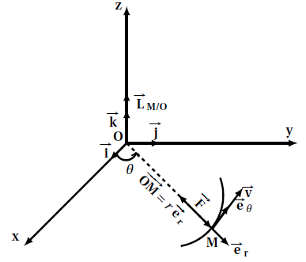

The particle of mass mmm is subjected to two forces:

Central force



Centrifugal force:​



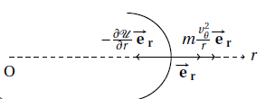

is a repulsive force, meaning that a body moving along a curvilinear trajectory with respect to O is effectively pushed outward.

From the conservation of angular momentum, we have:



This simplifies to:



where we have defined Ueff as:



The term represents a potential barrier. The problem is thus reduced to studying the motion of a particle of mass m with one degree of freedom in the generalized coordinate r, subjected to an effective force:



and governed by the fundamental principle of dynamics:

m=Feff

**B - Potential in ​:**

In the case of gravitational or electrostatic interaction, the Newtonian potential is written as:

U(r)=−

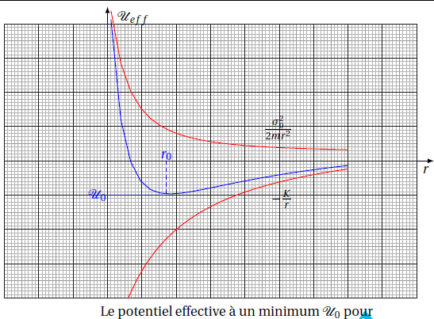

with K=Gm1m2 the gravitational case and K= in the electrostatic case. Thus, the effective potential is written as:



The effective potential has a minimum U0​ at:



We obtain:



Thus, for r=r0 ​, we have m=0 and the effective force acting on the particle is zero. This corresponds to a circular trajectory (where only θ\thetaθ varies). According to the conservation of angular momentum, the angular velocity is:



The equation of motion for θ(t) is:



For each time interval, the period τ\tauτ, during which θ\thetaθ increases by 2π (to complete one orbit), is given by:

