**Unit 2 The greenhouse effect.**

**Overview of the Unit 2**

Welcome to Unit 2 of the Scientific English! In Unit 1, you investigated why the Earth is getting warmer, and also learned about the topic of climate change. In this unit, you will examine the chemistry of climate change. Through readings and videos, you will explore how different chemicals and gases affect the environment, with a focus on the greenhouse effect. You will also learn how to use the present progressive and the language of cause and effect to explain climate change and its causes.

* **Learning Objectives**

By the end of this week, you will:

* Become familiar with the greenhouse effect
* Be able to identify several causes of climate change
* Use the present progressive
* Understand the language of cause and effect
* Read, watch, and listen to a variety of texts and multimedia sources.

**Unit 2: The greenhouse effect.**

**Video 01**: What is the Greenhouse Effect?

Hello, and welcome to unit two. In this video, we're going to talk about the question, what is the greenhouse effect? We will learn how the greenhouse effect works, and how it affects the Earth.

Before we get into the science behind how greenhouse effect works, let's first look at a simple example. To do this, we will look at a greenhouse. A greenhouse is a glass building used to protect plants from cold. It looks like this. So how does it work?

A greenhouse is a small house made of glass, that allows sunlight to enter. When the sun enters the house, it warms up the plants and air inside. Some of this heat is released or given away, and the rest gets trapped or held inside by the glass building. During the daytime, the greenhouse heats up. And at night, when the sun sets, the heat that is trapped inside keeps the temperature warm.

The Earth's atmosphere is just like this greenhouse.

On the Earth, certain gases in its atmosphere trap or hold the sun's heat, just like in a greenhouse. This is called the greenhouse effect. The greenhouse effect is when certain gasses in the Earth's atmosphere trap or hold heat created by the sun.

To better understand how it works, let's look at a model of the greenhouse effect.

Look at the picture. In the picture you see an image of the Earth. The sun in the picture is emitting or sending out energy to Earth through sunlight. A lot of this energy is absorbed by the land and water. The rest of the energy is reflected back to space, as you can see by the arrows.

The energy absorbed by the land and water heats up the Earth, and is emitted or sent as infrared radiation.

Infrared radiation is a type of energy commonly know as heat.

Some of the infrared radiation is then trapped by greenhouse gases in the Earth's atmosphere, while the rest is reflected back to space. This heat trapped by greenhouse gases, helps to keep the Earth's temperature warm.

So is the greenhouse effect good or bad? Well it's both. The greenhouse effect is good because it helps to keep the earth warm enough to humans, plants and animals to survive.

Think about this into comparison to the moon.

The moon almost has no atmosphere to trap heat. So its dark side gets cold to negative 153 degrees Celsius.

Without the greenhouse effect, the Earth, like the moon, would be too cold for us to live.

However, there's a problem. Recently, greenhouse gases have been increasing on Earth, causing the Earth's temperature to rise. Scientists have evidence that this increase in greenhouse gases is the cause of global warming. As you remember, global warming is the long-term increase in the temperature of the Earth. And as we learned in unit one, global warming causes climate change, or the long-term changes of climates in different regions of the world.

These changes can cause extreme weather like hurricanes and tropical storms, and other problems we will learn about later in this course.

To summarize, in this video, we learned about how the greenhouse effect works, and how it affects the Earth.

Next, you're going to learn about the four main types of greenhouse gases and how they are made.

​

**Unit 2: The greenhouse effect.**

**Video 02: Greenhouse Gases**

Hello, in the last video, we learned about the greenhouse effect. In particular, how it works and how it affects the Earth. In this video we are going to learn about four of the main greenhouse gases that contribute to the greenhouse effect.

Remember, greenhouse gases trap or hold heat created by the Sun. The four gases we will look at in this video are water vapor, carbon dioxide, methane, and nitrous oxide.

Let's start by looking at water vapor, the most common of all the greenhouse gases.

Water vapor is made of two elements. An element is the simplest form of a substance.

The two elements that make up water vapor are hydrogen and oxygen. There are two hydrogen atoms and one oxygen atom in water vapor.

An atom is the smallest piece of an element

So how is water vapor made?

Water vapor is made through evaporation.

Evaporation is the process of a liquid turning into a gas.

Water vapor is a natural part of our atmosphere and plays a big role in weather and climate. Water vapor is directly connected to evaporation. That means, that the warmer the Earth gets, the more water vapor there is in the atmosphere. As water vapor increases, it traps more heat in the Earth's atmosphere. This causes temperatures to get warmer. This is called a positive feedback loop. The second most common greenhouse gas is carbon dioxide. Carbon dioxide is made up of two elements, carbon and oxygen. There is one carbon atom and two oxygen atoms in carbon dioxide.

So how is carbon dioxide made? Carbon dioxide is made by natural processes such as breathing, the decomposition or decay of living things, and volcanic eruptions. It is also made by humans through actions like the cutting down of trees, known as deforestation, and the burning of fossil fuels.

Fossil fuels are natural materials such as oil, coal, or gas that are burned to create energy.

There has been a large increase in the amount of carbon dioxide in our atmosphere over the past several decades because of human activity. Such as making electricity and driving cars. This increase in carbon dioxide has been identified as a main factor of global warming and climate change.

The third most common greenhouse gas is methane. Methane is made up of two elements, carbon and hydrogen. There is one carbon atom and four hydrogen atoms in methane.

So how is methane made? Methane is created by natural things such as wetlands, termites, and oceans. It is also made by humans through things like fossil fuel production, agriculture or farming, and waste. Although there is less methane in the atmosphere, it traps more heat than other greenhouse gasses.

The last greenhouse gas we will learn about is nitrous oxide.

Nitrous oxide is made up of two elements, nitrogen and oxygen. There are two nitrogen atoms and one oxygen atom in nitrous oxide.

So how is nitrous oxide made? Nitrous oxide is created by natural things such as soil and the oceans. Natural sources create the majority of nitrous oxide in our environment. Like many of the the greenhouse gasses, human activity also creates nitrous oxide. These activities include things like agriculture, the burning of fossil fuels and industrial processes.

As we know, the greenhouse effect is a good thing because it makes the Earth warm enough for us to live.

However, recently, these greenhouse gases have increased in the environment because of human activity. This increase in these greenhouse gases is the main cause of climate change.

In this video, we learned about four of the main greenhouse gases that contribute to the greenhouse effect. In the next video, we will learn more about the natural causes of the greenhouse effect. And how the Earth's environment tries to get rid of greenhouse gases through something called natural sinks.

# Unit 02: Reading: A Blanket Around the Earth

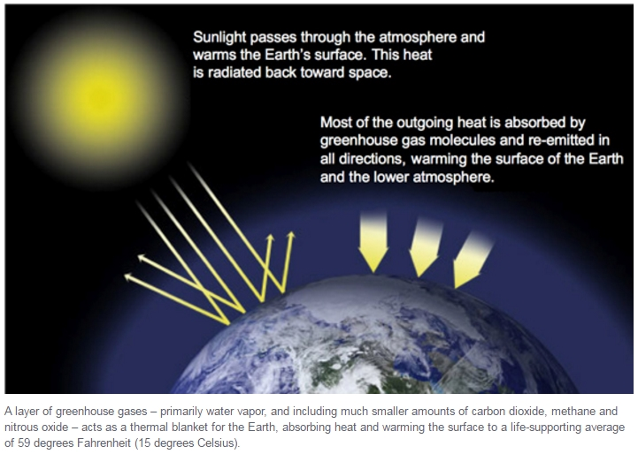

Most scientists say that humans are causing the Earth to grow warmer. They do this by adding to the greenhouse effect. The greenhouse effect is when gases in the air trap heat close to the Earth.

Certain gases in the air keep heat from escaping. These gases stay around for a long time and do not respond to changes in the temperature. They are said to "force" climate change. They also cause the Earth to warm and weather patterns to change. Here are some gases that add to climate change.

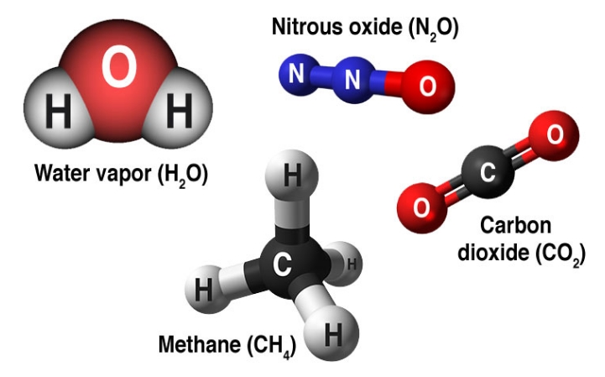

## Water Vapor

The most common greenhouse gas is water vapor. Water vapor is the gas form of liquid water. As the Earth warms up, there is more water vapor in the air. This also makes rain and storms more likely.

## Carbon Dioxide (CO2)

However, CO2 is an important part of the atmosphere. CO2 is released through natural processes such as volcano eruptions. Humans make CO2 when they burn gas and coal or cut down trees. Humans have increased CO2 in the air by more than a third in the last 150 years .

## Chlorofluorocarbons (CFCs)

These chemicals are only made by humans. Today, many national governments do not let people use chlorofluorocarbons (CFCs) because they damage the ozone layer. The ozone layer protects humans from the sun. CFCs are also greenhouse gases.

## The Role of Human Activity

Humans are changing the atmosphere. This will have many effects. On average, Earth will become warmer. The warmer conditions will change where and when rain falls. Some areas will become wetter, some dryer. The oceans may rise as they warm and more ice melts. Some crops may respond well to more CO2 in the air. However, the changing temperature and rains will change where crops grow best. Other crops will not do as well.

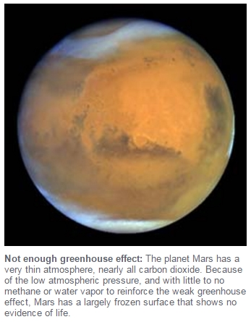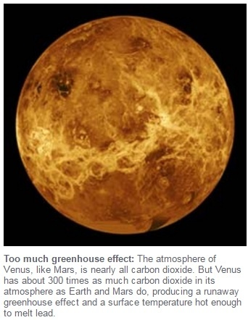

A group of 1,300 scientists from all over the world have studied climate change. They published a report for the United Nations. They think there is a 95 percent chance humans have caused global warming.

Our modern world relies on factories, cars and other machines. They run on coal and oil. Burning these materials has almost doubled the amount of CO2 in the air in the last 150 years.

## Solar Irradiance

The sun may be one cause of climate change. The sun is the main source of energy and heat for the planet. Studies show the sun has caused past climate changes. Changes in energy coming from the sun, for instance, may have caused the Earth to cool a few hundred years ago.

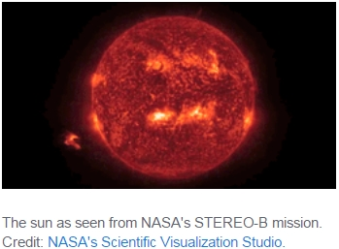

There is proof, though, that the current global warming is not caused by the sun. Since 1750, the energy coming from the sun has remained the same. If the sun were the cause, then the atmosphere would heat up evenly. However, the bottom of the atmosphere is warming up while the top is cooling. This means greenhouse gasses are trapping heat in the lower part. Scientists also ran tests to see if the sun could be the cause of global warming. The sun alone, though, could not cause the changes of the past 50 years. The scientists had to add greenhouse gases to the model to see the same change.

NASA. (2017, January 19). A Blanket Around the Earth. (Ed. Newsela staff). Retrieved from <http://climate.nasa.gov/causes/>

**Activity: 02**

### 1.Question 1 **Comprehension Check Instructions:**

**Instructions:** All questions in this quiz refer to the reading, “A Blanket Around the Earth." You are allowed to refer to this reading as you answer these questions. You can open the reading in a new tab by clicking one of the links:

BASIC: <https://www.coursera.org/learn/stem/supplement/CGGqA/basic-a-blanket-around-the-earth>

According to the article, most scientists agree that the main cause of global warming is:



Climate change



Solar Irradiance



The moon



The Greenhouse Effect

### 2.Question 2

Which of the following is NOT a greenhouse gas?



Sodium chloride



Methane



Carbon dioxide



Water vapor

### 3.Question 3

_______________________ is the most abundant greenhouse gas.



Carbon dioxide



Water vapor



Nitrous oxide



Methane

### 4.Question 4

Human activity has increased carbon dioxide (CO2) by more than ______ since the Industrial Revolution began (about 150 years ago).



one-third



75%



50%



half

### 1.Question 1

**Instructions: Match the greenhouse gas with its source.**

**If you want to review the lecture again, click the link below to open it in a new tab:**

<https://www.coursera.org/learn/stem/lecture/l65Q8/greenhouse-gases>

_______ is made by evaporation.



Water vapor



Methane



Carbon dioxide

### 2.Question 2

Wetlands, termites, and oceans add _______ to our atmosphere.



Methane



Water vapor



Nitrous oxide

### 3.Question 3

Natural causes of carbon dioxide include _________.



breathing



both breathing and decomposition



decomposition

### 4.Question 4

_______ is made of one carbon atom and four hydrogen atoms.



Methane



Carbon dioxide



Nitrous oxide

### 5.Question 5

There has been a large increase of _______ in our atmosphere because of human's use of electricity and cars.



nitrous oxide



carbon dioxide



methane

# Unit 02:

***Video 03: Nature's Role in the Greenhouse Effect***

Hello, in an earlier video, we learned about greenhouse gases, water vapor, carbon dioxide, methane, and nitrous oxide.

In this video, we will learn how nature plays a role in either increasing or decreasing the amount of greenhouse gases in the atmosphere. We will look specifically at the carbon cycle and what we call sources and sinks.

Nature plays a role in the greenhouse effects, because trees, soil, and oceans all release greenhouse gases into the atmosphere. Nature also stores elements or compounds of greenhouse gases in different parts of the earth.

Any process or activity that releases a greenhouse gas into the atmosphere is called a source.

Let's look at some of the natural sources of carbon dioxide.

One source is animal and plant respiration. What's that? Well, for animals and people that's breathing. We take in oxygen and we breathe out carbon dioxide. For plants, it's not breathing the same way humans do, but it does involve taking in oxygen and letting out carbon dioxide in order to release stored energy.

Another natural source of carbon dioxide to the atmosphere is soil respiration and decomposition. What do we mean by soil respiration or soil breathing? Well, when we mention soil respiration, the dirt itself doesn't breathe, but all the living things in the dirt do, things like plant roots, or tiny, little insects, bugs and bacteria. When they are alive and respire in the soil, we have soil respiration. When they die in the soil, they begin decomposition. To decompose is to be destroyed or broken down into simpler compounds by microbes, worms and insects. One of the products of decomposition is carbon dioxide.

Animal and plant respiration account for almost 29% of carbon dioxide in the atmosphere.

Soil respiration and decomposition also account for about 29% of the carbon dioxide in the atmosphere. But the largest natural source of carbon dioxide in the atmosphere, at about 43%, is the ocean atmosphere exchange.

Exchange is when you give one thing and receive another in return for it. In the ocean atmosphere exchange, the oceans and the atmosphere continuously exchange carbon dioxide and oxygen with each other.

That means they both give carbon dioxide and oxygen to each other and take carbon dioxide and oxygen from each other. In the oceans, like in the soil, a lot of carbon dioxide is produced from the plants and animals that live beneath the waters.

So those are the natural sources of carbon dioxide. What are the sinks? A sink is something that absorbs or takes in the greenhouse gases from the atmosphere and stores it.

One example of a sink would be trees absorbing carbon dioxide and then releasing oxygen.

It is the reverse of respiration. We call this photosynthesis.

As you can see, things can be sources and sinks. We mentioned earlier that trees and plants were sources. They are, they are both sources and sinks. They put some carbon dioxide into the atmosphere at night, but they absorb much more of it during the day.

You can say the same thing about the oceans, they are both sources and sinks. As we explained in describing the ocean atmosphere exchange, the oceans not only produce some of the carbon dioxide that goes into the atmosphere, they also store a massive amount of carbon dioxide in the water in the plants that live in it.

This exchange of carbon dioxide between the sources and sinks is called the carbon cycle.

The climate that we and all other living things on Earth are now comfortable with is created in part by this exchange.

But now experts say the climate is changing because humans are putting more carbon dioxide into the atmosphere than what occurs naturally between the sources and the sinks.

We will learn that even small changes to these natural cycles can cause large impacts.

In this video, we learned how nature plays a role in both increasing or decreasing the amount of greenhouse gases in the atmosphere. We specifically looked at the carbon cycle in what we call sources and sinks.

In the next video, we will look at how the human activity of burning fossil fuels can threaten the balance of the carbon cycle.

**Unit 02: Language Focus: Present Progressive**

***Video 04:***

Hello. In this video, we are going to look at two verb tenses, the present simple and the present progressive which is also sometimes called present continuous. We will examine each of these tenses, when we use them and practice their forms. So let's begin by looking at the present simple. We use the present simple to say if something happens all the time or is a usual activity. We also use it for stating facts. For example, I am an English language instructor, I teach English. Or other examples would be, a source releases carbon dioxide into the atmosphere, or a sink absorbs carbon dioxide from the atmosphere.

You can see that I'm the present simple, because I'm speaking about things that happened all the time for me and are usual activities, I teach. In the last two examples, I stated scientific facts. Sources release carbon dioxide and sinks absorb it. I also used present simple in those sentences.

Okay, so how do we form the present simple? Well, it's not called the present simple for no reason. It's actually pretty simple to form. You take the base verb and that's it. For example, I teach students English. Teach is the base form of the verb to teach. The only exception here is the third person singular that's he, she, Alyssa, the teacher, it.

In this case, we add an s or an es to the end of the base verb. For example, Alyssa teaches English. The factory burns fossil fuel to make electricity.

Next let's look at the present progressive. The tense is used to speak about actions that are happening right now or right about now. For example, right now, I'm speaking to you about the present progressive tense and you are learning how to use it correctly. Notice how in this sentence how I used the present progressive.

I'm speaking and you are learning. I'm using the present progressive because this is happening. I am doing and you are doing right now.

So, we use the present progressive to talk about an action that is happening right now.

Want to see what Alyssa is doing right now? Well Alyssa is reading a text about climate change and is planning a lesson for a new video.

We formed the present progressive by using the verb been in the present form. That's I am, you, we, they are and he, she, it is, then adding the base verb plus ing. For example, Alyssa is reading a text. She is planning a lesson.

To sum it up, in this video we've looked at two tenses, the present simple and the present progressive which is also called present continuous. If we compare these two tenses, we can see that the present simple is used to speak about actions that happened all the time or are facts. And the present progressive is used to speak about actions happening right now.

Now let's do a game to practice those verb tenses some more.

Question 1**Instructions: Choose the correct form of the present progressive to fill in each blank.**

The Earth ________ warmer.

1 point



is getting



are getting

**2.**Question 2

Scientists ______ evidence on Climate Change.

1 point



is gathering



are gathering

**3.**Question 3

The Earth ______ ten times faster than in the past.

1 point



is warming



are warming

**4.**Question 4

Alyssa and Jack ______ a course on Climate Change.

1 point



are teaching



is teaching

**5.**Question 5

Right now, we _______ questions on the discussion boards.

1 point



is answering



are answering

**6.**Question 6

Sea levels ______ faster than expected.

1 point



are rising



is rising

**7.**Question 7

Scientists _______ the levels of cloud cover in the sky.

1 point



are measuring



is measuring

**8.**Question 8

Air pollution _______ more carbon dioxide into the atmosphere than before.

1 point



are adding



is adding

**Unit 02:**

***Video 05: The Burning of Fossil Fuels***

Hello. In the last video, we learned about the carbon cycle and how sources release carbon dioxide into the atmosphere and sinks absorb or take in carbon dioxide from the atmosphere and store it.

In this video, we will talk about one of the largest sources of carbon dioxide -- fossil fuels. We will learn how fossil fuels were formed and how they're used to provide heat, energy, and transportation. And finally, we will learn about the impact of burning fossil fuels on the greenhouse effect.

In an earlier video, we introduced the term fossil fuels. Fossil fuels are natural materials, such as oil, coal, or gas, that are burned to create energy.

You may know the word fossil; fossils are what remains of plants or animals that lived long, long ago. One example is the impression of a leaf or a small animal from millions of years ago that we see in a rock today.

Fossil fuels are also what remains from living things from millions and millions of years ago. Fossil fuels are formed from the decomposition of living organisms. The most common examples are oil, natural gas, and coal. Oil and natural gas were created when plants and animals that died sank to the bottom of the oceans and rivers and were buried by sediment. Those sediments would have been things like stones in sand that washed into the water and then sink to the bottom. After time, there were many layers of sediment, and a great deal of pressure and heat were created.

In this intense environment, the remains were decomposed. Compounds are composed of two or more separate elements. So to make a compound simpler, you take them apart, so that each compound has fewer elements. Millions of years later, these compounds became oil or natural gas.

Coal is created in a similar way. For coal, it was trees or other plants that were buried in wet swamplands. When the plants died, they fell into the bottom of the swamps. As time went by, more plants died, and they formed a thick layer at the bottom of the water. These layers were then buried by dirt and water. The heat and pressure under, at the bottom of the piles, cause chemical reactions. In the end, after the oxygen was pushed out and mostly carbon remained, the materials that were left became coal.

Oil, natural gases, and coal have all played an important part in helping the world develop since the Industrial Revolution, when modern machines were invented to make our lives better. In modern society, many places in the world get their electricity so easily by simply plugging in a cord into a wall, but that electricity must be created somewhere. The largest share of greenhouse gas emissions come from burning fossil fuels, mostly coal and natural gases, to make electricity. In modern society, it is also very convenient and easy to get from one place to another.

You can visit another city or another country in one day, but most forms of transportation also depend on fossil fuels. Planes, trains, cars, trucks, ships -- they burn oil products, such as gasoline, petrol, or diesel, to make them run. Factories that make everything that we fill our stores with, such as clothes, toys, electronics, and cars, all use the burning of fossil fuels to make their machines work and to heat their buildings.

As we can see, most of us depend on burning fossil fuels for making almost everything we use and taking us almost everywhere we go. But burning so many fossil fuels does have an impact on the environment. It pushes all the carbon dioxide that was stored in the Earth up into the atmosphere in a way that would not happen naturally in the carbon cycle. And as we learned before, carbon dioxide is a greenhouse gas. So when there is more of it floating around the atmosphere, that means more heat is trapped from escaping our greenhouse -- the Earth's atmosphere.

In this video, we learned more about fossil fuels: how they were formed and how they are used to provide heat, energy, and transportation. And finally, we looked at the impact of burning fossil fuels on the greenhouse effect.

Our next video will be a language focus on cause and effect.

**Unit 02: Language Focus: Language Focus: Cause and Effect (so, because of, therefore, as a result)**

# *video06:* *Cause and Effect (so, because of, therefore, as a result)*

# Hello, in the previous video, you looked at the burning of fossil fuels. In this language focus video, we are going to look at how to talk about cause and effect.

# We'll look at different words and phrases, called connectors, that show cause and effect and we'll look at some examples of each.

# Why don't we start by defining these two terms, cause and effect. Cause means the reason that something happens.

# So, in the sentence, the rain storm was the cause of the flooding. The rain storm is the reason why the flooding happened. Effect, on the other hand, means the consequence of an action.

# So, if we take our earlier sentence, and look at it in another way, we can say the flooding was the effect of the rainstorm, meaning that the flooding was the result of the action.

# With the topica climate change it is very important to understand the relationship between different events to know which actions or events cause the others. The things we can see are often effects, but it is too late to change anything at that point. Only by changing the cause of an action can we prevent an effect from happening.

# Okay, so now that we know the difference between a cause and an effect, let's look at some of the ways that we can show this relationship.

# The words that we use to show these relationships are called connectors. A connector is something that joins two or more things together.

# In this case, we're joining clauses together.

# In earlier videos, we looked at the causes of global warming. We saw that more carbon dioxide or CO2 in the atmosphere causes clouds that trap the sun's heat making the Earth warmer. So there is a relationship between the more CO2 in the atmosphere, the cause, and more of the sun's heat being trapped, the effect.

# Let's talk about that relationship using connectors and putting the cause first.

# We can say there is more CO2 in the atmosphere so more of the sun's heat is trapped. Or we can say there is more CO2 in the atmosphere; therefore, more of the sun's heat is trapped. A third way to say this would be there is more CO2 in the atmosphere, consequently, more of the sun's heat is trapped.

# So, we can make a sentence by talking about the cause followed by so, therefore, or consequently, and then the effect.

# We can make sentences by putting the effect first as well. Let's look at a few examples of this. We'll use the same situation with CO2 in the atmosphere, and the heat trapped, and use different connectors.

# We can say, more of the sun's heat is trapped because of more CO2 in the atmosphere. Or we can say more of the sun's heat is trapped as a result of more CO2 in the atmosphere. A third way of saying this is more of the sun's heat is trapped due to more CO2 in the atmosphere. So we can construct the sentence by talking about the effect followed by because of, as a result or due to and then the cause.

# In this video we looked at the relationship between a cause and an effect. We saw that you can use connectors to accurately show this relationship. We can talk about the cause first followed by the connectors so, therefore, or consequently. Or we can talk about the effect followed by the connectors because of, as a result of, or due to.

# Next you're going to read about the ways that leaders of cities are working to clean the air.

Question 1 **Instructions: Choose the most appropriate connector to fill the gap.**

There will be droughts in certain parts of the world __________ less rainfall.

1 point



because of



consequently

**2.**Question 2

Greenhouse gases prevent some of the heat of the sun from returning to space, __________ the Earth becomes warmer.

1 point



due to



so

**3.**

Question 3

The glaciers are melting. __________, the sea levels are rising.

1 point



Therefore



As a result of

**4.**Question 4

More carbon dioxide is being released into the atmosphere __________ the burning of fossil fuels.

1 point



due to



therefore

**5.**Question 5

Many people will have to migrate to more fertile areas __________ desertification.

1 point



so



as a result of

**6.**Question 6

Low-lying coastal areas will be in danger of flooding. __________, residents of these places will need to move to higher ground.

1 point



Because of



Consequentl

# Unit 02: Reading: Need Strategies to Clear the Air? Ask a Megacity.

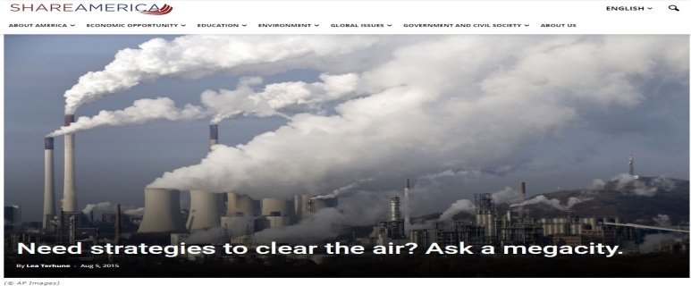

Air pollution starts in large cities, but smog can travel thousands of miles. It affects people in the city and far outside it as well. City mayors around the world are coming up with ideas to control air pollution.

The C40 Cities Climate Leadership Group is trying to help cities lower pollution. In 2005 the group brought together leaders from big cities around the world. The officials talked about ideas for solving environmental problems all cities share. Air pollution was at the top of the list.

The C40 has an initiative called the Climate Positive Development Program. The program supports projects in 17 cities. Each project is trying to lower greenhouse gas emissions. The emissions are from such things as cars, buses, energy and waste. The projects use different approaches. Some are high-tech, some are low-tech. Some projects are planting trees and putting gardens on roofs. Others are using different types of cars and gas. The cities also want to make energy that lasts longer and does not cause pollution.

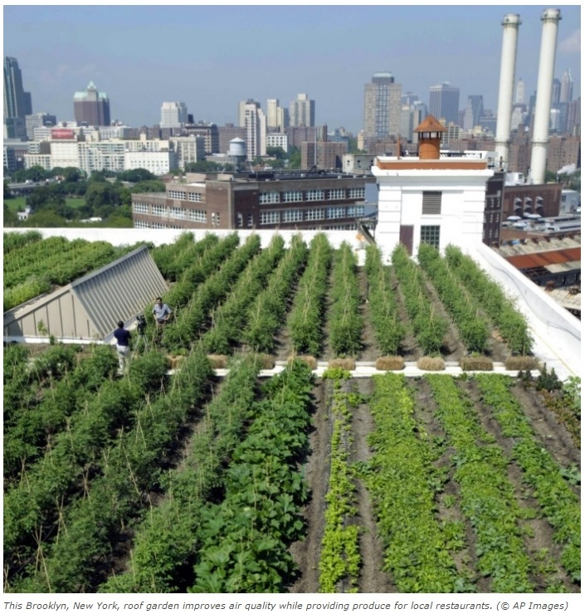

## Reducing emissions

The C40 group wants cities to have net carbon-negative emissions. Carbon dioxide is a gas that causes pollution. The group wants cities to capture the same amount of carbon dioxide that is released and reduce carbon dioxide in the atmosphere.

An adviser to the city of Stockholm spoke about this. He said that experiences show that smart, low-carbon ideas can lower the amount of dangerous gases. These ideas can also save money.

Each C40 project is monitored from beginning to end. The projects have clearly defined parts. So far, only six projects have reached part two without major changes.

One of the projects is Mahindra World City in Jaipur, India. Mahindra World City is a partnership between the Mahindra Group and the government of the state of Rajasthan. Mahindra World City wants to join people's lives, jobs and other needs into a single place. By 2025, nearly 300,000 will live and work there.

Other Climate Positive Development projects are located around the world in Sydney and Melbourne, Australia; Sonderborg, Denmark; London, England; and Oberlin, Ohio in the U.S.

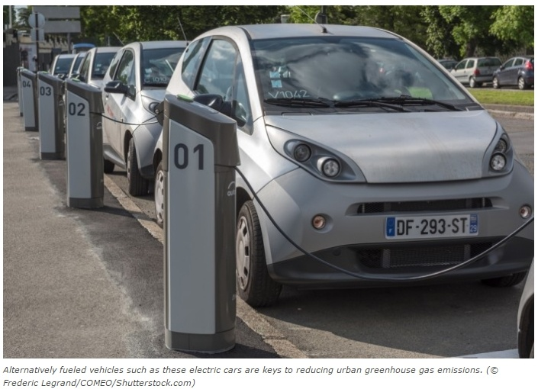

## Collaborative efforts

Every city needs its own answer. Still, the city-to-city network is working together and watching the different projects. The group wants to see if the projects lead to solutions that will work in other cities.

Many of the cities are hundreds of years old. Old neighborhoods are being changed alongside new buildings. The new buildings were planned and built especially to lower pollution.

A partnership with a group called the Climate & Clean Air Coalition announced in July will support efforts to clear the air in 50 C40 cities. Some of these cities are Addis Ababa, Ethiopia; Dar es Salaam, Tanzania; Dhaka, Bangladesh; Jakarta, Indonesia; Lagos, Nigeria; Rio de Janeiro and Sao Paulo, Brazil; and Stockholm, Sweden.

_________

Terhune, L. (2015, August 04). Need strategies to clear the air? | Share America. (Ed. Newsela staff). Retrieved from <https://share.america.gov/need-strategies-clear-air/>

**Activity: 03**

### 1.Question 1

**Comprehension Check Instructions:**

**Instructions:** All questions in this quiz refer to the reading, “Need Strategies to Clear the Air? Ask a Megacity." You are allowed to refer to this reading as you answer these questions. You can open the reading in a new tab by clicking one of the links:

BASIC: <https://www.coursera.org/learn/stem/supplement/PX7ut/basic-need-strategies-to-clear-the-air-ask-a-megacity>

What is the main idea of the reading?



Leaders in large cities are creating new ideas to deal with air pollution.



People are waiting for the federal government to pass clean air legislation.



People in rural areas are complaining about air quality.



The mayor of Stockholm wants to ban cars from the city.

### 2.Question 2

What does the number 17 refer to in the article?



The number of years it will take for Sydney to become net carbon negative.



The year, 2017, when the C40 proposals will begin to take effect.



The distance in miles that pollution from a factory can travel.



The number of cities that currently have projects supported by the C40 group.

### 3.Question 3

Net carbon-negative means:



Balancing out emissions of carbon dioxide by capturing the same amount of waste CO2 and also reducing carbon dioxide in the atmosphere.



Not using any product that produces waste carbon dioxide.



Planting more trees than you cut down in any given year.



Putting a roof garden on every second building in the downtown area of a city.

### 4.Question 4

Which cities have reached the second phase of the C40 project?



Stockholm, Mexico City, Mahindra World City, and Sydney



Sao Paulo, Delhi, London, and Melbourne



Mahindra World City, Addis Ababa, London, and Delhi



London, Oberlin, Mahindra World City, and Sydney

**Unit 02:**

**Video 07: Deforestation and Farming**

Hello, so far in this unit, we've learned about the greenhouse effect, greenhouse gases, and the main sources that create greenhouse gases. Remember, greenhouse gases hold or trap heat created by the sun. We've looked at natural causes and some human causes like the burning of fossil fuels. In this video, we are going to learn about two more human activities that create greenhouse gases. Deforestation and Farming.

First, let's look at deforestation. What is deforestation? Deforestation is the destruction or clearing of forests to make land available for other uses.

Deforestation happens for many reasons. Sometimes deforestation happens so people can use the wood from trees to create fuel, paper, and other commercial goods. Most often though, deforestation happens so people can use the land for things like farming and housing.

So why is this a problem? Well, as you learned earlier in the unit, there are things in our environment called the carbon sinks. Carbon sinks absorb greenhouse gasses from the atmosphere and store them.

Forests are a primary carbon sink in our environment.

Trees take carbon dioxide from the air and turn it into oxygen during photosynthesis.

Photosynthesis is a chemical process by which plants make food using sunlight to turn carbon dioxide, water, and certain salts into sugar or carbohydrates.

So basically, trees absorb the carbon dioxide in the air to make food, and release oxygen for us to breathe. By destroying the forests, we are destroying trees and these very important carbon sinks.

Furthermore, when we cut down trees, they release the carbon that is stored inside them. Each year, deforestation is the cause of about one billion tons of carbon dioxide being released into the atmosphere. Overall, deforestation creates about 15% of our greenhouse gases in our atmosphere.

In addition to this, deforestation limits the amount of water vapor in the atmosphere. A fully grown tree releases about 1,000 liters of water vapor a day. When we cut down forests, we are losing this very important source of water vapor that creates clouds and rain, leading to dry weather and other severe climate effects.

As mentioned earlier in the video, the land clear from deforestation, is often used for farming or agriculture. That sounds like a good thing, right? After all, we need food to survive. Well, most farming today uses chemicals and fossil fuels that add even more carbon dioxide, methane, and nitrous oxide to our atmosphere. In fact, according to the inter-governmental panel in climate change, agriculture land use creates 12% of greenhouse gases globally. So not only does the process of deforestation cause greenhouse emissions to be released. But the use of the land for farming afterwards, also adds greenhouse gases to our atmosphere.

In this video, we learned about deforestation and farming. We learned how important trees are to our environment. And how deforestation can increase the amount of carbon dioxide in the atmosphere.

We also learned about farming, and how the use of land and chemicals in farming add greenhouse gases to our atmosphere. In the next video, we will learn about different ways of disposing waste, and how each one affects the environment.

**Unit 02:**

**Video 08: The Disposal of Waste**

Hello.

In the previous video, we looked at deforestation and farming.

In this video, we're going to look at the disposal or throwing away of waste. We'll look at some of the most popular ways to dispose of waste, and talk about what each one means for the environment and the greenhouse effect.

First of all, let's make sure we understand the meaning of the term.

Disposal of Waste means removing, throwing away something that we do not want.

Examples of this might be the box and the other packaging that your mobile phone came in, the can that is left after you drink your soda, or the peel of a banana after you eat it.

Think about what you might do with the waste.

Do you throw it in the garbage can or a recycling container?

What happens to it after that?

We're going to look at four ways to dispose of waste: landfill, incineration, composting, and recycling.

Let's look at a landfill first. The definition of a landfill is a place to dispose of waste material

by burying it and covering the waste with soil.

This method does have the benefit of creating more usable land which can be used for other purposes.

However, there are many disadvantages to landfills. Dangerous chemicals can contaminate both the soil and the groundwater in areas around a landfill site.

Also, landfills produce large amounts of methane gas, CH4 which contributes to global warming.

A second method of waste disposal is incineration. This is a process that involves the burning of waste materials.

People all over the world have been burning waste for centuries.

Its disadvantages are that it releases harmful pollutants into the air, including greenhouse gases which are breathed in by people or can cause problems for water, plants, wildlife, and the climate.

Recently, some countries have created very large incineration plants.

These places can keep in the harmful pollutants caused by burning waste.

Also, the heat created by burning the waste is turned into steam which then produces power.

Another method of waste disposal that has been going on for a long time is composting.

Composting is the process of decomposing, breaking down into separate parts, organic matter like plants to provide more nutrients for the soil.

In other words, over a period of time, the waste is broken down into separate parts.

These parts then help the soil become richer which means that plants can grow more easily.

More composting also means less waste is sent to landfill, which means that less methane is in the atmosphere.

The last method of waste disposal, we're going to look at today, is recycling which as you probably know means to change waste into something useful.

The best example might be the soda can, we talked about at the beginning of the video.

When you recycle this, it goes into a plant where it is cleaned and melted.

It is then rolled out and made into another aluminum product.

While workers in the recycling industry run a small risk of exposure to harmful materials,  the benefits of recycling strongly outweigh the disadvantages.

It reduces the amount of waste sent to landfills, reduces greenhouse gas emissions, and stops the pollution created by finding and processing new raw materials.

So in this video, we looked at different ways of disposing of waste.

We looked at landfill, incineration, composting, and recycling.

Each of these has its own impact on the greenhouse effect.

Next, you're going to complete a speaking assessment about the impacts of climate change.

**Unit 2 Assessment 2: Written Instructions**

**Basic Instructions:**

Choose one man-made source of the Greenhouse Effect and describe one or two ways it is contributing to climate change in our world.

**Detailed instructions:**Review the content discussed in Videos 2, 4, 5, 7, and 8. Choose a man-made source of the Greenhouse Effect that you want to discuss. This could include the burning of fossil fuels, deforestation, farming, or the disposal of waste. First, introduce the man-made source and define what it is. Then give one to two examples of how it is contributing to climate change in our world. Remember to include:

1. A clear definition of your source (burning of fossil fuels, farming, or disposal of waste). **Note:** Do not use "deforestation" as our model is of this man-made source of the Greenhouse Effect.

2. One or two specific examples of how it is contributing to climate change

3. Accurate use of the present progressive

4. Cause and effect language (so, therefore, consequently, because of, as a result of, due to)

You should write a paragraph.

**Model (Deforestation):**There are many things that humans **are doing** in our world today that **are contributing** to the Greenhouse Effect. One thing humans **are doing** that **is having** a big impact on the environment is deforestation. Deforestation is the destruction or clearing of forests to make land available for other uses. People want land for things like farming and housing, ***therefore*** deforestation **is** **happening** more. Trees release carbon dioxide when they are cut down. Because of deforestation there are more trees being cut down, ***as a result*** more carbon dioxide is being released into the atmosphere. This extra carbon dioxide in the atmosphere created by humans **is adding** to the problem of climate change.

# Unit 02: Reading

# Charcoal Trade Is Destroying Africa’s Forest Cover

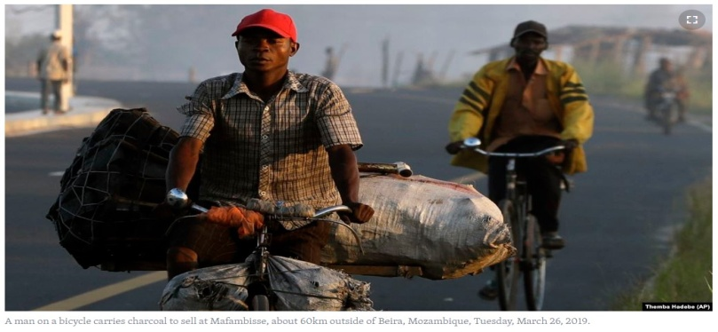

Across Africa, men carrying tools for cutting down trees spend weeks deep inside forests. They cut down the trees to burn them in order to make fuel for fires known as charcoal.

Because they work at night, mainly on public land, they operate without fear of the law while destroying forests in many countries.

Fires in [Brazil’s Amazon rainforest](https://www.apnews.com/8cb1b56b83f144ae90ffcd6eeaa7d57b) have brought attention to the difficulties of protecting the Earth’s forest lands. The Congo Basin **tropical** rainforest is about the size of Western Europe. After the Amazon, it is the world’s second largest rainforest. Some people call it Earth’s second lung.

Africa is home to over 1.2 billion people and poverty on the **continent** remains a problem. Many nations have struggled to protect forests as growing populations demand plant-based energy resources that are considered low cost. Charcoal is widely used.

The European Space Agency says that 25 to 35 percent of climate-changing **greenhouse gases** come from biomass burning. Biomass burning is natural or manmade burning of organic material, including seasonal fires people set to clear land for farming. Most of this kind of burning happens in tropical areas of Africa.

A 2018 report from the United Nations Food and Agriculture Organization found dependence on charcoal or firewood to be highest in Africa and Asia. Some African cities are almost completely dependent on charcoal for cooking. In Kinshasa, the capital of The Democratic Republic of the Congo, 90 percent of residents depend on it, the report said.

In Somalia, the U.N. has warned that cutting down trees to support an [illegal charcoal trade](https://www.apnews.com/9b0bcd2c5b354e83b2882cd147e17385) is so widespread that **desertification** there threatens stability. The country is already suffering a wave of extremist violence.

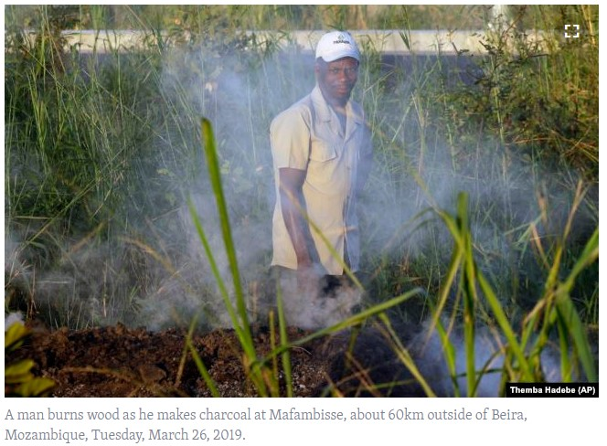

The U.N. report said that the estimated value of the charcoal export trade from East Africa to the Middle East and other places is over $360 million a year. This is the case although the trade is banned. About 8.2 million trees were cut down for charcoal between 2011 and 2017, the U.N. said.

Ugandan government officials have warned about the charcoal trade for a long time. The trade continues although the electrical power system now extends deep into the country. **Hydroelectric** power is still too costly for many people even in the capital, Kampala.

Edwin Muhumuza is an environmental activist who runs the group Youth Go Green in Kampala. He told the Associated Press that charcoal has become a valuable product, like gold or coffee.

“We are really concerned,” he said. “They cut down the trees but they don’t **replace** them.”

Now the National Environment Management Authority, a government agency, is urging officials to lift taxes on liquid petroleum gas. It is another cooking fuel that could be used instead of charcoal.

**Africa’s forests are shrinking, researchers warn**

Research shows a difficult situation. Uganda’s forest cover as a percentage of land area was nine percent in 2015. Government data shows that is down from 24 percent in 1990.

But officials in northern parts of Uganda such as Gulu, which provides much of the charcoal entering Kampala, are taking action. Their campaign has seized many charcoal trucks since 2015.

Gulu chairman Martin Mapenduzi organizes raids in hopes of arresting charcoal burners.

“Illegal **logging** has gone down but the destruction of forests for charcoal burning is still high,” Mapenduzi said. “It’s something that is giving us a lot of **headache**, but we are fighting.”

The price of enough charcoal to support a small family for several weeks has been rising in Kampala. In August, it reached about $28. That is largely because of reduced supply from places such as Gulu.

The cost is still far too much for families, said Rose Twine. She is a business woman who sells a cooking device called the eco-stove. Twine says one eco-stove comes with volcanic rocks that, she said, can last for up to two years. It costs $110. Yearly charcoal costs for an average family, can grow to more than $300.

“Charcoal is actually not **cheaper**,” Twine said. “People are just stuck in their old ways.”

Widespread destruction of forests has led to campaigns to take action in some African countries.

This week, Gabon became the [first African country](https://www.cafi.org/content/cafi/en/home/all-news/gabon--first-in-africa-to-receiving-payments-for-preserved-rainf.html) to receive payments for provable efforts to reduce greenhouse gases resulting from the destruction of forests. The U.N. Development Program said payments would reach $150 million over 10 years. It called the payments “historic in many ways.”

In July, The U.N. Environment Program said that Ethiopia’s prime minister led an effort in which [over 350 million trees](https://www.unenvironment.org/news-and-stories/story/ethiopia-plants-over-350-million-trees-day-setting-new-world-record) were planted across the country in one day.

But some activists say tree-planting may not be enough to save Africa’s forests. They urge governments to spend more on **alternative**energy sources for the poorest people.

Mapenduzi, the Ugandan official campaigning against charcoal burning, called for laws against it and urged officials to make electricity cheaper.

Others also believe only urgent action, such as a ban on the charcoal trade, will help.

“A total ban,” said activist Muhumuza, “One hundred percent.”

I’m Anna Matteo.And I’m Pete Musto.

Pete Musto adapted this Associated Press story for VOA Learning English. Mario Ritter Jr. was the editor. We want to hear from you. How does your country protect its forests? Write to us in the Comments Section.

___________________________________________________________

## ****Words in This Story****

**tropical** – adj. of, relating to, occurring in, or used in the part of the world that is near the equator where the weather is very warm

**continent** – n. one of the great divisions of land, such as North America, South America, Europe, Asia, Africa, Australia, or Antarctica, of the Earth

**greenhouse gas**(**es**) – n. pollution that causes the Earth’s atmosphere to warm

**desertification** – n. the process by which an area becomes a desert

**hydroelectric**– adj. of or relating to the production of electricity by using machines that are powered by moving water

**replace**– v. to put someone or something new in the place or position of someone or something

**log**(**ging**) – v. to cut down trees in an area for wood

**headache** – n. a difficult or annoying situation or problem

**cheaper**– comparative adj. costing less money than something else

**alternative** – adj. offering or expressing a choice

_________________________

Voice of America. (2019, Sept. 29). Charcoal Trade Is Destroying Africa's Forest Cover | Learning English. Retrieved from: <https://learningenglish.voanews.com/a/charcoal-trade-is-destroying-africa-s-forest-cover/5100247.html>

### 1.Question 1

**Instructions:** All questions in this quiz refer to the reading, “Charcoal Trade Is Destroying Africa’s Forest Cover." You are allowed to refer to this reading as you answer these questions. You can open the reading in by clicking the link below:

[Charcoal Trade is Destroying Africa's Forest Cover](https://www.coursera.org/learn/stem/supplement/gWuyF/charcoal-trade-is-destroying-africas-forest-cover)

The Congo Basin is the largest rainforest in the world.

1 point



True



False

### 2.Question 2

Why hasn't electricity replaced charcoal in Uganda?

1 point



electricity is too expensive



charcoal provides a lot of jobs



the taxes on charcoal are low



electricity isn't available in most parts of the country

### 3.Question 3

What are some ideas mentioned in the article to decrease the charcoal trade? Check all that apply.

1 point



lift taxes on liquid petroleum gas which is used for cooking



legalize the charcoal trade so that governments can profit



use the wood from deforestation in the Congo Basin



arrest more of the illegal charcoal burners



provide solar panels to public areas for people to use

### 4.Question 4

True or False. The eco-stove is a cheaper alternative to using charcoal for cooking.

1 point



True



False

**1.**Question 1

**Instructions: Decide if the following sentences are examples of general scientific facts or new things that are happening now.**

Nowadays, human activities are changing the natural greenhouse effect.

1 point



a general scientific fact



something new happening now

**2.**Question 2

Water vapor increases as the Earth’s temperature warms.

1 point



a general scientific fact



something new happening now

**3.**Question 3

Sources in the “Carbon Cycle” release carbon dioxide into the atmosphere.

1 point



a general scientific fact



something new happening now

**4.**Question 4

Nature plays a role in the levels of greenhouse gases in the atmosphere.

1 point



a general scientific fact



something new happening now

**5.**Question 5

As climate change continues, ice wedges are melting at a faster rate in the Arctic.

1 point



a general scientific fact



something new happening now

**6.**Question 6

Now, mayors in large cities are trying to control air pollution.

1 point



a general scientific fact



something new happening now

**7.**

Question 7

Deforestation increases the threat of climate change.

1 point



a general scientific fact



something new happening now

**8.**

Question 8

As temperatures rise, climate change is forcing some animals to change their migration.

1 point



a general scientific fact



something new happening now

# Melting of Ice Wedges Adds to Arctic Warming

March 16, 2016

by Kevin Enochs

Ice wedges are a particularly cool surface feature in the Arctic tundra. And new research suggests they are melting fast, which is bad news for the ecosystem at the top of the world — and the planet in general.

Ice wedges are formed when groundwater freezes, then — when the air gets cold enough at minus 17 degrees Celsius or lower — the ice begins to expand and contract, with more ice filling the cracks.

Eventually the wedge gets big enough to reach the surface, where it splits the earth like cracks in a sidewalk.

These ice wedges look like giant honeycombs on the frozen landscape. In the spring, the Arctic tundra looks like a jigsaw puzzle of small ponds with the ice wedges acting as the border between each little pond.

## More carbon, more runoff

But new research published in this week's journal [Nature Geoscience](http://www.nature.com/ngeo/journal/vaop/ncurrent/full/ngeo2674.html) suggests these wedges play a significant role in maintaining huge stores of carbon dioxide held captive in the permafrost.

"The unique structure of ice wedge polygon landscapes promotes ponding of water and the accumulation of vast stores of soil carbon as wetland vegetation dies off seasonally and is buried and frozen over thousands of years" said Cathy Wilson, the Los Alamos National Laboratory geomorphologist who co-authored the paper.

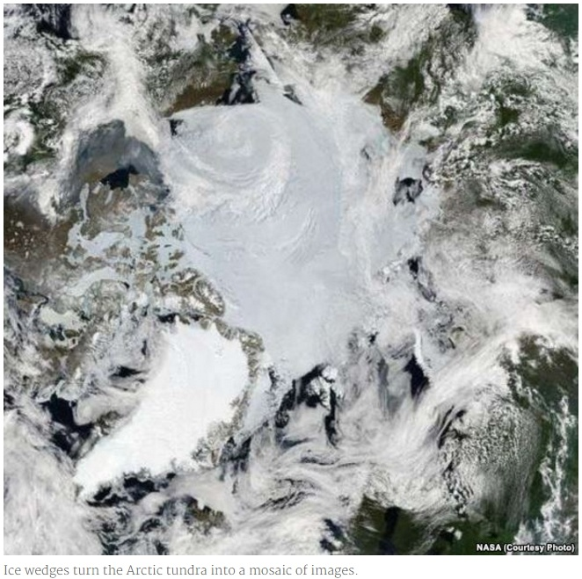

While researchers have seen the collapse of ice wedges before, Wilson's study is the first to find that the rapid melting of ground ice has become widespread, with a ripple effect across the entire Arctic.

These collapses are called thermokarsts, and Wilson says they can change the area's hydrology by "creating a lot of new ponds, or by draining and drying polygon-shaped ponds by connecting them into a continuous drainage network."

The researchers also found that the melting ice wedges are speeding up the rate at which permafrost is thawing.

Permafrost is ground that has stayed frozen for at least two years. Most of the northern permafrost has been frozen for tens, or even hundreds, of thousands of years. It locks away season after season of plant life on ice, nearly 1,700 gigatons of organic carbon.

That's a whole lot more than all the greenhouse gas floating around our atmosphere in the form of methane and carbon dioxide, and it is released into the atmosphere as the permafrost thaws.

## Tipping point

The scientists are concerned about the speed at which the arctic wedges and the permafrost are degrading.

"Change is happening so fast,” Wilson said. “I never thought I'd see thermokarst occur over the course of a few years at our field site. It's pretty exciting, but scary too."

The team noted that some of the wedge melting has occurred just from season to season, and in the case of one unusually warm summer, the surface wedges melted about 10 centimeters.

"It's really the tipping point for the hydrology," said the paper's lead author, Anna Liljedahl from the University of Alaska Fairbanks. "Instead of being absorbed by the tundra, the snowmelt water will run off into lakes and larger rivers. It really is a dramatic hydrologic change across the tundra landscape."

That change could release even more greenhouse gases into the atmosphere, potentially speeding up climate change.

________________

Enochs, K. (2016, March 16). Melting of Ice Wedges Adds to Arctic Warming. Retrieved from <http://www.voanews.com/a/melting-ice-wedges-add-arctic-warming/3240733.html>

### 1.

Question 1

**Comprehension Check Instructions:**

**Instructions:**All questions in this quiz refer to the reading, “Melting of Ice Wedges Adds to Arctic Warming." You are allowed to refer to this reading as you answer these questions. You can open the reading in by clicking the link below:

<https://www.coursera.org/learn/stem/supplement/HMFkZ/melting-of-ice-wedges-adds-to-arctic-warming>

According to the article, what are ice wedges?

1 point



Ice that has formed at the tops of icebergs



Ice that has formed around cooler rocks



Ice that has formed in the ocean when seawater freezes



Ice that has formed when groundwater freezes in the earth

### 2.

Question 2

Ice wedges are melting faster. Why is this a problem for the environment?

1 point



The melting ice and cracks in the earth are dangerous to walk on



Carbon dioxide and methane are being released into the atmosphere



They release water vapor which can cause heavy rains



The excess water is causing the seas to rise

### 3.

Question 3

What does the number 1,700 refer to in the article?

1 point



The number of years that permafrost takes to fully form



The weight in kilograms of the average ice wedge



The average number of ice wedges in each square kilometer of the Arctic



The number of gigatons of organic carbon stored in the permafrost

### 4.

Question 4

Which of the following words is a synonym for collapsing ice wedge?

1 point



tundra



thermokarst



permafrost



hydrologic