Ministry of Higher Education and Scientific Research
University of Djilali Bounaama in Khmis Miliana
Faculty of Science and Technology of Physical and Sports Activities.

+

1st lesson:

- What is body movements ?
Movement is the change in the position of a body part with respect to the whole body; these movements are possible because of joints. Joints are points in our body where two or more parts of our skeleton are connected together. Different joints help our body carry out different activities and movements.

- Types of body movements:

- Flexion: (ثني)or bending, it involves decreasing the angle between the two entities taking part in the movement (bones or body parts).
Example: flexion of leg (knee), elbow joints, foot, vertebral column, shoulder, and neck.
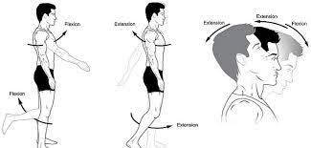
- Extension: (تمديد)or straightening, it involves increasing the respective angle.
Example: extension of leg (knee), elbow joints, foot, vertebral column, arm, shoulder, and neck.
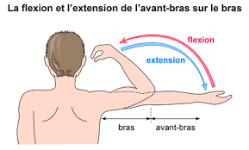

- Adduction:(حركة التقريب) bringing closer to the reference axis.
- Abduction:(حركة الاختطاف) moving away from the reference axis.
Examples: arms and legs.
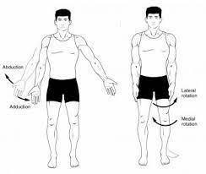
- Protraction:( حركة الاطالة للامام) or forward
it involves a movement going straight ahead or forward.
- Retraction:حركة التراجع للخلف) (or backward
It is the opposite and it involves going backwards
Example: tongue, chin, lips and shoulder

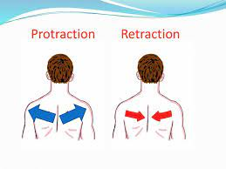
- Lateral rotation: (الدوران الجانبي)
rotating away from the middle. It involves moving it further away.
- Medial rotation: (الدوران الوسطي)
rotating toward the midline. It involves bringing the anatomical structure closer to the median plane.
Example: head, vertebral column, arm, leg.

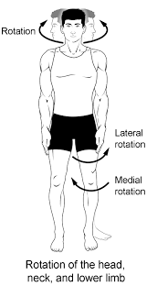
- Circumduction:( حركة دورانية) is a special type of movement that is actually a combination of flexion, abduction, extension and adduction. The result is a circular movement.
Example: upper limb (ventral view) arm and leg.
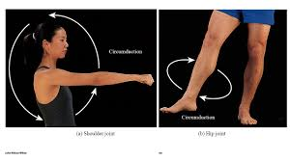
- Inversion: (حركة الانقلاب للداخل)plantar side toward the medial plane. The plantar side is moved towards the median plane, resulting in a medial turn.
- Eversion:( حركة الانقلاب للخارج) plantar side away from the medial plane. Plantar side of the foot is moved away from the median plane so that it is turned laterally.
Example: foot
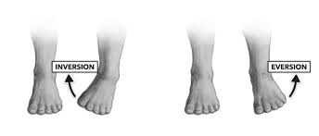

2nd lesson:
Sport equipments
Sporting equipment, also called sporting goods. Has various forms depending on the sport, and it is essential to complete the sport. The equipment ranges from balls, to nets, and to protective gear like helmets. Sporting equipment can be used as protective gear to require or as tool used to help the athletes play the sport.
Different sports with its equipments:
Examples:
Sport | Equipment
Football | Ball-cleats-uniform-shin guards-goal
Basketball | Ball-hoop-tennis shoes-uniform-backboard
Baseball | Helmet-hat-ball-uniform-bat-mask-mitts
Hockey | Helmet-puck-uniform-stick-mask-gloves
Volleyball | Uniform-net-knee pad-ball
Bowling | Ball-pins-shoes
Tennis | Racket-net-ball-sweet band.

Places where sports are played:
Examples:
Sport | Place
Tennis | Court
Handball | Court
Volleyball | court
Baseball | Diamond
Cricket | Pitch
Skating | Rink
Boxing | ring
Golf | Course
Swimming | Pool/sea
Judo/karate/taekwondo | Mat
Horse riding | Arena
Football | Field
Hockey | Field
Athletics | Track
Ice hockey | Rink
Archery | Range
Skiing | Slope
Motor racing | Circuit

Using “ play, do, go” in sports
- Use play for team sports or with competitive games like: football, basketball tennis…
Eg: I play football with my friends.
- Use go for sports that end in “ing” like: swimming, climbing, diving, skating…….
Eg: I go swimming in summer.
- use do with solo (individual) sports and activities or sports that you don’t need any equipments like: aerobics, martial arts, gymnastics ………….
Eg: they do aerobics in the gym

3rd lesson

Sport injuries
Definition:
Refer to the kind of injuries that occur during sports or exercise, while it is possible to injury any part of the body when playing sports.

The most common types injuries include:
- Sprains:(التواء)

Overstretching or tearing the ligaments (are pieces of tissues that connect two bones to one another in a joint).
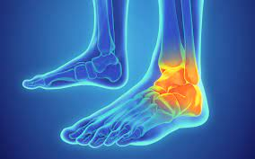
- Strains: (اجهاد عضلي)
Overstretching or tearing muscles or tendons. Tendons are thick, fibrous cords of tissues that connect bone to muscles.
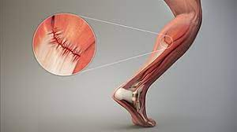

- Knee injuries: (اصابات الركبة)
It could range from an overstretch to a tear in the muscles or tissues in the knee.

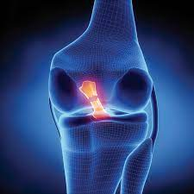

- Swollen muscles:( تورم العضلة)
Swelling is a natural reaction to an injury. It may also be painful and weak.
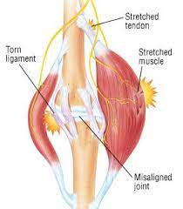
- Achilles tendon rupture:( اصابة وتر العرقوب)
Is a thin, powerful tendon at the back of the ankle, it can break or rupture when it
does you may experience sudden, sever pain and difficulty in walking.
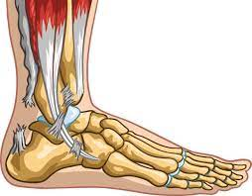
- Fractures:( كسور)
Is a crack or break in a bone, most fracture results from force applied to a bone. It usually results from injuries or overuse. The injured part hurts (especially when it is used), is usually swollen, and may be bruised or look distorted, bent, or out of place.
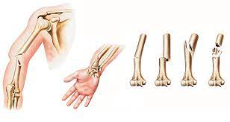

- Rotator cuff injury:( اصابة الكفة الدوارة)
Four pieces of muscles work together to form the rotator cuff. It keeps the shoulder moving in all directions. A tear in any of these muscles can weaken the rotator cuff.

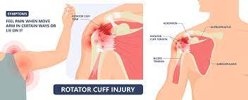
- Dislocations:(خلع المفصل)
Sport injuries may dislocate a bone in the body. When that happens a bone is forced out of its socket. This can be painful a lead to swelling and weakness.

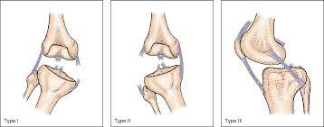

4th lesson
Sport injuries treatment

Most sports injuries do not need surgery. Treatment for a sports injury can include taking pain relievers, putting ice on the injured area, and keeping it immobilized with a cast or sling. In some cases, surgery may be needed to fix torn tissue or realign bones.

PRICE method:
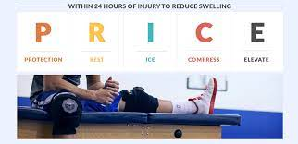
The PRICE method stands for protection, rest, ice, compression, and elevation.
- Protection(حماية) : protect the affected area from further injury like using a support.

- Rest(الراحة) : avoid exercise and reduce your daily physical activities using crutches or a walking stick may help if you can’t put weight on your ankle or knee, or a sling for your injured shoulder.

- Ice( وضع ثلج) : apply an ice pack to the affected area for 15-20 minutes every two to three hours.

- Compression(ضغط) : use elastic compression bandages during the day to minimize leakage of blood and swelling.

- Elevation(ارتفاع) : keep the injured body part raised above the level of your heart whenever possible. This may also help reduce swelling.

-For best result in the first 24-36 hours after the injury.
- It can help reduce swelling and prevent additional pain and bruising in the early days after a sport injury.
-Treatment can include taking pain killers like Paracetamole. And surgery and procedures for very severe injuries.

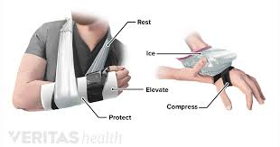
5th lesson
Paragraph Structure
A paragraph is a group of related sentences that discuss one (and usually only one) main idea. A paragraph can be as short as one sentence or as long as ten sentences.
The number of sentences is unimportant; however, the paragraph should be long enough to develop the main idea clearly.
A paragraph may stand by itself. In academic writing, you often write a paragraph to answer a test question. A paragraph may also be one part of a longer piece of writing such as an essay or a book.
We mark a paragraph by indenting the first word about a half inch (five spaces on a typewriter or computer) from the left margin.
The Three Parts of a Paragraph
All paragraphs have a topic sentence and supporting sentences, and some paragraphs also have a concluding sentence.
The topic sentence states the main idea of the paragraph. It not only names the topic of the paragraph, but it also limits the topic to one specific area that can be discussed completely in the space of a single paragraph. The part of the topic sentence that announces the specific area to be discussed is called the controlling idea.
Supporting sentences develop the topic sentence. That is, they explain or prove
the topic sentence by giving more information about it.
The concluding sentence signals the end of the paragraph and leaves the reader
with important points to remember: Concluding sentences are customary for stand-alone paragraphs. However, paragraphs that are parts of a longer piece of writing usually do not need concluding sentences.

