CHAPTER XIV: ANALYSIS OF ALKALOIDS

Objectives
Upon the completion of this chapter, the student will be able to :
- Define alkaloid.
- Perform a standard identification test for alkaloids using Dragendorff's reagent.

Introduction
Alkaloids are a very large class of substances with a somewhat vague definition. Traditionally alkaloids have been identified with the use of four analytical reagents:
• Mayer’s reagent, a potassiomercuric iodide solution
•Wagner’s reagent, a solution of iodine in potassium iodide
• Hager’s reagent, a picric acid solution
• Dragendorff’s reagent, a potassium bismuth iodide solution
One definition of an alkaloid is that it is a substance that gives a positive reaction to the above reagents. Another definition is given by Trease and Evans: “Typical alkaloids are derived from plant sources, they are basic, they contain one or more nitrogen atoms (usually in a heterocyclic ring) and they usually have a marked physiological action on man or animal.” From this definition, a few general properties can be expected. Owing to the nitrogen atom they are basic (alkaloids means alkalilike), and therefore they have a higher water solubility at low pH than at high pH. Besides alkaloids constitute a large group with a variety of properties. Usually alkaloids are distinguished through a classification based on the amino acid from which they are derived, for example the ornithine alkaloids. The chemical diversity of the alkaloid group can be illustrated by the structures of morphine (Fig.XIV.1) and hyoscyamine (Fig.XIV.2) given below. Both of them are substances used in therapy. At the present about 10 monographs make reference to alkaloids.

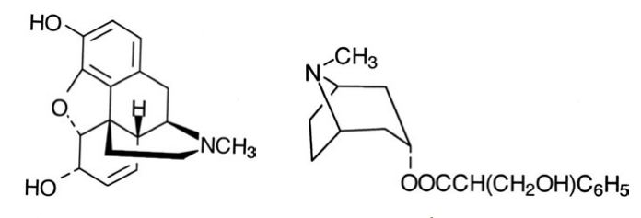
Fig.XIV.1 Morpine. Fig.XIV.2 Hydroscyamine.

Identification test
The identification test of the European Pharmacopoeia makes use of the Dragendorff’s reagent, which is a solution of potassium iodobismuthate, KBiI₄.
A test solution is prepared by dissolving a few milligrams of the substance to be examined, or the prescribed quantity, in 5 ml of water R. When dissolved, dilute hydrochloric acid R is added until an acid reaction occurs. Then 1 ml of potassium iodobismuthate solution R is added, an orange or orange-red precipitate is formed immediately.
The acid reaction occurs, as defined in the test, when methyl red changes from yellow to orange or red at about 5.1 pH or when bromothymol blue changes from blue to yellow at about 7.1 pH. This means that most tertiary and quaternary amines are found in the ionic acid form, and this allows the thereby cationic alkaloid to precipitate with anionic iodobismuthate. The salt is believed to be constituted not of monomeric entities, of for example one nitrogen base and one iodobismuthate, but of oligomeric cations and anions.
(alkaloid+)m (BiI4–)m
A positive reaction is obtained with many tertiary and quaternary amines, but not with most primary and secondary amines. All the alkaloids described in monographs making reference to alkaloids are tertiary and quaternary. Obviously, alkaloids are not the only group of substances containing tertiary and quaternary amine groups, so not much specificity can be claimed.
Most of the literature dealing with the specificity of the Dragendorff,s reagent concentrates on the risk of false positive reactions by other secondary metabolites potentially present in plant material. Here cumarines, hydroxyflavones, some triterpenes, and cardenolides could be mentioned. Even proteins can sometimes give positive reactions.
When judging the specificity of the reagent and its usefulness in relations to analysis on pure active pharmaceutical ingredients, one should keep in mind that the original purpose of the reagent was somewhat different. It was used, together with other reagents, to screen whether a plant might contain something that could prove to be an alkaloid.

