CHAPTER XII: ANALYSIS AND CONTROL OF AROMATIC PHARMACEUTICAL PREPARATIONS

Objectives
Upon completing this chapter, the student will be able to:
- Identify the main classes of aromatic pharmaceuticals and their key functional groups.
- Select appropriate analytical techniques for different quality control purposes.
- Explain how the chemical structure of an aromatic compound influences its analysis.

Introduction
Aromatic compounds, characterized by the presence of one or more benzene rings, form a cornerstone of modern therapeutics. This class encompasses a vast and diverse array of active pharmaceutical ingredients, including non-steroidal anti-inflammatory drugs (NSAIDs), local anesthetics, barbiturates, and numerous cardiovascular and psychotropic agents. The very stability and reactivity conferred by the aromatic ring make these compounds both therapeutically invaluable and analytically challenging.
The analysis and control of aromatic pharmaceutical preparations is therefore a critical discipline within pharmaceutical chemistry, dedicated to ensuring the safety, efficacy, and quality of these essential medicines. This field moves beyond simply confirming the identity of the active molecule to encompass a comprehensive assessment of its purity, stability, and final dosage form performance. This chapter is dedicated to the analytical strategies for three critically important sub-classes of aromatics pharmaceuticals: phenol, aniline, benzoic acid, and salicylic derivatives.

Analysis of phenol and aniline derivatives
Phenol and aniline derivatives constitute a foundational class of aromatic pharmaceuticals where biological activity is intrinsically linked to the aromatic ring and its substituents. The phenol functional group (–OH directly attached to the benzene ring) and the aniline functional group (–NH₂ attached to the benzene ring) are key pharmacophores. Phenols often exhibit antiseptic, disinfectant, and antioxidant properties, while anilines serve as crucial synthetic precursors for many drugs, including sulfonamides and acetaminophen. Their analysis is critical as they can function as APIs, preservatives, or potentially toxic impurities and degradation products.
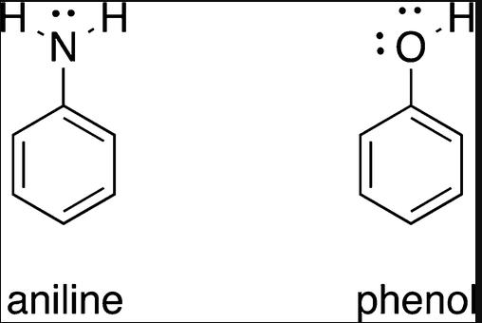
Fig.XII.1 Phenol and aniline.

Analysis techniques

High-performance liquid chromatography
High-Performance Liquid Chromatography with UV or Photodiode Array detection stands as the dominant technique for the assay and impurity profiling of phenol and aniline derivatives. The development of an effective HPLC method is critically dependent on the precise control of the mobile phase pH, which is used to manipulate the ionization state of the analytes' functional groups. For phenolic compounds, which are weakly acidic, employing a mobile phase with a pH significantly below their pKa (typically in the range of pH 2-4) ensures they remain in a neutral, unionized form, thereby promoting strong retention on standard reversed-phase C18 columns. Conversely, for basic aniline derivatives, using a mobile phase pH below their pKa (around pH 3-4) protonates the amino group, forming a cationic anilinium species that can improve chromatographic peak shape and retention; at a higher pH, the neutral form prevails, increasing lipophilicity. This technique is routinely applied for the accurate quantification of APIs like paracetamol (an aniline derivative) and propofol (a phenol derivative), as well as for monitoring their related substances and degradation products to ensure product stability and purity.

Gas chromatography-mass spectrometry
Gas Chromatography-Mass Spectrometry plays a specific role in the analysis of volatile phenol and aniline derivatives and is particularly valuable for identifying volatile impurities. Its applications include the analysis of volatile phenol-based compounds such as creosote components and certain preservatives like ortho-phenylphenol. Furthermore, GC-MS is indispensable for detecting and identifying volatile synthetic impurities or decomposition products within complex pharmaceutical matrices. A significant limitation of this technique, however, is its requirement that analytes be both thermally stable and volatile without decomposing in the injection port or column. For many less volatile phenols or anilines, this often necessitates a derivatization step to increase their volatility and thermal stability before analysis can be performed.
    - Titrimetry
Titrimetry represents a classical approach for the assay of basic aniline derivatives, leveraging their fundamental chemical properties. The principle involves non-aqueous titration, where an acidic titrant such as perchloric acid in glacial acetic acid is used to determine the purity of aniline-based APIs by exploiting their inherent basicity in a non-aqueous medium. While this method provides a robust means of quantifying the main component, its current status is that it has been largely superseded by more informative chromatographic techniques for comprehensive impurity profiling. Despite this, it remains an official compendial method for the assay of pure substance batches in various pharmacopoeias.

Fourier-transform infrared spectroscopy
Fourier-Transform Infrared Spectroscopy serves as a primary tool for identity testing, as mandated in many pharmacopoeial monographs. The identification is based on characteristic absorption bands unique to each functional group. For phenols, this includes a broad O-H stretching band observed between 3200-3600 cm⁻¹, alongside aromatic C=C stretches appearing near 1500 and 1600 cm⁻¹. For anilines, the spectrum typically shows N-H stretching vibrations, usually presenting as two bands in the 3300-3500 cm⁻¹ region for primary amines, in addition to the same diagnostic aromatic C=C stretches.

Nuclear magnetic resonance spectroscopy
Nuclear Magnetic Resonance Spectroscopy is the definitive technique for structural elucidation and confirmation of phenol and aniline derivatives. In ¹H NMR spectroscopy, characteristic chemical shifts provide clear evidence of these functional groups. The phenolic -OH proton appears as a broad singlet over a wide range, typically δ 5-9 ppm, while the -NH₂ protons of anilines appear as a broad singlet in the δ 3-5 ppm region; both of these signals are exchangeable with deuterium from D₂O. Beyond these functional group identifiers, the pattern, chemical shifts, and coupling constants of the aromatic ring protons are highly diagnostic, allowing for the precise determination of the substitution pattern—whether ortho, meta, or para—on the benzene ring, which is crucial for confirming the identity of isomeric compounds.

Analysis of benzoic acid and its derivatives
Benzoic acid and its derivatives are characterized by a carboxylic acid group directly attached to a benzene ring. This structure confers both aromatic character and acidity, leading to diverse pharmaceutical applications. Benzoic acid itself is a classic preservative, while its derivatives, particularly the para-aminobenzoic acid (PABA) core, are essential for sulfonamide antibiotics and local anesthetics like procaine.
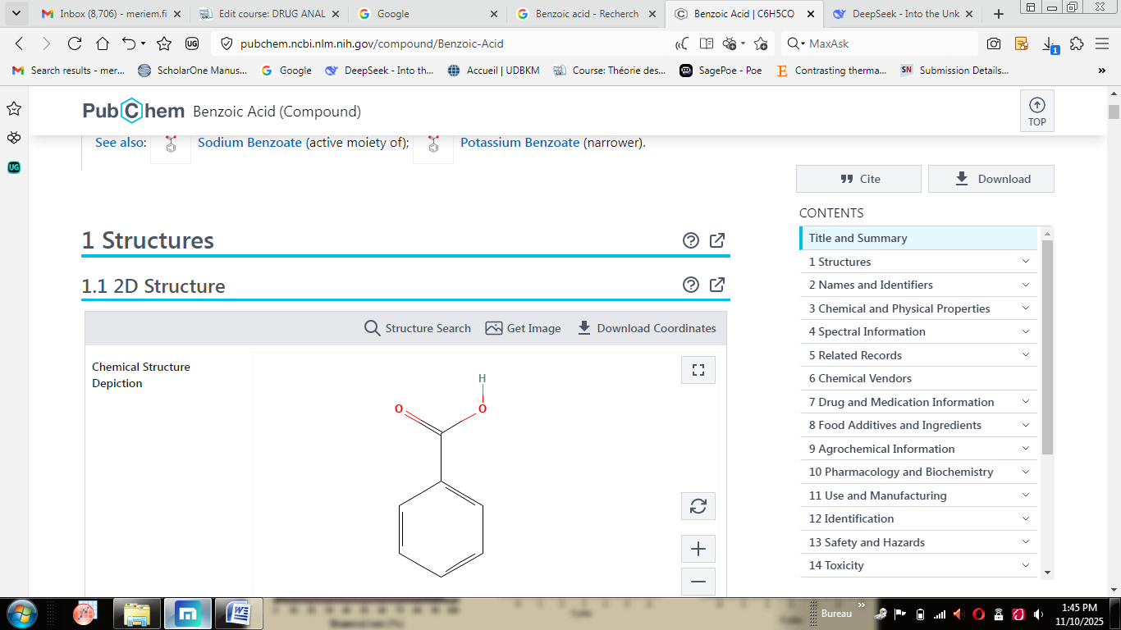
Fig.XII.2 Benzoic acid.

4.1. Analytical techniques

4.1.1. High-performance liquid chromatography with uv or photodiode array detection
serves as the principal technique for the analysis of benzoic acid derivatives. Reversed-phase chromatography, typically using a C18 column, is the standard mode of operation. A critical aspect of method development involves the use of acidic mobile phases, such as those containing 0.1% formic acid or phosphoric acid. The low pH of these mobile phases functions to suppress the ionization of the carboxylic acid group, ensuring the analyte remains in its neutral form. This suppression significantly improves chromatographic performance by enhancing peak shape and increasing retention on the hydrophobic stationary phase, leading to more robust and reproducible assays for both the active ingredient and its related substances.

4.1.2. Titrimetry
It represents a classical yet reliable method for the quantitative assay of pure benzoic acid. This approach involves a direct acid-base titration, which can be performed in either an aqueous or, more commonly, a non-aqueous medium. The method directly exploits the inherent acidity of the carboxylic acid functional group, using a standardized basic titrant to determine the substance's purity. While this technique provides accurate results for the bulk substance, it lacks the specificity to distinguish the parent acid from potential interfering impurities or degradation products, which is a key advantage of chromatographic methods.

4.1.3. Spectroscopic techniques
provide essential information for the identification and structural confirmation of benzoic acid derivatives. Fourier-Transform Infrared Spectroscopy is highly effective for identity testing, revealing characteristic functional group absorptions. For the carboxylic acid, this includes a very broad O-H stretching band in the 2500-3300 cm⁻¹ region and a strong carbonyl (C=O) stretch at approximately 1690 cm⁻¹. In contrast, ester derivatives like the parabens exhibit a sharper, more distinct carbonyl stretch at a higher frequency, around 1720 cm⁻¹. For definitive structural analysis, Nuclear Magnetic Resonance Spectroscopy is employed. In a ¹H NMR spectrum, the acidic proton of the carboxylic acid group appears as a characteristically very broad singlet in the downfield region of δ ~11-12 ppm. Furthermore, the number, chemical shifts, and splitting patterns of the aromatic protons provide diagnostic information for determining the specific substitution pattern on the benzene ring.

Analysis of salicylic acid and its derivatives
Salicylic acid (2-hydroxybenzoic acid) is a fat-soluble organic acid that exists naturally in holly and salicylic. It is an ancient medicine with excellent exfoliation, pore cleaning ability, and high security, and the stimulation effect on the skin is lower than the fruit acid. It has an essential function in the medical esthetics profession. Salicylic acid is extensively used as a disinfectant preservative in the pharmaceutical industry. Salicylic acid can be used as a pharmaceutical intermediate to synthesize salazosulfanilamidum, aspirin, natrii salicylas, salicylamide and other sodium salicylates. Aspirin is a white crystal powder, slightly soluble in water and easily soluble in ethanol. It is a derivative of salicylic acid. Under humid acid-base conditions, aspirin is prone to degradation and generates free salicylic acid. If the residual amount of salicylic acid exceeds the limit value, patients who take it are likely to experience severe gastrointestinal irritation. As salicylic acid is one of the intermediates in the aspirin synthesis pathway, monitoring its content can effectively evaluate the completeness of the synthesis reaction and examine the control effect of the production process. Therefore, the importance of detecting salicylic acid in aspirin is crucial.
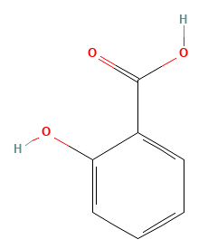

Fig.XII.3 Salicylic acid.

5.1. Analytical techniques

5.1.1. Titrimetric Method
The titrimetric method is a classical approach based on the neutralization of the monobasic carboxylic acid group in salicylic acid with a standard basic solution. In a procedure based on the USP, a known, accurately weighed quantity of the sample is dissolved in a mixture of neutralized alcohol and water. This solution is then titrated with a 0.1 N sodium hydroxide (NaOH) volumetric solution, using phenolphthalein as an indicator; the endpoint is marked by the first appearance of a faint pink color that persists for at least 30 seconds. The percentage purity is calculated using the formula: `
% Purity = (V × N × Eq. Wt. × 100) / W`
where V is the volume of NaOH consumed in mL, N is its normality, Eq. Wt. is the equivalent weight of salicylic acid (138.12 g/mol), and W is the weight of the sample in mg.
The primary advantages of this method are its simplicity, rapidity, low cost, and robustness. However, a significant limitation is its lack of specificity, as any acidic impurity in the sample will interfere and lead to an overestimation of purity, making it unsuitable for impurity testing.

5.1.2. Spectrophotometric Method
The spectrophotometric method leverages the fact that the phenolic group in salicylic acid forms a colored complex with ferric ions (Fe³⁺), which exhibits a strong absorption maximum in the visible region around 530 nm, allowing for quantitative analysis. In practice, a sample solution is prepared by extracting the drug from its formulation, after which a dilute solution of ferric chloride (FeCl₃) is added to an aliquot of both the sample and standard solutions. The intensity of the developed violet color is then measured at 530 nm using a UV-Vis spectrophotometer, and the concentration of the unknown is determined by comparing its absorbance to a calibration curve prepared with salicylic acid reference standards. This method offers greater sensitivity than titration and is relatively simple, making it well-suited for quantifying low-level impurities. Its limitations include susceptibility to interference from other phenolic compounds or excipients and a sensitivity to experimental conditions such as pH, temperature, and reaction time.

5.1.3. High-performance liquid chromatography - the reference method
High-performance liquid chromatography is the reference method for this analysis, operating on the principle of separating compounds based on their differential partitioning between a stationary and a mobile phase. The most common mode is reverse-phase HPLC, which employs a non-polar stationary phase, such as a C18 column, and a polar mobile phase. Typical conditions for Aspirin impurity testing, as per the USP, involve a C8 or C18 column (250 mm x 4.6 mm, 5 µm), a mobile phase comprising a buffer and Acetonitril, a flow rate of 1.0 - 2.0 mL/min, and UV detection at 280-305 nm. HPLC is the preferred technique due to its exceptional specificity, which allows for the excellent separation of salicylic acid from Aspirin, excipients, and other potential impurities. It also provides high sensitivity, capable of detecting salicylic acid at levels as low as 0.03% relative to Aspirin, and offers superior accuracy, precision, and automation, making it ideal for high-throughput quality control laboratories.

Practical application: HPLC analysis of salicylic acid in aspirin tablets
The practical application of HPLC for analyzing salicylic acid in Aspirin tablets involves a systematic workflow for impurity testing. It begins with standard solution preparation, where approximately 10 mg of salicylic acid reference standard is accurately weighed, dissolved, and diluted with the mobile phase to create a stock solution, which is then further diluted to a final concentration representing the specification limit. For the sample solution preparation, not less than 20 tablets are weighed and finely powdered, after which a portion equivalent to the weight of one tablet is accurately weighed, transferred to a volumetric flask, and dissolved in the mobile phase with the aid of sonication before being diluted to volume and filtered. The chromatographic analysis then proceeds with system suitability tests performed by injecting the standard solution to ensure the system meets performance criteria; following this, the standard and sample solutions are injected separately.
The percentage of salicylic acid in the sample is calculated using the formula:
% Salicylic Acid = (A_u / A_s) × (C_s / C_u) × 100`
where `A_u` and `A_s` are the peak areas of salicylic acid from the sample and standard injections, respectively, and `C_s` and `C_u` are the concentrations of the standard and sample preparations, respectively.

