CHAPTER XI: ANALYSIS AND CONTROL OF ALIPHATIC PHARMACEUTICAL PREPARATIONS

Objectives
By the end of this chapter, the student will be able to:
- Categorize the fundamental roles of aliphatic compounds specifically halogenated derivatives, alcohols, ethers, and urea derivativesas Active Pharmaceutical Ingredients, excipients, and impurities in pharmaceutical formulations.
- Design a strategic analytical workflow for the quality control of a pharmaceutical preparation containing aliphatic compounds, ensuring identity, potency, purity, and safety in compliance with regulatory standards.

Introduction
Aliphatic compounds, characterized by carbon atoms arranged in straight or branched chains, or non-aromatic rings, form a foundational class of molecules in pharmaceutical science. Unlike their aromatic counterparts with rigid, delocalized electron systems, aliphatic molecules exhibit greater conformational flexibility, which directly influences their physicochemical properties, biological interactions, and analytical behavior. This category encompasses a vast range of substances, from simple hydrocarbon gases to complex macromolecules. The analysis of these preparations is critical, as their properties can dictate drug delivery, stability, and efficacy. This chapter is dedicated to the analytical strategies for four critically important sub-classes of aliphatic pharmaceuticals: alcohols, ethers, halogenated derivatives, and urea derivatives.

Analysis of halogenated derivatives
Halogenated derivatives, organic compounds containing one or more atoms of fluorine (F), chlorine (Cl), bromine (Br), or iodine (I), hold a position of critical importance in modern pharmaceuticals. The introduction of a halogen atom is a fundamental strategy in medicinal chemistry, primarily used to modulate a drug molecule's properties. Halogens can influence lipophilicity, metabolic stability, receptor binding affinity, and overall pharmacokinetic profile. Consequently, a vast number of blockbuster drugs, from antibiotics and antidepressants to chemotherapeutic agents, are halogenated. However, this very utility introduces significant analytical and regulatory challenges, as many halogenated compounds can be toxic, genotoxic, or persistent environmental pollutants. This chapter details the analytical strategies employed to ensure the safety, quality, and efficacy of halogen-containing pharmaceuticals.

Roles in pharmaceutical formulations
Halogenated derivatives play a dual and critical role in pharmaceutical formulations, serving both as essential Active Pharmaceutical Ingredients and as significant impurities requiring strict control. As APIs, specific halogens are strategically incorporated into drug molecules to enhance their properties: chlorine is found in antibiotics like Ciprofloxacin and antihistamines like Loratadine; fluorine, commonly used to block metabolically labile sites, is a key feature in drugs such as the antidepressant Fluoxetine, the cholesterol-lowering Atorvastatin, and the anticancer agent 5-Fluorouracil; bromine appears in antihistamines like Dexbrompheniramine; and iodine is crucial in thyroid hormones like Levothyroxine and iodinated contrast agents for medical imaging. Conversely, the analysis of these compounds is often driven by their role as impurities, including highly reactive alkyl halides (e.g., alkyl chlorides, bromides) classified as Potential Genotoxic Impurities (PGIs) that must be controlled at very low levels, halogen-containing counterions of elemental impurity catalysts (e.g., Palladium, Nickel), and various halogenated acids or other unwanted derivatives formed through hydrolysis or oxidative degradation.

Analysis methods
The analysis of halogenated compounds leverages techniques that are particularly sensitive to the presence of the halogen atom. The choice depends on the analyte's volatility, polarity, and the required level of detection.

Gas Chromatography
Gas Chromatography is highly effective for volatile halogenated compounds. While Flame Ionization Detection (FID) can be used, the method of choice for trace analysis is Gas Chromatography with Electron Capture Detection (GC-ECD). The ECD is exceptionally sensitive to compounds with high electron affinity, such as those containing chlorine, bromine, or iodine, offering detection limits in the parts-per-trillion range. This makes it ideal for monitoring halogenated residual solvents like chloroform or dichloromethane. For identification, GC-MS is used, where halogens provide characteristic isotope patterns in the mass spectrum that aid in confirmation.

High-Performance Liquid Chromatography
HPLC is the primary technique for non-volatile halogenated APIs and their related substances. Standard UV/PDA detection is commonly employed, as many halogenated compounds have good chromophores. However, for the detection of trace-level halogenated impurities, especially Potential Genotoxic Impurities (PGIs), coupling to Mass Spectrometry (LC-MS) is essential. Liquid Chromatography with tandem mass spectrometry (LC-MS/MS) provides the superior sensitivity and selectivity required to detect and quantify these hazardous compounds at the strict ppm or ppb levels.

Inductively Coupled Plasma Mass Spectrometry (ICP-MS)
It represents a technique of paramount importance for halogen-specific detection, particularly for fluorine and chlorine, which are difficult to analyze by conventional MS. In this approach, the HPLC effluent is introduced into the ICP torch, which atomizes and ionizes the elements. The mass spectrometer then detects specific ions. HPLC-ICP-MS is a powerful hyphenated technique used for "halogen screening," allowing for the sensitive and specific detection of any molecule containing a halogen atom, regardless of its structure, making it invaluable for profiling unknown halogenated degradation products.

Nuclear Magnetic Resonance (NMR) Spectroscopy
This method provides definitive structural confirmation. The presence of halogens can directly influence the chemical shift of nearby protons and carbons due to their electronegativity. Furthermore, ¹⁹F NMR is an exceptionally powerful and direct probe for characterizing fluorinated pharmaceuticals, as fluorine-100% naturally abundant and gives a strong NMR signal, providing direct insight into the integrity of the fluorinated part of the molecule.

Analysis of alcohols and ethers
Alcohols and ethers are two fundamental functional groups in organic chemistry with immense significance in the pharmaceutical industry. They are not just common ingredients in drug substances and excipients but also potential impurities or degradation products that must be carefully monitored. The analysis of these compounds is critical for ensuring drug safety, efficacy, quality, and stability.

Roles in pharmaceutical formulations

Alcohols
Alcohols serve multiple roles in pharmaceutical preparations:
- Active Pharmaceutical Ingredients: Many drugs contain alcohol functional groups.
  - Menthol: A cyclic alcohol used in topical analgesics and decongestants for its cooling effect.
  - Cholesterol: A steroid alcohol essential for cell membrane integrity and a precursor for steroid hormones.
  - Erythromycin: A macrolide antibiotic containing multiple alcohol groups.
  - Salbutamol (Albuterol): A bronchodilator containing a secondary alcohol group.
- Excipients (Inactive Ingredients): Alcohols are widely used as solvents, preservatives, and co-solvents.
- Ethanol: Used as a solvent for APIs with poor water solubility, a preservative, and a penetration enhancer in topical products.
- Glycerol (Glycerin): Used as a humectant, sweetener, and solvent in syrups and elixirs.
- Propylene Glycol: A common solvent and stabilizer in oral, topical, and injectable formulations.
- Benzyl Alcohol: Used as a preservative in injectables and a local anesthetic.
- Impurities and Degradation Products:
- Residual Solvents: Methanol and ethanol can be residual solvents from the synthesis of an API. Their levels are strictly controlled by ICH guidelines (e.g., ICH Q3C).
- Degradation Products: Oxidation of active molecules can lead to the formation of alcohols, or dehydration of alcohols can form alkenes or ethers.

Ethers
Ethers are less common as excipients but are crucial as APIs and synthetic intermediates.
- Active Pharmaceutical Ingredients (APIs):
  - Diethyl Ether: Historically used as a general anesthetic.
  - Polyethylene Glycol (PEG): While a polyether, it's a crucial excipient. Many modern drugs, including anticancer agents, are PEGylated (covalently attached to PEG chains) to improve solubility and circulation time.
- Excipients:
- Polyethylene Glycol (PEG): Used extensively as a solvent, plasticizer, lubricant, and base in suppositories and ointments.
- Polysorbates (Tweens): Surfactants and emulsifiers containing polyether chains, vital for stabilizing emulsions and protein-based therapeutics.
- Impurities and degradation products:
  - Genotoxic Impurities: Certain alkyl ethers can be potential genotoxic impurities (GTIs) formed during synthesis. For example, alkyl halides reacting with alcohols can form ethers, which must be controlled at very low levels (ppm).
  - Peroxides: A significant hazard with low molecular weight ethers like diethyl ether. They can form explosive peroxides upon exposure to air and light. Analysis of peroxide content is critical for safety.

Analysis methods

Gas Chromatography
It is the premier technique for analyzing volatile alcohols and ethers. In pharmaceutical analysis, GC is indispensable for Residual Solvent Testing, where volatile impurities like methanol, ethanol, or diethyl ether must be quantified according to strict regulatory limits. This is typically performed using Static Headspace-GC(Fig.X.29), where a sample is heated in a sealed vial, and the vapor phase is injected, protecting the instrument from non-volatile matrix components. Detection is commonly achieved with a Flame Ionization Detector (FID) for robust quantification or Mass Spectrometry (GC-MS) for definitive identification of unknown volatile impurities.
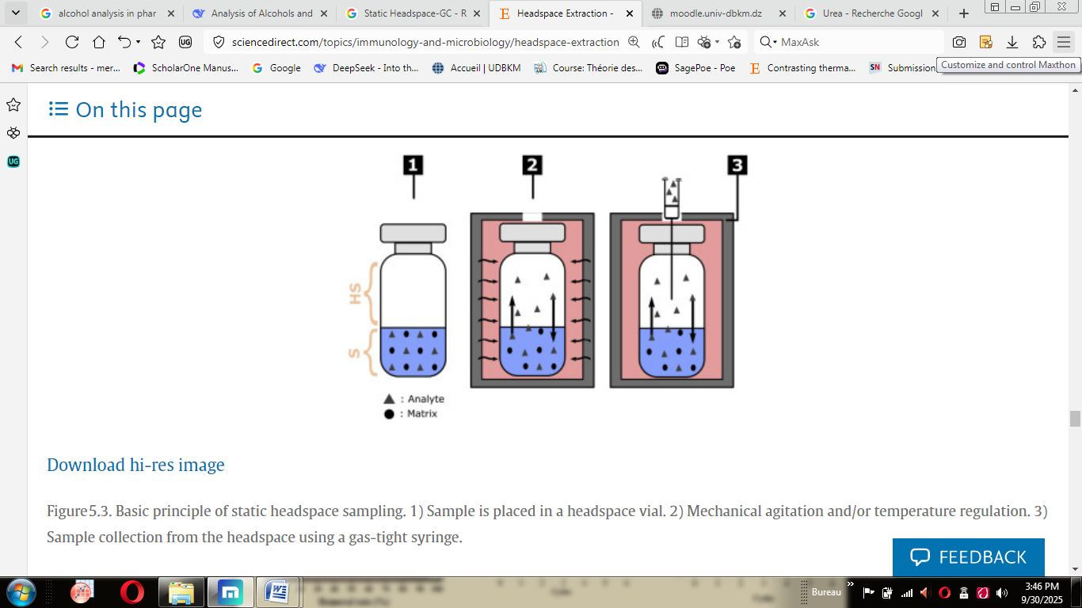
Fig.XI.1 Basic principle of static headspace sampling. 1) Sample is placed in a headspace vial. 2) Mechanical agitation and/or temperature regulation. 3) Sample collection from the headspace using a gas-tight syringe.

High-performance liquid chromatography
It serves as the workhorse for non-volatile, thermally unstable, or polar molecules containing alcohol or ether functional groups. This technique separates compounds based on their polarity and affinity for the chromatographic column under high pressure. HPLC is primarily used for the assay and purity testing of Active Pharmaceutical Ingredients (APIs) like Guaifenesin or Erythromycin, and for excipients like Polyethylene Glycol (PEG). A critical application is the development of stability-indicating methods, which are validated to separate and quantify the main active compound from its degradation products. Detection strategies vary, with UV/PDA for chromophore-containing analytes, and universal detectors like Refractive Index (RID) or Charged Aerosol Detection (CAD) for molecules like sugars and PEGs that lack a strong UV chromophore.

Fourier-transform infrared spectroscopy
It is a rapid and essential tool for identity testing, as mandated in many pharmacopoeial monographs. It identifies functional groups through their characteristic absorption of infrared light: alcohols show a broad O-H stretch (~3200-3600 cm⁻¹) and a strong C-O stretch (~1000-1260 cm⁻¹), while ethers display a C-O-C stretch (~1060-1150 cm⁻¹) and, critically, no O-H band.

Mass Spectrometry
It is the definitive tool for determining molecular weight and elucidating fragmentation patterns. When coupled with a separation technique like GC or LC, it acts as a powerful detector that provides both qualitative and quantitative data. In the analysis of alcohols and ethers, MS is crucial for identifying unknown impurities and degradation products. By analyzing the mass-to-charge ratio of molecular ions and their characteristic fragments—such as the loss of a water molecule from an alcohol or cleavage adjacent to the oxygen in an ether

Analysis of urea derivatives.
Urea derivatives represent a therapeutically vital class of aliphatic compounds characterized by the presence of the urea functional group (–N–C(=O)–N–). While urea itself (H₂N–C(=O)–NH₂) is a simple diamide of carbonic acid, its derivatives form the cornerstone of numerous major drug classes. The urea moiety is a key pharmacophore, contributing to strong hydrogen bonding, which is critical for target binding and imparting favorable physicochemical properties. The analysis of these compounds is paramount, as they can function as Active Pharmaceutical Ingredients (APIs), prodrugs, or critical impurities, each requiring specific and validated analytical methods to ensure identity, potency, purity, and safety.

Major classes of urea-based pharmaceuticals
Urea derivatives are found in a wide array of therapeutic areas:
- Anticonvulsants: Phenytoin and its derivatives, where the urea moiety is incorporated into a heterocyclic hydantoin ring.
- Antipsychotics / Anxiolytics: Carbamazepine (a tricyclic compound with a urea group in a carbamazepine ring) and Buspirone.
- Diuretics: Acetazolamide and related compounds, which often contain a sulfonamide group in addition to the urea functionality.
- Chemotherapeutic Agents: Hydroxyurea, a simple yet critical derivative used in the treatment of sickle cell disease and certain cancers.
- Dermatological Agents: Urea itself is used in high concentrations as a keratolytic agent. Dexpanthenol is also a common derivative.
- Cardiovascular Drugs: Certain ACE inhibitors and other antihypertensive agents are urea derivatives.

Analysis methods

High-performance liquid chromatography
High-Performance Liquid Chromatography serves as the primary analytical technique for urea derivatives, with Reversed-Phase (C18) chromatography being the most common mode, often employing buffered mobile phases to control ionization and enhance chromatographic peak shape. The selection of the detection system is critical and is dictated by the specific analyte's properties: Ultraviolet/Photodiode Array (UV/PDA) detection is suitable for derivatives possessing aromatic rings or conjugated systems, such as Phenytoin and Carbamazepine, whereas Charged Aerosol Detection (CAD) or Evaporative Light Scattering (ELSD) are crucial for quantifying non-UV absorbing derivatives like urea and hydroxyurea, as these universal detectors provide a robust response independent of chromophore presence. For definitive identification, comprehensive impurity profiling, and sensitive bioanalysis, Mass Spectrometry (MS/MS) is employed due to its superior sensitivity and selectivity.

Gas chromatography
Limited to thermally stable and volatile urea derivatives. Often requires derivatization (e.g., silylation) to increase volatility and reduce polarity. Typically coupled with Flame Ionization (GC-FID) or Mass Spectrometry (GC-MS).

Fourier-transform infrared spectroscopy
Fourier-Transform Infrared Spectroscopy is a fundamental technique for the identity testing of urea derivatives, as mandated in many pharmacopoeial monographs, with identification based on their characteristic absorption bands: a broad N-H stretch around 3200-3500 cm⁻¹, a strong C=O stretch (Amide I band) around 1620-1680 cm⁻¹ for the urea carbonyl, and an N-H bending band (Amide II band) around 1560-1640 cm⁻¹.

