CHAPTER IX: CHEMICAL ANALYSIS METHODS FOR CHEMICAL PREPARATIONS IN PHARMACY

Objectives
Upon the completion of this course, the student will be able to:
- Form a system of knowledge about the chemical pharmacopoeial methods for drugs quality control.

Introduction
Pharmaceutical analysis relies heavily on chemical methods to ensure the identity, purity, quality, and stability of drugs. These methods, rooted in classical analytical chemistry, remain indispensable in modern laboratories due to their accuracy, cost-effectiveness, and alignment with global pharmacopeial standards like the USP (United States Pharmacopeia) and EP (European Pharmacopoeia). This chapter focuses on three foundational chemical techniques: titrimetric methods for quantification, the oxygen flask method for elemental analysis, and chemical identification tests for verifying substance identity.

Titrimetric Methods

3.1. Generality
Titrimetric analysis represents a foundational chemical method based on the precise measurement of reagent volumes required to complete a chemical reaction with an analyte. This technique relies on well-defined stoichiometric relationships and characteristic endpoint detection to deliver accurate quantitative results. As a classical analytical approach, it remains widely valued for its robustness, cost-effectiveness, and compliance with international pharmacopeial standards. The methodology encompasses several reaction types including acid-base, redox, complexometric, and non-aqueous titrations, each serving specific analytical purposes. Particularly in the examination of fats and oils, titrimetry provides critical chemical parameters such as acid value, peroxide value, saponification value, and iodine value through characteristic chemical reactions that reveal material composition, stability, and purity. This chemical method continues to form an essential component of analytical protocols where specific, reproducible, and economically efficient quantitative analysis is required.

3.2. Definition
The term titrimetric analysis refers to quantitative chemical analysis carried out by determining the volume of a solution of accurately known concentration, which is required to react quantitatively with a measured volume of a solution of a substance to be determined. The solution of accurately known concentration is called standard solution. The term volumetric analysis was used for this form of quantitative determination but it has now been replaced by titrimetric analysis. In titrimetric analysis the reagent of known concentration is called titrant and the substance being titrated is termed the titrand.

3.2.1. Definition of some terms
Titration
Titration is the process in which the standard reagent is added to a solution of an analyte until the reaction between the analyte and reagent is complete.
Equivalence point and End point
The equivalence point of a titration is a theoretical point that cannot be determined experimentally. Instead, we can only estimate its position by observing some physical change associated with the condition of equivalence. This change is called the end point for titration.
Titration error
The difference between the observed end point and the true equivalence point in a titration.
TE = V ep − V eq
Indicators
Indicators are often added to analyte solution in order to give an observable physical change (end point) at or near the equivalence point. In other wards indicator is a compound having a physical property (usually color) that changes abruptly near the equivalence point of a chemical reaction. Indicator selection also depends on the type of reaction: acid-base indicators – phenolphthalein, methyl red, methyl orange, phenol red, and others; starch solution is used in iodometric titrations, tropeolin ОО for diazotisation titrations, in argentimetric titrations solutions K2CrO4, FeSO4, etc. are used; murexide is applied in complexometric titrations.

End points in volumetric analysis
Detection of an end point involves the observation of some property of the solution that change in a characteristic way at or near the equivalent point. The properties that have been used for this purpose are numerous and varied; they include:
1. Color due to the reagent, the substance being determined, or an indicator substance.
2. Turbidity changes resulting from the formation or disappearance of solid phase.
3. Electric conductivity of the solution.
4. Electric potential between a pair of electrodes immersed in the solution.
5. Refractive index of the solution.
6. Temperature of the solution.
7. Electric current passing through the solution
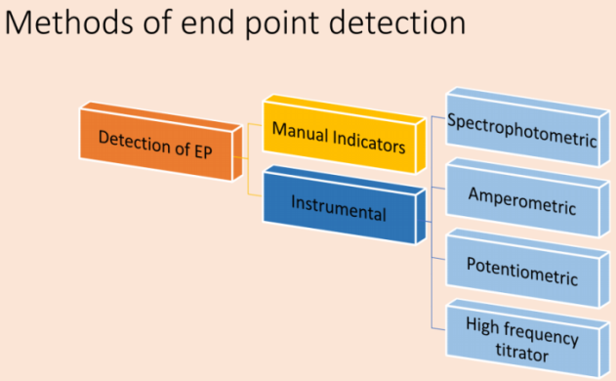
Fig.IX.1 Methods of end point detection.

Classification of reaction in titrimetric analysis
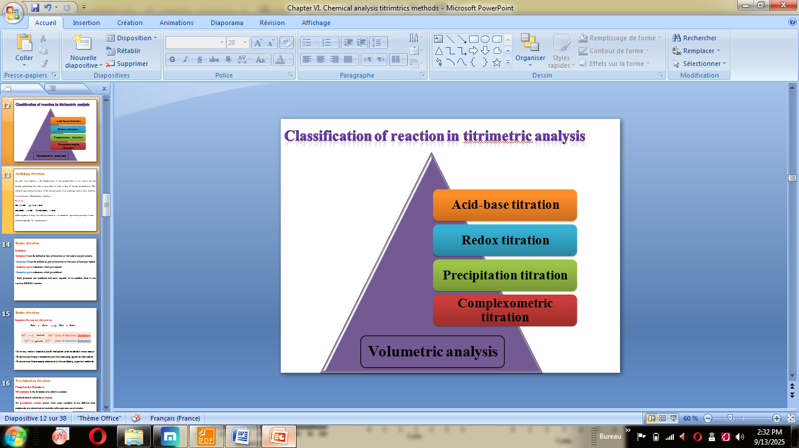

Fig.IX.2Classification of volumetric analysis.

Acid-base titration
An acid base titration is the determination of the concentration of an acid or base by exactly neutralizing the acid or base with an acid or base of known concentration. This allows for quantitative analysis of the concentration of an unknown acid or base solution. It’s also known as Neutralization titration.
Example:
HCl + NaOH NaCl + H₂O
CH₃COOH + NaOH CH₃COONa + H₂O
The objective of carry out acid base titration is to determine equivalent quantity of other substance required for neutralization.

Redox titration
Oxidation: It can be defined as loss of electrons or increase in oxygen content.
Reduction: It can be defined as gain of electrons or increase of hydrogen content.
Oxidizing agent: substance which get reduced.
Reducing agent: substance which get oxidized.
Both processes are combined and occur together so we combine them in one word as REDOX reaction.
Reaction of ferrous ion with ceric ion:
Fe²⁺ + Ce⁴⁺ Fe³⁺ + Ce³⁺
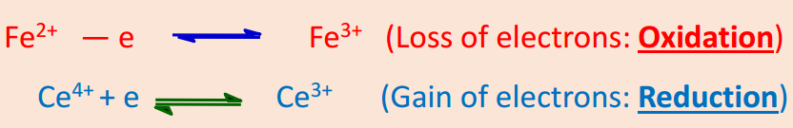
Remarks:In every redox reaction, both reduction and oxidation must occur. Substance that gives electrons is the reducing agent or reductant. Substance that accepts electrons is the oxidizing agent or oxidant.

Precipitation titration
Precipitation Reactions
Precipitation is the formation of a solid in a solution. Solid formed is called the precipitate. A precipitation reaction occurs when water solutions of two different ionic compounds are mixed and an insoluble solid separates out of solution. The precipitate is itself ionic; the cation comes from one solution and the anion from another.
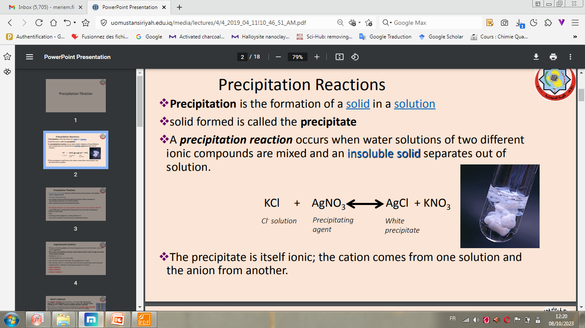
Precipitation titration
Precipitation titration is a titration method based on the formation of precipitate, which is slightly soluble. The basic requirements are:
• The reaction must be sufficiently rapid and complete, lead to a product of reproducible composition and of low solubility.
• And a method must exist to locate the end point.
- Argentometric titration:
Titrations involving silver are termed argentometric, from the Latin name for silver, argentum. The major precipitation reaction used is that of silver with a range of anions. These anions include:
• Halides (Cl⁻ , Br⁻ , I⁻).
• Pseudohalides (S²⁻ , HS⁻, CN⁻, SCN⁻).

Complexometric titration
Complexometry
A volumetric titration involves the formation of solublecomplex between metal ion (as acceptor) and ligand (as donor) to form coordination bonds. (A titration based on the formation of a coordination complex is known as a complexometric titration). Complexometric titrations are particularly useful for the determination of a mixture of different metal ions in solution. The metal ion is known as Central metal atom.The anion or neutral molecule is known as Ligand (L). The metallic ion (atom) has stable electronic configuration. It forms additional completed shells by accepting electron pairs from donor atoms.
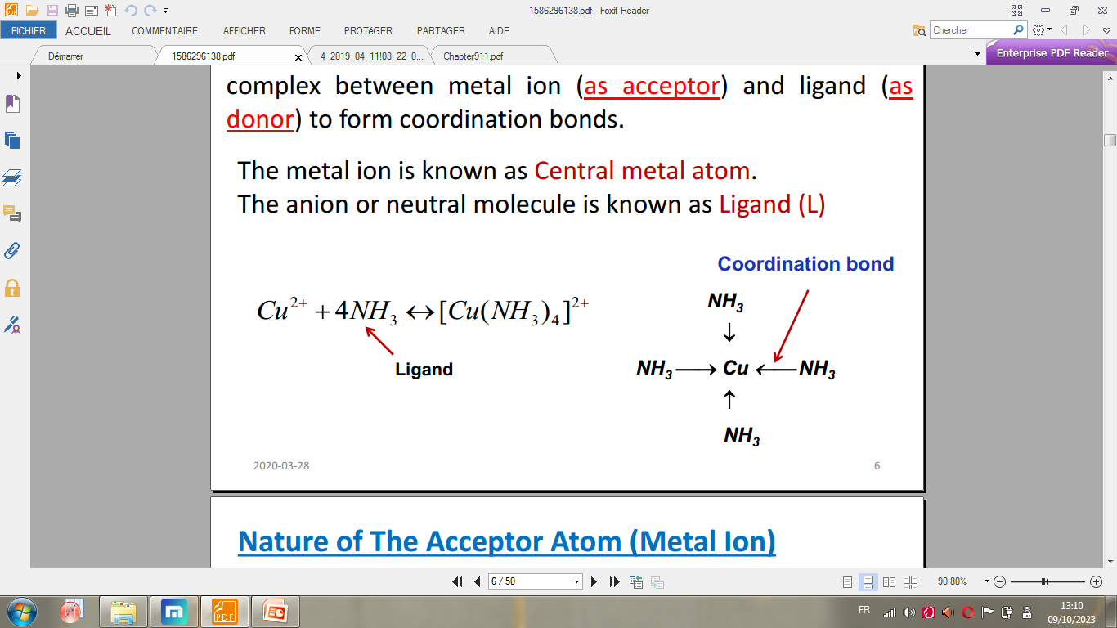
Fig.IX.3Complex.
Titration with multidentate complexers (Chelating Agents)
Ethylene diamine tetra acetic acid (EDTA) possess enough donor atoms to fill the whole coordination sphere of metal ions in one step (Fig.).
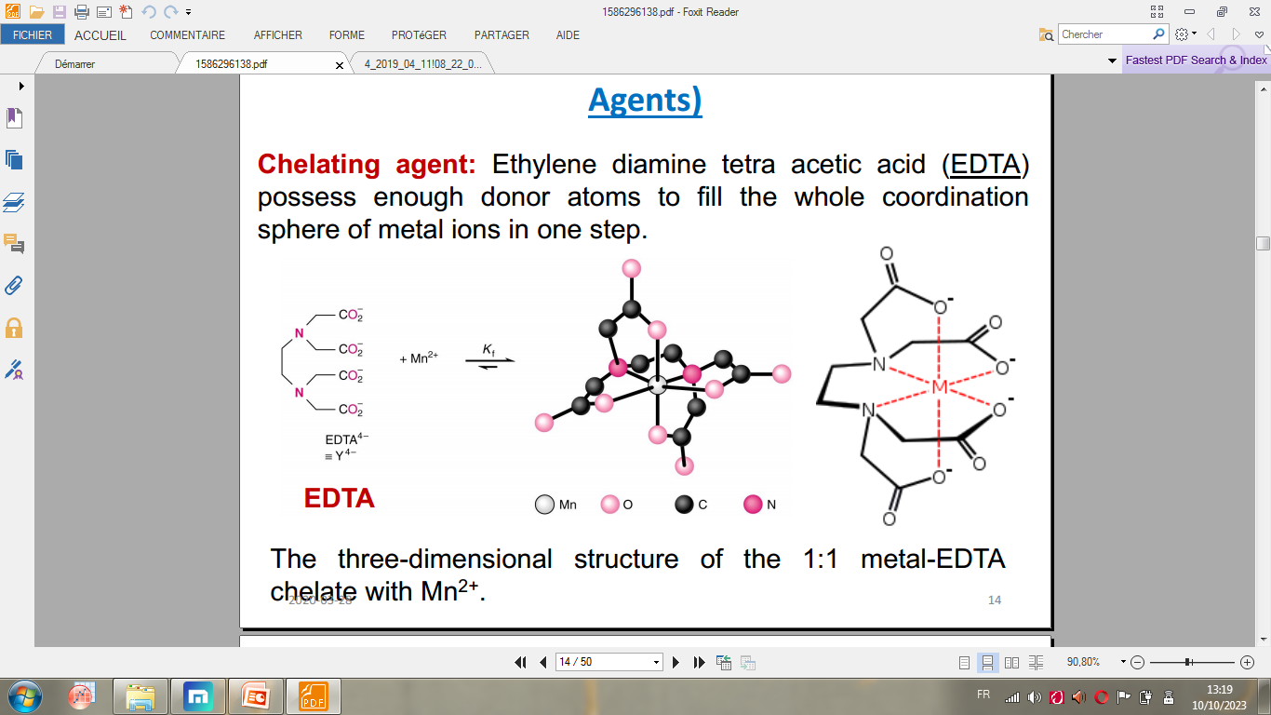
Fig.IX.4The three-dimensional structure of the 1:1 metal-EDTA chelate with Mn²⁺.
Detection of end point: use metal ion indicators
Indicator is a dye which is capable of acting as a chelating agent to give a dye-metal complex.The latter is different in colour from the dye itself and also has a low stability constant than the chelate-metal complex. The colour of the solution, therefore, remains that of the dye complex until the end point, when an equivalent amount of sodium EDTA has been added. As soon as there is the slightest excess of EDTA, the metal-dye complex decomposes to producefree dye; this is accomplished by a change in colour.Metal indicators must comply with the following requirements:
• Metal-indicator complex must be less stable than the metal-EDTA complex.
• Binding between metal and indicator must not be too weak. It has to avoid EDTA replacing at the beginning of the titration.
• In general, the metal-indicator complex should be 10 to 100 times less stable than the metal-titrant complex.
• Colour of the indicator and the metal complexed indicator must be sufficiently different.
Examples of metal ion indicators
  - Eriochrome black T (EBT)
It can be represented by H₂In. The color ofIndicator changes with the change of pH. EBT contains 2 replaceable phenolic hydrogens (Fig.IX.5).
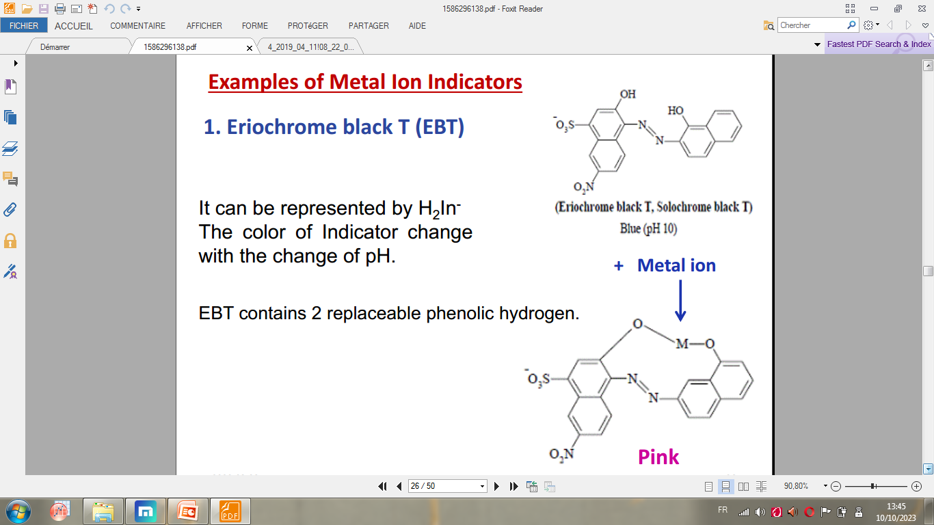
Fig.IX.5 Eriochrome black T.
  - Murexide
Ammonium salt of purpuric acid and its anion has the following structure. Murexide is used for the direct titration of calcium at pH=10, the end point changes from pink to violet(Fig.IX.6).
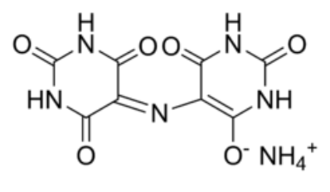
Fig.IX.6 Murexide.
Examples:direct determination of water hardnessof metal ion indicators
•Water hardness is due to the presence of Ca²⁺& Mg²⁺salts.
•EDTA forms complex with Ca²⁺& Mg²⁺
•Ca-EDTA complex is more stable than Mg-EDTA complex.
•At pH 12 EDTA forms complex with Ca²⁺ only.
Total Ca²⁺& Mg²⁺
•Total Ca²⁺and Mg²⁺determined by titration with EDTA at pH 10 using ammonia buffer and EBT as indicator. Upon titration with EDTA, Ca²⁺ will be chelated first, then Mg^{2+.}
For Ca²⁺ Only
Direct titration with EDTA at pH 12 using 8% NaOH and Murexide. Mg²⁺ is precipitated as Mg(OH)₂leaving Ca²⁺to be titrated with EDTA.
For Mg ²⁺
Total – Ca²⁺= Mg²⁺

Analysis of oils and fats in the pharmaceutical industry
In the pharmaceutical industry, oils and fats are analyzed for key chemical properties to ensure their purity, stability, and quality for use in formulations such as emulsions, softgel capsules, and topical products. Critical analytical parameters include fatty acid profiles, peroxide value, acidity, saponification value, and iodine value.

Acid Value
The acid value is defined as the number of milligrams of potassium hydroxide (KOH) required to neutralize the free fatty acids present in 1 gram of fat or oil.This value is determined by dissolving a weighed quantity of the sample in neutral ethanol and titrating it against a standard KOH solution using phenolphthalein as an indicator. The acid value indicates the amount of free fatty acids present, which is a marker of freshness. A higher acid value suggests hydrolysis (often due to moisture or enzymatic action) and is an indicator of rancidity, typically resulting from improper storage conditions.

Saponification Value
The alkaline hydrolysis of a fat or oil is called saponification, as it produces soap (the sodium or potassium salt of fatty acids). This reaction is used to determine the saponification value, defined as the number of milligrams of KOH required to completely saponify 1 gram of oil or fat.This value represents the amount of KOH needed to neutralize the fatty acids released from the complete hydrolysis of the triglycerides. The saponification value is inversely related to the average molecular weight of the fat: a higher molecular weight results in a lower saponification value, and vice versa. It provides insight into the average chain length of the fatty acids in the sample.

3. Iodine Value (Iodine Number)
The degree of unsaturation in a fat or oil is measured by its iodine value. The absorption of halogen is proportional to the number of carbon-carbon double bonds present in the fatty acid chains. The iodine value is defined as the number of grams of iodine (or iodine equivalent, from reagents like ICl or IBr) absorbed by 100 grams of fat or oil.
Therefore, a higher number of double bonds (greater unsaturation) corresponds to a higher iodine value. This value is crucial for assessing the oxidative stability of an oil; oils with high iodine values (e.g., linseed oil) are more susceptible to oxidation and rancidity.

4. Acetyl Value
The acetyl value is a measure of the free hydroxyl groups (e.g., from hydroxy acids like ricinoleic acid in castor oil) present in an oil or fat. It is defined as the number of milligrams of KOH required to neutralize the acetic acid produced by the hydrolysis of 1 gram of the acetylated fat.This value is determined by first acetylating the sample (reacting it with acetic anhydride) to esterify all free hydroxyl groups. The acetyl value helps in characterizing oils that contain hydroxy fatty acids.

5. Ester Value
The ester value represents the proportion of the material that is present in esterified form (primarily triglycerides). It is defined as the number of milligrams of KOH required to saponify the esters present in 1 gram of a substance.If the saponification value and acid value have been determined, the ester value can be easily calculated from the difference:
Ester Value = Saponification Value − Acid Value

5. The oxygen flask method

5.1. Definition
The oxygen flask combustion (OFC) method was invented by Wolfgang Schöniger in 1955. It is a useful technique for the estimation of certain elements, such as halogens (chlorine, bromine, iodine, and fluorine) and sulfur, in organic compounds within pharmaceuticals.In this technique, the sample is combusted in a sealed flask filled with oxygen. The combustion converts the elements into water-soluble inorganic ions (e.g., Cl⁻, Br⁻, SO₄²⁻). These ions are absorbed in a solution and quantified via titration or other analytical methods. The technique is also known as the Schöniger oxygen-flask method.

5.2. Apparatus and reagents
The apparatus for this method consists of a thick-walled conical flask, typically made of borosilicate glass, with a capacity of 500–1000 mL and a ground-glass stopper to ensure an airtight seal. A platinum or quartz sample holder is attached to the stopper, as these materials resist high temperatures and do not interfere with the combustion. Key reagents include high-purity oxygen to maintain an oxygen-rich environment and an appropriate absorbing solution, such as sodium hydroxide for halogens or hydrogen peroxide for sulfur, which captures and converts the combustion products into analyzable ions. Ashless filter paper is used to wrap the sample to prevent introducing external contaminants.
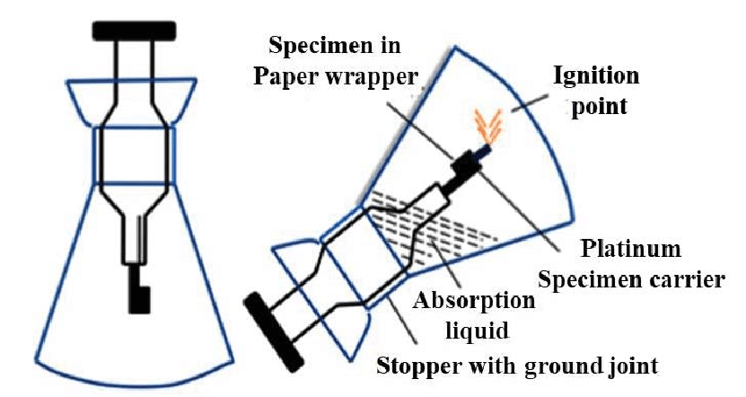
Fig.IX.6Oxygen-flask method.
5.3. Procedure
The procedure begins with weighing a small sample, typically 5–20 mg, and wrapping it in ashless filter paper. The wrapped sample is placed in the platinum holder, and the absorbing solution is added to the flask. The flask is flushed with pure oxygen to displace any air, ensuring efficient combustion. The sample is ignited, and the stopper is swiftly inserted to seal the flask. During combustion, the sample burns completely, and the resulting gases are absorbed into the solution. After cooling, the flask is shaken to ensure complete absorption of the combustion products, and the solution is then analyzed for the ions of interest.
5.4. Applications in pharmaceuticals
In pharmaceuticals, the Oxygen Flask Method is widely used for quantifying halogens in active pharmaceutical ingredients (APIs), such as chlorine in chlorothiazide or fluorine in fluoroquinolones. It is also employed for sulfur determination in compounds like penicillins and cephalosporins. Additionally, the method supports limit tests for halogen and sulfur impurities, as mandated by pharmacopeias like the European Pharmacopoeia (Ph. Eur.) and the United States Pharmacopeia (USP), ensuring the purity and safety of pharmaceutical products.

5.2. Determination of bromine and chlorine via oxygen flask combustion

5.2.1. Principle
The organic sample is combusted in a sealed flask filled with oxygen. Bromine and chlorine atoms covalently bound in the molecule are quantitatively converted to their corresponding hydrogen halides (HBr, HCl) and halogens (Br₂, Cl₂). These combustion products are absorbed in a suitable solution, where they are oxidized to bromate and chlorate, or directly reduced to bromide (Br⁻) and chloride (Cl⁻) ions. These ions are then quantified by titration. The choice of absorption solution is critical to ensure complete recovery and avoid errors.
- For Simultaneous Br/Cl Determination: A mixture of sodium hydroxide (NaOH) and hydrogen peroxide (H₂O₂) is most common. NaOH neutralizes the acidic hydrogen halides. H₂O₂ reduces any free halogens (Br₂, Cl₂) to halides and oxidizes sulfur interferences to sulfate.

5.2.2. Procedure
Precisely weigh 5-20 mg of the organic sample and wrap it in an ashless filter paper. Place the wrapped sample in the platinum gauze carrier attached to the flask's stopper. Add the absorption solution to the bottom of the flask.Flush the flask thoroughly with a stream of pure oxygen for 10-15 seconds. Ignite the tip of the paper and immediately insert the stopper into the flask, ensuring a tight seal. Invert the flask to allow the absorbing solution to form a liquid seal. Allow the combustion to complete and the flask to cool. Shake the flask vigorously for 1-2 minutes to ensure complete absorption of all combustion products. After combustion, the halides in the absorbing solution are quantified. The most common method is argentometric titration (using silver nitrate).

Exercise
Briefly, discuss according to the EU Ph the determination procedure of fluorine, sulfure, and iodine using the oxygen flask method.

Chemical identification tests

Definition
Chemical identification tests are analytical procedures that use specific, observable chemical reactions to confirm the identity of a substance. These tests rely on the principle that functional groups, ions, or molecules undergo predictable reactions producing visible changes (e.g., color formation, precipitate, gas evolution) to verify their presence. They are qualitative or semi-quantitative and are foundational in pharmacopeial compliance for raw materials, APIs, and excipients.

Examples of common tests

Ferric chloride test for phenols
The ferric chloride test is used to identify phenolic compounds. When a sample containing phenol is mixed with a neutral ferric chloride (FeCl₃) solution, it forms a complex with Fe³⁺ ions, resulting in a distinct color change. The color varies depending on the specific phenol ranging from violet (e.g., salicylic acid) to blue, green, or red. This test is particularly useful in pharmaceuticals to detect phenolic APIs or degradation products; for example, aspirin hydrolyzes to salicylic acid, which yields a violet color with FeCl₃.

Silver nitrate test for halides
The silver nitrate test detects halide ions (Cl⁻, Br⁻, I⁻) in a sample. When silver nitrate (AgNO₃) solution is added to a halide-containing sample, it forms insoluble silver halide precipitates: white for chloride (AgCl), pale yellow for bromide (AgBr), and yellow for iodide (AgI). The precipitates can be further distinguished by their solubility in ammonia. This test is critical for identifying halogenated APIs (e.g., chlorothiazide) or inorganic halides in excipients.

