CHAPTER X: PHYSICO-CHEMICAL ANALYSIS METHODS FOR DRUG QUALITY CONTROL

Objective
At the end of this chapter, the student will be able to:
- Learn the theoretical and practical foundations of ultraviolet and visible spectroscopy.
- Assess the quality of medicine using UV/Visible spectroscopy.
- Learn the theoretical and practical foundations of infrared spectroscopy.
- Create a system of knowledge about the Atomic adsorption spectroscopy aspharmacopoeial method of medicines quality control.

Introduction
Physico-chemical analysis methods are essential tools in drug quality control, ensuring the safety, efficacy, and consistency of pharmaceutical products. These techniques evaluate critical attributes, including the identity, purity, strength, and stability of active ingredients and finished drugs. Ranging from classical titrimetry to advanced instrumental techniques, physico-chemical analysis forms the scientific foundation for guaranteeing that all medicines meet required quality standards. This chapter will focus on three pivotal instrumental categories: spectral, chromatographic, and electrochemical methods.

Spectral methods for drug quality control

3.1. Ultraviolet and visible spectrophotometry

3.1.1. Generality
The spectrophotometer has well been called the workhorse of the modern laboratory. In particular, ultraviolet and visible spectrophotometry is the method of choice in most laboratories concerned with the identification and measurement of organic and inorganic compounds in a wide range of products, including, pharmaceuticals. In every branch of molecular biology, medicine and the life sciences, the spectrophotometer is an essential aid to both research and routine control. Modern spectrophotometers are quick, accurate and reliable and make only small demands on the time and skills of the operator.

3.1.2. The electromagnetic spectrum
Man lives in an environment that is permanently exposed to naturally occurring electromagnetic radiation, some of which he detects with his own senses. Radiant heat from the sun is recognised by the body as warmth while the eye responds to light to give the power of sight. But the visible spectrum, that part of the whole spread of wavelength to which the human eye is sensitive, is a very small part of the total range.
The familiar rainbow colors extend in one direction beyond red through infrared to microwaves and radio waves (increasing wavelength) and in the other direction past violet to ultraviolet and then, with progressively diminishing wavelength, via X-rays and gamma rays to cosmic rays (Fig.X.1).
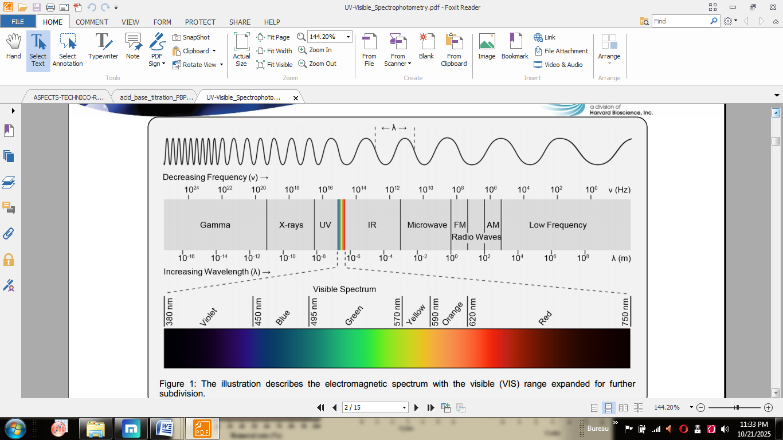
Fig.X.1 The electromagnetic spectrum.
All electromagnetic radiation travels at a fixed speed of 3 × 10^10 cm per sec which is the speed of light, c, in a vacuum. The distance between two peaks along the line of travel is the wavelength, λ, and the number of peaks passing a point in unit time is the frequency, ν, usually expressed in cycles per second (hertz) (Fig.X.2).
The arithmetic relationship of these three quantities is expressed by:
c = λ· ν
The laws of quantum mechanics may be applied to photons to show that:
E = h· ν
Where E is the energy of the radiation; v – the frequency and his Planck's constant.
Combining these two equations:
E = h · c / λ.
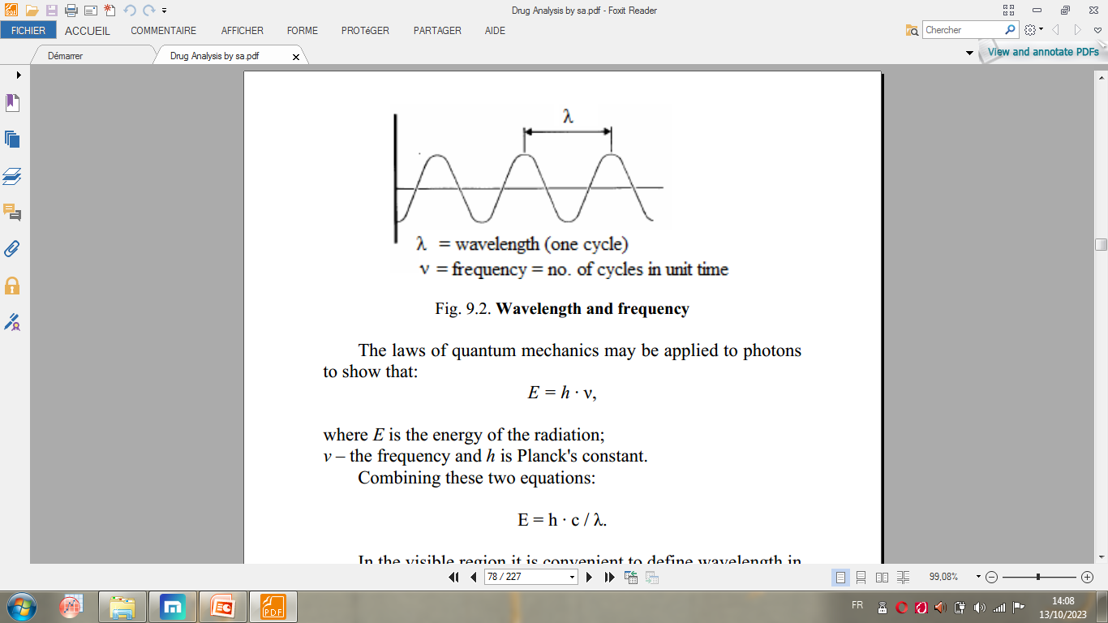
Fig.X.2 Wavelength and frequency.
In the visible region it is convenient to define wavelength in nanometers (nm), that is in units of 10-9 meters. The visible spectrum is usually considered to be 380–770 nm and the ultraviolet region is normally defined as 200–380 nm.

3.1.3. Specific absorption
Because each electron in a molecule hasunique ground state energy, and because the discrete levels to which it may jump are also unique, it follows that there will be a finite and predictable set of transitions possible for the electrons of a given molecule. Each of the transitions, or jumps, requires the absorption of a quantum of energy and if that energy is derived from electromagnetic radiation there will be a direct and permanent relationship between the wavelength of the radiation and the particular transition that it stimulates. That relationship is known as specific absorption and a plotof those points along the wavelength scale at which a given substance shows absorption «peaks», or maxima, is called an absorption spectrum (Fig.X.3).
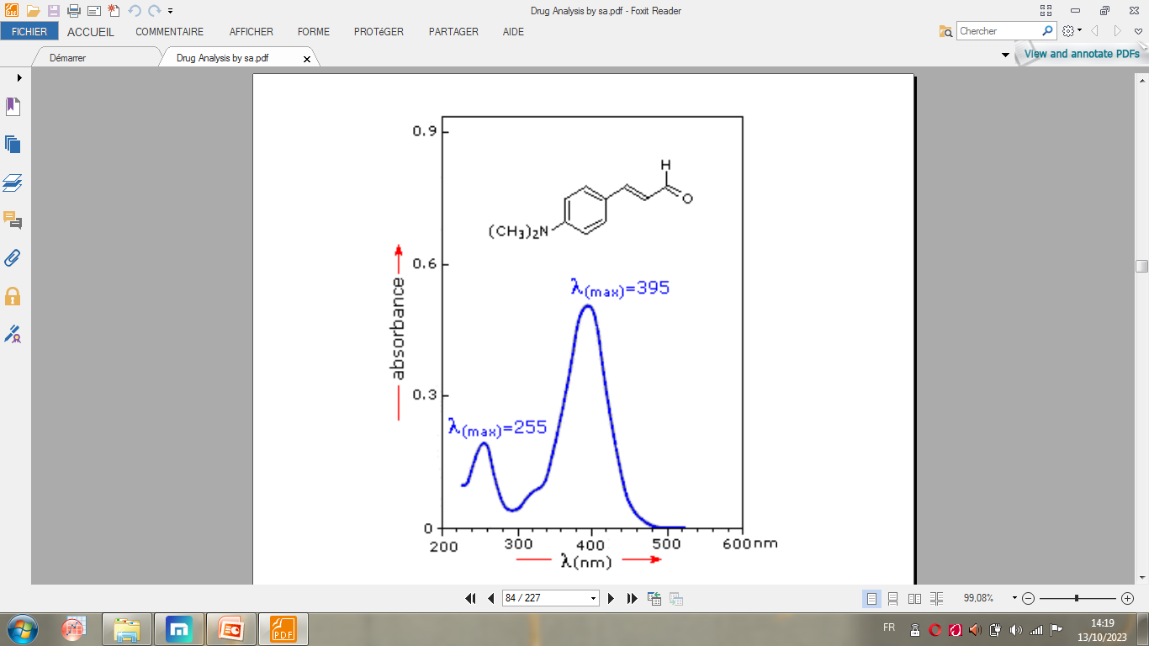
Fig.X.3 Typical absorption spectrum in UV/visible region.
The chemical group most strongly influencing molecular absorption characteristics is called a chromophore. Chromophores which can be detected by UV/Vis spectrophotometers always involve a multiple bond (such as C = C, C = O or C ≡N) and may be conjugated with other groups to form complex chromophores.A typical example is the benzene ring which has an absorption peak at 254 nm. Increasingly complex chromophores move the associated absorption peak towards longer wavelengths and generally increase the absorption at the maxima.

3.1.4. Absorption and concentration
Fig. 5 shows the absorption of radiation by a solution containing absorbing compound.
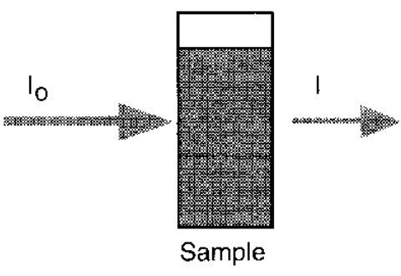
Fig.X.4 Absorption of light by a solution
For analytical purposes, two main propositions define the laws of light absorption.

- Lambert's Law.
The proportion of incident light absorbed by a transparent medium is independent of the intensity of the light (provided that there is no other physical or chemical change to the medium). Therefore, successive layers of equal thickness will transmit an equal proportion of the incident energy. Lambert's law is expressed by:
I/I₀ = T
Where I is the intensity of the transmitted light; I₀– the intensity of the incident light; T– the Transmittance.
- Beer's Law.
The absorption of light is directly proportional to both the concentration of the absorbing medium and the thickness of the medium in the light path.
A combination of the two laws (known jointly as the Beer Lambert Law) defines the relationship between absorbance (A) and transmittance (T):
A= logI0/I= log 1/T= - logT= ε· C· l,
Where
A is absorbance (no unit of measurement); ε– molar absorptivity (dm³mol⁻¹cm⁻¹); C– molar concentration (mol dm⁻³); l – path length (cm).

3.1.3. Instrumentation
The minimum requirements of an instrument to study absorption spectra (a spectrophotometer) are shown below (Fig.X.5) and include:
1) a source of radiation of appropriate wavelengths;
2) a means of isolating light of a single wavelength and getting it to the sample compartment – monochromator and optical geometry;
3) a means of introducing the test sample into the light beam – sample handling;
4) a means of detecting and measuring the light intensity.
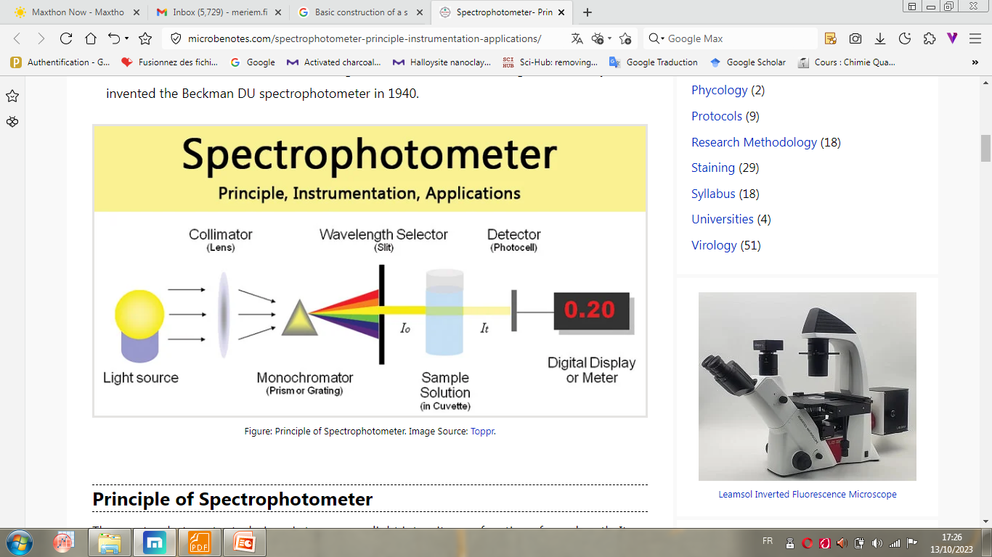
Fig.X.5Basic construction of a spectrophotometer.
- Sources
The ideal light source would yield a constant intensity over all wavelengths with low noise and long-term stability. Unfortunately, however, such a source does not exist. Two sources are commonly used in UV-visible spectrophotometers
- The first source, the deuterium arc lamp, yields a good intensity continuum in the UV region and provides useful intensity in the visible region (see Fig.X.6). Although modern deuterium arc lamps have low noise, noise from the lamp is often the limiting factor in overall instrument noise performance. Over time, the intensity of light from a deuterium arc lamp decreases steadily. Such a lamp typically has a half-life (the time required for the intensity to fall to half of its initial value) of approximately 1,000 h.
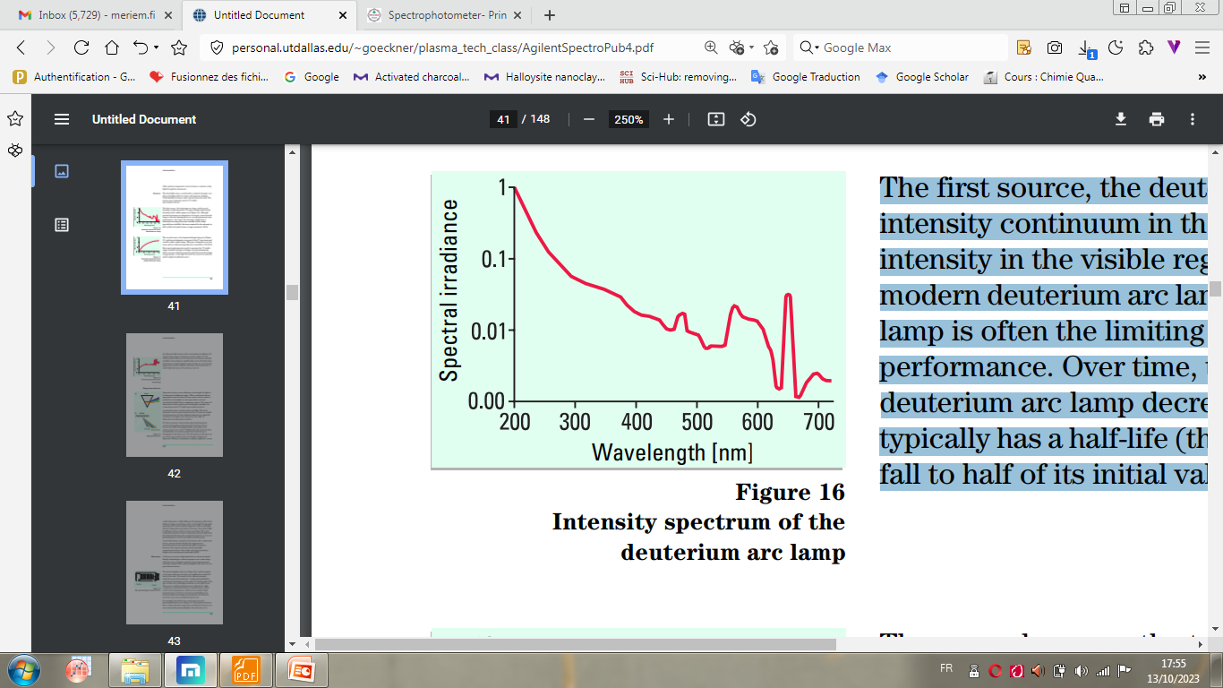
Fig.X.6 Intensity spectrum of the deuterium arc lamp.
- The second source, the tungsten-halogen lamp (see Fig.X.7), yields good intensity over part of the UV spectrum and over the entire visible range. This type of lamp has very low noise and low drift and typically has a useful life of 10,000 h. Most spectrophotometers used to measure the UV-visible range contain both types of lamps. In such instruments, either a source selector is used to switch between the lamps as appropriate, or the light from the two sources is mixed to yield a single broadband source.
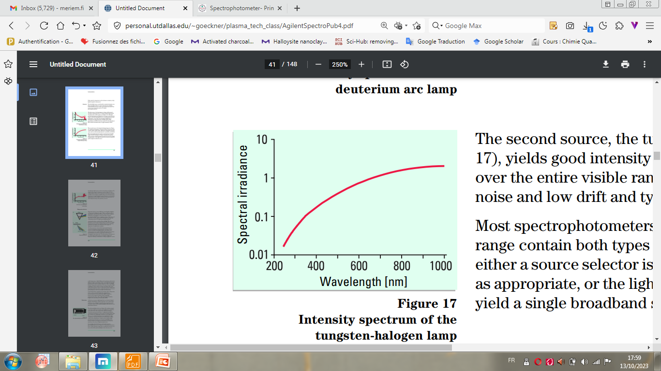
Fig.X.7Intensity spectrum of the tungsten-halogen lamp.
An alternate light source is the xenon lamp (see Fig.X.8), which yields a good continuum over the entire UV and visible regions. However, because the noise from currently available xenon lamps is significantly worse than that from deuterium or tungsten lamps, xenon lamps areused only for applications such as diffuse reflectance measurements, in which high intensity is the primary concern.
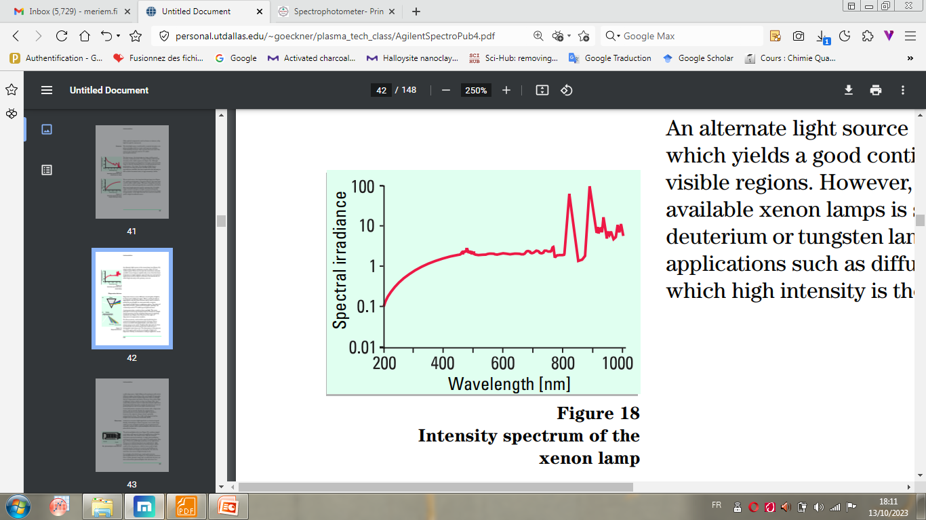
Fig.X.8 Intensity spectrum of the xenon lamp.
- Ultraviolet light is generally derived from a deuterium arc that provides emission of high intensity and adequate continuity in the 190–380 nm range.
- Visible light is normally supplied by a tungsten lamp or, in modern systems, by a tungsten-halogen.
- Dispersion devices
Dispersion devices cause different wavelengths of light to be dispersed at different angles. When combined with an appropriate exit slit, these devices can be used to select a particular wavelength (or, more precisely, a narrow waveband) of light from a continuous source. Two types of dispersion devices, prisms and holographic gratings, are commonly used in UV-visible spectrophotometers.
A prism generates a rainbow from sunlight. This same principle is used in spectrophotometers. Prisms are simple and inexpensive, but the resulting dispersion is angularly nonlinear (see Fig.X.9a). Moreover, the angle of dispersion is temperature sensitive.
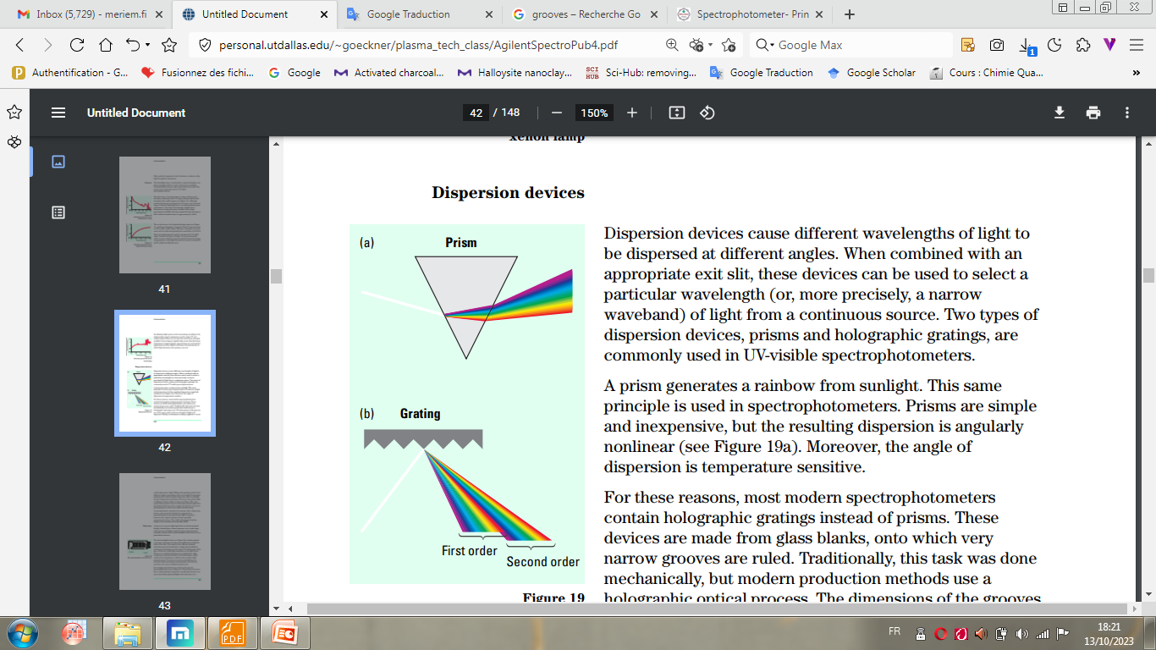
Fig.X.9 Dispersion devices.
For these reasons, most modern spectrophotometers contain holographic gratings instead of prisms. These devices are made from glass blanks, onto which very narrow grooves are ruled. Traditionally, this task was done mechanically, but modern production methods use a holographic optical process. The dimensions of the grooves are of the same order as the wavelength of light to be dispersed. Finally, an aluminum coating is applied to create a reflecting source. Light falling on the grating is reflected at different angles, depending on the wavelength. Holographic gratings yield a linear angular dispersion with wavelength and are temperature insensitive. However, they reflect light in different orders, which overlap (see Fig.X.9b). As a result, filters must be used to ensure that only the light from the desired reflection order reaches the detector. A concave grating disperses and focuses light simultaneously.
A monochromator consists of an entrance slit, a dispersion device, and an exit slit. Ideally, the output from a monochromator is monochromatic light. In practice, however, the output is always a band, optimally symmetrical in shape. The width of the band at half its height is the instrumental bandwidth (IBW).
- Sample handling
Cuvettes are typically made of glass or UV grade silica (according to the wavelength range of interest). The holder that locates the cuvette in the light beam must ensure precise and reproducible location with respect to the beam. The most commonly used cuvette has a light path length of 10 mm,
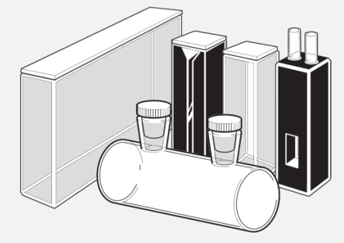
Fig.X.10 Sample cuvettes.
- Detectors
A detector converts a light signal into an electrical signal. Ideally, it should give a linear response over a wide range with low noise and high sensitivity. Spectrophotometers normally contain either a photomultiplier tube detector or a photodiode detector.

- Measuring Systems
The primary function of a spectrophotometer ends with the provision of a signal (normally an electrical voltage) that is proportional to the absorption by a sample at a given wavelength. The signal handling and measuring systems can be as simple as an amplifier and a meter or as elaborate as a personal computer and printer, depending on the application.

3.2. Infrared (IR) spectroscopy
Infrared spectroscopy is a technique based on the vibrations of the atoms of a molecule. An infrared spectrum is commonly obtained by passing infrared radiation through a sample and determining what fraction of the incident radiation is absorbed at a particular energy. The energy at which any peak in an absorption spectrum appears corresponds to the frequency of a vibration of a part of a sample molecule.
Infrared spectroscopy is certainly one of the most important analytical techniques available totoday’s scientists. One of the great advantages of infrared spectroscopy is that virtually any sample in virtually any state may be studied. Liquids, solutions, pastes, powders, films, fibres, gases and surfaces can all be examined with a judicious choice of sampling technique. The term «infrared» covers the range of the electromagnetic spectrum between 0,78 and 1000 μm (Fig.X.11). It is suitable to divide the infrared region into three sections; near, mid and far infrared. The most useful for chemical structure determination is the middle IR region, which lies between 4000– 670 cm⁻¹.
Table.X.1 Sub divisions of infrared region.
Region | Wavenumber range cm⁻¹
Near | 12800-4000
Middle | 4000-200
Far | 200-10

In the context of infrared spectroscopy, wavelength is measured in «wavenumbers», which have the units cm⁻¹. Wavenumber is defined like this:
Wavenumber = 1/λ

3.2.1. Energy of a molecule
Energy of molecule consists of translational, rotational, vibrational and electronic energy. Translation energy of a molecule is associated with the movement of the molecule as a whole, for example in a gas. Rotational energy is related to the rotation of the molecule, whereas vibrational energy is associated with the vibration of atoms within the molecule. Finally, electronic energy is related to the energy of the molecule's electrons. Like radiant energy, the energy of a molecule is quantized too and a molecule can exist only in certain discrete energy levels. Within an electronic energy level, a molecule has many possible vibrational energy levels. To raise the electronic energy state of a molecule from the ground state to the excited state will cost more energy than to raise the vibrational energy state. A simplified representation of the quantized electronic and vibrational energy levels of a molecule can be found in Fig.X.11.
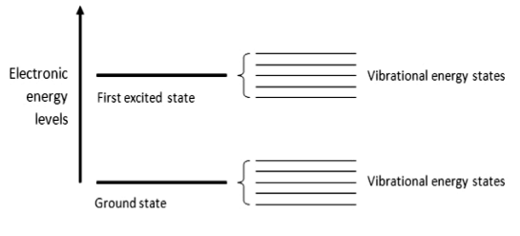
Fig.X.11A schematic representation of the quantized electronic and vibrational energy levels of a molecule: to raise the electronic energy state of a molecule from the ground state to the excited state will cost more energy than to raise the vibrational energy state.
3.2.2. Interaction of light and molecules
IR radiation does not have enough energy to induce electronic transitions as seen with UV and visible light. Absorption of IR is restricted to excite vibrational and rotational states of a molecule. Even though the total charge on a molecule is zero, the nature of chemical bonds is such that the positive and negative charges do not necessarily overlap in this case. Such molecules are said to be polar because they possess a permanent dipole moment. For a molecule to absorb IR, the vibrations or rotations within a molecule must cause a net change in the dipole moment of the molecule. The alternating electrical field of the radiation interacts with fluctuations in the dipole moment of the molecule. If the frequency of the radiation matches the vibrational frequency of the molecule then radiation will be absorbed, causing a change in the amplitude of molecular vibration. The result of IR absorption is heating of the matter since it increases molecular vibrational energy (Fig.X.12).
Molecular vibrations give rise to absorption bands throughout most of the IR region of the spectrum. The far IR, lying adjacent to the microwave region, has low energy and may be used for rotational spectroscopy.
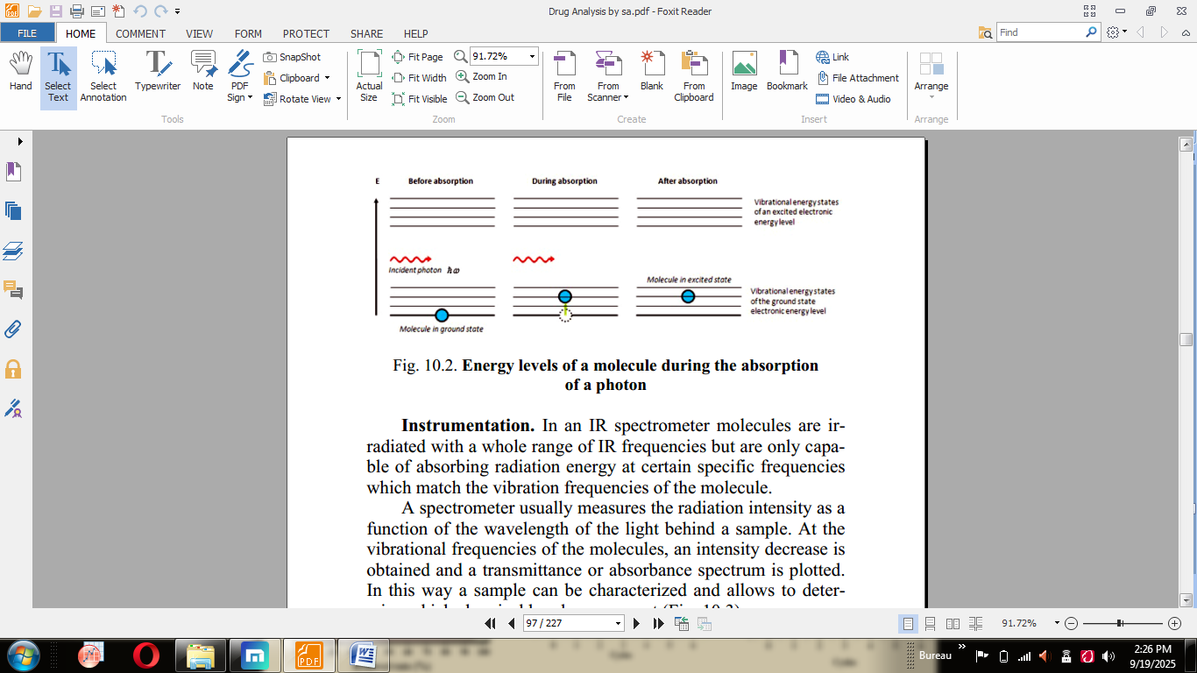
Fig.X.12 Energy levels of a molecule during the absorption of a photon.

3.2.3. Older Technology
The original infrared instruments were of the dispersive type. These instruments separated the individual frequencies of energy emitted from the infrared source. This was accomplished by the use of a prism or grating. An infrared prism works exactly the same as a visible prism which separates visible light into its colors (frequencies). A grating is a more modern dispersive element which better separates the frequencies of infrared energy. The detector measures the amount of energy at each frequency which has passed through the sample. This results in a spectrum which is a plot of intensity vs. frequency. Fourier transform infrared spectroscopy is preferred over dispersive or filter methods of infrared spectral analysis for several reasons:
• It is a non-destructive technique.
• It provides a precise measurement methodwhich requires no external calibration.
• It can increase speed, collecting a scan every second.
• It can increase sensitivity – one second scans can be co-added together to ratio out random noise.
• It has greater optical throughput.
• It is mechanically simple with only one moving part.

3.2.4. Fourier Transform Infrared (FT-IR) spectrometry
Fourier Transform Infrared (FT-IR) spectrometry was developed in order to overcome the limitations encountered with dispersive instruments. The main difficulty was the slow scanning process. A method for measuring all of the infrared frequencies simultaneously, rather than individually, was needed. A solution was developed which employed a very simple optical device called an interferometer. The interferometer produces a unique type of signal which has all of the infrared frequencies “encoded” into it. The signal can be measured very quickly, usually on the order of one second or so. Thus, the time element per sample is reduced to a matter of a few seconds rather than several minutes. Most interferometers employ a beamsplitter which takes the incoming infrared beam and divides it into two optical beams. One beam reflects off of a flat mirror which is fixed in place. The other beam reflects off of a flat mirror which is on a mechanism which allows this mirror to move a very short distance (typically a few millimeters) away from the beamsplitter. The two beams reflect off of their respective mirrors and are recombined when they meet back at the beamsplitter. Because the path that one beam travels is a fixed length and the other is constantly changing as its mirror moves, the signal which exits the interferometer is the result of these two beams “interfering” with each other. The resulting signal is called an interferogram which has the unique property that every data point (a function of the moving mirror position) which makes up the signal has information about every infrared frequency which comes from the source. This means that as the interferogram is measured, all frequencies are being measured simultaneously. Thus, the use of the interferometer results in extremely fast measurements. Because the analyst requires a frequency spectrum (a plot of the intensity at each individual frequency) in order to make an identification, the measured interferogram signal cannot be interpreted directly. A means of “decoding” the individual frequencies is required. This can be accomplished via a well-known mathematical technique called the Fourier transformation. This transformation is performed by the computer which then presents the user with the desired spectral information for analysis.

3.2.5. The Sample Analysis Process
The normal instrumental process is as follows:
1. The Source: Infrared energy is emitted from a glowing black-body source. This beam passes through an aperture which controls the amount of energy presented to the sample (and, ultimately, to the detector).
2. The Interferometer: The beam enters the interferometer where the “spectral encoding” takes place. The resulting interferogram signal then exits the interferometer.
3. The Sample: The beam enters the sample compartment where it is transmitted through or reflected off of the surface of the sample, depending on the type of analysis being accomplished. This is where specific frequencies of energy, which are uniquely characteristic of the sample, are absorbed.
4. The Detector: The beam finally passes to the detector for final measurement. The detectors used are specially designed to measure the special interferogram signal.
5. The Computer: The measured signal is digitized and sent to the computer where the Fourier transformation takes place. The final infrared spectrum is then presented to the user for interpretation and any further manipulation.
Because there needs to be a relative scale for the absorption intensity, a background spectrum must also be measured. This is normally a measurement with no sample in the beam. This can be compared to the measurement with the sample in the beam to determine the “percent transmittance.” This technique results in a spectrum which has all of the instrumental characteristics removed. Thus, all spectral features which are present are strictly due to the sample. A single background measurement can be used for many sample measurements because this spectrum is characteristic of the instrument itself.
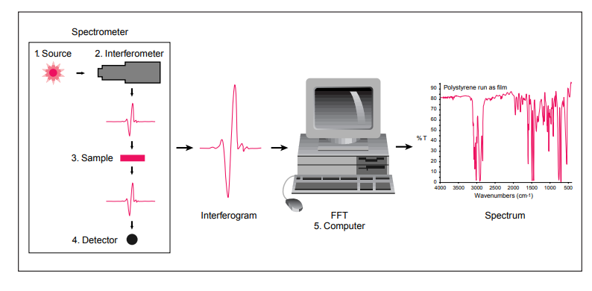
Fig.X.13 FT-IR Instrumental process.
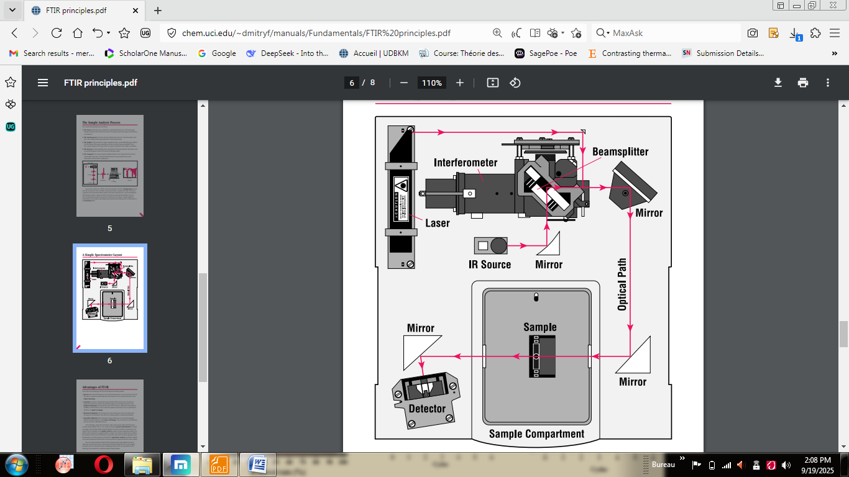
Fig.X.14 FT-IR Instrumental process.
3.2.6. An example of IR spectrum analysis
Fig.X.15 illustrates the diffuse reflectance infrared spectrum of acetylsalicylic acid (aspirin).
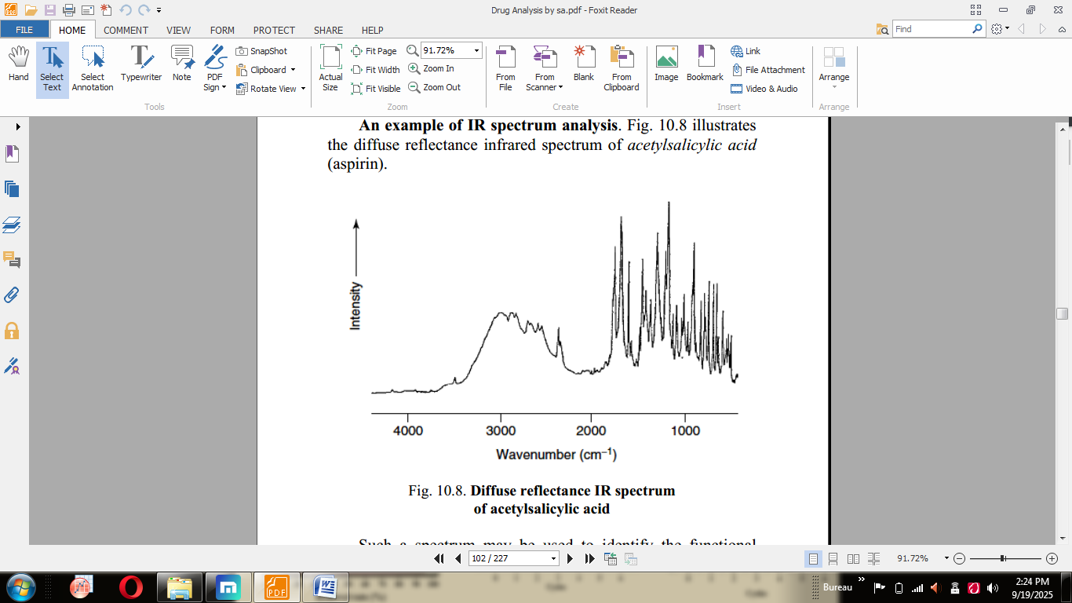
Fig.X.15 Diffuse reflectance IR spectrum of acetylsalicylic acid.
Such a spectrum may be used to identify the functional groups present in this molecule (Fig.X.16).
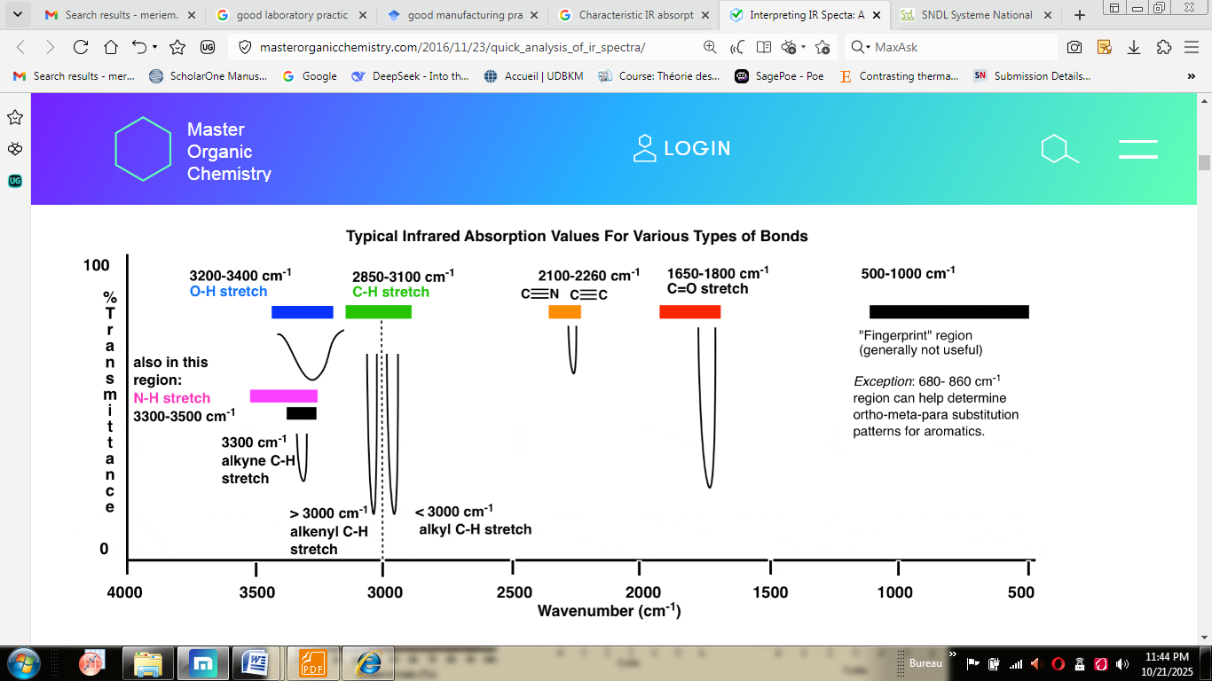
Fig.X.16 Characteristic IR absorption frequencies of organic functional groups.
The presence of O–H groups in acetylsalicylic acid is indicated by a broad band in the 3400–3300 cm⁻¹ region and C–H stretching bands overlap with this band in the 3000–2800 cm⁻¹ range. The spectrum shows two strong C = O stretching bands at 1780, 1750 cm⁻¹, so indicating that the molecule contains carbonyl groups in different environments. The spectrum also shows strong bands at 1150 and 1100 cm⁻¹ due to C–O stretching: the 1150 cm⁻¹ band is due to the presence of a C–O–H group, while the 1100 cm⁻¹ band is due to a C–O–C group in the structure. There is also evidence of a benzene ring, including a series of characteristic bands in the 800–500 cm⁻¹ range due to C–H stretching in the aromatic ring. In summary, acetylsalicylic acid contains O–H, C = O, C–O–C, C–O–H and aliphatic and aromatic C–H groups.
The acetylsalicylic acid structure is illustrated in Fig.X.16, hence confirming the presence of these functional groups.
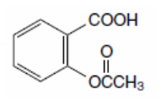
Fig.X.16 Structure of acetylsalicylic acid.

3.3. Atomic absorption spectroscopy (AAS)
Atomic absorption spectroscopy is a spectroanalytical procedure for the quantitative determination of chemical elements employing the absorption of optical radiation (light) by free atoms in the gaseous. Atomic absorption spectrometry was first used as an analytical technique, and the underlying principles were established in the second half of the 19th century by R.W. Bunsen and G.R. Kirchhoff, both professors at the University of Heidelberg, Germany. In analytical chemistry the technique is used for determining the concentration of a particular element (the analyte) in a sample to be analyzed. AAS can be used to determine over 70 different elements in solution or directly in solid samples employed in pharmacology, biophysics and toxicology research. The method’s intrinsic sensitivity, specificity, andaccuracy make it invaluable in metallurgy, pharmaceutical sciences, environmental analysis, and other sectors; it also spurs improvements in industrial processes, research, and quality control procedures.

3.3.1 Theory of absorption by atoms
The essential concepts behind atomic absorption spectroscopy, a crucial analytical chemistry method, are explained via the idea of absorption by atoms. Atoms have distinct energy levels, and quantum mechanics predicts that these energy states can change when an atom is exposed to electromagnetic radiation. A cylindrical cathode lamp in AAS provides light at certain wavelengths that match the target element's resonance frequencies. The element's atoms absorb photons at precisely these wavelengths when the sample is placed in an ignition or graphite furnace, changing their energy levels from lower to higher. The resonance condition, in which the energy of the incoming photons equals the disparity in energy between atomic energy levels, is necessary for this absorption process to occur. The quantitative evaluation in AAS is based on the direct relationship between the coefficient of absorption and the element's concentration in the sample. Comprehending the physics of absorption by atoms is essential for evaluating spectrum data and maximizing experimental parameters in applications of AAS in a variety of domains, including materials science, pharmaceutical analysis, and environmental monitoring.
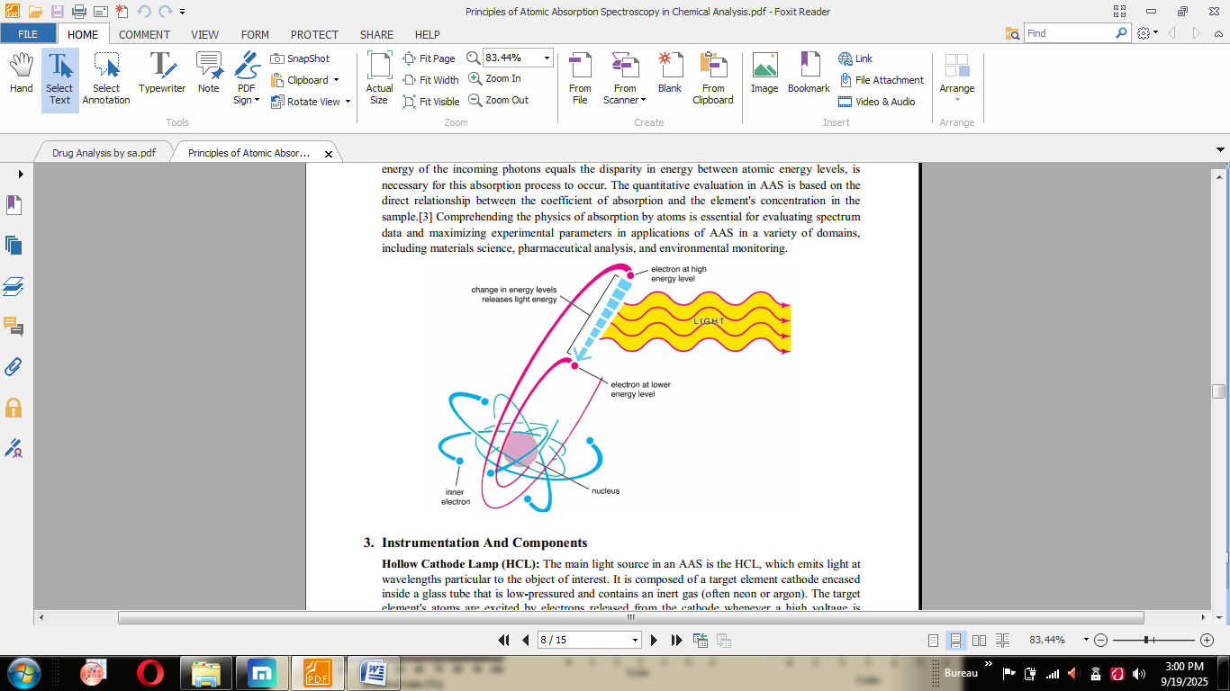
Fig.X.17 The process of atomic absorption.

3.3.2. Instrumentation and components
Hollow Cathode Lamp (HCL): The main light source in an AAS is the HCL, which emits light at wavelengths particular to the object of interest. It is composed of a target element cathode encased inside a glass tube that is low-pressured and contains an inert gas (often neon or argon). The target element’s atoms are excited by electrons released from the cathode whenever a high voltage is applied across the anode and cathode, leading to the emission of distinctive radiation.
Monochromator: The chosen wavelength of light that the HCL emits for analysis is chosen by the monochromator. It usually comprises a prism or diffraction grating that splits the lightproduced into its individual wavelengths. A particular wavelength matching to the element's resonance line is separated and directed toward the sample by turning or modifying the grating or prism.
Sample Introduction System:To atomize and introduce the specimen onto its light path for analysis, the sample introduction mechanism is essential. The sample is inhaled through an ignited object (which is frequently an aperture or cup burner) in flame AAS, where the heat of the flame atomizes, vaporizes, and then excites the sample. A small quantity of sample solution is put onto a graphite tube in the graphite furnace AAS, and the tube is subsequently warmed to high temperatures, atomizing and excitivizing the sample.
Detector: Following contact with the sample, the detector calculates the transmitted light's intensity. AAS frequently uses photomultiplier tubes (PMTs) as detectors because of their high sensitivity and quick reaction times. The light intensity is transformed by the detector toward a signal of electricity, which is subsequently processed and examined to ascertain the sample’s absorbance.
Automation and Control Systems: In order to improve the efficiency and repeat ability of analyses, modern AAS devices frequently include automation capabilities and computer control systems. Throughput can be increased and operator mistakes can be decreased by using automated sample changers, which enable sequential analysis of manysamples without the need for manual intervention. To guarantee optimal performance and precision, computer control systems allow for the exact modification of equipment parameters such wavelength selection, slit width, and lamp current.
Accessories and Optional Components: AAS equipment may be made more capable and versatile by adding different alternative parts and accessories. These might include programs that perform data processing and analysis, thermostat systems like a flame or graphite furnace, and background correction systems (such as the deuterium / Zeeman effect correction). To maximize instrument performance, guarantee precise measurements, and successfully interpret experimental data, one must have a thorough understanding of the instruments and components of AAS. Each part is essential to the instrument's overall operation, which ultimately determines the tool's analytical potential and practicality in a range of settings.
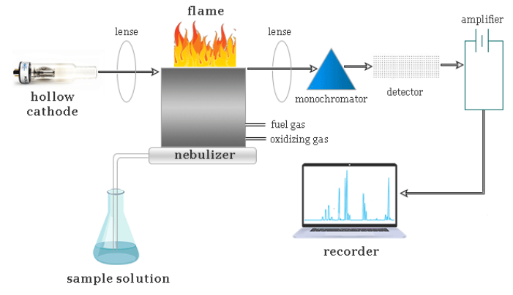
Fig.X.18 Instrumentation and components of AAS.

3.3.3. Sample preparation techniques
Sample preparation strategies are critical to achieving precise and dependable findings with atomic absorption spectroscopy (AAS). The basic goal of preparing a sample is to transform the sample into a format appropriate for analysis while reducing disturbances and matrix effects. Some common sample preparation procedures in AAS include:
Dissolution: Solid samples are frequently dissolved in suitable solvents to ensure uniform dispersion for the chemical in solution. Digestion with acids or microwave-assisted digestion procedures can be used to break down complicated matrices and improve analyte recovery.
Dilution: Samples with high analyte concentrations may need to be diluted to put them within the instrument’s linear range. Dilution also helps to reduce matrix influences and interferences, resulting in precise measurement.
Filtration: Filtration is used for eliminating suspended particles and insoluble contaminants from sample solutions, preventing nebulizer clogging and interfering alongside the atomization process in flame AAS.
Centrifugation: Centrifugation separates intractable constituents or portions separate the sample solution, making it easier to collect supernatants for examination.
Extraction: To separate the substance being studied through interference species or complex matrices, liquid-liquid or solid-phase extraction procedures can be used, increasing selectivity and sensitivity.
Matrix Modification: Matrix modification approaches, such as the use of pharmacological or electromagnetic suppression devices, are used to decrease matrix effects and increase AAS results precision.
Overall, meticulous sample preparation is required to reduce interferences, improve analytical sensitivity, and ensure the precision and dependability of AAS findings. Proper sample preparation procedure selection and optimization are crucial for attaining optimal elemental analysis performance across a wide range of data matrices and applications.

3.3.4. Calibration and standardization methods
Calibration and standardization are critical procedures in the technique of atomic absorption spectroscopy (AAS) to enable accurate and consistent elemental concentration measurements in samples. Calibration is the process of creating a curve for calibration using standard solutions with known analyte concentrations of substances, whereas standardization guarantees that the instrument operates within prescribed parameters. Some popular calibration and standardization procedures in AAS are:
External Calibration: External calibration involves preparing and analyzing an array of typical solutions with known analyte concentrations using an AAS instrument. The absorbance values regarding the benchmarks are displayed against their concentrations to create a calibration curve. The amount present of the component in unidentified specimens is calculated by extrapolating the absorbance measurements over the calibration curve.
Internal Calibration: Internal calibration entails adding an established amount of a standard substance to the two parts the standard solution and the sample. The absorption proportion of the metaboliteto the standard solution is subsequently compared against the amount present ratio, therefore removing any inaccuracies caused by instrument parameter fluctuations and sample handling.
Instrument Standardization: Instrument standardization entails testing and modifying instrument settings to achieve precise andrepeatable readings. This might involve assessing lamp intensity, wavelength correctness, background security,and detector sensitivity. To ensure analytical accuracy and precision, equipment performances should be standardized on a regular basis using approved materials for reference and validation processes. AAS provides the preciseness, accuracy, and dependability of quantitative elements analysis across a wide range of specimen matrices and applications by using suitable calibration and standardisation procedures. These techniques are critical for confirming analytical data, meeting regulatory criteria, and providing transparency in analytical measurements.

3.3.5. Applications in pharmaceutical analysis:
AAS is used in pharmaceutical analysis for determination of metal residues in drugs remaining from the manufacturing process, for assay ions (Ca²⁺, Mg²⁺) in haemodialysis fluid, zinc (Zn²⁺) in insulin, etc. In Ph. Eur. AAS is used in a number of limit tests for metallic impurities, e.g.: magnesium and strontium in calcium acetate; palladium in carbenicillin sodium and lead in bismuth subgalate. It is also used to assay metals in a number of other preparations: zinc in zinc insulin suspension and tetracosactrin zinc injection; copper and iron in ascorbic acid; zinc in acetylcysteine; lead in bismuthsubcarbonte; silver in cisplatinum; lead in oxyprenaolol; aluminium in albumin solution and calcium, magnesium, mercury and zinc in water used for diluting haemodialysis solutions.

Chromatographic methods for drug quality control
In the rapidly evolving landscape of pharmacy and nursing, chromatographic techniques play a pivotal role in pharmaceutical analysis. Chromatography, as a powerful separation and identification tool, is indispensable in the pharmaceutical industry for ensuring the quality, safety, and efficacy of drugs and formulations. The chapter introduces the fundamental principles of chromatography, highlighting its differential interaction between the stationary and mobile phases, leading to precise separation of complex mixtures. Subsequently, the instrumentation and key parameters affecting separation in prominent techniques like High Performance Liquid Chromatography (HPLC), Gas Chromatography (GC), and Thin Layer Chromatography (TLC) are explored. Additionally, the chapter discusses other important chromatographic techniques, including Size Exclusion Chromatography and Ion Exchange Chromatography, each offering unique advantages in pharmaceutical analysis. The significance of method validation to ensure the accuracy and reliability of results is emphasized throughout the chapter. By providing valuable insights into cutt ing-edge advancements and best practices, this chapter equips researchers and analysts with the knowledge needed to leverage chromatographic techniques effectively in pharmaceutical research and quality control.

4.1. Chromatography principle
Chromatography is based on the principle where molecules are transferred between the mobile phase and the stationary phase. It occurs due to the absorbance or partition of molecules present in the mixture which we want to separate.The rate of travel of individual solute molecules through a column or thin layer is not uniform. It is directly related to the partition of the molecules between the mobile phase and stationary phase.

4.2. Stationary phase in chromatography
The stationary phase may be a column, plate, or paper in chromatographic technique. It is a solid phase or a liquid phase coated on the surface of a solid phase.
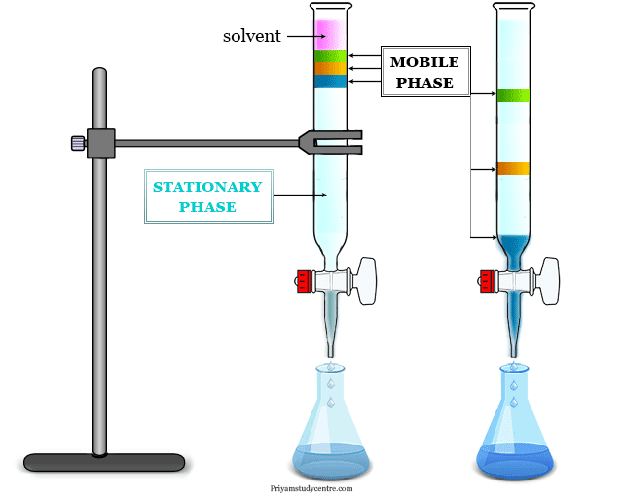
Fig.X.19 Stationary phase.
Depending upon the nature of the stationary phase, three chromatographic techniques have been used widely in the laboratory. These techniques are,
- Liquid-solid absorption or column chromatography (LSC)
- Paper chromatography (PC)
- Thin-layer chromatography (TLC)

4.3. Mobile phase in chromatography
The mobile phase (liquid or gas) moves through the stationary phase when different components are separated due to different rates of migration.
- If the mobile phase is liquid, it is called liquid chromatography (LC).
- If the mobile phase is gas then it is called gas chromatography (GC).
The migration of molecules depends on their affinity to the stationary and mobile phases. Therefore, the components which are attached less by the stationary phase will move faster in mobile phases.

4.4. High performance liquid chromatography (HPLC)
HPLC is the most widely used chromatographic technique for analysis of drugs and pharmaceutical formulations. It offers high resolving power, sensitivity, accuracy and reproducibility. HPLC has advantages like high selectivity, sensitivity and speed of analysis which make it an invaluable technique for pharmaceutical analysis and quality control applications. Developing robust and optimized HPLC methods is an essential part of drug development and product lifecycle management.
4.4.1. Principle of HPLC
HPLC is a type of partition chromatography that utilizes the partitioning of substances between the stationary and mobile phases. The mobile phase consists of a solvent or a mixture of solvents that moves through the column carrying the sample when a pump exerts pressure. The stationary phase is a solid material, such as silica, packed in a column or cartridge. When the sample passes through the column, the stationary phase adsorbs the components of the sample with different affinities, resulting in a separation of the components. The basis of HPLC is that molecules will move through the stationary phase at different speeds, depending on their relative affinity for the stationary phase. Different compounds travel at different speeds, which results in the separation of the compounds. The rate of movement of the components is determined by the relative affinities of the analyte molecules for the mobile and stationary phases. Compounds with a high affinity for the stationary phase will travel slower and separate morethan less strongly adsorbed molecules.

4.4.2. Instrumentation of HPLC System
A basic HPLC system (Fig.X.20) consists of high pressure pumps, injection system, chromatographic column, a detector like Ultraviolet (UV), Photo Diode Array (PDA), Evaporative light scattering detector (ELSD), etc., and data acquisition and processing system.
Solvent delivery pump: Also known as a solvent delivery system, it is used to maintain a constant flow rate of the mobile phase through the HPLC system. The purpose of the pump is to force the mobile phase through the column while maintaining a specific flow rate.
Injector: An HPLC injector allows the introduction of samples onto the column. These injectors inject the sample without disturbing the flow rate and pressure of the HPLC system. The role of the injector has a lot of significance because direct injection of the sample is not suggested as the working pressure of the HPLC is adequately high that we cannot inject the sample into the mobile phase. Care must be taken while injecting the sample. Points that must be kept in mind like introducing a sample without air bubbles, a sample introduced with constant pressure and flow rate, injection volume of the sample is in microliters, and the sample must be free from any particulate matter.
There are many conventional types of injectors like Rheodyne injector, Septum injector, and Stop flow injector; however, an advanced injector known as Auto-sampler injector is used to deliver an aliquot of sample to the HPLC column. It is high-tech automation equipment with high precision, variable volume, and long-term reliability.
HPLC Column: The HPLC column is an integral part of the HPLC system that performs the critical task of separating molecular compounds during analysis. Several types of columns are used in the pharmaceutical industry; however, the most commonly used ones are C18 and C8 columns.
Detector: Detectors are used to sense the presence of separated compounds as they leave the column. The separates are monitored and expressed electronically by the detectors. Detectors used shall be sensitive, have good stability, reproducibility, inexpensive, non-destructive, highly reliable, and withstand temperatures ranging up to 400 C. Detectors measure the difference in some physical properties of the solute in the mobile phase compared to the mobile phase alone.
Computer Data Station (Recorder) Electronic data signals expressed by the detectors are interpreted and processed into a meaningful inference in the form of chromatograms. They record the baseline and all the peaks obtained with respect to time. Present date data stations perform multiple complex tasks like data acquisition, interpretation, data processing, data storage, and distribution across the connected systems within an organization.
Degasser: The mixing of liquids involves the entrapment of gases like oxygen, which contributes to noise and causes an unstable baseline. Degasser is a high-efficiency in-line system designed to remove dissolved gases from a solvent. The degasser is easy to use, provides reliable continuous operation, and eliminates the need for helium sparging to remove gases. Polymeric Teflon tubing inside the degasser has micropores, which contribute to outward gaseous exchange to the environment while preventing any liquid from passing through the pores.
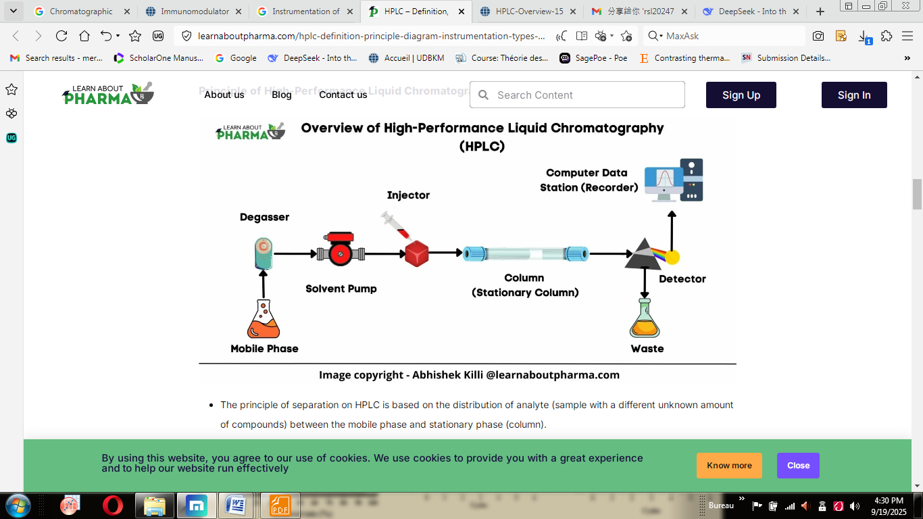
Fig.X.20 High performance liquid chromatography.

4.4.3. Types of High-Performance Liquid Chromatography (HPLC)
- Normal Phase chromatography:
This chromatography type uses columns packed with a polar stationary phase and a nonpolar or moderately polar mobile phase to separate polar compounds. The polar stationary phase includes silica, alumina, or polar-bonded phase, whereas the nonpolar mobile phase includes hexane, heptane, etc. This method separates analytes based on polarity. Less polar solutes move the fastest and therefore exit the column and are detected first, followed by solutes of increasing polarity, which move more slowly. This technique is used for water-sensitive compounds, geometric isomers, class separation, and chiral compounds.
- Reverse Phase Chromatography:
This chromatography type uses columns packed with a nonpolar stationary phase and a moderately polar, aqueous mobile phase to separate polar, nonpolar, ionic, and ionizable compounds. It works on the principle of hydrophobic interactions. In this chromatography, the surface of the column stationary phase is covalently bound with alkyl or aromatic ligands to provide a hydrophobic surface. Hydrophobic solutes present in the mobile phase tend to get bound to the stationary phase via hydrophobic interactions, forming the basics of separation.
- Ion Exchange Chromatography:
Ion exchange chromatography (IEX) is a chromatographic separation method based on the protein’s net charge. IEX separates molecules by their surface charge, a property that can vary vastly between different proteins.
- Size Exclusion Chromatography:
Size Exclusion Chromatography is a method where molecules in a solution are separated by their size and molecular weight. The separation is achieved by the attraction between solute ions and the charged sites bound to the stationary phase. It is usually applied to large molecules or macromolecular complexes such as proteins and industrial polymers.

4.4.4. Parameters affecting HPLC separation
Following are the parameters that affect HPLC separation:
- Nature of stationary and mobile phases
- pH, ionic strength and temperature of mobile phase
- Flow rate of mobile phase
- Column dimensions

4.4.5. Applications of HPLC in pharmaceutical analysis
The applications of HPLC in pharmaceutical analysis are:
- Determination of drug content and impurities in samples
- Simultaneous determination of multiple drug components
- Determination of drugs in biological samples like plasma and urine
- Separation of enantiomers for chiral drugs
- Stability-indicating assays for drug degradation products.

4.5. Gas chromatography (GC)
Gas chromatography in analytical chemistry is a common type of chromatography analysis process where the mobile phase is a gas and the solute of the analyzed sample is separated as a vapour. The mobile phase which we usually use in gas chromatography is noble gas or an unreactive gas such as helium, argon, nitrogen, and hydrogen. The main working principle of gas solid chromatography (GSC) or gas liquid chromatography (GLC) instrumentation is based on the movement of different components of the sample through a stationary phase present in the column. A gas chromatography system provides great advantages in testing the purity of substances or the separation of a particular component from a mixture of analyzed samples.

4.5.1. Principle of GC
The main principle of gas chromatography instrumentation is based on the movement of different components of the sample through a stationary phase present in the column. The component of a sample that has a greater affinity for the stationary phase spends more time in the column. Therefore, it elutes later and has a longer retention time than the component that has a lower affinity for the stationary phase.
Separation in gas chromatography is feasible by partitioning the sample between a mobile gas phase and a thin layer stationary phase of nonvolatile, high boiling liquid held on the solid support. The idea of fractioning gases by passage over solid or immobilized gases was first introduced in 1941 and became popular after 1955.
- A sample is injected into a heating block where the compound is readily vaporized. The sample vapour is carried by the carrier gas into the column inlet.
- The solute is absorbed in the head of the column by the stationary phase. However, it travels at its own rate through the column according to its partition coefficient value.
- Solutes are eluted according to their partition coefficient and entered into the detector.
- In the detector, solutes give a series of signals resulting from concentration changes and different rates of elution.
- A plot or chromatogram of time against the composition of the carrier gas stream appears in the recorder of the GC machine. The peaks of the plot give the quantitative data in the gas chromatogram.

4.5.2. Instrumentation of GC System
A good gas chromatography machine contains the following important components,
- Pressure regulator
- Sample injection port
- GC column
- Stationary phase
- Mobile phase
- Detector
- Signal recorder
The instrumentation of the gas chromatography machine is given below the picture,
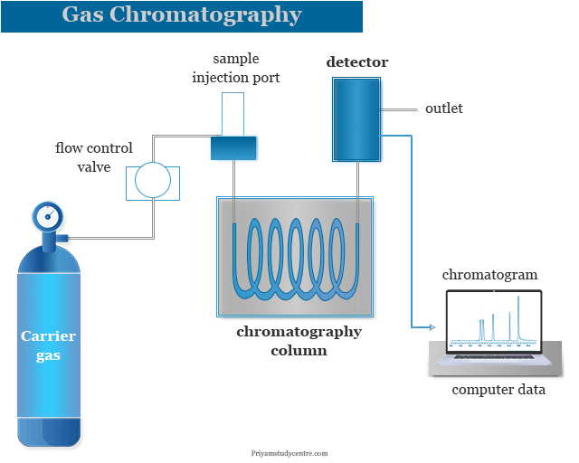
Fig.X.21.Gas chromatography machine.

- Pressure Regulator
Pressure is adjusted within the limits of 1 to 4 atmospheres while the flow control valve measures 1 to 1000 liters per minute of gas. A trap containing a molecular sieve is used in GC instrumentation to filter out contaminating impurities.
- Sample Injection Port
Samples are injected by a microsyringe through a self-sealing silicon rubber septum in a heated metal. Generally, the metal bock is heated by an electrical heater fitted in the GC instrument.
- Gas Chromatography Column
The gas chromatography column can be made by tubing coiled into an open spiral. Copper or stainless steel is used because they are stable during high-temperature operation. The choice of the column depends on the sample which we analyzed. The column in the gas chromatography instrument contains an electrically controlled oven. The velocity of the carrier gas flow rate depends on the inner diameter of the chromatographic column. The usual size of the column is 2 meters
- Mobile Phase
The mobile phase is a chemically inert gas that is used to carry analyte molecules through the stationary phase of a heated column. The mobile phase which we usually use in GC instrumentation is noble gas or an unreactive gas such as helium, argon, nitrogen, and hydrogen.
- Detector
The detector can detect the arrival of separated components coming from the column to provide an electrical signal. Pressure and temperature detectors are the two major groups of detectors used in GC analysis. The detector in gas chromatography instrumentation is situated near the column to avoid the condensation of liquids or to detect the sample before decomposition. In a packed column GC instrumentation, we used mostly a thermal conductivity detector (TCD) or a flame ionization detector (FID). Among these TCD is the most popular.

4.5.3. Stationary phase in gas chromatography
Gas liquid chromatography can be available in almost an infinite variety of liquid partition materials. The liquid or stationary phase in gas chromatography can be divided into nonpolar, intermediate polarity, polar carbowaxes, and hydrogen bonding compounds like glycol. The maximum temperature of the stationary phase can be determined by its volatility. The excess volatility of the stationary phase can shorten the life of the column. Loading of the column by stationary phase can be expressed by percentage of weight. For example, 15% means, a 100 g column has 15 g of stationary phase.

4.5.4. Parameters affecting GC separation
The parameters affecting GC separation are: nature and flow rate of carrier gas, temperature and pressure of column, nature of stationary and coated phases, column dimensions.

4.5.5. Applications of GC in pharmaceutical analysis
- Analysis of thermal stability and degradation products of drugs
- Analysis of organic volatile impurities in drugs and formulations
- Determination of residual solvents and pesticide residues
- Chiral separation of drug enantiomers
- Detection of counterfeit and substandard drugs

4.6. Thin layer chromatography (TLC)
TLC is a simple, cost-effective and rapid technique for preliminary separation and analysis of drugs.Thin layer chromatography in analytical chemistry is a chromatography principle or technique, which we use to separate or identify non-volatile mixtures on a small scale. In the TLC technique, the adsorbent is coated on a glass plate which acts as a stationary phase. Usually, we used alumina or silica gel with little calcium sulfate for the production of thin layer chromatography plates. The solvent or mobile phase which we used in thin layer chromatography is a very important step. Compared to paper chromatography, it uses a very small amount of samples for quantitative analysis with a lower detection limit. The TLC technique is very useful for the analysis of a large number of compounds. Therefore, compounds that are not volatile or too labile for liquid or gas chromatography can be analyzed by the TCL technique. Though it lacks sensitivity and resolution compared to HPLC and GC, TLC finds practical applications as an initial step in method development and quality control testing

4.6.1. Principle of TLC
The thin layer chromatography can be performed on the TLC plate. A TLC plate is a sheet of aluminum foil, plastics, or glass that supports the stationary phase or a thin layer of solid absorbent. Silica or alumina are used commonly for making solid absorbents. The mobile phase in the TLC technique is a solvent or a mixture of solvents.
After sporting the TLC plate, it is kept in a closed jar or beaker (TLC chamber) containing the eluent or mobile phase. The solvent rises up the TLC plate by capillary action. The solvent also drags the sample mixture along with it.
The component of the sample is attracted by the polar sites of the absorbent surface by the electrostatic force of attraction. The solvent also interacts with the components of absorbents. Depending on the polarity and interaction of solute, solvent, and absorbent, different components of the mixture move at different rates. When the solvent almost reaches 90 percent of the length of the TLC plate, it is taken out from the TLC chamber.The TLC plate is allowed to dry by evaporating the solvent and the components of the mixture are marked under the ultraviolet (UV) light. Therefore, the individual components are identified by calculating the retardation factor (Rf) and comparing it with the standard substances.

4.6.2. Solvent used in thin layer chromatography
The compounds in the spot will move up on the TLC plate depending on the solvent used in the mobile phase. Polar solvents will drug polar substances while nonpolar solvents can help to move nonpolar compounds with them.
- Very polar solvents: Methanol > ethanol > isopropanol
- Moderately polar solvents: Acetonitrile > ethyl acetate > chloroform > dichloro methane > diethyl ether > toluene
- Nonpolar solvents: Cyclohenane, petroleum ether, hexane, pentane
The choice of solvent system and composition of thin layer plate determined the principle of TLC. The solvent used in the TCL technique should be nonpolar and volatile. The eluting powers of the common solvents are,Pentane < hexane < carbon tetrachloride < chloroform < diethyl ether < ethyl acetate < acetone < ethanol < methanol < water.

4.6.3. Instrumentation of TLC
The basic components of a TLC system are: TLC plates coated with adsorbent like silica gel, mobile phase solvents for development, developing chamber, and UV lamp or staining reagents for visualization.
- Thin Layer Chromatography Plates
Thin layer chromatography or TLC plate is a glass plate that has three different sizes 25 × 75 mm, 5 × 20 cm, and 20 × 20 cm. We used alumina or silica gel with little calcium sulfate for the coating of TLC plates. Cellulose powder and diatomaceous earth can also be used for coating TCL plates.
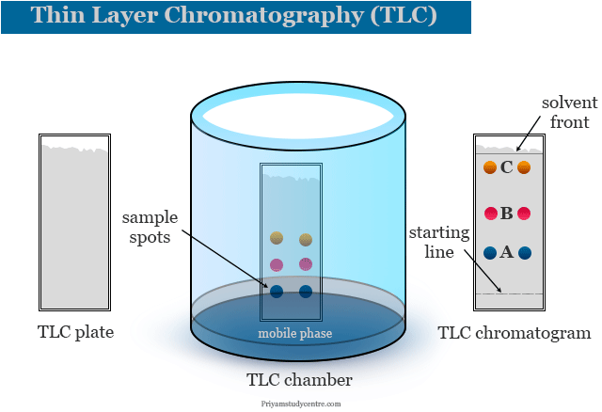
Fig.X.22 Thin Layer Chromatography.
- Chromatogram
When the spot becomes dry, the plate is put into the chamber which contains a suitable solvent with its saturated vapour. The absorbent layer must be under the solvent and spots must be above the solvent. When the solvent front travels at least three fourth of the length of the plate, a chromatogram is developed.

- Identification of components
Components of colour compounds mixture are directly identified by colour spots in the chromatogram. Components of colorless compounds can be identified by UV light on the dried plate to obtain fluorescence or by placing it into an iodine chamber or spring with a suitable reagent to give coloured spots. After making the spot, the R_{f} values are calculated.

4.6.4. Applications of TLC in pharmaceutical analysis
- Quick screening and identification of compounds in complex mixtures
- Determination of Rf values for standardization and method development
- Purity testing of drug substances and formulations such as analgesics, anesthetics, hypnotics, anticonvulsants, sedatives, tranquilizers, etc
- Separation of isomers and enantiomers
- Identification of degradation products

4.7. Paper Chromatography
Paper chromatography in analytical chemistry is a technique that we used for the identification and separation of coloured samples. In paper chromatography experiments, a mixture of substances is located and identified by the flow of a mixture of two solvents which is immiscible or partially miscible on specially designed Whatman filter paper. The solvent rises up on paper owing to capillary action. Paper chromatography experiment is used mainly for the separation or identification of amino acids, dyes, or sugars. Presently, the paper chromatography procedure is used as a teaching tool in labs due to the discovery of other chromatography methods such as thin-layer chromatography, ion-exchange chromatography. In 1944 Consden, Gordon, and Martin first introduced the paper chromatography technique.
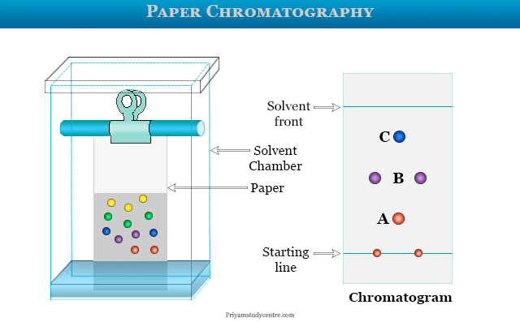
Fig.X.23 Paper chromatography.

4.7.1. Paper chromatography principle
- In paper chromatography experiments, a drop of mixed solution is placed near one short end of rectangular filter paper by a microsyringe or capillary tube. The spot on the paper is allowed to dry.
- The spotted filter paper is suspended vertically in the solvent chamber where the spot just touches solvent levels. Simply, the filter paper below the spot dipped into the solvent.
- When the solvent front moves upward and passes the spot, it carries the different components upwards. The rates of upward capacity depend on the nature of substances, the polarity of the solvents, and the size of the molecules.
- The solvent front is allowed to move upward until it travels 3/4 of the height of the filter paper.
- What is R_{f} Value?
The relative rate of movement of solute and solvent is called the R_{f} value. It is the ratio of the distance traveled by the sample component and the distance traveled by the solvent.R_{f} value is constant for a given substance under given conditions. Therefore, various components can be identified by their R_{f} value in paper chromatography. R_{f} value has no unit but varies with the change of solvent.

4.7.2. Material required in paper chromatography
- Whatman filter paper strip.
- A mixture of unknown amino acids is dissolved in 10 ml of water.
- Solution of glycine: 5 mg of glycine in 1 ml of water.
- Ninhydrin spray: 200 mg of ninhydrin is dissolved in 99 ml of n-butanol and 1 ml of acetic acid.
- Solvent: n-butanol, acetic acid, and water = 80ml, 20 ml, and 100ml.

4.7.3. Paper chromatography procedure
A line parallel to the short end of the chromatography paper sheet is drowned by a pencil about 10 cm apart. Two points are marked on the Whatman filter paper strip.
The mixture of amino acids is spotted on one mark with no more than 5 mm diameter. Similarly, the second mark is spotted by the standard solution of glycine. The spot is allowed to dry.
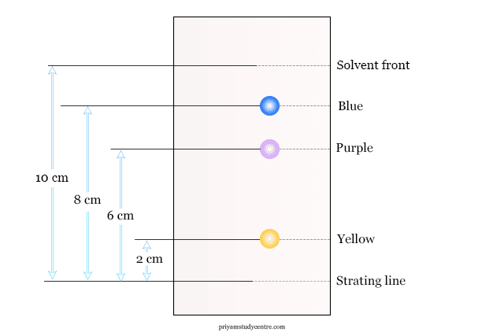
Fig.X.24 Paper chromatography.
The developing solvent is placed in a clean dry glass chamber of a paper chromatographic instrument. The glass chamber is covered with a glass plate having a hole in the middle.
The paper strip hangs from a wire hook dipped into the solution where the spots are just above the solvent front. The solvent rises owing to capillary action on the paper strip. When it almost reaches the point of suspension from the wire hook, the paper strip is carefully taken out from the chamber.

4.7.4. Uses of paper chromatography
It is used mainly for the identification of substances such as amino acids, sugars, dyes, etc. The separations by the paper chromatography principle are possible because of the continuous partitioning of substances between the aqueous phase and organic mobile phase running down the paper.
Solute migration is initiated from a small narrow spot. Surface tension is the driving force for capillary action. Therefore, a liquid-liquid partition is predominant in the mechanism of paper chromatography.
4.8. Other chromatographic techniques

4.8.1. Size exclusion chromatography
Also known as gel permeation chromatography. Separation is based on size rather than interactions. Large molecules are excluded and elute first while smaller molecules penetrate into pores and elute later. It is used for:
- Determining molecular weight distribution of polymers
- Purification of macromolecules
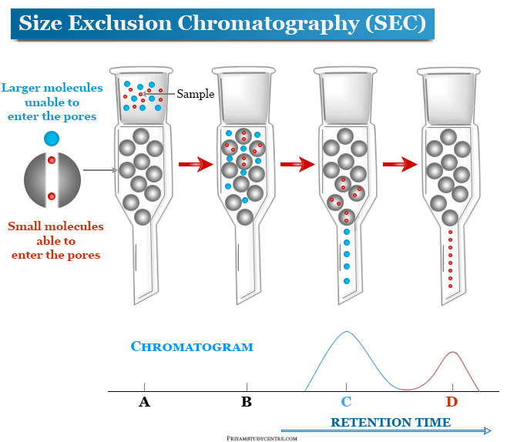
Fig.X.25 Size exclusion chromatography.

4.8.2. Ion exchange chromatography
Separation based on ionic interactions between sample ions and oppositely charged stationary phase. This technique is used for:
- Determination of ionic impurities
- Purification of chiral drugs by changing buffer pH and salt concentration
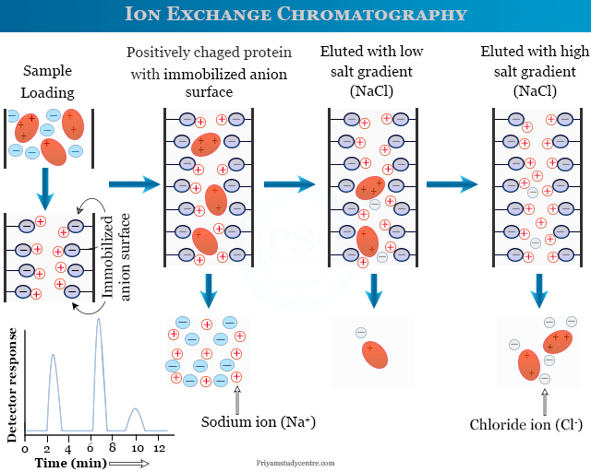
Fig.X.26Ion Exchange Chromatography.

4.8.3. Super critical fluid chromatography
This technique uses supercritical carbon dioxide as mobile phase instead of liquids. The advantages of this method are:
- Higher diffusivity and lower viscosity for better separation
- Greens chemistry technique
- Used for analysis of thermally labile compounds
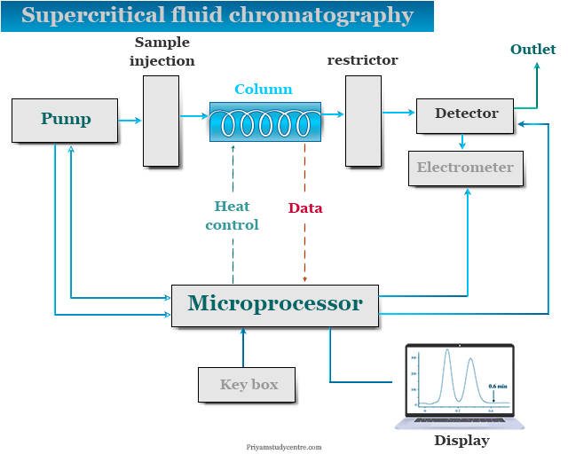
Fig.X.27Super critical fluid chromatography.

4.8.4. Chiral Chromatography
This chromatographic technique uses Enantioselective separation of chiral drugs using chiral stationary phases or chiral mobile phases. It is used for:
- Enantiomeric purity testing of chiral drugs
- Separation of enantiomers for development of single enantiomer drugs
These chromatographic techniques offer various separation mechanisms and advantages that complement HPLC and GC. They find applications in specific areas like determination of impurities, purification of samples and chiral separations which are important tasks in pharmaceutical analysis.

4.9. Method validation for chromatographic techniques
- Specificity: It is defined as the ability of method to measure analyte response in the presence of interferences. Specificity is assessed by comparing chromatograms of blank, standard and sample.
- Accuracy: Accuracy is closeness of test results to the true value. It is determined by recovery studies at multiple concentration levels.
- Precision: Precision is the degree of reproducibility of test results under normal operation. It is assessed by repeatability and intermediate precision.
- Limit of Detection (LOD) and Quantification (LOQ): The smallest concentration that can be reliably detected is called as LOD and while that can be quantified is called LOQ by the method. It is determined from the calibration curve.
- Linearity and Range: Method's ability to obtain test results proportional to concentration within a given range. It is established by analyzing standards at multiple concentration levels.
- Robustness: Robustness is the method's capacity to remain steady with small alterations in parameters. It is assessed by deliberately changing conditions and analyzing the impact on method performance.
Thorough method validation as per regulatory guidelines is essential to demonstrate that a chromatographic technique will consistentl y provide reliable results for its intended use. The various parameters ensure the method is specific, accurate, precise and rugged enough for quantitative analysis of drugs and impurities .

Electrochemical methods
Electrochemical method has emerged as a critical tool in the pharmaceutical industry, offering several advantages over traditional techniques like spectrophotometry and chromatography. One of its key benefits is its high sensitivity and selectivity, which enable the detection of trace amounts of drugs, metabolites, and impurities. Unlike chromatography, which often requires extensive sample preparation and expensive solvents, electroanalytical methods operate with minimal sample volumes and offer rapid and cost-effective analysis. Additionally, electroanalysis provides real-time monitoring, which is particularly useful for therapeutic drug monitoring and point-of-care diagnostics. This chapter explores the principles, techniques, and applications of electroanalysis in pharmaceuticals.

5.1. Principles of electrochemical methods
Electrochemical methods rely on measuring electrical characteristics, including current, voltage, and charge. The analyte and electrode interaction under an applied voltage is the foundation of these approaches, as shown in Fig.X.28. The redox processes occurring at the electrode surface are critical for the detection and quantification of analytes.
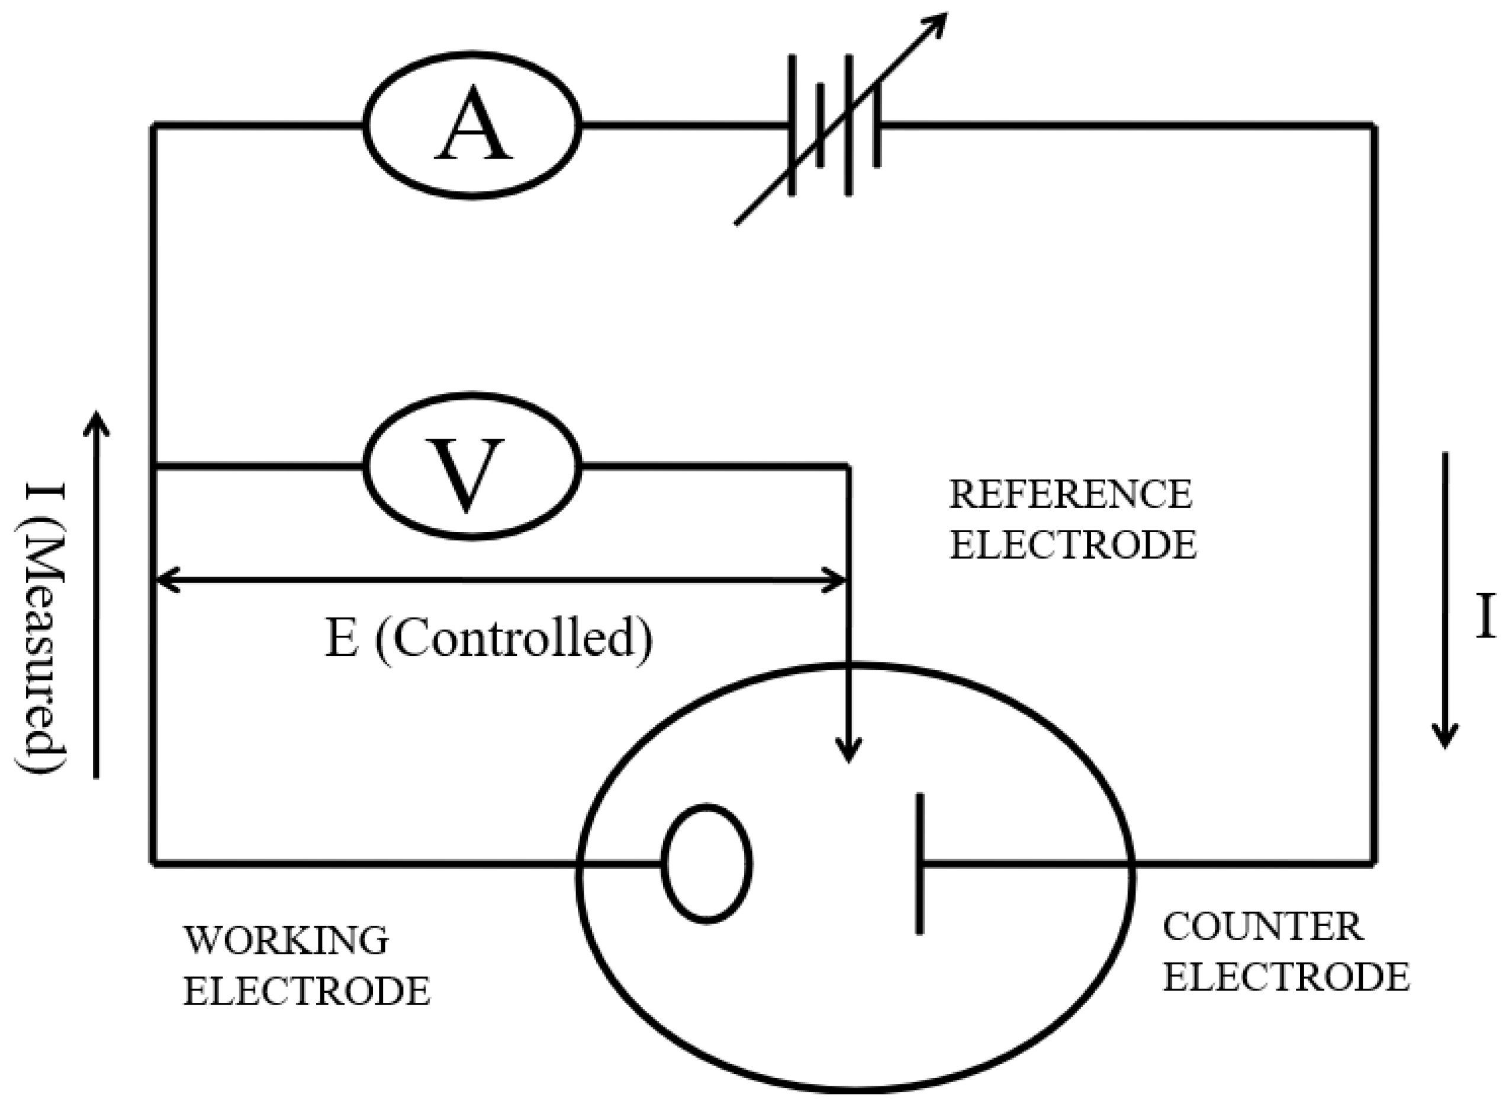
Fig X.28. A simplified circuit for cyclic voltammetry. Where A is an Ammeter to measure the current (I) flowing through the circuit. V is a Voltmeter used to measure and control the potential difference (E) between the working and reference electrodes. Working Electrode is the electrode where the electrochemical reaction of interest occurs while Reference Electrode provides a stable reference potential against which the working electrode’s potential is controlled. Counter Electrode also known as the auxiliary electrode, completes the circuit and allows current to flow.

5.2. Electrochemical techniques
Electrochemical techniques are a group of analytical methods based on the measurement of electrical properties (like current, potential, or conductivity) in an electrochemical cell. They are prized for their sensitivity, selectivity, and applicability to a wide range of samples, from pharmaceuticals to environmental monitoring.These techniques can be broadly categorized based on what is measured and controlled.

5.2.1. Voltammetry

Principle
Voltammetry involves measuring the current that flows in an electrochemical cell as a function of an applied voltage. . It is well known for its sensitivity and capacity to provide extensive information on the electrochemical behavior of the analytes, including redox potentials and reaction kinetics.This category includes techniques such as differential pulse voltammetry (DPV, cyclic voltammetry (CV)and square wave voltammetry(SWV). The main distinction within voltammetry lies in how the voltage is applied.

Specialized voltammetric techniques
- Polarography: A historical type of voltammetry that uses a dropping mercury electrode (DME). It is the foundation for many modern voltammetric methods.
- Amperometry: A subset of voltammetry where the current is measured at a single, fixed potential over time. Often used in biosensors and detection systems (e.g., glucose meters) where a stable current is proportional to concentration after an initial voltammetric characterization.

5.2.2. Potentiometry

Principle
Potentiometry involves measuring the potential (voltage) of an electrochemical cell at zero current (i.e., under conditions of no current flow). This measured potential is related to the concentration of an ion in solution.

Key component: ion-selective electrodes (ISEs)
Potentiometric measurements commonly use Ion-Selective Electrodes (ISEs), which are designed to be sensitive to a specific ion.The most common ISE is the pH electrode, which is sensitive to H⁺ ions.Ion-Selective Electrodes areCrucial for measuring ion concentrations (like Na⁺, K⁺, Ca²⁺, Cl⁻) in pharmaceutical formulations, clinical blood tests, and environmental samples.

5.2.3. Conductometry

Principle
Conductometry measures the ability of an electrolyte solution to carry an electric current, known as its electrical conductivity.The conductivity is directly related to the total concentration of ions present. It is used for:
- Monitoring water purity.
- Tracking the progress of a reaction involving ions (e.g., titration).
- Various industrial and clinical applications where a quick measurement of total ion content is needed.

5.3. Practical Applications
Electroanalysis is an indispensable tool in the pharmaceutical industry, offering highsensitivity, selectivity, and rapid response times for various analytical applications.Its versatility allows for the precise measurement of drug compounds, impurities, andmetabolic byproducts.
Drug Discovery and Development—Electroanalytical techniques aid in screeningpotential drug candidates by evaluating their redox properties, stability, and bioavailability,thereby accelerating the early-stage development process.
Quality Control and Assurance—Differential pulse voltammetry and related techniques enable the precise quantification of active pharmaceutical ingredients (APIs) andthe detection of impurities, ensuring compliance with regulatory standards.
Pharmacokinetics and Metabolism Studies—Real-time monitoring of drug and metabolite concentrations in biological fluids using amperometric biosensors provides critical data
for determining optimal dosage regimens and administration routes.
Therapeutic Drug Monitoring (TDM)—Electroanalytical methods facilitate personalized medicine by continuously tracking patient drug levels, optimizing treatment effectiveness, and minimizing adverse effects.
Environmental Monitoring—The detection of pharmaceutical residues in environmental samples, such as wastewater and surface water, is crucial for assessing their ecological impact. Square wave voltammetry allows for the highly sensitive identification oftrace contaminants.
Counterfeit Drug Detection: Electroanalysis offers a rapid and reliable approach forcounterfeit drug detection by identifying variations in active pharmaceutical ingredients(APIs) and excipients through electrochemical fingerprinting. Portable electrochemicalsensors further enable on-site testing, aiding regulatory bodies and pharmacies in ensuringdrug authenticity and patient safety.

