CHAPTER VIII: PHYSICAL ANALYSIS METHODS FOR CHEMICAL PREPARATIONS IN PHARMACY

Objectives
Upon completing this chapter, the student will be able to:
- Explain the fundamental principle and pharmacopoeial procedure for determining the colour of liquids and its significance in purity assessment.
- Differentiate between mass density and relative density, and describe the pycnometer method for their determination.
- Define melting point, boiling point, and congealing point, and relate their determination to the identification and purity testing of pharmaceutical substances.
- Compare the principles of Loss on Drying and Karl Fischer titration for water content determination, identifying the advantages and limitations of each.
- Apply the principles of Polarimetry to calculate specific rotation and explain its critical role in characterizing chiral active pharmaceutical ingredients.
- Describe the principle of refractive index measurement and its application in identifying liquid substances and testing their purity

Introduction
Physical analysis methods form the first line of assessment in pharmaceutical quality control, providing fundamental, rapid, and often non-destructive means of evaluating chemical substances. These techniques focus on measuring the intrinsic physical properties of a material—such as its color, density, melting point, and optical characteristics—rather than its chemical reactions. This chapter details the standard procedures for these essential tests, which are critical for confirming identity, assessing purity, and ensuring batch-to-bustch consistency. From the visual assessment of a solution's colour to the precise determination of a compound's specific rotation, these methods are indispensable for verifying that raw materials and finished products comply with stringent pharmacopoeial standards before they are released for therapeutic use.

3.Colour of liquids

3.1.Definition
The test for colour of liquids is carried out by comparing the test solution prepared as specified in the monograph with a standard colour solution indicated in the monograph. The composition of the standard colour solution is selected depending on the hue and intensity of the colour of the test solution corresponding to the limits permitted in the specifications.

3.2. Recommended procedure
Unless otherwise specified in the monograph, carry out the comparison in flat-bottomed tubes of transparent glass that are matched as closely as possible in internal diameter and in all other respects (tubes of about 16 mm internal diameter are suitable). Use 10 m1 of the test solution and 10 m1 of the standard colour solution; the depth of liquid should be about 50 mm. The colour of the test solution is not more intense than the standard colour when viewed down the vertical axis of the tubes in diffused light against a white background.

4. Determination of mass density and relative density

4.1. Definition
The mass density (ρ) of a substance is the mass of one unit volume of the substance. In terms of SI base units, mass density is expressed in kilograms per cubic metre. However, in the International Pharmacopoeia the mass density is expressed in kilograms per litre (which is equivalent to grams per millilitre) at a temperature of 20 °C (ρ20) and it is corrected for buoyancy (i.e. reduced to vacuum conditions).
For pharmacopoeial purposes the mass density of liquids is not measured directly but calculated from their relative density. The relative density d²⁰₂₀ is the ratio of the mass of the substance in air at 20 °C to that of an equal volume of water at the same temperature. A relative density less than 1 means the substance is less dense than the reference and will float in water, while a relative density greater than 1 means the substance is denser and will sink.
The term "relative density" d²⁰₂₀ is equivalent to the formerly used term "specific gravity determined at 20 °C". The relative density d²⁰₄ denotes the ratio of the mass of the substance in air at 20 °C to that of an equal volume of water at 4 °C. As the relative density of water at 20 °C is 0.998234, these values are related by the following equation:
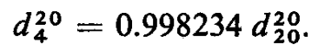

4.2. Recommended procedure
Determine the relative density (d²⁰₂₀) using a hydrostatic balance (only when the precision indicated in the monograph is three decimal digits) or a pycnometer. If the value of mass density ρ20 (in kg/l or g/mL) is referred to in the monograph, carry out the measurement of relative density and from the value obtained calculate the mass density according to the formula:
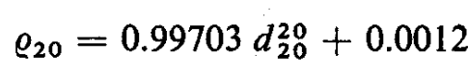

4.2.1. Use of a pycnometer
Use a pycnometer of suitable form of a capacity of not less than 5 mL. Weigh accurately the empty, dry pycnometer(Fig.VIII.1), and fill it with the test liquid brought previously to a temperature of about 20 °C. Hold the filled pycnometer at a temperature of 20 ± 1 °C for about 30 minutes, adjust the liquid to the mark using, if necessary, a small strip of filter-paper to remove the excess and to wipe the inlet from the inside, and weigh accurately. Calculate the weight of the liquid in the pycnometer. Remove the liquid, clean and dry the pycnometer, repeat the measurement with carbon-dioxide-free water R, also at 20 ± 1 °C, and calculate the weight of water in the pycnometer. The ratio of the weights of the test liquid and of water gives the relative density d²⁰₂₀.
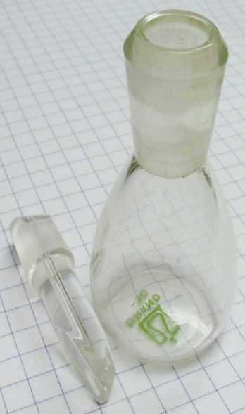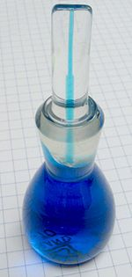
Fig.VIII.1 Empty glass pycnometer and filled glass pycnometer.

5. Determination of melting temperature, congealing point, and boiling point

5.1. Determination of melting points

5.1.1. Definition
The melting point (m.p)℃ of a compound is the temperature at which it changes from a solid to a liquid. Since this requires that the intermolecular forces that hold the solid together have to be overcome. The melting point is a physical property (melting point, boiling point, density, solubility, etc.) often used to identify compounds. The presence of impurities in a substance results in a more or less pronounced lowering of its melting point. Even more significant is that impurities present in the substance may cause its melting range to be extended. In most cases where melting behavior is used as a criterion of purity the International Pharmacopoeia therefore prescribes determination of the melting range rather than the melting point.
Melting point range: The interval between the temperature at which a solid sample just begins to turn to liquid and the temperature at which the entire sample becomes liquid. or range of temperatures in which the first crystal starts to melt until the temperature at which the last crystal just disappears
The statement in a monograph "melting range a-b "C" means that the melting range determined by the method below must fall within these limits.
The melting temperature of a substance is the corrected temperature at which it is completely melted as shown by the disappearance of the solid phase.
- Why measure melting points?
There are various methods of chemical and physical analysis used to differentiate, identify, and classify materials. Measurement of the melting point is, among other things, one of these standard laboratory procedures. It is an experimental and easily performed method of physical analysis used to find out the identity, the purity, and the thermal stability of a material.
- Identification
Pure materials have exactly defined melting points which can be obtained from reference tables. Thus, the identity of a material can be determined by measuring its melting point: One needs only to compare the melting point of the substance as determined in the test with the values in the technical literature. Of course, determination of the melting point alone is not yet enough for the clear identification of a substance. There may be several substances with the same melting point. In such cases, the shift in the mixed melting point can provide an indication about the definitive identification of the material.
- Purity
Even slight impurities in a material cause a lowering of its melting point or at least a widening of its melting range (the material melts within a range of temperatures and not at a precisely definable melting point).
- Thermal stability
Many materials change at high temperatures, e.g., decomposition or discoloration. Measurement of the melting point is one method that can be used to determine how much the material can be heated without causing chemical changes. This value is useful as an indicator for the thermal stability of a substance and can be used to suggest a possible temperature for drying.

5.1.2. Principles and methods of melting point determination
- Determining the melting point in the capillary tube
Melting temperature determined using the capillary method is that temperature at which the last solid particle from a compact column of the substance in the melting point tube goes over into the liquid phase. The determination thus uses the so-called «clear» melting point since this represents an unmistakable criterion for recording the melting point.
The standard capillary method described in the pharmacopoeias starts with a heated liquid bath equipped with a thermometer for measuring the temperature. A glass capillary tube containing the substance to be determined is introduced into this liquid in such a way that the substance in the capillary tube is located close to the mercury reservoir on the thermometer. At the clear melting point, the temperature reading on thermometer is taken. The capillary method described in the pharmacopoeias starts from visual detection of the melting point. More modern instruments for melting point determination enable detection of the melting point not only in the traditional way, visually, but also automatically. Fig. VIII.2 shows two possible instruments that operate using the «bath method» described in the pharmacopoeias.
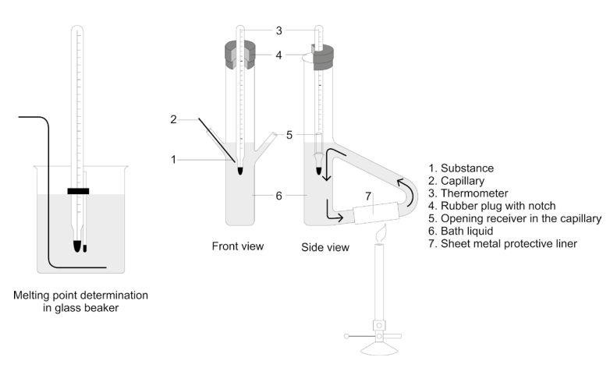
Fig.VIII.2 Melting point determination in the glass beaker and in the Thiele apparatus.
- Immediate melting point
Some materials decompose during the melting process or show a tendency toward polymorphous modifications. The capillary method is not suitable for use with such substances, which is why the pharmacopoeia provides for using the flash melting point in such cases. In this method, the temperature does not affect the substance at all prior to its reaching its melting point. This method uses a heatable metal block (e.g., of brass) that is heated up evenly. A few crystals of the substance to be determined are scattered on this block at regular intervals. The first temperature at which the substance melts immediately on contact with the metal block is read off as T1. The heating of the block is discontinued, and while it is cooling down, small samples of the substance are again scattered on the block at regular intervals. T2 is the temperature at which the substance stops melting immediately on contact with the metal. The immediate melting point is then obtained from the formula. The Kofler heating stand is particularly well-suited for series measurement of the immediate flash point where no special requirements are made with regard to accuracy of measurement. Fig.VIII.3 and Fig.VIII.4 show the various instruments available.

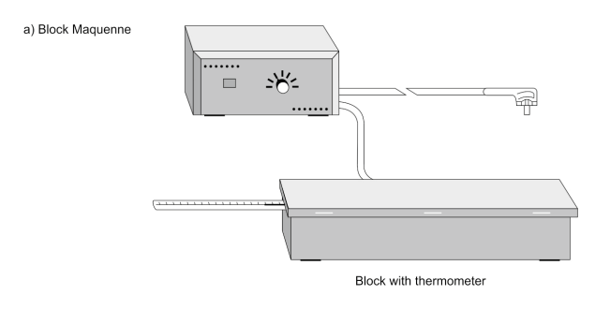
Fig.VIII.3 Metal block instruments for determining the immediate melting point: Block Maquenne.

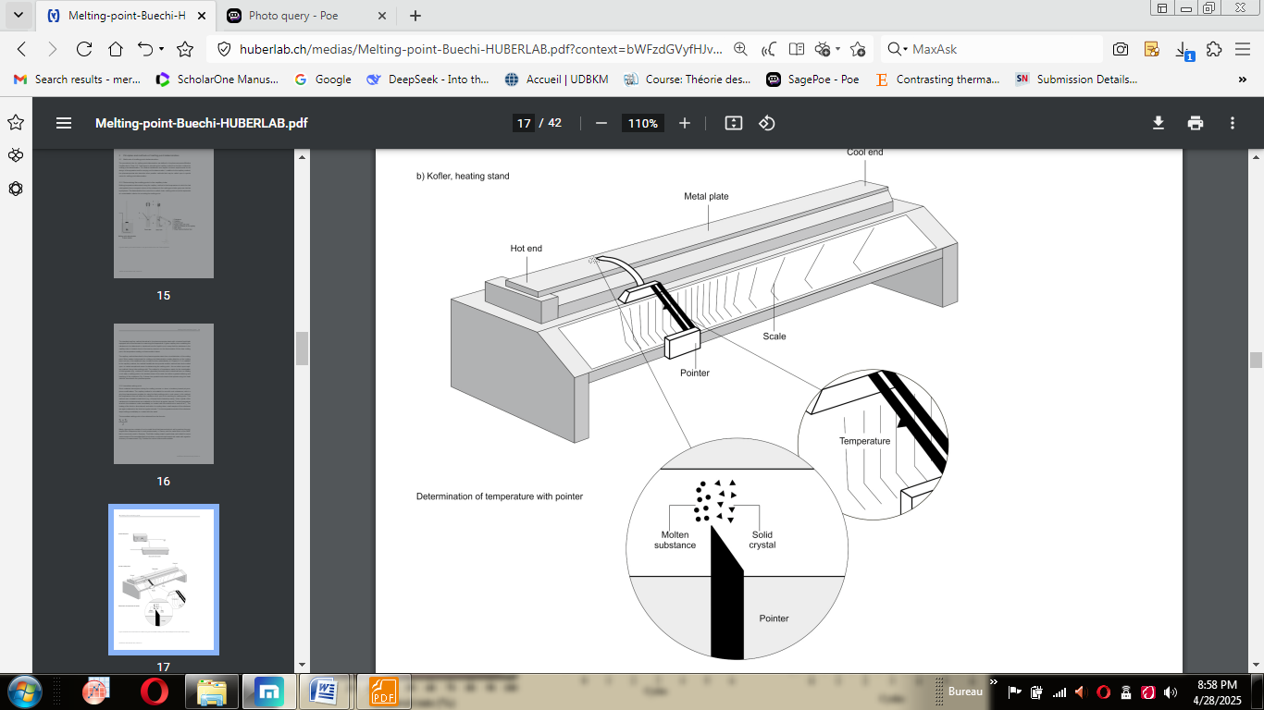
Fig.VIII.4 Metal block instruments for determining the immediate melting point: Kofler heating.

5.2. Determination of boiling points
The boiling point of an organic liquid is the temperature at which its vapour pressure equals the atmospheric pressure over the liquid or it is the temperature at which the vapour and liquid phases are in equilibrium at a given pressure. The boiling point is considered as a criterion of purity of a compound and is useful for identification of organic compounds. Similar to the melting point the boiling point may be sharp or may vary over a temperature range. Pure liquids have sharp boiling points while mixtures show a boiling point range. The atmospheric pressure plays an important role in determination of the boiling point correctly. Reduction of the pressure leads to a decrease or a depression in the boiling point and vice versa.

5.2.1. Apparatus and experimental procedures
A suitable apparatus for the determination consists of a vessel with appropriate liquid, a source of heat, and a thermometer, a thin-walled test-tube of glass of external diameter about 4 mm and length suitable for the apparatus used and a thin-walled capillary tube of glass of internal diameter not exceeding 1 mm, which should be closed by fusing about 2 mm from one end (Fig.VIII.5).
Attach a clean and empty test tube to a thermometer with sewing thread. Put an empty capillary tube in the test tube so that the open end of capillary is down.
Ensure that the temperature of the paraffin oil is below 50 °C. Place 2‐3 mL of sample in the test tube.
Turn on the hot plate and use a clean glass rod to stir the paraffin oil to ensure a uniform heat distribution.
Record the temperature when rapid air bubbles come out from the capillary. At this stage, the vapor pressure of the unknown inside the capillary is higher than the atmospheric pressure.
Turn off the hot plate and carefully insert a ceramic tile between the beaker and the hotplate. Alternatively, you may replace the hot plate with the one that has not been used. However, the thermometer bulb and the content in the test tube should be submerged in the paraffin oil at all times.
As the temperature decreases, air bubbling will gradually slow down. Record the temperature when you see the last bubble come out and some liquid goes into the capillary.
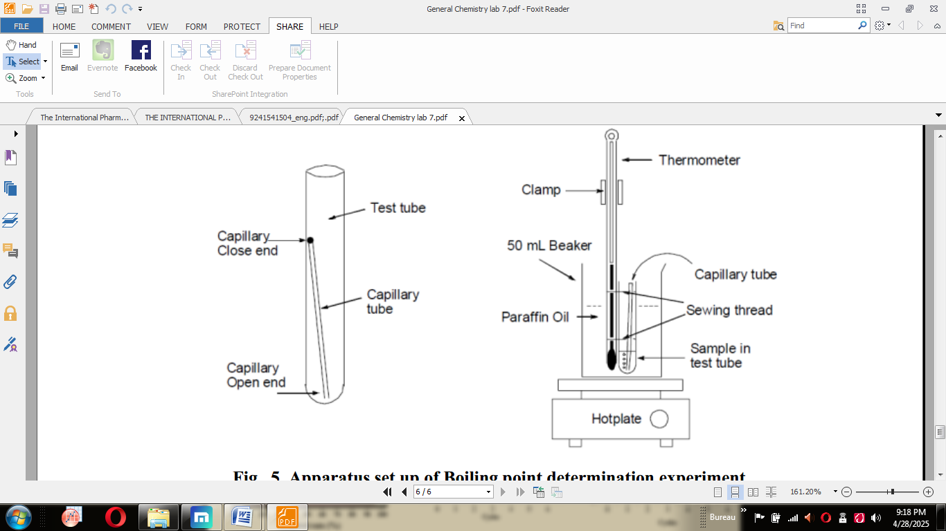
Fig.VIII.5Apparatus set up of boiling point determination experiment.

5.3. Determination of congealing point
The congealing point of a liquid or of a melted solid is the highest temperature at which it solidifies. The congealing point of the liquid is the same as the melting temperature of the solid, but since the liquid may be cooled to a temperature below its congealing point without assuming the solid form, the method described below is used to determine the congealing point of a liquid or of a melted solid.

5.3.1. Apparatus and experimental procedures
A suitable apparatus consists of a test-tube of about 2 cm internal diameter and about 10 cm in length, suspended by means of a bored cork inside a larger tube, about 3 cm in diameter and 12 cm in length, a vessel with water or suitable freezing mixture, and an accurately standardized thermometer.
Unless otherwise specified in the monograph, place in the inner test- tube about 10 m1 of the liquid, or 10 g of the melted solid, to be tested and cool together the inner and the outer tubes in water or in a suitable freezing mixture to a temperature about 5 °C below the expected congealing point of the liquid; with the thermometer gently stir the liquid until it begins to solidify. At first there is a gradual fall in temperature. Then, as the solid phase forms, the temperature remains constant for some time or rises before becoming constant. The highest temperature observed is regarded as the congealing point. If the liquid does not start to congeal within 2 °C of the expected temperature, congelation may be induced by adding a small crystal of the substance to the liquid or by rubbing the inner walls of the test-tube with the thermometer.

Determination of water content in pharmaceutical substances
The accurate determination of water content is critical in pharmaceuticals as it can affect a drug's stability, shelf life, efficacy, crystallinity, and processing behavior.

6.1. Drying methods (Thermogravimetric Methods)
These methods involve the removal of water from the sample, and the result is calculated based on the mass loss. A key limitation is that they are non-selective; any volatile material lost during drying (e.g., solvents, volatile oils, decomposition products) will be measured as "water."

6.1.1. Direct Determination
- Principle: The sample is heated, and the released water vapor is carried by a dry gas into a tube containing a chemical desiccant (like phosphorus pentoxide, P₂O₅ or anhydrous magnesium perchlorate). The water is trapped, and the increase in mass of this tube is the mass of the water.
- Procedure:
  - The absorption tube is weighed.
  - The sample is placed in a heated chamber, and a dry inert gas is passed over it.
  - The volatile components, including water, are swept into the absorption tube where water is selectively trapped.
  - The absorption tube is weighed again.
- Calculation: % Water = (Mass gained by absorption tube / Initial sample mass) × 100

6.1.2. Indirect Determination: Loss on Drying (LOD)
- Principle: The sample is weighed, subjected to a precisely defined drying process and then weighed again. The mass loss is reported as "Loss on Drying."
- Procedure:
  - The sample is placed in a tared (pre-weighed) dish.
  - It is dried under specified conditions (e.g., 105°C for 2 hours) in an oven.
  - The dish is cooled in a desiccator (to prevent moisture reabsorption from the air) and reweighed.
  - This process may be repeated until constant mass is achieved.
- Calculation: % LOD = [(Initial mass - Final mass) / Initial sample mass] × 100
This is the reference (standard) method in many pharmacopoeias for substances that are stable and do not contain other volatiles. The conditions (temperature, time, pressure) are strictly defined for each monograph.

6.2. Selective (Chemical) Methods
These methods are specific for water and do not measure other volatile substances.

6.2.1. Karl Fischer (KF) Titration

This is the most widely used and precise method for direct water quantification in pharmaceuticals.
- Principle: A reaction based on the reduction of iodine by sulfur dioxide in the presence of water. The reaction requires a buffer (to maintain pH) and a solvent (to dissolve the sample).
  - The fundamental reaction is:
I₂ + SO₂ + 2H₂O → 2HI + H₂SO₄
  - This reaction only proceeds stoichiometrically in the presence of water.
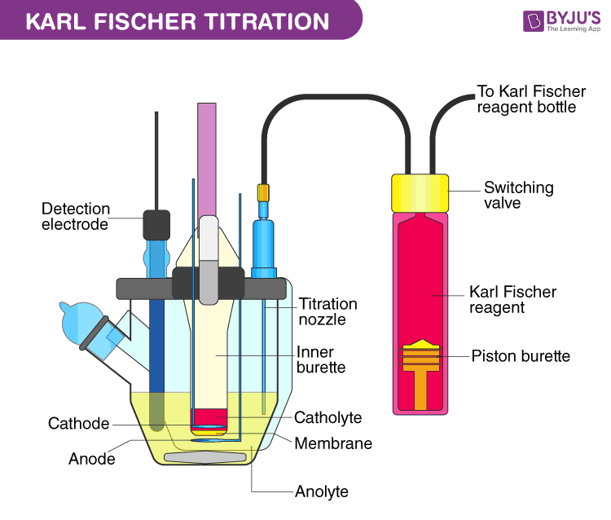
Fig.VIII.6Karl Fischer titration.

Determination of optical rotation and specific rotation

7.1. Generality
Optical isomers, or enantiomers, have the same sequence of atoms and bonds but are different in their 3D shape. Two enantiomers are non superimposable mirror images of one another (i.e., chiral), with the most common cited example being our hands (Fig.VIII.7). Optical isomers have basically the same properties (melting points, boiling points, etc.) but there are a few exceptions (uses in biological mechanisms and optical activity). There are drugs, called enantiopure drugs, which have different effects based on whether the drug is a racemic mixture or purely one enantiomer. For example, d-ethambutol treats tuberculosis, while l-ethambutol causes blindness. Optical isomers differ in a property called optical activity, in which a sample rotates the plane of polarization of a polarized light beam passing through.
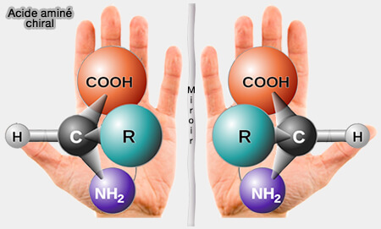
Fig.VIII.7Chiral molecule.

7.2. Polarimetry
It is the measurement and interpretation of the polarization of electromagnetic waves that have traveled through some material in order to characterize that object. Polarimetry is a sensitive, nondestructive technique for measuring the optical activity exhibited by inorganic and organic compounds. Some chemical substances are optically active, and polarized (unidirectional) light will rotate either to the left (counter-clockwise) or right (clockwise) when passed through these substances. The amount by which the light is rotated is known as the angle of rotation. A polarimeter is a scientific instrument used to measure the angle of rotation caused by passing polarized light through an optically active substance (Fig.VIII.8).
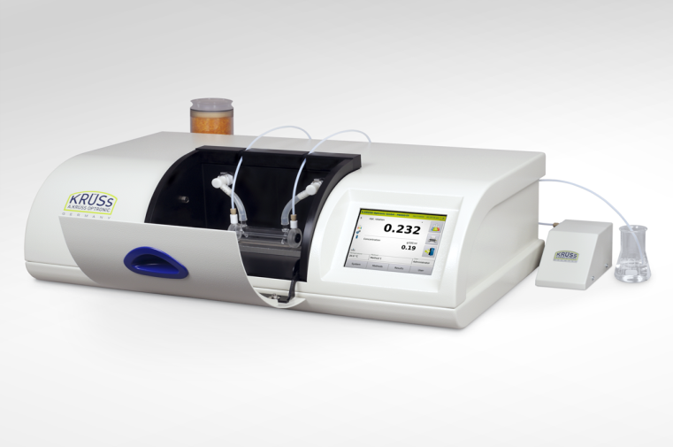
Fig.VIII.8 An automatic digital polarimeter.

7.3. Measuring optical rotation
The sample is usually prepared as a tube where the optically active substance is dissolved in an optically inactive chemical such as distilled water, ethanol, methanol. Optically active samples, such as solutions of chiral molecules, causes rotation of the polarization of plane polarized light as it passes through the sample (Fig.VIII.9). In an ordinary light, the vibrations occur in all planes perpendicular to direction of propagation. When it is allowed to pass through a Nicol prism then itsvibrations in all directions except the direction of axis of the prism are cut off. The light emerging out of the prism is said to be plane polarizedbecause its vibration is in one direction. If two Nicol prisms are placed with their polarization planes parallel to each other, then the light rays emerging out of the first prism will enter the second prism. As a result, complete bright light is observed. If the second prism is rotated by an angle of90°, the light emerging from the first prism is stopped by the second prism due to which complete dark or no light region is observed.
In a polarimeter (Fig.VIII.9), plane-polarized light is introduced to a tube (typically 10 cm in length) containing a solution with the substance to be measured. If the substance is optical inactive, the plane of the polarized light will not change in orientation and the observer will read an angle of α= 0o. If the compound in the Polarimetry cell was optical active, the plane of the light would be rotated on its way through the tube. The observed rotation is a result of the different components of the plane polarized light interacting differently with the chiral center. In order to observe the maximum brightness, the observer (person or instrument) will have to rotate the axis of the analyzer back, either clockwise or counterclockwise direction depending on the nature of the compound. For clockwise direction, the rotation (in degrees) is defined as positive («+») and called dextrorotatory (from the Latin: dexter = right). In contrast, the counterclockwise direction is defined as negative («-») and called levorotatory (from the Latin laevus=left). The specific rotation of the sample may then be calculated. Temperature can affect the rotation of light, which should be accounted for in the calculations.
[α]=α/ ​/l × c
Where:
[α] is the specific rotation (in °·mL·dm⁻¹·g⁻¹), T is the temperature (in °C), λ is the wavelength of light (in nm), α is the measured optical rotation (in degrees), l is the length of the polarimeter tube (optical path length in dm), and c is the mass concentration of the solution (in g/mL)
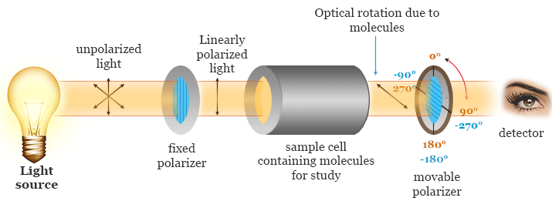
FigVIII.9 Circuit to explain the rotation of polarized light plane as it passes through the optically active sample.

7.4. Calibration
Polarimeter can be calibrated or at least verified by measuring a quartz plate, which is constructed to always read at a certain angle of rotation (usually +34°, but +17° and +8,5° are also popular depending on the sample). Quartz plates are preferred by many users because solid samples are much less affected by variations in temperature, and do not needs to be mixed on-demand like sucrose solutions.

Determination of refractive index

8.1. Definition
The refractive index (n) of a substance is the ratio of the velocity of light in a vacuum to its velocity in the substancewhich means it describes how light, or any other radiation, propagates through that medium. It varies with the wavelength of the light used in its measurement and with the temperature. It is therefore necessary to specify these conditions. It is defined as
n= c/ υ
Where c is the speed of light in vacuum and υ is the phase velocity in the substance.
For example, the refractive index of water is 1,33, meaning that light travels 1,33 times as fast in vacuum as it does in water.
The measurement of the refractive index is employed for pharmacopoeial purposes mainly to establish the identity ofliquid substances. It may also be used to test the purity of such substances. The accuracy of the measurement should be related to the requirements of the monograph. For pharmacopoeial purposes it is usually adequate to express the refractive index to three decimal places. In practice it is usually convenient to measure the refraction with respect to air and the substance, rather than with respect to a vacuum and the substance, since, for pharmacopoeial purposes, this has no significant influence on the observed values.

Apparatus
Refractometers are instruments that measure the bending of light as it crosses an interface between dissimilar substances and converts the bending light rays into a useful scale. A refractometer is a laboratory or field device for the measurement of an index of refraction.
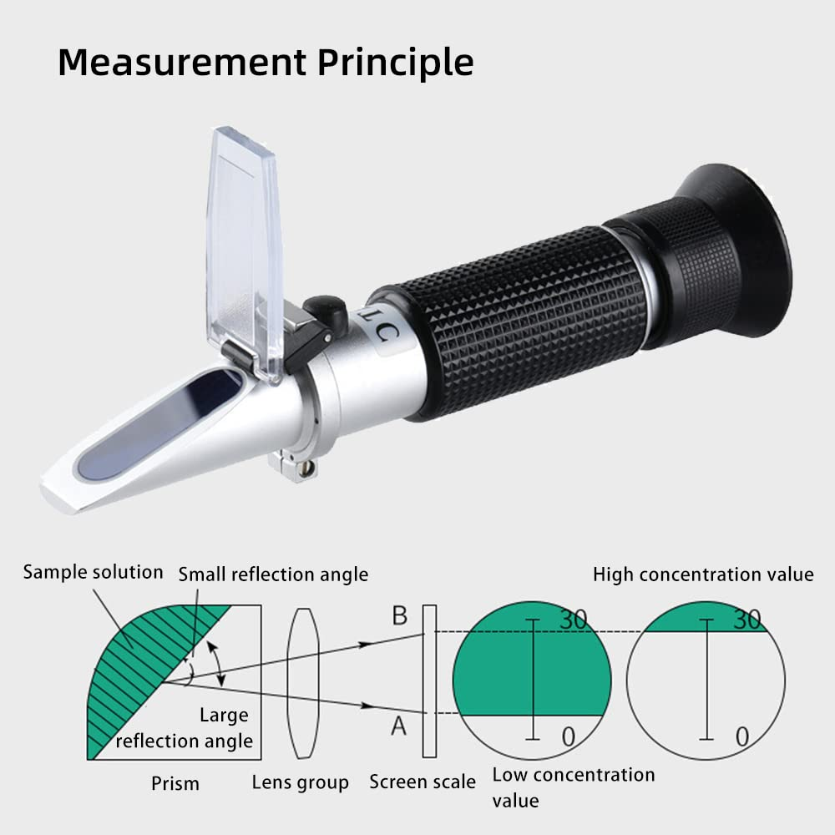
Fig.VIII.10Refractometer.
Commercial refractometers are normally constructed for use with white light but are calibrated to give the refractive index in terms of the sodium light of wavelength 589.3 nm. The optical parts of the apparatus should be kept brilliantly clean. The working surfaces of prisms should be free from scratches.
The instrument should be calibrated against a standard provided by the manufacturer; the temperature control of the liquid being examined and the cleanliness of the prism should be checked frequently by deter- mining the refractive index of distilled water, which is 1.3330 at 20 °C and 1.3325 at 25 °C.

