Table of Content
CHAPTER VII: ASH ANALYSIS 3
1. Objectives 3
2. Introduction 3
3. Ash values 3
3.1. Determination of total ash 4
3.1.1. Principle 4
3.1.2. Apparatus 4
3.1.3. Procedure 4
3.2. Determination of acid insoluble ash 5
3.3. Sulphated ash analysis 5
3.3.1. Procedure 5

CHAPTER VII: ASH ANALYSIS

Objectives
By the end of this chapter, the student will be able to:
- Understand the principles and significance of ash values in quality control.
- Perform ash determination techniques.

Introduction
Total ash and acid-insoluble ash are fundamental purity tests for pharmaceuticals and herbal medicines. While total ash measures all inorganic residues (both natural and contaminants), acid-insoluble ash specifically detects adulterants like silica or sand. This chapter covers the principles, standard methods, and step-by-step techniques to perform these analyses accurately.

Ash values
The in-organic content remaining after incinerating a crude drug is called as ash content. An ash value implies the naturally inherent inorganic salts or those imparted from external sources. Official ash values are chiefly used for quality confirmation of powdered drugs. Determination of ash value helps in knowing absence of mineral matter that is accidentally introduced from earth, sand, floor sweepings, absence of other parts of plant, absence of adulterated and exhausted drug, and absence of materials that possess with stone cells, starch which modify the value.
Total ash value is used for ensuring quality of drugs which possess with little calcium oxalate (ex: ginger). Acid-insoluble ash is referred if calcium oxalate present is high. It is believed that acid-insoluble ash gives different values due to varying conditions of ignition. Treatment of ash with hydrochloric acid leaves only silicawhich is imparted from soil and hence acid-insoluble ash is preferred. Water soluble ash is the difference between total ash and water insoluble residue.

Determination of total ash

Principle
Principle involved is that when a known weight of feed is ignited to ash, the weight of ash thus obtained is expressed in terms of percentage.

Apparatus
• Silica crucible
• Tongs
• Weighing balance
• Electrical bunsen burner
• Muffle furnace
• Desiccator
• Asbestos sheet

Procedure
1. Find out the weight of a clean dry crucible.
2. Place about 2 g of sample and weigh this to find out accurate weight of the sample taken.
3. Carefully place the weighed crucible over electric burner. The crucible should be partially opened.
4. The sample will get charred with initial expulsion of smoke.
5. Place the crucible in a muffle furnace (Fig. 7.2) and heat to 600ºC. Keep it for 2 hours.
At this temperature all organic matter will be burnt leaving behind minerals.
6. Remove the crucible from the furnace carefully and cool it in a dessicator to room temperature and weight again.
The percentage ash was calculated using this equation.
%Total Ash = (W₁−W₀)/(W₂−W₀)×100
Where
W₀ = Weight of empty crucible
W₁ = Weight of crucible + dry sample
W₂ = Weight of crucible + ash sample
What is obtained after complete combustion of a sample is total ash. It comprises of two portions: The portion that is soluble in dilute acids contains all essential minerals and that is the useful portion of the ash. Other portion, insoluble in dilute acids consists of mainly sand and silica. For the most part, itrepresentsimpurity or adulteration.

Determination of acid insoluble ash
The ash obtained described as total ash was boiled for 5 min. with 25 cm3 of 10 % dilute hydrochloric acid. The insoluble matter was collected on an ash-less filter paper and washed with hot water and ignited to constant weight. The percentage of acid insoluble ash was calculated with reference to the air dried drug
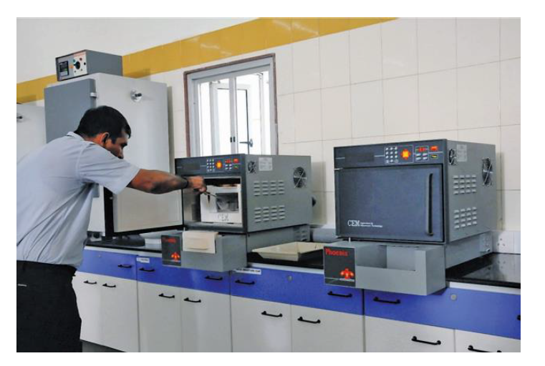
Fig.VII.1 Muffle furnace.

Sulphated ash analysis
The sulfated ash test is a critical method for evaluating non-volatile inorganic impurities in unorganized drugs (e.g., resins, gums) and organic substances. This procedure involves igniting the sample with sulfuric acid, which decomposes organic matter and oxidizes residual materials, leaving only stable sulfate salts of cationic impurities. Compared to other ash tests, this method offers superior reproducibility due to the thermal stability of inorganic sulfates at high temperatures. By quantifying non-volatile residues after ignition, the test provides a reliable measure of inorganic contaminants in accordance with pharmacopeial standards.

Procedure

- Method A
Accurately weigh about 1 g of the substance, or the quantity specified in the monograph, into a suitable crucible (usuallyplatinum) and moisten with sulfuric acid (~1760 g/l) TS. Heat gently to remove the excess of acid and ignite at about 800 °C untilall the black particles have disappeared; again moisten with sulfuric acid (~1760 g/l) TS and reignite. Add a small amount ofammonium carbonate R and ignite to constant weight.
- Method B
Ignite a suitable crucible (for example silica, platinum, quartz or porcelain) at 550 °C to 650 °C for 30 minutes, cool the crucible in a desiccator (silica gel or other suitable desiccant) and weigh it accurately. Take the amount of test sample specified in the individual monograph in the crucible and weigh the crucible accurately. Moisten the sample with a small amount (usually 1 mL) of sulfuric acid (~1760 g/l) TS, heat gently at a temperature as low as practicable until the sample is thoroughly charred. After cooling moisten the residue with a small amount (usually 1 mL) of sulfuric acid (~1760 g/l) TS, heat gently until white fumes areno longer evolved and ignite at 550 °C to 650 °C until the residue is completely incinerated. Ensure that flames are not produced at any time during the procedure. Cool the crucible in a desiccator (silica gel or other suitable desiccant), weigh accurately and calculate the percentage of residue. Unless otherwise specified, if the amount of residue so obtained exceeds the limit specified in the individual monograph, repeat the moistening with sulfuric acid, heating and ignition as before, using a 30-minute ignition period, until two consecutive weighings of the residue do not differ by more than 0.5 mg or until the percentage of residue complies with the limit in the individual monograph.

