Table of Content
CHAPITRE VI: STERILZATION 3
1. Objectives 3
1. Introduction 3
2. Sterilization methods 3
3.1. Destruction based methods 4
3.1.1. Heat (Dry and moist) 4
3.1.2. Radiation 5
3.1.3. Gas Sterilization 6
3.2. Elimination-Based Methods 7
3.2.1. Filtration 7

CHAPITRE VI: STERILZATION

Objectives
By the end of this chapter, the student will be able to:
- Define and explain the core concept of sterilization.
- Classify the different sterilization methods.

Introduction
Sterilization is a term referring to any process that eliminates (removes) or kills all forms of microbial life, including transmissible agents (such as fungi, bacteria, viruses, spore forms, etc.) present on a surface, contained in a fluid, in medication, or in a compound such as biological culture media. Sterilization can be achieved by applying heat, chemicals, irradiation, high pressure, or filtration.

Sterilization methods
Sterilization methods are fundamentally categorized into two overarching principles: destruction-based methods, which actively kill microorganisms, and elimination-based methods, which physically remove them. These principles are executed through physical and chemical meansFig.1.
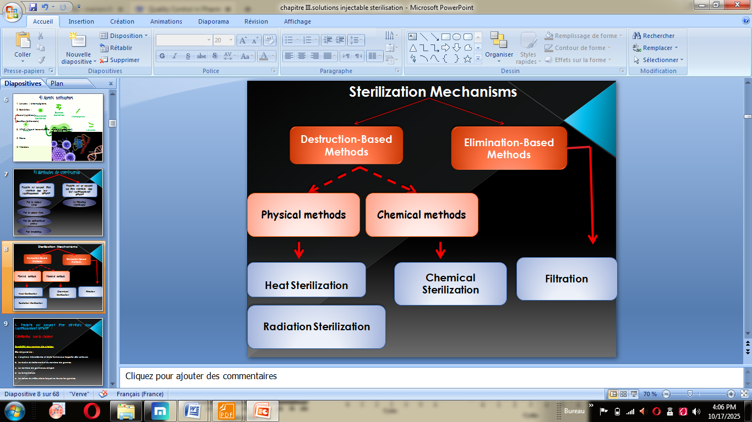
Fig.VI.1 Sterilization mechanism.

3.1. Destruction based methods
These methods work by actively destroying or inactivating microorganisms at the molecular or structural level. They cause irreparable damage to essential microbial components like proteins, DNA, and cell membranes, leading to cell death.

3.1.1. Heat (Dry and moist)
Heat is considered to be most reliable method of sterilization of objects that can withstand heat.
A. Dry heat
Dry heat is one such method, whose primary mechanism of action is the oxidation of microbial cell components, effectively burning them. It is applied through several techniques. Flaming (Fig.2)is a common practice for the direct sterilization of small items like inoculating loops, wires, and spatulas. For larger or more complex items, a hot air oven is used, typically operating at standard cycles of 160°C for 2 hours or 170°C for 1 hour. This method is commonly employed to sterilize glassware, such as Petri dishes and test tubes, as well as metallic instruments like scalpels and forceps.
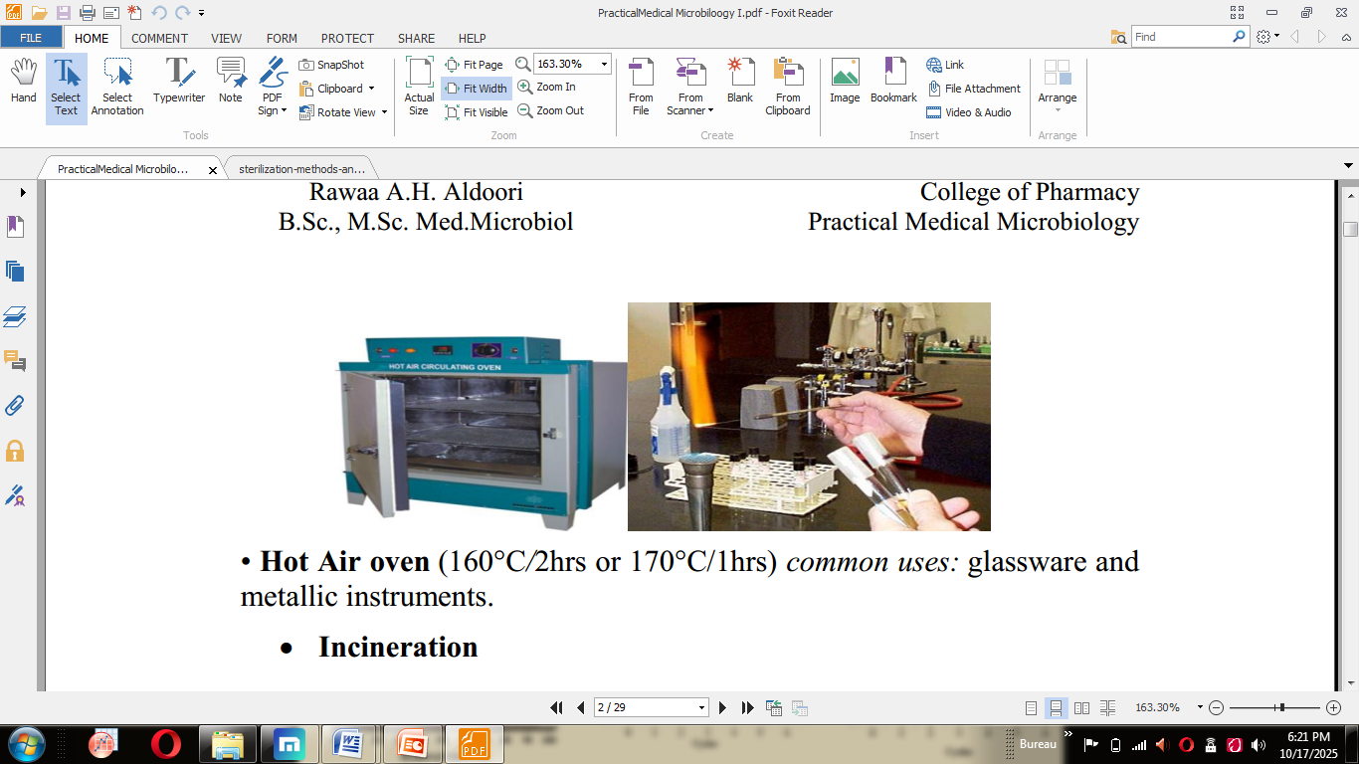
Fig.V.2 Dry heat sterilization.
B. Moist heat
The sterilization method of choice in most laboratories is autoclave(Fig.3). It uses pressurized steam to heat the material to be sterilized. This is a very effective way to kill all microbes, spores and viruses, but some specific bugs require particularly high temperatures or incubation times. Autoclaves kill microorganisms by hydrolyzing and coagulating cellular proteins. This is efficiently achieved by applying intense heat in the presence of water. Intense heat comes from steam. Compressed steam has a high latent heat. It retains 7 times more heat than water at the same temperature. This heat is released upon contact with the colder surface of the material to be sterilized, allowing rapid heat release and good penetration into high density materials. At these temperatures, water does a great job of hydrolyzing proteins.
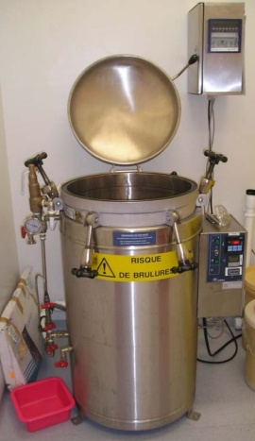
Fig.V.3 Autoclave.

3.1.2. Radiation
There are two main types of radiation used for microbial control, both of which typically destroy nucleic acids.
A. Non-ionizing Radiation
- UV Radiation has a germicidal effect on microorganisms. However, it has limited penetration in air, so sterilization is only effective in a reasonably small area around the lamp. It is a relatively safe method and is useful for sterilizing small, enclosed spaces like laminar flow hoods(Fig.4).
- Common uses: Surface disinfection in hospitals, operating theatres, and laboratories.
B. Ionizing Radiation
- X-rays and gamma rays are far more penetrating than UV light. This makes them more hazardous to handle but also highly effective for the large-scale, "cold" sterilization of items like plastic syringes during manufacturing. This type of radiation uses high energy to cause direct breaks in DNA strands and generates free radicals that damage other cellular structures.
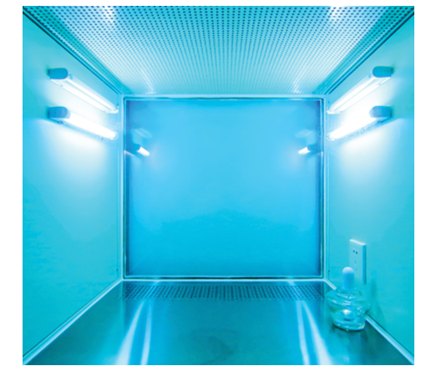
Fig.V.4 Sterilization by UV.

3.1.3. Gas Sterilization
Ethylene oxide gas is a low-temperature alkylating agent used to sterilize heat-sensitive objects that would be damaged by steam sterilization. Its common applications include medical and pharmaceutical products, as well as plastic containers. Formaldehyde, a water-soluble gas often supplied as a 35% solution in water known as formalin, is another effective sterilant. It acts as a broad-spectrum germicide against bacteria, fungi, viruses, and even endospores through a mechanism of protein denaturation. It is commonly used for the sterilization of surgical instruments. In contrast, alcohols such as ethanol (80%), propanol (60%), and isopropanol (70%) are primarily used as disinfectants rather than sterilants. Their action, which also involves protein denaturation, is quite effective against bacteria and fungi but less so against viruses, and they are entirely ineffective against bacterial spores. Consequently, their most common uses are for the surgical and hygienic disinfection of skin and hands.
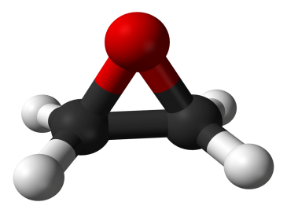
Fig.V.5 Ethylene oxide.

3.2. Elimination-Based Methods
These methods work by physically separating and removing microorganisms from the product or medium. They do not necessarily kill the microbes; instead, they are mechanically separated and retained by a barrier.

3.2.1. Filtration
Membrane filters with a pore size of 0.22 μm are commonly used as sterilizing filters. However, macromolecules, such as proteins and peptides, can be damaged during filtration due to shear stress, leading to an alteration of their three-dimensional structure. In some cases, the formulation can affect the integrity of the filter and cause clogging. Furthermore, some filters adsorb the drug product. Therefore, drug interactions with the filter material are carefully studied before implementing this sterilization method. Common filter materials include nylon and Teflon.

