Table of Content
CHAPTER V: SAMPLING OPERATIONS 3
1. Objectives 3
2. Introduction 3
1. Sample selection in drug analysis 3
2. Termes and types of samples 4
5. General rules 6
5.1. Sampling facilities 6
5.2. Health and safety 7
5.3. Sampling operation and precautions 8
3. Packaging, labeling and storage of samples 9

CHAPTER V: SAMPLING OPERATIONS

Objectives
By the end of this chapter, the student will be able to:
- Define sampling and explain its critical importance in the overall validity of pharmaceutical analysis.
- Identify the roles and necessary qualifications of a competent sampler.
- Differentiate between key sampling terms
- Outline the general rules for sampling, including the requirements for dedicated facilities, health and safety protocols, and the proper use of sampling tools.
- Describe the correct procedures and essential precautions for conducting a sampling operation to ensure a representative sample is obtained.
- Explain the appropriate methods for packaging, labeling, and storing different types of samples.

2. Introduction
Sampling comprises the operations designed to select a portion of a pharmaceutical product for a defined purpose. The sampling procedure should be appropriate to the purpose of sampling, to the type of controls intended to be applied to the samples and to the material to be sampled. All operations related to sampling should be performed with care, using
proper equipment and tools. Any contamination of the sample by dust or other
foreign material is liable to jeopardize the validity of the subsequent analyses.

Sample selection in drug analysis
The selection of one or more appropriate samples from a larger quantity of material is a very important step in chemical analysis. This is rarely a simple matter. If the final results obtained are expected to have practical value, it is preferable that the sampling steps be carried out by or under the direction of a qualified sampler who understands the general context of the analysis. This person should be an experienced analyst or someone specially trained in sampling. When it is impossible to use the services of such qualified persons to collect samples, the laboratory is encouraged to work with the client to obtain advice and possibly practical assistance, to ensure sampling is as appropriate as possible. It is a very common pitfall to underestimate the importance of the sampling procedure and to entrust it to an employee who is neither qualified nor trained for this task.

Termes and types of samples
One of the best approaches to sampling terminology is provided in the recommendations published by IUPAC. The following definitions have been used as proposed by IUPAC.
Sample
A portion of a material collected according to a defined sampling procedure. The size of any sample should be sufficient to allow all anticipated test procedures to be carried out, including all repetitions and retention samples. If the quantity of material available is not sufficient for the intended analyses and for the retention samples, the inspector should record that the sampled material is the available sample (see Sampling record) and the evaluation of the results should take account of the limitations that arise from the insufficient sample size.
Sampler
Person responsible for performing the sampling operations.
Sampling method
That part of the sampling procedure dealing with the method prescribed for with drawing samples.
Batch
A quantity of any drug produced during a given cycle of manufacture. If the manufacturing process is continuous, the batch originates in a defined period of time during which the manufacturing conditions are stable and have not been modified.
Available sample
Whatever total quantity of sample materials is available.
Original sample
Sample collected directly from the material.
Final sample
Sample ready for the application of the test procedure.
Retention sample
Sample collected as part of the original sampling process and reserved for future testing. The size of a retention sample should be sufficient to allow for at least two confirmatory analyses. In some cases statutory regulations may require one or more retention samples, each of which should be separately identified, packaged and sealed.
Combined sample
Sample resulting from combining all or parts of two or more samples of the material.
Consignment
The quantity of a bulk starting material, or of a drug product, made by one manufacturer or supplied by an agent, and supplied at one time in response to a particular request or order.
Homogeneity
A material is regarded as homogeneous when it is all of the same origin (e.g.from the same batch) and as non-homogeneous when it is of differing origins.
Uniformity
A starting material may be considered uniform when samples drawn from different layers do not show significant differences in the quality control tests which would result in non-conformity with specifications. The following materials may be considered uniform unless there are signs to the contrary: organic and inorganic chemicals; purified natural products; various processed natural products such as fatty oils and essential oils; and plant extracts. The assumption of uniformity is strengthened by homogeneity, i.e. when the consignment is derivedfrom a single batch.
Sampling plan
Description of the location, number of units and/or quantity of material that should be collected, and associated acceptance criteria.
Sampling record
Written record of the sampling operations carried out on a particular material for a defined purpose. The sampling record should contain the batch number, date and place of sampling, reference to the sampling protocol used, a description of the containers and of the materials sampled, notes on possible abnormalities, together with any other relevant observations, and the name and signature of the inspector.
Fig. shows the different classed of materials to be samples in the pharmaceutical industry.
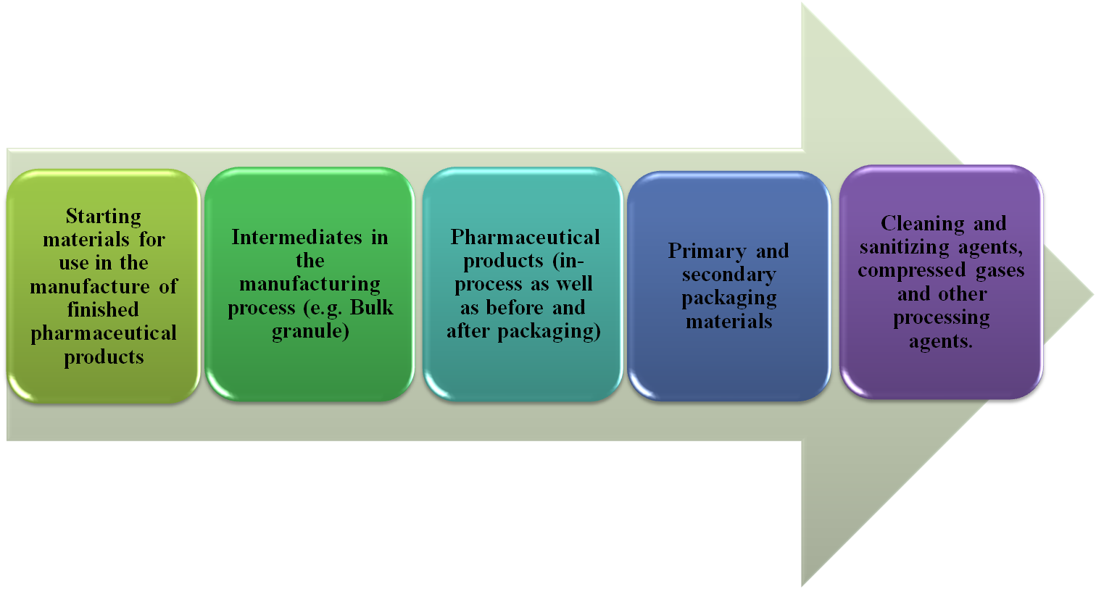
Fig.V.1.Different classes of materials to be samples in the pharmaceutical industry.

5. General rules

5.1. Sampling facilities

Where possible, sampling should be performed in an area designed for and dedicated to this purpose, although this will not be possible where samples are required to be taken from a production line (e.g. in-process control samples). The area in which the sample was taken should be recorded in the sampling record.
Sampling from large containers of starting material or bulk products can present difficulties. Whenever possible, this work should be carried out in a separate, closed cubicle within the warehouse, to reduce the risk of contamination (e.g. by dust) of either the sample or the materials remaining in the container, or of cross-contamination.
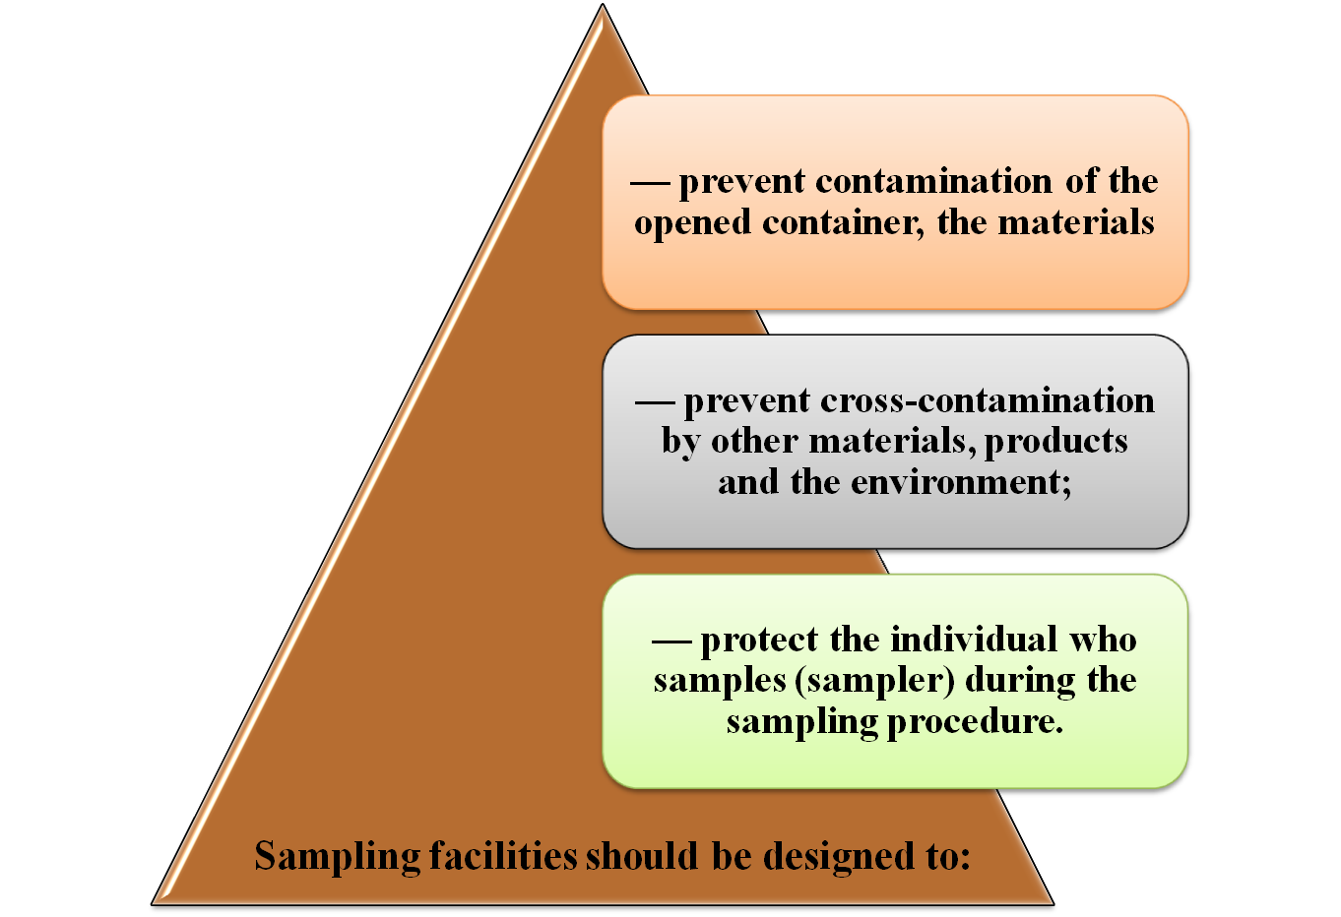
Fig.V.2Sampling facilities requirements.

5.2. Health and safety
- The sampler should:
- read the relevant health and safety information (e.g. the safety data sheet for a pharmaceutical product and related materials) before sampling the material. The information should include necessary safety precautions and requirements for both the operator and the environment.
- wear appropriate protective clothing for the task. If specific safety precautions are required, such as the use of respiratory equipment, the sampler should be properly trained in its use.
- have safe access to and egress from the place where the sample is taken. The sample storage areas should have adequate light and ventilation and should be arranged to satisfy the requirements for safety as well as any special ones arising from the characteristics of the material being sampled.
- Care should be taken to guard against collapse of stacked containers or solids in bulk.
- For the sampling of products, the responsible person should have at his or her disposal all the tools needed to open the containers
- All sampling tools and implements should be made of inert materials and kept scrupulously clean. After use or before reuse, they should be thoroughly washed, rinsed with water or suitable solvent, and dried. They should be stored in clean conditions. Adequate washing facilities should be provided in, or in close proximity to, the sampling area, otherwise samplers will need to bring separate clean sets of implements for sampling each product.
- The cleaning procedure used for all sampling tools and implements should be documented and recorded.

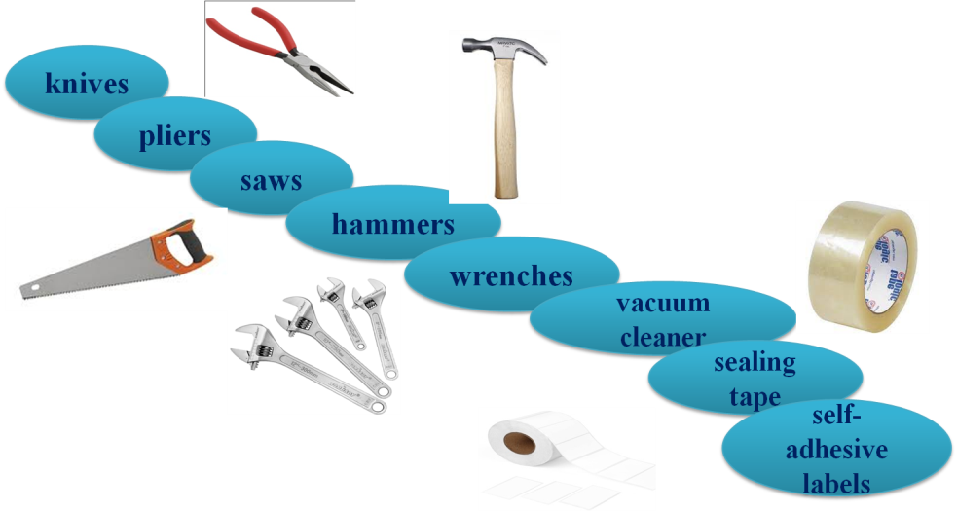
Fig.V.3 Sampling tools.

5.3. Sampling operation and precautions
- Sampling procedure should include the details of the health and safety aspects of sampling.
- Sampling procedure should ensure that representative samples are taken in sufficient quantity for testing in accordance with specifications.
- Samples should never be returned to the bulk.
- The sampling process should be appropriately supervised and documented
- During the sampling procedure, attention should be paid to any signs of nonconformity of the material (differences in shape, size or color of particles in crystalline, granular or powdered solid substances; moist crusts on hygroscopic substances; deposits of solid pharmaceutical product in liquid or semi-liquid products; and stratification of liquid products. Such changes, some of which may be readily reversible, can occur during prolonged storage or exposure to extreme temperatures during transportation).

Packaging, labeling and storage of samples
- The container used to store a sample:
- Should also protect the sample from light, air and moisture, as required by the storage directions for the pharmaceutical product or related material sampled.
- Liquid samples should be transported in suitable bottles closed by screw tops with inert liners that provide a good vapor-proof (moisture-proof) seal for the contents.
- Suitable screw-top jars in exceptional cases only should be used for solid or semi-solid pharmaceutical products.
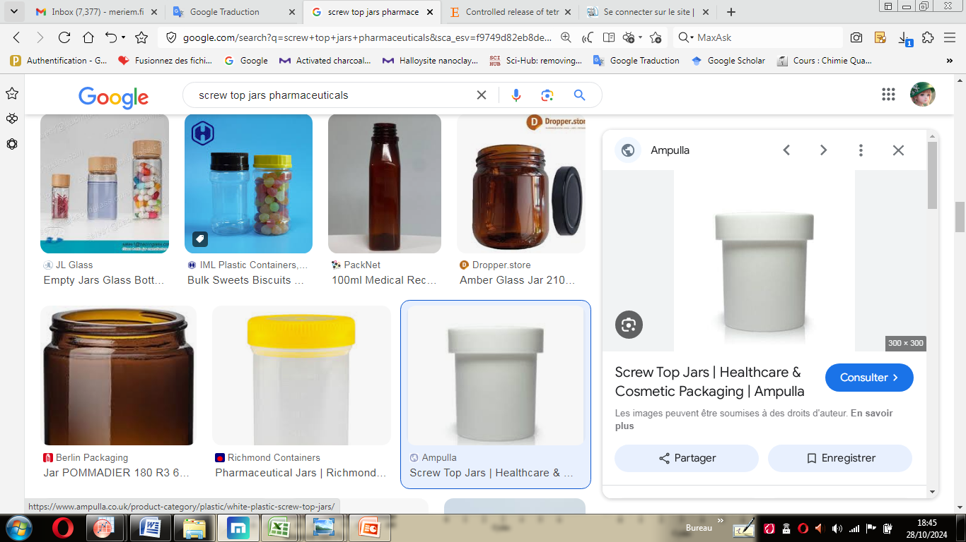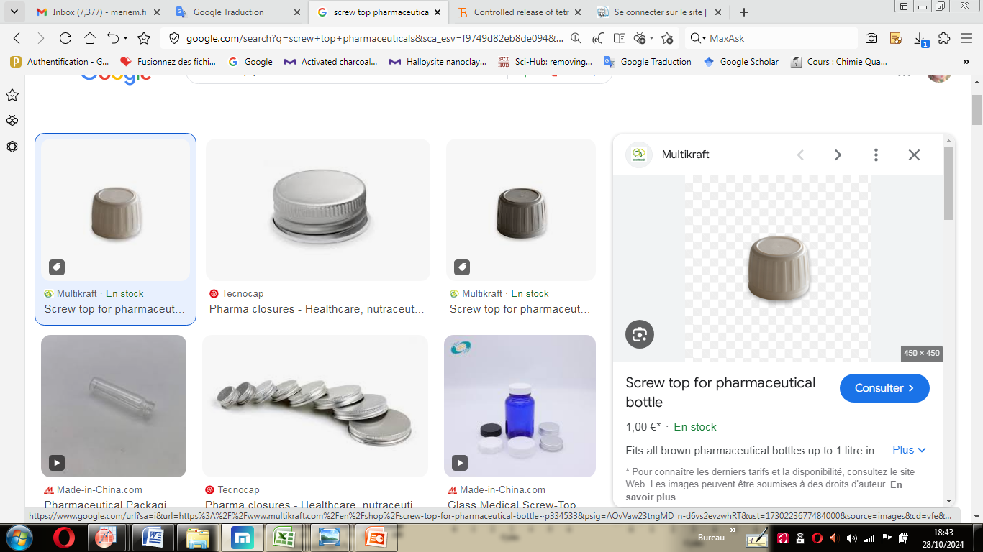
Fig.V.4 Screw-top jars and screw tops.
- Solid dosage forms such as tablets or granules should be protected during transit, either by totally filling the container with the product or by filling any residual space with a suitable material. All samples should be packaged adequately and transported in such a way as to avoid breakage and contamination during transport.

- Labeling of samples should provide appropriate details, including the batch number and, if known, the container number from which the sample was taken, the amount taken and for what purpose. Labels should be applied at the time of sampling. The container used to store the sample should also be properly labeled with appropriate details such as sample type, name of material, identification code, batch/lot number, code, quantity, date of sampling, storage conditions, handling precautions and container number.

