Table of Content
CHAPTER III: PARTICULARITIES OF PHARMACEUTICAL ANALYSIS AND THE ESSENTIAL CRITERIA 3
1. Objective 3
2. Introduction 3
3. Essential criteria of pharmaceutical analysis 4
3.1. Accuracy 4
3.2. Precision 5
3.3. Detection Limit (Limit of Detection, LOD) 6
3.4. Quantitation Limit (Limit of Quantitation, LOQ) 6
3.5. Selectivity and Specificity. 7
3.6. Robustness 8
3.7. Linearity 8

CHAPTER III: PARTICULARITIES OF PHARMACEUTICAL ANALYSIS AND THE ESSENTIAL CRITERIA

Objective
By the end of this chapter, the student will be able to:
- get an idea about the rules of pharmaceutical analysis data treatment and reporting, the scope and process of validation of analytical procedures
- consolidate knowledge in problem solving and laboratory work

Introduction
Pharmaceutical analysis involves the analytical signals treatment and transformation into data concerning the nature and amount of a substance, its chemical structure or spatial location of the sample - important components that require statistical treatment to have any real value. According to pharmacopoeial and GMP requirements, the analytical procedures used for drug quality control must be validated to confirm experimentally that they provide relevant and reliable information about the object of analysis and are suitable for their intended purpose. All quantitative tests, including impurities limit tests, should be validated, as should identification tests if it is necessary to confirm their specificity. The validation of analytical procedures is regulated by various national and international standards (ICH), which evaluate characteristics such as accuracy, precision, specificity, detection limit, quantitation limit, linearity, range, and robustness. Strict adherence to these validation parameters is essential to ensure the reliability and integrity of pharmaceutical analysis, which is critical for product quality, safety, and efficacy.
Revalidation of an analytical procedure is performed in case of:
– changes in drug manufacturing process (the object of analysis);
– changes in the drug's composition;
– changes in the previously approved analytical procedure.
Trueness with regard to a set of measurements involves a combination of two components: Accuracy and Precision.

Essential criteria of pharmaceutical analysis

3.1. Accuracy
Accuracy is a crucial aspect of pharmaceutical analysis and refers to the closeness of the test result obtained by the analytical procedure to the true value Fig. III.1. The value of the bias (systematic error) is an indicator of the accuracy. An analytical procedure to be validated is considered accurate if the values accepted as conventionally true fall within the confidence intervals of the relevant average test results obtained by this procedure.
There are different approaches for assessing the accuracy of quantitative tests (assays):
a) Analysis by a validated procedure using Reference Standards (RS) or model mixtures to which known quantities (concentrations) of the drug substance to be analyzed are added. This allows the comparison of the measured values to the true/expected values.
b) Comparison of the results of the proposed analytical procedure with those of a second well-characterized procedure, the accuracy of which is stated and/or defined. This provides a direct comparison between the two methods.
c) Consideration of the linearity of the proposed analytical procedure: if the absolute term of the equation y = b x + a is not statistically different from zero, then the use of this procedure gives results free of bias.
These approaches provide a robust evaluation of the accuracy of the analytical procedure, which is essential for ensuring the reliability and integrity of pharmaceutical analysis. Maintaining high levels of accuracy is critical for product quality, safety, and efficacy.
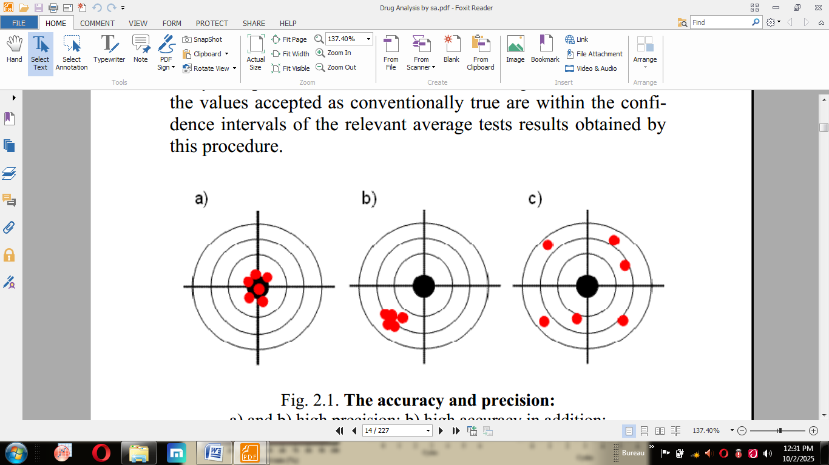
Fig. III.1. The accuracy and precision: a) and b) high precision; b) high accuracy in addition; c) the low accuracy and precision. Black circle indicates that the measured value is accepted to be true.

3.2. Precision
Precision is another crucial characteristic of pharmaceutical analysis, and it refers to the scattering of the results obtained by the analytical procedure around the average value. This characteristic depends only on random factors and is not connected to the true value being measured. The measure of this scattering is the standard deviation of the individual measurements obtained from a sufficiently large sample size.
Precision is assessed for all quantitative tests (assays) using the results of at least three determinations for three levels of values to be measured (lower, middle, and upper), which are within the range. In many cases, the precision can be evaluated based on the experimental data using the least squares method.
The precision study is performed using homogeneous samples and can be assessed in three ways:
- Repeatability: This evaluates the precision under the same operating conditions over a short interval of time.
- Within-laboratory (intermediate) precision: This evaluates the precision within the same laboratory, but under different conditions, such as different days, analysts, or equipment.
- Between-laboratory reproducibility (precision): This evaluates the precision between different laboratories.
The results of these precision studies are usually characterized by the corresponding value of the standard deviation of the individual determinations, along with the number of degrees of freedom. The characteristic of an analytical procedure, connected with the possible identification or detection of analyte within the range of its small amounts is called Sensitivity and in the presence of other components – Specificity. Let's consider the basic numerical characteristics of sensitivity and specificity. Sensitivity is characterized by Detection and Quantitation Limits.

3.3. Detection Limit (Limit of Detection, LOD)
The Detection Limit is the lowest amount of analyte in a sample that can be detected, but not necessarily quantitated, under the stated experimental conditions. This means that limit tests can only confirm whether the analyte is present above or below a certain level, without providing a precise quantitative measurement.
The LOD is typically expressed as the concentration of the analyte (e.g., percentage, parts per billion) in the sample. It characterizes the procedure in terms of qualitative analysis.
For procedures with visual result assessment, the LOD is estimated by analyzing samples with known concentrations of the analyte to determine the minimum detectable amount.
For procedures with instrumental result assessment, the LOD can be calculated using either the signal-to-noise ratio or the standard deviation of the analytical signal and the slope of the calibration curve.
For the calculation using analytical signal/noise level ratio it is necessary to determine the minimum amount (concentration) of the analyte in the sample, in which the signal/noise ratio is in the range of 3 to 5.
The equation LOD = 3.3 × S/b is commonly used, where S is the standard deviation of the analytical signal, and b is the sensitivity coefficient (slope of the calibration curve).

3.4. Quantitation Limit (Limit of Quantitation, LOQ)
The Quantitation Limit is the lowest amount of analyte in a sample that can be quantitatively determined with the required within-laboratory (intermediate) precision and accuracy. The LOQ is particularly important for the determination of impurities and/or degradation products at low levels.
Similar to the LOD, the LOQ is expressed as the concentration of the analyte (e.g., percentage, parts per million) in the sample.
For procedures with visual result assessment, the LOQ is estimated by analyzing samples with various known concentrations of the analyte to determine the minimum value at which the analysis result can be obtained visually with the required accuracy and within-laboratory (intermediate) precision.
For procedures with instrumental result assessment, the LOQ can be calculated using either the signal-to-noise ratio or the standard deviation of the analytical signal and the slope of the calibration curve. For the calculation using analytical signal/noise level ratio it is necessary to determine the minimum amount (concentration) of the analyte in the sample, in which the signal/noise ratio ≥10
The equation LOQ = 10 × S/b is commonly used, where S is the standard deviation of the analytical signal, and b is the sensitivity coefficient (slope of the calibration curve).

3.5. Selectivity and Specificity.
Selectivity - The proposed analytical procedure is considered selective if it allows for the quantitative determination of the analyte in a mixture of compounds with similar properties without bias.
Specificity - If the proposed procedure provides the ability to identify and determine quantitatively only the target analyte, then the procedure is considered specific.
For identification tests, the proposed procedure should provide reliable information on the presence of the drug substance in the API or dosage form, even in the presence of other excipients or ingredients.
For quantitative tests (assays), the procedure's specificity should be estimated experimentally to prove that the presence of related substances does not affect the result of the analysis.
Evaluation of specificity can be done in a few ways:
- Analysis of model mixtures containing the analyte and known composition
- Comparison of the results obtained using the proposed procedure to those of a second well-characterized and specific procedure
The specificity is also confirmed by analyzing blank samples without the analyte present. For example, the HPLC chromatograms (Fig.III.2) show that endogenous substances in the blood serum do not interfere with the identification of the target drug components.
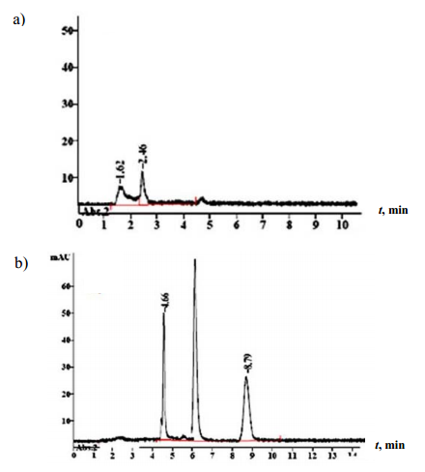
Fig.III.2 HPLC chromatograms of blood serum samples: a) sample without the analytes (blank test); b) spiked sample (standard addition of analytes).

3.6. Robustness
Robustness refers to the ability of a validated analytical procedure to remain unaffected by small but deliberate variations in the method parameters. In other words, it means the procedure should maintain the estimated characteristics (e.g. precision, accuracy) that were obtained under optimal (nominal) conditions, even when there are likely small deviations from those conditions.

3.7. Linearity
Linearity refers to the presence of a linear relationship between the analytical signal (e.g. peak area, absorbance) and the concentration (or amount) of the analyte in the sample, within a given range of the analytical procedure.
To evaluate the linearity of the procedure, you would experimentally measure the analytical signals for at least five samples with different amounts or concentrations of the analyte.
The correlation coefficient (r) should then be calculated. In analytical chemistry, a linear dependence is typically considered acceptable if |r| ≥ 0.99.
For the analysis of trace amounts, a slightly lower correlation coefficient of |r| ≥ 0.90 may be acceptable. The linearity can also be represented graphically as a function of the analytical signal versus the analyte concentration(Fig.III.3).
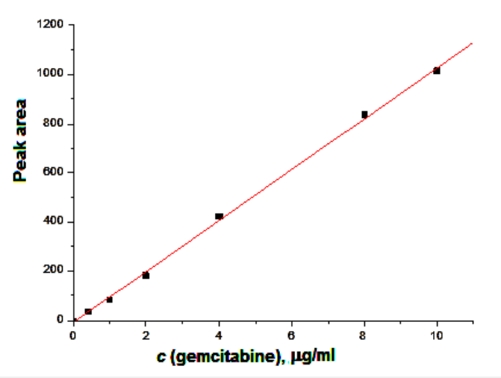
Fig.III.3 Dependence of the area of chromatographic peaks of the concentration of the active ingredient (gemcitabine) in the «Gemzar».

