Table of Content
CHAPTER II: QUALITY CONTROL OF DRUGS IN PHARMACIES 2
1. Objective 2
2. Introduction 2
3. Definition of quality 2
4. Definition of quality assurance 3
5. Quality in the pharmaceutical industry 3
6. Good laboratory practices (GLP) 3
6.1. GLP principles 4
7. The European pharmacopoeia 6
7.1. Definition of the European pharmacopoeia 6
7.2. The role of the European pharmacopoeia 6
8. Definition of quality control 7
8.1. Quality management in the drug industry 7
8.1.1. Quality assurance 8
8.1.2. Quality control responsibilities 9
8.1.3. Quality assurance responsibilities 9

CHAPTER II: QUALITY CONTROL OF DRUGS IN PHARMACIES

- Objective
By the end of this chapter, the student will be able to:
- Define the core concepts of quality, quality assurance, and quality control.
- Outline the ten fundamental principles of Good Laboratory Practices (GLP) and their significance in ensuring quality in pharmaceutical research and development.
- Describe the role and importance of the European Pharmacopoeia (Ph. Eur.) in setting quality standards for medicines and protecting public health.
- Differentiate between the roles and responsibilities of Quality Control (QC) and Quality Assurance (QA) within the pharmaceutical quality management system.

Introduction

This chapter introduces the fundamental principles of quality control for drugs in pharmacies. It begins by defining key concepts like "quality" and "quality assurance" according to international standards. The chapter then explores the critical frameworks that ensure drug safety and efficacy, including Good Laboratory Practices (GLP) for research and the standards of the European Pharmacopoeia for quality control. Finally, it distinguishes between the roles of Quality Control (QC) and Quality Assurance (QA), highlighting their interconnected responsibilities in guaranteeing that every pharmaceutical product is effective, safe, and reproducible.

Definition of quality
The official ISO definition: "Quality is the set of properties and characteristics of a product, process or service that gives it the ability to satisfy expressed or implied needs." (Paula Marc).

- Definition of quality assurance
According to ISO standard 8402-94, quality assurance is "All the pre-established and systematic activities implemented within the quality system, and demonstrated as needed, to provide appropriate confidence that an entity will meet the requirements for quality."

Quality in the pharmaceutical industry
The rules to be followed in the pharmaceutical field to obtain a quality product, in this case the drug, are described in Good Manufacturing Practices (GMP). GMP describes the means, organization and controls to be put in place. The goal of the pharmaceutical industry is to produce a quality drug, through thorough clinical and preclinical studies, controlled production, in order to obtain a sufficient benefit/risk ratio to satisfy the patient. A quality drug can be described as:
- Effective: with the required and sufficient therapeutic effect
- Safe: the patient's health must not be jeopardized
- Controlled by a quality system: which guarantees its reproducibility
All these aspects are included in the Marketing Authorization (MA) dossier, which is a kind of product identity card, as it combines the efficacy and safety of the drug (through clinical and preclinical trials) and the quality (through the controls put in place by the manufacturer). These elements assure us that the drug is reproducible and of quality, and that the manufacturer has an effective quality system.

Good laboratory practices (GLP)
Since 1978, "Good Laboratory Practices" have regulated quality assurance in pharmaceutical research and development, aiming to prevent health scandals in the pharmaceutical industry. Issued worldwide, the guidelines they contain are now recognized internationally. Although GLP measures depend on the size of companies and institutes, certain standards must be respected in all laboratory activities. GLP-related operations can only be authorized if all controls have been carried out and fully documented.

GLP principles
As shown in Fig.II.1. The basic principles of GLP include:
- Organization and personnel of the test facility
- Quality assurance program
- Facilities
- Equipment, materials and reagents
- Test systems
- Test and reference items
- Standard operating procedures
- Performance of the study
- Reporting the study results
- Storage and retention of records and materials
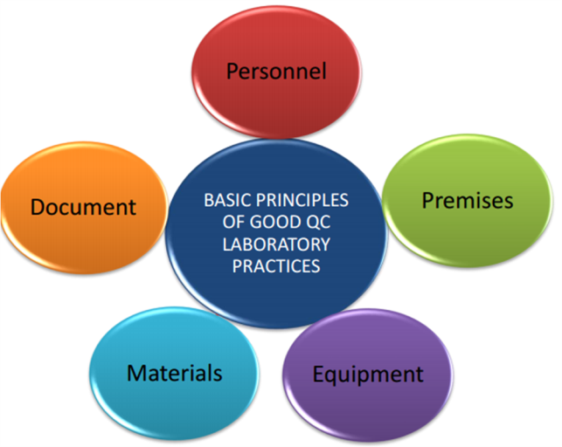
Fig II.1. GLP principles.
Chapter 1: Organization and personnel of the test facility
- Management: must ensure compliance with GLP principles in the test facility
- Study director: solely responsible for the control of the study and assumes responsibility for the overall conduct of the study and the final report
- Principal investigator: will ensure that the phases of the study delegated to them are carried out in accordance with the applicable GLP principles
- Study personnel: are familiar with the test protocol, implement it, document the results and report any deviations from the protocol
Chapter 2: Quality assurance program
- Deviations
- Non-conformities and corrective actions
- Amendments
Chapter 3: Facilities
- Facilities and premises
- Equipment and apparatus
- Electronic data and validation of computerized systems
- Archiving
Chapter 4: Apparatus, materials and reagents
Chapter 5: Test systems
- Management of the test items: test and reference items
- Management of reagents
- Test systems and specimens
Chapter 6: Test and reference items
Chapter 7: Standard operating procedures
- Documentary organization and traceability
- Data and record management
- Raw data: recording, validation
Chapter 8: Performance of the study
- Implementation and conduct of studies
- The different phases of the study
- Documentation of activities
- Study monitoring
- Management of unforeseen events and decisions during the study
- Management of study data
- Closure of the study
Chapter 9: Reporting the study results
Chapter 10: Storage and retention of records and materials

The European pharmacopoeia

Definition of the European pharmacopoeia
The European Pharmacopoeia (Ph. Eur.) is a unique reference work for quality control of medicines. The official standards published provide a scientific basis for quality control throughout the life of medicines. They concern the qualitative and quantitative composition and the tests to be carried out on the medicines, on the raw materials used in their production and on the synthesis intermediates. All producers of medicines and/or pharmaceutical substances must apply these quality standards in order to market their products in the signatory states of the Convention.

The role of the European pharmacopoeia
The role of the European Pharmacopoeia is to contribute to the protection of public health through the development of recognized common specifications relating to the quality of the medicinal product and its components. These specifications must be appropriate since they constitute, for the patient, one of the fundamental guarantees regarding the safe use of medicines. In addition, their existence facilitates the free movement of medicines within Europe and beyond.
The monographs and other texts of the European Pharmacopoeia are developed to meet the needs of:
- Regulatory authorities
- Services responsible for quality control of medicines and their constituents
- Manufacturers of medicines and their various components
The European Pharmacopoeia is widely used internationally. Globalization and the expansion of international trade in the pharmaceutical field have increased the need to develop quality standards of global scope, and the Commission works closely with all users of the Pharmacopoeia worldwide (Anonymous 9).
- Definition of quality control
Quality Control is part of Good Manufacturing Practice which is concerned with: sampling, specifications and testing, and the organisation, documentation and release procedures which ensure that the necessary and relevant tests are actually carried out and that materials are not released for use, nor products released for sale or supply, until their quality has been judged to be satisfactory.
Quality control refers to the sum of the procedures undertaken to ensure the identity and purity of a particular pharmaceutical.
- Manufacturers of drugs shall have a quality control systems which is designed to ensure that products are manufactured under adequate conditions and in accordance with procedures so as to meet established specifications,
• Quality control is not confined to laboratory operations, but must involve in all decisions which may concern the quality of the product.
- To meet this purpose, Quality Control Department should be appropriate and independent.

Quality management in the drug industry
In the drug industry at large, quality management is usually defined as the aspect of management function that determines and implements the “quality policy”, i.e. The overall intention and direction of an organization regarding quality, as formally expressed and authorized by top management (Fig.II.2).

Fig.II.2. Quality relationship.

Quality assurance
− A wide-ranging concept which covers all matters which individually or collectively influence the quality of a product.
− The sum total of the organized arrangements to ensure that the products are of the quality required.
− Quality Assurance therefore incorporates Good Manufacturing Practice plus other factors outside the scope of these Guidelines, such as product design and development.
According to ISO 9000: QA is a part of quality management focused on providing confidence that quality requirements will be fulfilled. Whereas, QC is a part of quality management focused on fulfilling quality requirement.
- Within an organization, quality assurance serves as a management tool. In contractual situations, quality assurance also serves to generate confidence in the supplier. The concepts of quality assurance, GMP and quality control are interrelated aspects of quality management. They are described here in order to emphasize their relationship and their fundamental importance to the production and control of pharmaceutical products

Quality control responsibilities
- Perform testing of finished product
- Control of quality of the product on a daily basis at the company.

Quality assurance responsibilities
- Define quality standards and metrics
- Review quality standards and metrics by working closely with all departements
- Perform in-process checks
- Help in the prevention of defects
- Perform self-inspection
- Prepare documents
- Help in preparing a quality improvement plan
Fig.II.3 shows the difference between quality control and quality assurance.

Fig.II.3. Difference between quality control and quality assurance.

