PART II: New Technologies Create New Solutions

VEDEO 05

New Discoveries in Renewable Energy

Hello, in the last video, we learned about the rise of renewable energy. In this video, we will look at new discoveries in renewable energy from simple devices used in daily life, to the gathering of large data to make current discoveries work better. Finally, we'll talk about an exciting direction for the science of renewable energy.
In the beginning of this course, we did a warming experiment with two jars which showed us how the earth gets warmer when heat is trapped in the atmosphere. It was a simple project that helped us understand a very large idea.
Well, a few engineers at the Massachusetts Institute of Technology, MIT, have also made a big discovery using low-tech or simple tools. An engineer is someone who designs and builds products, machines, systems, or structures. In this case, the engineers at MIT, were trying to find a low tech, or simple way to boil water using solar power. They called their design a solar vapor generator. It used a simple device made of little more than a sponge bubble wrap and a couple of thin layers of material to use the sun to boil water. In addition to just boiling water for cooking, this design could be used as an inexpensive way to take the salt out of sea water.
Or as a simple way to sterilize medical tools. That means to make doctors tools clean from live bacteria or other micro-organisms. Scientists are not only trying to create new discoveries. They are also trying to find new ways to make old systems work cleaner and more efficiently. They can do this with data or information.
For example, scientists are using motion sensors devices that detect moving objects on off shore windmills. Windmills that are in the ocean. The sensors send data to the scientists, about how strong the wind and waves are, over a period of time. With this information, they can know when the wind is likely to be strongest, and they can make sure that the equipment is set for maximum efficiency. In some cases, this could mean they're able to get 20% more electricity from windmills that already exist.
Where might scientists look next?
Hydropower is one of the most common forms of renewable energy in places where there are rivers because people can build dams. But what about oceans?
As we discussed earlier, the oceans cover more than 70% of the planet Earth. They absorb the largest amount of solar energy, and they have the most predictable energy from motion due to its tides and waves.
What if we could find a way to use some of that giant and predictable energy to create power? Maybe someday, we will. Maybe you will discover the way to do it. In this video, we looked at new discoveries in renewable energy. From simple devices to the gathering of large data. And finally, we talked about an exciting direction the science of renewable energy might be heading in the future. Now let's meet a scientist who is discovering new ways to recreate renewable energy.

VEDEO 06

Language Focus: Using Modal Verbs to Make a Suggestion

In this language focus video we are going to look at modal verbs. Modal verbs include words like can, should, might and several more.
Using modal verbs help you to describe how you feel about a situation in a more precise way. Modal verbs can be used in different ways.
In this video we will look at the modals we use to make a suggestion. We'll talk about the structure of modal verbs and the meaning of different types of modals. Then we'll look at some examples.
In order to talk about modal's the very first thing you have to do is define verb.
A verb is the word that tells an action or a state of being in a sentence. Run, walk, think and be are all verbs.
Now we can define modal. A modal is a special type of verb usually used with another verb that describes ideas such as making a suggestion, giving advice or talking about the probability, the chance of something happening. We're going to look at modals for making a suggestion in four modal verbs in particular. Should, can, and might, and must.
First, let's look at the grammar from four modal verbs. And then, we'll talk about the differences between these four. The grammar for most modals is quite simple. Use only one modal and put the modal in front of the verb in a sentence.
Let's see an example. In the previous video you listened to an expert talking about capturing extra heat and using it as energy. In this instance, you capture extra heat for energy. We should first identify the verb. Did you find it? It's capture. Now, we just need to put our modal right in front of the verb. Let's try could for suggestion and remember we can add only one modal. That gets us this sentence, you could capture waste heat for energy. Because we have add a model for suggestion, could, the sentence now means that we are making a suggestion. The person we are talking to could follow our suggestion or they could not.
Let's look at another example. The government builds some wind farms. Can you find the verb? That's right. It's builds. Now let's imagine that we are answering the question. What can the government do with a suggestion? The government might build some wind farms. Notice that the s from builds has gone. When we use a modal verb, we use the base form of the verb, build, in this case. Okay, so now we know the structure of using modal verbs. Let's look at the different modals we can use.
When you're making a suggestion you can use different modal verbs. Use must, should, shouldn't, could or might, depending on how strong your suggestion is.
For example, if you want to make a strong suggestion, then use should. Countries should reduce the amount of carbon emissions. In this case we are making a strong suggestion.
We have included must in this video even though must is not really a suggestion. It is an obligation, something that you have to do. However, because climate change is such an important subject, many people use must when they are making a suggestion about what to do. You must take action to stop climate change now.
Sometimes we are not so certain about our suggestion. In these cases, we use a weaker suggestion, like could or might. You could open more recycling sites. You might start composting at home.
We can also use should to make negative suggestions. These are also strong suggestions but we use should not or must not to tell people not to do something. For example. You shouldn't invest more money in fossil fuels.
So in this video, we looked at the modals we use to make a suggestion. We talked about the structure of modal verbs and then the meaning of different types of modals followed by some examples.

ACTIVITY 3: Strength (Strong Suggestion – Weak Suggestion)

1.Question 1
Imagine your friend is going to visit the Antarctic, to see for themselves the melting of the polar ice-caps. Choose the most appropriate modal verb to complete the following suggestions. To help you, the strength or weakness of each suggestion is marked on a line.
1. You __________ take warm clothing like a hat and gloves.
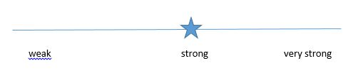
might
shouldn't
should

2.Question 2
You __________ pack a telescope, if you have room in your suitcase.
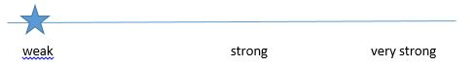
could
should
shouldn't

3.Question 3
You __________ try to touch a polar bear. They are beautiful, but very dangerous.
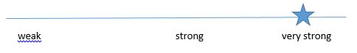
must not
might
should

4.Question 4
You __________ start writing a journal of your experiences, if you have time.
shouldn't
might
should

5.Question 5
You __________ pick up any trash that you see, to help keep the environment clean.
shouldn't
should
might

6.Question 6
You __________ watch the stars at night, assuming it’s not too cold.
shouldn't
should
could

READING 02 : Salting Away Renewable Energy for Future Use

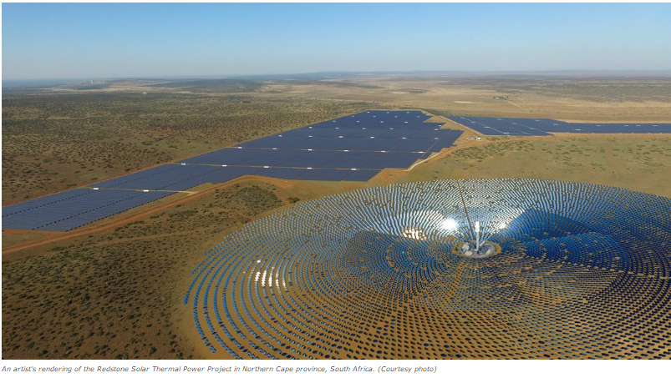

One problem with using solar energy is where to keep it. How do you store electricity from the sun? Scientists think salt may be the answer.
Solar Reserve is a California company. It is figuring out how to use melted salt to store energy for a long time.
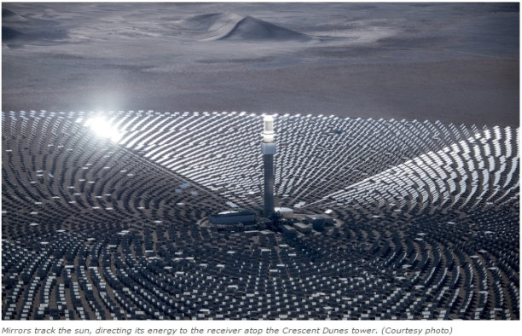
The company has a solar power plant in Tonopah, Nevada, called Crescent Dunes. It was built in 2015. Solar Reserve is the first private energy plant to use the new storage technology.
The plant can power 75,000 homes and run for 10 hours from the energy stored. This means it can keep running overnight.
Kevin Smith is in charge of SolarReserve. He said that the Paris agreement on climate change will change the way people use energy around the globe. Many nations signed the agreement. They promised to release fewer greenhouse gases.
Greenhouse gases are contributing to global warming. They are released by burning gas and coal. To cut back, more people will need to use renewable energy, like solar and wind. Countries in Africa, Latin America and Asia are using more electricity. They are very interested in renewables.
Smith added that people are already looking to Crescent Dunes as a model. The technology will change how people store energy across the globe, he said.
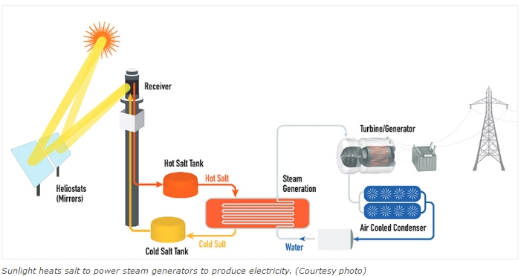

How does it work?
Ten thousand (10,000) mirrors reflect sunlight onto a receiver that sits on top of a 195-meter tower. Liquid salt is piped through the heated receiver. The melted salt flows into hot salt tank. As electricity is needed, the hot salt moves through a steam-generation system where water is heated to produce high-pressure steam. The steam turns a turbine that produces electricity. It works whether the sun is shining or not.
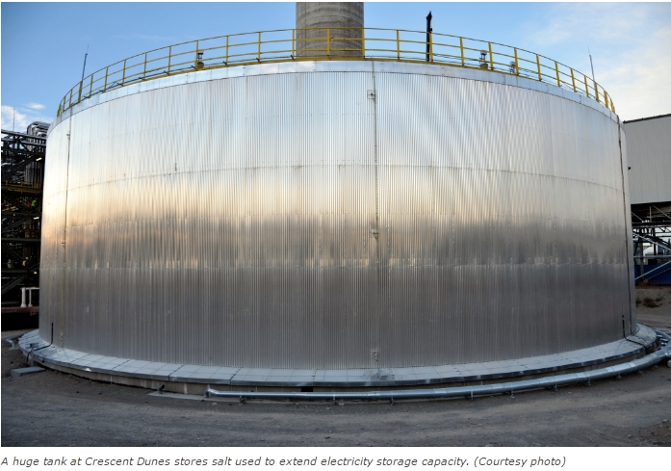
The steam-generation process is just like those used to produce electricity from gas, coal or nuclear power plants, but it is 100 percent renewable. There are no harmful greenhouse gas emissions.
“So far, in the industry, that’s the state of the art — molten salt storage,” University of South Florida solar power expert Yogi Goswami told the Los Angeles Times.
The molten salt storage technology was developed after decades of research design and testing by U.S. aerospace companies Rockwell International, Rocketdyne, Boeing, Pratt & Whitney and Aerojet.
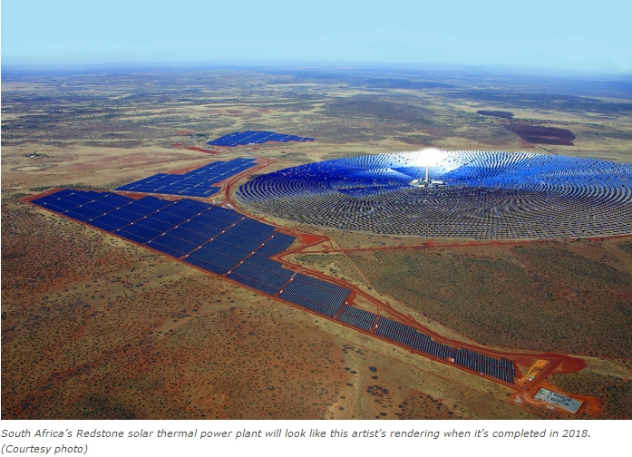
Solar Reserve has started projects that use molten salt storage in other countries, in partnership with governments and private energy providers. Its Redstone thermal power project in South Africa’s Northern Cape province is expected to be completed in 2018. Another project is being built in Chile. And the company recently signed a deal with Shenhua Group to build 1,000 megawatts of advanced solar energy installations in China.

___________
Terhune, L. (2016, Nov 17). Salting away renewable energy for future use. (Ed. Newsela staff). Retrieved from https://share.america.gov/salting-away-renewable-energy-for-future-use/

ACTIVITY 03: Check Your Understanding: "Salting away renewable energy for future use."

1.Question 1
Comprehension Check Instructions:
Instructions: All questions in this quiz refer to the reading, “Salting away renewable energy for future use." You are allowed to refer to this reading as you answer these questions. You can open the reading in a new tab by clicking one of the links:
BASIC: https://www.coursera.org/learn/stem/supplement/f3GcR/basic-salting-away-renewable-energy-for-future-use
What is the main idea of this reading?
exploring ways to increase government funding of solar energy
exploring ways to increase the size of solar panels
exploring ways to store solar energy using salt

2.Question 2
What does the number 10,000 refer to?
the number of watts of electricity generated by this process
the number of homes that will benefit from this solar energy
the number of mirrors that reflect the sun’s rays to a receiver

3.Question 3
The text refers to molten salt. What does the word ‘molten’ mean?
cold
liquid
hard

4.Question 4
According to the article, which of the following countries is NOT involved in similar projects?
China
Chile
Japan
South Africa

VEDEO 07

Assessment 2 Sample, New Energy System

Come in. Thanks for coming. Please take a seat. Now, as you know, we are looking at a new energy policy for the country, one that's better for the environment. I believe you've conducted some research on this subject. Is that correct? Excellent. Well, what we need is for you to talk about the current energy system and then to suggest a new one. Could you come in and give a brief presentation tomorrow?
Great. I'll see you then. Thank you for inviting me to talk about our nation's energy systems.
I have a suggestion. We should use solar power. At the moment, our country uses a lot of oil. The oil is pumped from the ground. It is turned into gasoline in a refinery and used to power cars and other vehicles. This source of energy creates a lot of air pollution. It is possible that our country could create solar-powered cars. The sun shines a lot in our country. So solar panels make sense. Solar panels work by using silicon to absorb energy from the sun and change it into another kind of energy that can be stored and used. This energy is clean and does not create any pollution. To conclude, I think our country should use solar-powered cars instead of gasoline-powered cars.

Unit 4 Assessment 2: Written assessment instructions

Basic Instructions: Describe the energy systems used in your country. Suggest a new energy system for your country and explain how it would be better for the environment. You can choose an example of a new energy system from our course readings or introduce a new one from your own research. Write one paragraph.
Detailed Instructions:
Part 1: Describe a current energy system being used in your country.
- Name the energy source.
- Explain how the energy source creates power.
Part 2: Suggest a new energy system for your country.
- Name the energy source.
- Explain how the energy source creates power and is better for the environment.
- Use appropriate modals of suggestion.

