Stages of Academic Writing
Sequence Two: Evaluating and Revising
Introduction
- Evaluation is an important step in almost any writing process including academic writing.
- Academic evaluation of writing pieces involves a set of criteria.
- evaluation is a must in the process of determining the value of an academic piece of writing
What is evaluation?
To start with, one can say that evaluating means assessing or appraising
“evaluation is the process of examining a subject and rating it based on its important features we determine how much or how little we value something arriving at our judgment on the basis of criteria that we can Define”.
Another definition could be
“The evaluative aspects maybe: grammar, sentence structure, spelling content, usage of sources, style, or many other things”.
“other things to consider when evaluating a piece of writing is whether the writing appealed to its target audience”.
The process of evaluation can be illustrated as follows :
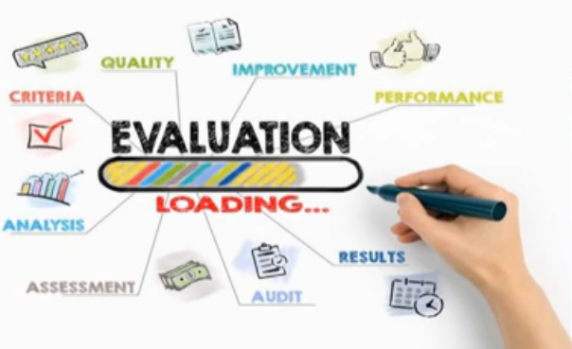
Some academic writing evaluation criteria
- While evaluating your academic writing Productions such as research papers or reviews you need to consider some important criteria that will help you ensure your final piece of writing is relevant.
- Some of these criteria are provided by Melissa Latin Crystals in their book expression and inquiry published in 2020
This criteria include

- Focus
This Criterion is mainly concerned with the context, purpose, and overall coherence of the piece of writing
in order to check to what extent your text is focused you may ask these questions :
- What is the topic of your paper?
- What is the aim of your paper?
- What thesis is your paper defending?
Example
A paper about artificial intelligence in general is too broad for most education journals. It is better to FOCUS on the use of artificial intelligence in teaching vocabulary to Young Learners in Algeria.
- Development
- Development deals with the quality and the quantity of details and evidence you include in your paper
You can ask the following questions
- Does your paper include relevant supporting materials?
- Does your paper mention relevant works in the field?
- Does your paper comprise adequate references and quotations?
Note :the details you include depend on your target audience, whether general or specialized.
Example an essay about artificial intelligence intended to humanity students will contain less details than a research paper aimed to be published in a Computer Sciences Journal.
- Organization
- Organization has to deal with the structure and overall layout of your piece of writing.
- As seen in the previous week it depends on the type of the academic writing
- However there are common organization features that need to be respected. If not the paper will be an agglutination of unrelated topics.
For example: it is important that:
- Each paragraph is meant to present single topic or idea to ensure unity.
- Transition between paragraphs needs to be smooth and logical that is moving from one paragraph to another paragraph you need to occur for logical connectors and discourse connectors.

- Style
- Style is related to clarity, precision, and objectivity
- In other words, it is the obligation to use appropriate and precise vocabulary and avoid expressions of subjectivity or opinion statement.
- Remember! Academic writing style is neutral and straightforward. It does not allow for figurative language.
- Writing conventions
- Writing conventions are common rules that cover grammar, spelling and punctuation,….Etc
- Poor language, in terms of grammar and spelling can reduce considerably the value of your piece of academic writing even if it contains interesting ideas and develops sound argumentation.

Conclusion
We can say that the evaluation of your writing allows you to:
- Find the main point of your writing
- Identify your audience and your purpose
- Evaluate evidence provided keep only the relevant pieces
- Clean up your language
- eliminate mistakes in grammar and usage

