Exercise N°1:
Consider the diagrams in the following figures:
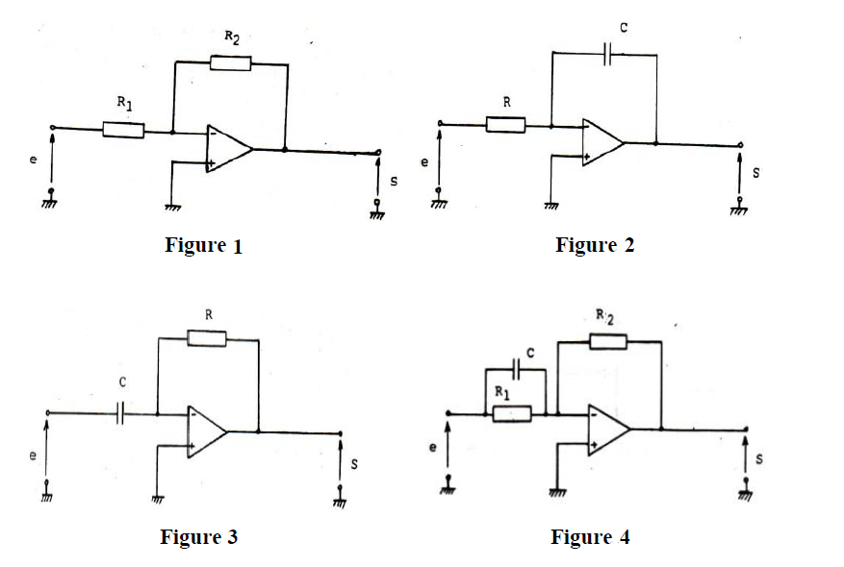

- Determine the transfer function of each controller: Hi(p) = 𝑆𝑖(𝑝)/𝐸𝑖(𝑝)
- Determine the type (nature) of each controller.

Exercise N°2:
Consider the process: G(p)=2/(2p+1)​
and the PI controller: Gr (p)=𝐾𝑟(1+1/𝜏p) , with 𝐾r = 4 and 𝜏 = 2 s.
Study individually the effect of the parameters 𝐾𝑟 and τ (while keeping the other parameter constant) on the poles of the closed-loop system.
Exercise N°3:
Consider a second-order system with the transfer function: $F\left(p\right)= \frac{1}{p^{2}+1.6p+2}$
By using a proportional controller defined as (𝑝)=𝐾𝑝
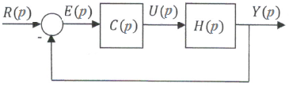
- Give, in terms of 𝐾_{p}, the expressions of: K_{CL}, ω_{nCL} and ξ_{CL} ​
- Determine the steady-state error for a step input of amplitude 10.
- What value of 𝐾p is necessary to achieve a steady-state error of 0.01.
- Calculate the steady-state error if the controller C(s) is replaced by a PI controller with transfer function: $C\left(p\right)=K_{p}(1+\frac{1}{τp})$

