- Selection and tuning of controllers

This allows choosing the type of controller and determining its parameters (time constant). There are several methods for tuning standard controllers that make it possible to compute the controller parameters, such as the Ziegler–Nichols criterion. In industrial tuning practice, other criteria are used that provide more satisfactory results, namely:
- The flatness criterion
- The symmetric criterion
  - The flatness criterion
Consider the unity feedback control system shown in the figure below.
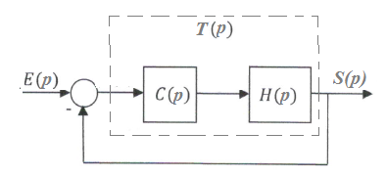

G(p) is the transfer function of the system (of order 𝑛) to be controlled:
(1)
Transfert Function : $F\left(p\right)=\frac{T(p)}{1+T(p)}$
With the flatness criterion, we aim to obtain, for the tuned system, the widest possible bandwidth while ensuring that the resonance factor does not exceed 1. The corresponding open-loop frequency response T(p) associated with this objective is shown in the figure below.
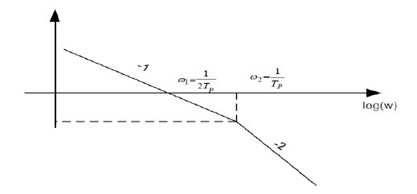

Frequency response of (𝑝), controller tuning according to the flatness criterion.
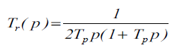
Let T_{r} (p) be the desired open-loop transfer function: (2)
To obtain Tr(p) ≈ T(p), the controller cutoff frequency(ies) (1/T1, and if applicable 1/𝑇2) are matched with the system’s cutoff frequency(ies) to be controlled (1/τ1, and if applicable 1/τ2).The transfer function of the controller is then:
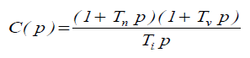
(3)
T_{n}: Integral time constant
𝑇_{𝑣}: Derivative time constant (derivative weighting factor)
𝑇_{𝑖}: Integral time constant (integral action parameter)
By substituting (3) into (1), we obtain:
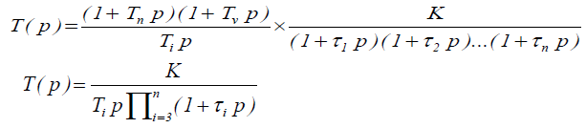

(4)
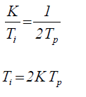
By comparing (2) and (4), we obtain:
(5)
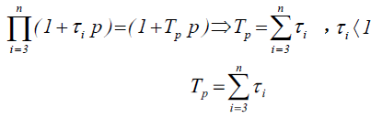
(6)

The controller coefficients obtained using the flatness criterion is listed in the following table:
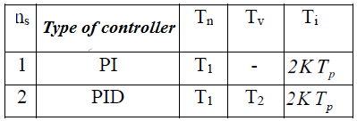

n_{s} being the order of the system to be controlled.
I-2 The symmetric criterion
The use of the flatness criterion causes problems when the system to be controlled exhibits integral behavior. Similarly, if the dominant time constants are large, the settling time required to eliminate the effect of the disturbance becomes too long. To overcome these drawbacks, the controller can be tuned using the symmetric frequency response criterion.
Criterion formulation:
The open-loop frequency response must have a symmetric shape. High amplification of this response at low angular frequency values 𝜔.The controller parameters calculated using the symmetric criterion are given in the following table:
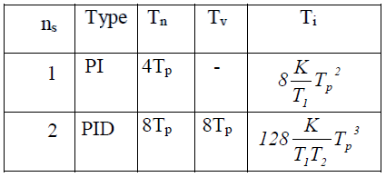

I-3 Practical Ziegler–Nichols method for tuning a P.I.D controller
I-3-1 Operating procedure
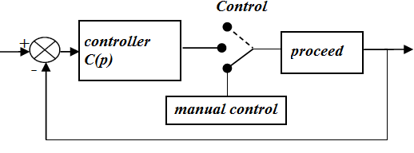

The controller is in automatic mode and the loop is in a steady state. The controller output indicates a control signal 𝑢₀, and the process output indicates a value 𝑦_{0.}
- The value ₀ is displayed on the manual control module.
- The controller is switched to manual mode, meaning it is disconnected from the loop.
- A constant variation of the control signal is applied to the process input, and the variation of the measured output signal is recorded using a chart recorder.
This corresponds to recording the step response of the process alone.
I-3-2. Analysis of the step response
From the recorded step response shown below, the tangent at the inflection point 𝑄of the curve is drawn as accurately as possible. Then, the time _{𝑢} corresponding to the intersection between the tangent and the time axis is measured, as well as the time 𝑇_{𝑎}, which is the “rise time of the tangent.”
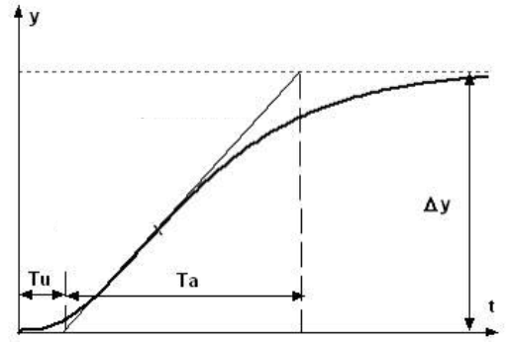

Step response
- PID controller tuning
Ziegler and Nichols propose calculating the parameters of the P, PI, or PID controller using the following recommendations:
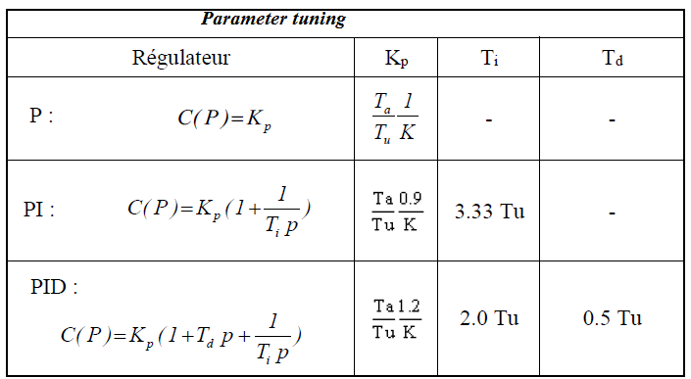

An illustration of this procedure is given below for the step response of a process subjected to a unit step input.
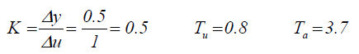
- The following parameters are obtained:
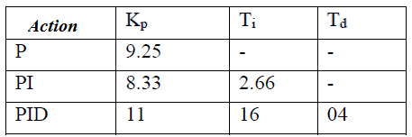
The tuning table proposed by Ziegler and Nichols is:

The closed-loop step responses are shown in the following figures for a unit reference input.
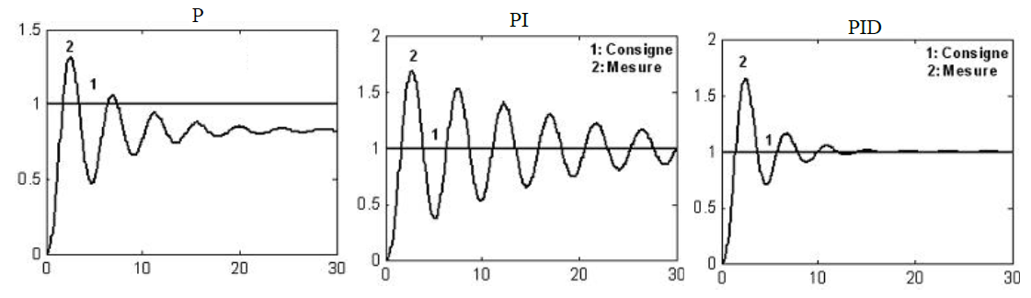

1.3.3. Ziegler–Nichols closed-loop method
1.3.3.1. Operating procedure
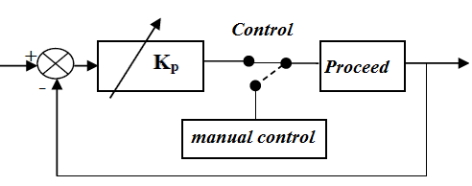

- The controller is in automatic mode with a low value of _{𝑝}. The I and D actions are disabled by setting 𝑇_{𝑖}=𝑇_{𝑖max} and 𝑇_{𝑑}=0
- The proportional gain _{𝑝} is progressively increased, with only proportional action active, until the loop exhibits sustained oscillations (marginal stability).

3.2.2. Analysis of the loop oscillation results

The ultimate gain 𝐾_{𝑝𝑐}, which leads to sustained oscillations of the loop, and the oscillation period 𝑇(see figure below) are determined from this operating condition, using any observation point (controller output, process output, etc.).
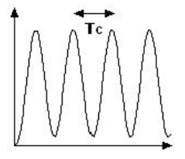

- PID controller tuning
Ziegler and Nichols propose calculating the parameters of the selected controller using the following recommendations:
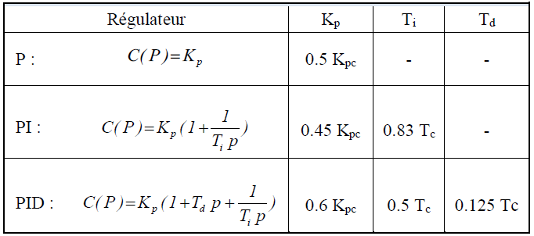

To illustrate this approach, we consider the same system as above, for which the following oscillation results are obtained: 𝐾_{𝑝𝑐}=16 and 𝑇𝑐= 3.63 (the time unit is not specified here).
The tuning table proposed by Ziegler and Nichols is:
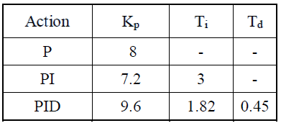

NB: It is worth noting that both Ziegler and Nichols methods lead to very close values for the controller parameters, and consequently the performance will be similar.

