4.1 Proportional (P) Controller:
The proportional controller (or P controller) is a simple control action, as it generates a control signal u(t) that is proportional to the error e(t).
The P controller does not allow independent tuning of response speed, accuracy, and stability margins.
- Control law of the P controller: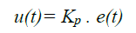
- Transfer function of the P controller: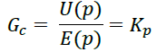
- Functional block diagram of the P controller: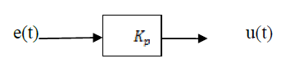
- The step response and the frequency response of the P controller are given by:
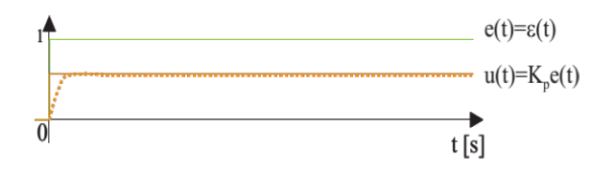
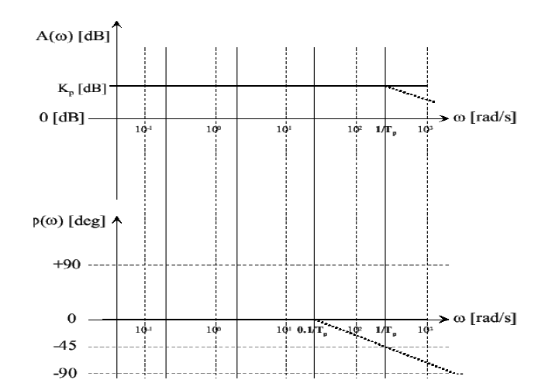
Frequency response
The frequency response of a P controller is constant in magnitude and introduces no phase shift:
𝐺(𝑗𝜔)=𝐾𝑝
Magnitude: ∣G(jω)∣=Kp
Phase: ∠G(jω)=0∘
This means the P controller amplifies all frequencies equally without altering their phase.

- Effect of the controller:

Modification of the open-loop (OL) system gain
- If Kc>1 (amplification):
-Upward shift of the Bode magnitude plot
- Increase in crossover frequency 𝜔_{𝑐𝑜} → faster response
- Decrease in phase margin (degradation of closed-loop stability)
- Improvement in closed-loop accuracy
2) If < 1 (attenuation):
- Downward shift of the Bode magnitude plot
- Decrease in crossover frequency ω_{co} → slower response
- Increase in phase margin (improved stability)
- Decrease in closed-loop accuracy
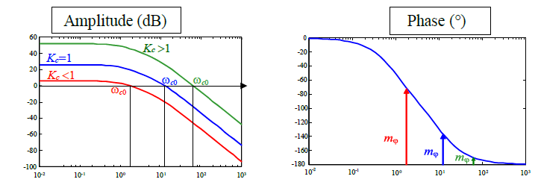
- Practical implementation of the P controller:
The electronic schematic of a proportional (P) controller is generally realized using an operational amplifier (op-amp) in a simple proportional configuration.
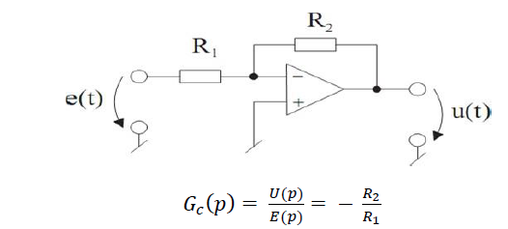
We can write the general relationship at the inverting (−) node of the amplifier.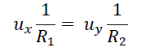
And finally, the transfer function is: 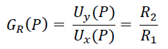
4.2 Proportional-Integral (PI) Controllers:
It is a combination of P and I actions
. 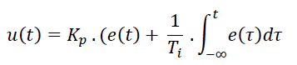
Transfer function of the PI controller:
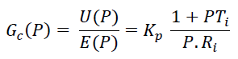

Functional block diagram:
The step response of the PI controller is given:
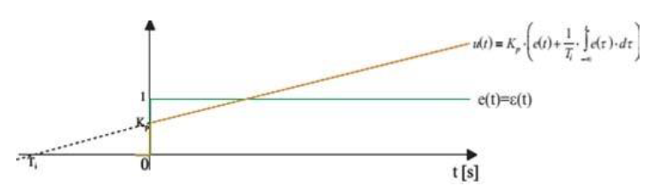
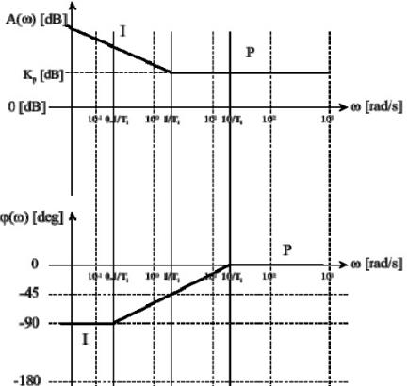

Effect of the controller:
- Introduction of an integrator
- Infinite low-frequency gain (ω≪1/Ti) → zero steady-state error
- The gain of the compensated system is not modified at high frequencies(1/Ti ≪ω) The crossover frequency ωco (speed) is not changed
- The phase of the compensated system is modified only at low frequencies (unlike a pure I controller)
- The phase margin is not affected if: 1/Ti ≪ω

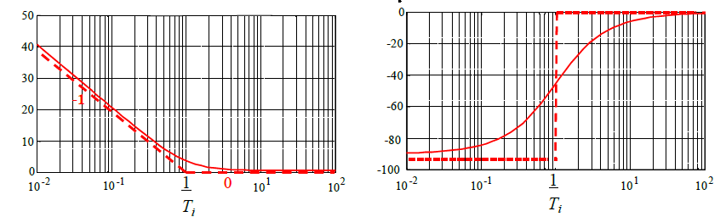
Practical implementation:
The electronic schematic of a proportional-integral (PI) controller.
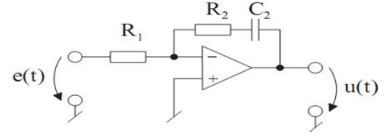
It has a feedback circuit composed of a capacitor C2 in series with a resistor R2. We can write the general relationship at the inverting (−) node of the amplifier:
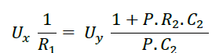
And finally, the transfer function:
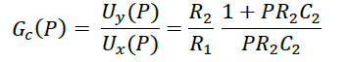 with :

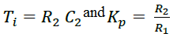

4.3 Proportional-Derivative (PD) Controllers:
It combines proportional (P) and derivative (D) actions.
➤ Control law of the PD controller:
Where : 𝑇𝑑 is the derivative time constant; the larger 𝑇𝑑 is, the more significant the derivative action becomes.
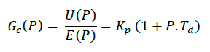
- The transfer function
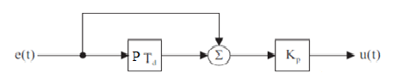
- Functional block diagram:

The step response of the PD controller and its frequency response are given by:
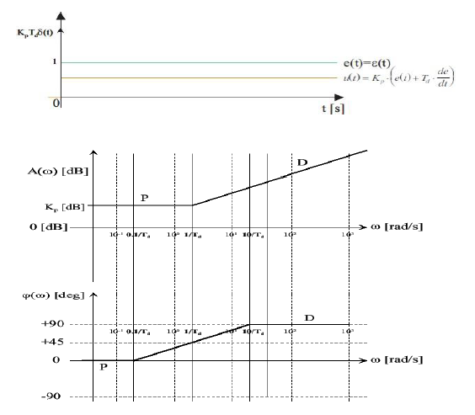

Effect of the controller:
- Maximum phase lead of 90° for ω≫10/Td, improving stability (phase margin).
- Increase in the crossover frequency 𝑐𝑜, leading to improved speed (reduced rise time 𝑡𝑟 and settling time 𝑡𝑚).
- High-frequency amplification (for ω>1/Td), which broadens the system bandwidth in close loop and increases sensitivity to noise.
- Reduction of steady-state error.
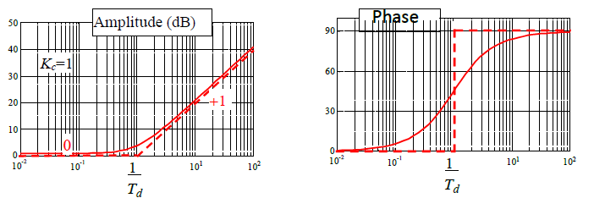
Practical implementation:
The electronic circuit diagram of a PD (proportional-derivative) controller.

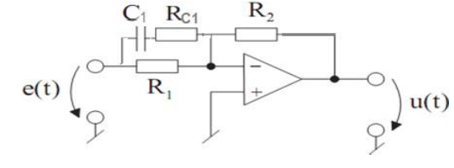
4.4 Proportional-Integral-Derivative (PID) Controller:
The PID controller is a combination of P, I, and D controllers.
Thanks to the integral action, it eliminates the steady-state error. The derivative action improves the system stability and transient response speed.
Transfer function: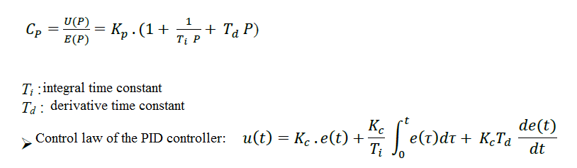
Effect of the controller:
- Phase lead at high frequencies
- Amplification at high frequencies → PD effect in the high-frequency range
- Infinite gain at low frequencies
- Phase lag at low frequencies → PI effect in the low-frequency range
- At mid frequencies: the controller has little influence
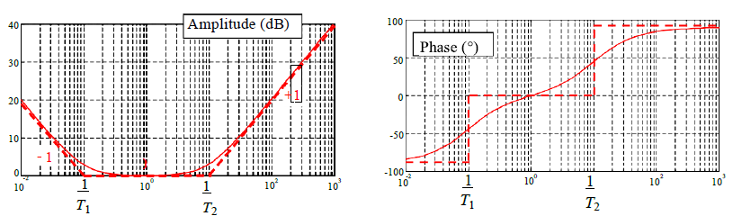
4.4.1 Series and parallel PID
These two forms are described by the following equations:
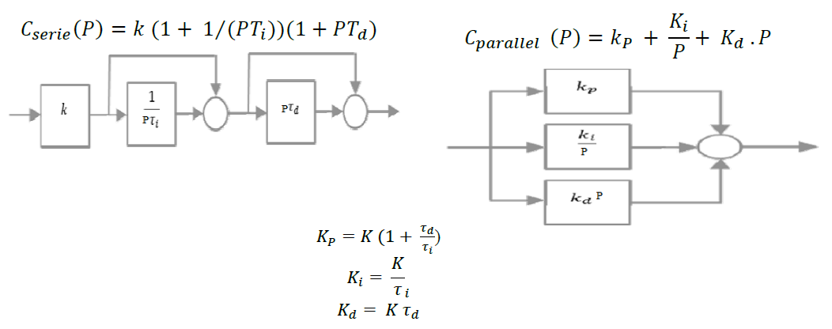
4.5.2 Standard, mixed, or ideal PID
A third form of PID exists, called the “standard”, “mixed”, or sometimes “ideal” form. It is defined by the following equation:
