A) Open-Loop System Identification
1. Objective of Identification:
To achieve the objectives described in the specifications of a process control system, it is necessary to analyze the static and dynamic behavior of the process itself, that is, its process transfer function.
A known input signal Y(t) (impulse, step, or ramp) is applied,
and the output signal X(t) is recorded and then analyzed.
The two most commonly used signals are the step and the ramp.
- The step signal is the easiest and fastest to apply, but it can cause relatively abrupt variations in very sensitive processes.
- The ramp signal is used so that the process undergoes a smoother variation, which is therefore more acceptable in terms of product safety and installation safety.
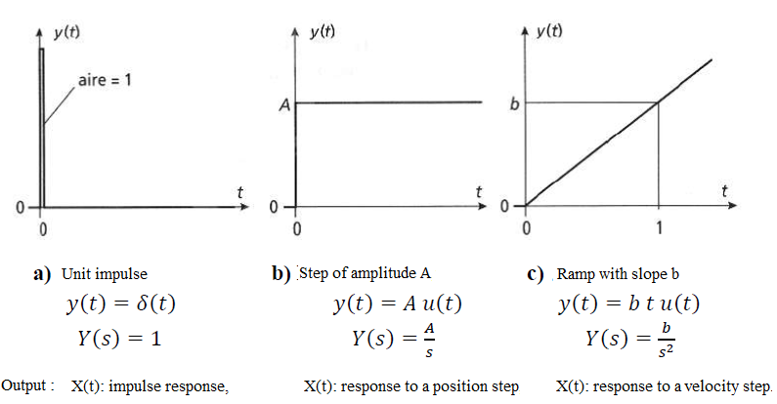
The three main families of curves most commonly encountered are as follows:
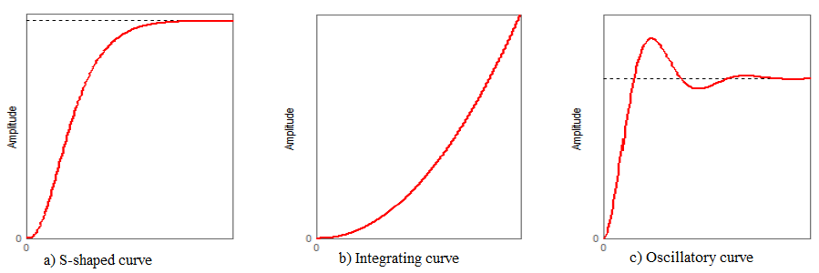
The shape of the obtained curve suggests the method to be used to model the process. If the system has no overshoot and its slope shows a discontinuity at the origin, it can be modeled as a first-order system of the form: $\frac{K}{1+τs}$ to determine the parameters K and 𝜏:
We choose a step input of amplitude A, and the response X(t) is then plotted.
The parameter τ is deduced from the curve (at 63.2% of the final value), and K is given by:
𝐾 =𝑋(∞)/𝐴
Example: After applying a step input of amplitude A=5 at t = 0 to the input Y(t) of a process, the response curve X(t) shown in the following figure is obtained. The goal is to determine the transfer function of this process.
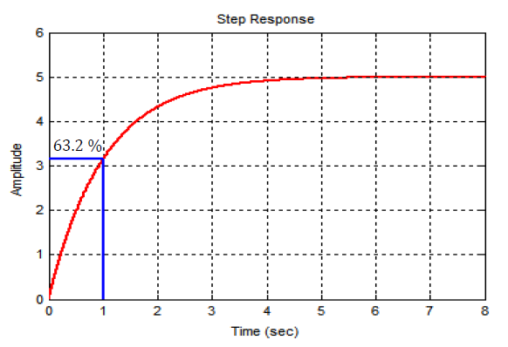
𝐾 =𝑋(∞)/𝐴= 5/5=1 and τ=1 , so The transfer function of the process is therefore: G(s)=1 /(1+s).
1-2. S-shaped curve:
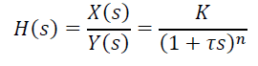
1) Strejc Method: Strejc model for a self-regulating (naturally stable) system.
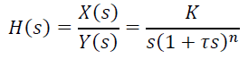
b) Strejc model for an integrating system.
If the system has no overshoot and its slope does not show a discontinuity (S-shaped), its response is modeled by:
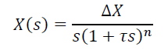
​
The Strejc method allows identifying such models from the step response.
The identification procedure can therefore be summarized as follows:
From the step response, first identify the static gain: 𝐾 = (𝑋(∞)/𝐴) = (∆X/A)
(where ΔX is measured directly).
Next, determine the system order n and the time constant τ. For this:
- Draw the tangent to the curve at the inflection point (the point of maximum slope).
- Measure the time 𝑡1 between the moment the step is applied and the point where the tangent intersects the initial value of X(t).
- Measure the time 𝑡2 between this intersection and the point where the tangent reaches the final value of X(t).
- From the ratio t1/t2, the system order n is determined n is determined (if it falls between two lines in the table, the smaller value of n is chosen). For the selected value of n, the time constant τ is determined from the ratio t1/τ or t2/τ (if there is no delay). ​
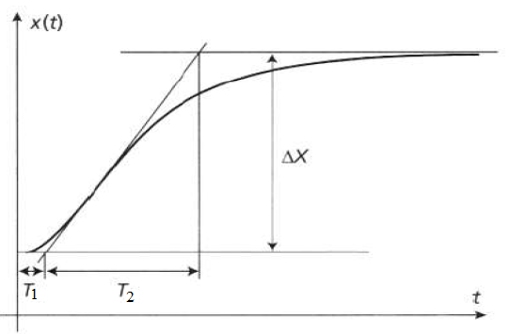
Ratios of time constants for identification using the Strejc method (standard Strejc tables)
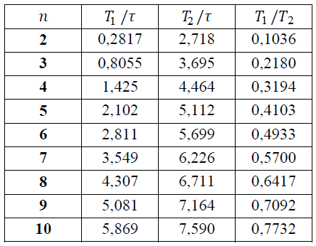
2) Strejc-Davoust Method:
The process response is modeled by:

The principle for determining the dead time T, the time constant τ (where τ is determined from t1/τ and not from t2/τ), and the system order n is similar to that of the Strejc method. However, the dead time T is determined from the difference between the measured value of t1 and the value given by the t1/τ column in the table above.
Example, for a given system, we have measured:
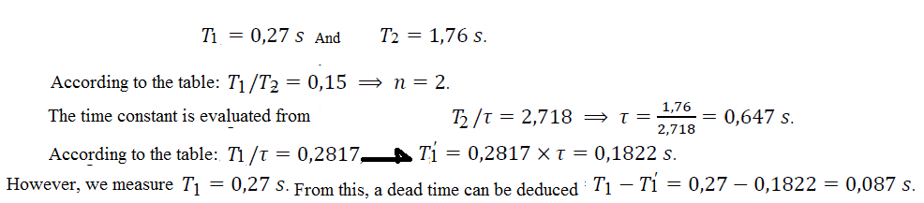

3) Broïda Method:
The Broïda model includes a time constant 𝜏 and a delay (dead time) T.
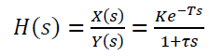
a) Broïda model for a self-regulating system:
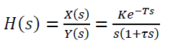
b) Broïda model for an integrating system:
The Broïda method provides an accurate model if :
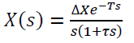
The S-shaped response of the process is modeled by:
To obtain the time constant τ and the dead time T, we measure 𝑡1 at 0.28 ΔX and 𝑡2 at 0.4 ΔX (see figure below).
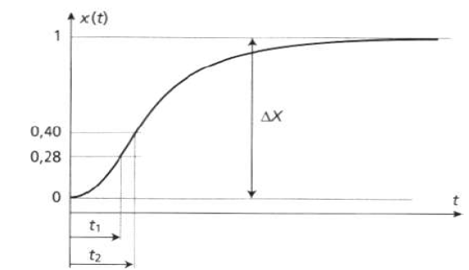
The change ΔX is measured directly. We then calculate:
1-3. Integrating curve:
Quick method: The proposed quick model is that of a self-regulating system or an integrating system:
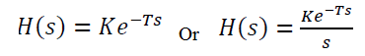
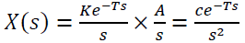
The response is modeled by:
To obtain the dead time 𝑇 (represented by AA′), we draw the asymptote D1 on the curve 𝑥(𝑡) (see figure below), where c is the slope of D1.
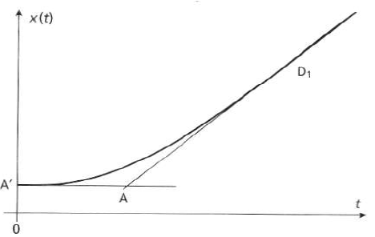
2.3. Oscillatory curve:
In industrial processes, this type of response occurs in closed-loop systems, and the identification is used to verify the obtained tuning. The proposed model is that of a second-order system with delay, either self-regulating or integrating:
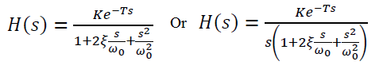
To obtain the dead time T, the damping coefficient ζ , and the undamped natural frequency 𝜔0, we record the following elements:
- The time of the first peak, denoted 𝑡1
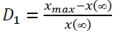
- The relative overshoot D1:
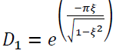
The damping coefficient is calculated from:
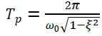
The natural frequency is:
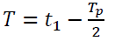
The dead time is calculated as T :
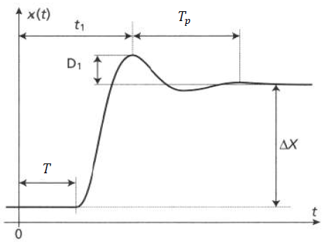
B) Closed-loop identification:
1- The ultimate oscillation method:
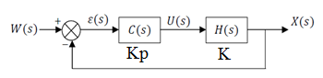
It involves two trials:
- First trial: This first trial is to determine whether the process is naturally stable.
If the measurement does not reach the setpoint, there remains a static or positional error ɛ_{p}
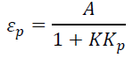
(the process is naturally stable with a static gain K), and it can be shown that:
If the measurement reaches the setpoint, the studied process is naturally unstable; a ramp w=b⋅t is then applied.
- There is an integration if the steady-state speed error ɛ_{𝑣} is non-zero; the dynamic gain 𝐾 is calculated using the relation:
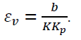
- There are two integrations if the steady-state speed error is zero, and the dynamic gain
𝐾′ cannot be determined.
- Second trial:
The transfer function regulator C(p) has a gain 𝐾p. By increasing the gain 𝐾, the goal is to bring the process to sustained oscillations; the output signal X(t) is recorded (see figure below).
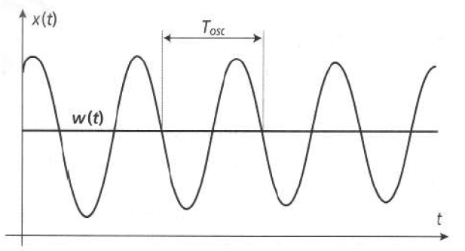
When the controlled process operates in a harmonic regime, the gain 𝐾p is called the critical gain of The controller critical gain is 𝐾_{lim}, and the oscillation period is 𝑇_{osc.}
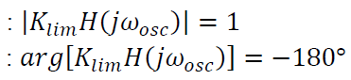
- The amplitude condition is:
- The phase condition is:
From these two equations, the parameters of the imposed model are determined, for example, for a naturally stable process:
- Strejc model:
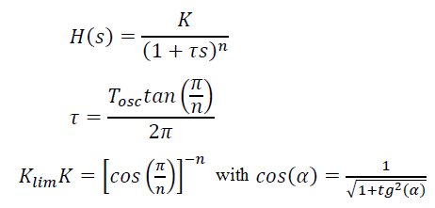
- Broïda model:
