Exercise 1: We want to control a system using a ON/OFF controller with a threshold (u_{thres}), with input u(t) (see the following figure) and output y(t).
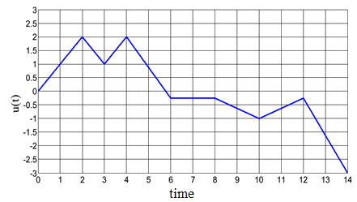
a. Give the formula for the output signal y(t). We are given: M=1, 𝑢_{thres} = 0.5
b. Sketch the shape of the output signal y(t) in this case.

Exercise 2: The boiler burner turns off when the water temperature reaches 80°C. It restarts when the water temperature drops below 76°C. Therefore, the burner maintains the water temperature between 76°C and 80°C, as follows:
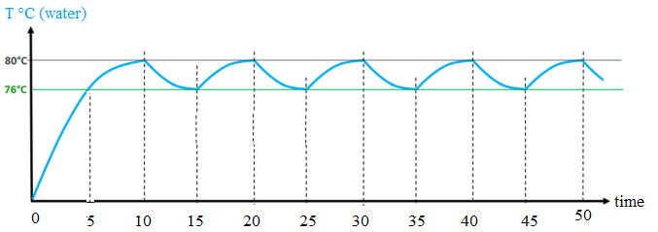
- Calculate the differential “S.D” of the aquastat.
- During a regulation cycle, the operating time of the burner depends on the ratio between the total power of the installed emitters (radiators, underfloor heating, etc.) and that of the burner. A 21 kW burner supplying heat to 7 kW of radiators.
- the burner duty cycle ratio (on-time ratio).
- What is therefore the off-time ratio of the burner?
- Represent this on–off regulation phenomenon on a graph.

