(A regulation system is generally a system in which the control signal depends on the output; that is, the output signal is compared with the input signal.)
Exercise1:
Find the equivalent transfer function for the following system.
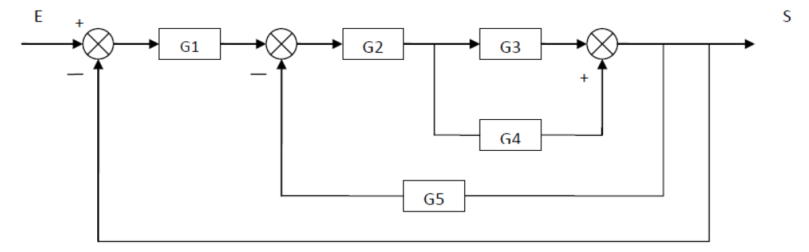
Exercise2:
Find the equivalent transfer function for the following system.
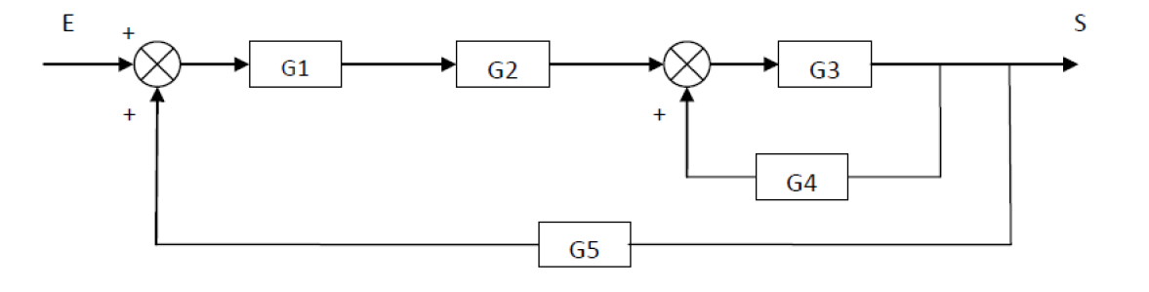
Exercise3:
Find the equivalent transfer function for the following system.
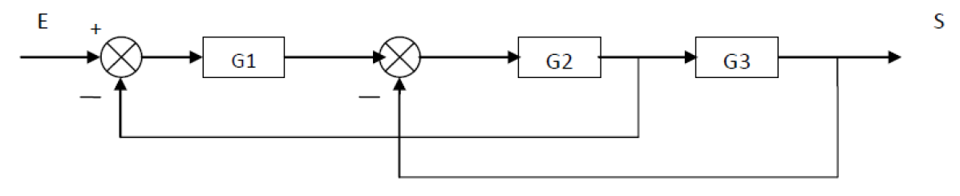
Exercise4:
Find the output signal S for the system represented by the following block diagram:
