- On-Off Regulation
* Continuous Action – Discontinuous Action
The operation of a regulator is divided into two distinct types of actions: Continuous action, where the regulator’s output can take any value between 0 and 100%. Discontinuous action, where the regulator’s output 𝑌 only takes two values. This type of operation is also called On-Off operation.
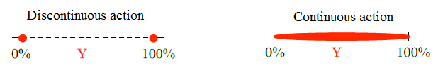
Presentation
The On-Off (O-O) operation is characterized by two possible states for the control:
One corresponding to the maximum control (100%)
One corresponding to the minimum control (0%).
A threshold limits the switching frequency of the
system to prevent premature wear of the control components.
The regulator is adjusted using two parameters:
Setpoint W, provided in measurement units;
Threshold DIFF, usually given as a percentage of the setpoint.

*Operation
The controlled variable oscillates around the operating point. Each time the switching thresholds are exceeded, the regulator’s output changes state. Considering the system’s inertia, the absolute value of the error 𝜀 can exceed the DIFF threshold.
Note: The measurement cannot remain constant in this type of regulation; the system operates in a sustained unstable regime.
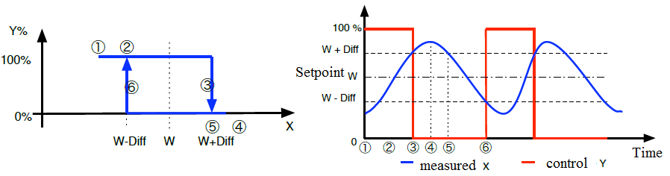
Differential Calculation

The differential (or hysteresis) is calculated as:
𝑆.𝐷=𝑇𝑚𝑎𝑥−𝑇𝑚𝑖𝑛
Example: Boiler Aquastat
Temperature setpoint: 78°C
Hysteresis (differential): 4°C
Burner ON when T < 76°C
Burner OFF when T > 80°C
This keeps the temperature between 76°C and 80°C.
If the burner turns off at 80°C and on at 76°C: S.D=80−76=4°C
- On–off (bang-bang) operation is characterized by two possible control states: one corresponding to the maximum command (100%) and the other corresponding to the minimum command (0%).
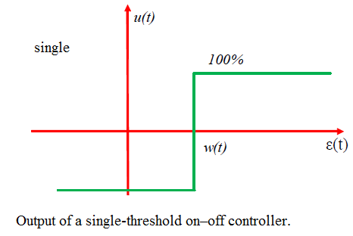
The following figure shows the output of a single-threshold on–off controller. As long as the measured value Y is below the setpoint W, the control U is 100% (ON). As soon as Y reaches or exceeds the setpoint W, the control U is 0% (OFF).
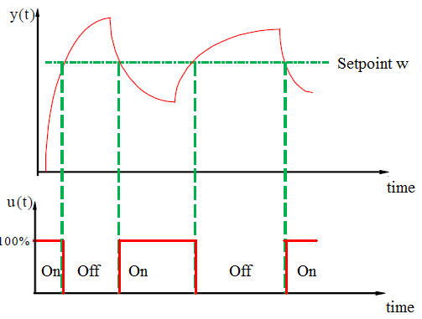

- Two-threshold on–off controller:
The difference between the two types of controllers lies in how the switching thresholds between operating states are determined. For an on–off controller with hysteresis, the setpoint and the difference between its two thresholds—called the hysteresis—are defined. Logically, the smaller the hysteresis, the higher the precision of the control system, since the controlled variable varies within a narrow range. For a simple on–off controller, only the desired measured value is specified.
The setpoint value W that stops the control (OFF: Y = 0%) and the second threshold value that restarts the control (ON: Y = 100%) can be identified on the control diagram in the following figure by the rising arrow (activation) and the falling arrow (deactivation).
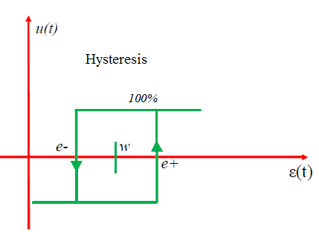
output of a two-threshold on–off controller.
The following figure shows the output of a two-threshold on–off controller. The controlled variable oscillates around the operating point. Each time the switching thresholds are exceeded, the controller output changes state. Due to the system’s inertia, the absolute value of the error ε may exceed the upper threshold (e+). As soon as the variable to be controlled falls below the setpoint, the control element is reactivated.
The controller is adjusted using two parameters:
➢ The setpoint W, given in measurement units;
➢ The threshold (e+), usually expressed as a percentage of the setpoint.
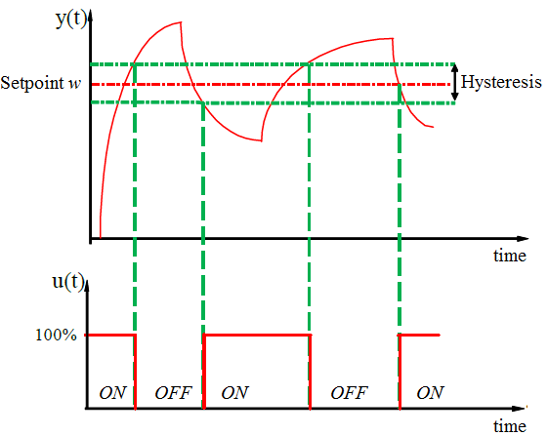
Response of a system with a two-threshold on–off (T–O–R) controller.
Example:
Let’s consider an example of ambient temperature control using a refrigeration unit. Suppose the setpoint is set at 27 °C.
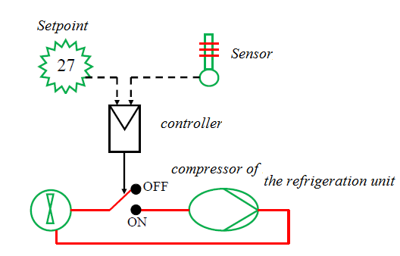
In the case of a single-threshold on–off (T–O–R) controller, if the ambient temperature exceeds the setpoint (27.10 °C), the controller detects it and closes the switch. The compressor is activated at 100%, and the room temperature decreases. A temperature of 26.90 °C is enough to stop the refrigeration unit, so the compressor switches from “ON” to “OFF” and back to “ON” repeatedly. With such a switching frequency, the equipment will suffer.
From this, it can be concluded that an on–off controller with hysteresis is more suitable, as its value can be adjusted. For example, the compressor can be set to turn on at 28 °C and turn off at 26 °C.
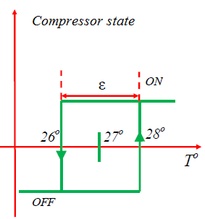

- Hysteresis comparator implementation.
