Exercise 1:
The current transmitted by a sensor-transmitter with a measurement range of 4 to 20 mA is equal to 13 mA.
- What is the measured value for a tank containing between 2 and 8 m of liquid at this current?
- Same question for a tank containing between 3 and 12 m of liquid.
Exercise 2:
The temperature (20°C) measured by a sensor-transmitter has a measurement range of 0 to 80°C.
- Calculate the current transmitted by the sensor-transmitter with an output range of 4 to 20 mA.
- Same question for a temperature of 40°C.
Exercise 3:
Consider a pressure control system for a tank containing a solvent, as shown in the diagram below.
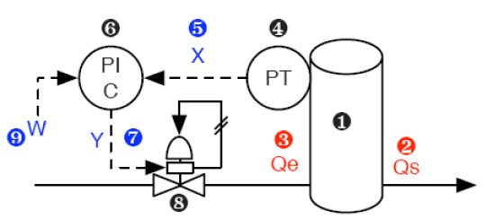

- Identify the numbered elements.
- Provide the functional block diagram of this control loop.
- A level of 5 m is measured using a sensor-transmitter with a measurement range of 0–15 m.
- Calculate the pressure transmitted by the sensor-transmitter with an output range of 0.1 to 1 bar.
- Same question for a measured level of 7 m.

