4. Communication signals – wiring
Nature of transmitted signals:
We will transmit the information using a physical medium that is easy to control. It will be either electrical or pneumatic (air pressure in tubes).
4.1 Electrical signal – Current intensity
Communication signals are generally a DC current varying from 4 to 20 mA.
To connect the wires:
- Identify the 4–20 mA electrical source.
- If the sensor is passive (not powered), an external power supply must be installed:
- Transformer – Rectifier converting 220 V AC to 24 V DC.
- If the sensor is active (powered at 220 V), it acts as the current source itself.
- Set the current direction arrow according to the polarities.
- Generator convention: current flows out through the positive (+) terminal.
- Load (receiver) convention: current flows into the positive (+) terminal.
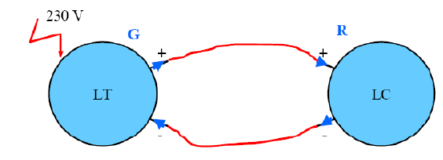

Figure 1 : Electrical signal – current
The electrical signal carrying the information about M is transmitted by the sensor–transmitter in the form of an electric current. The current flows through the controller and returns to the sensor, since the current loop is closed.
The controller measures this current as it passes through and thus obtains the transmitted information.
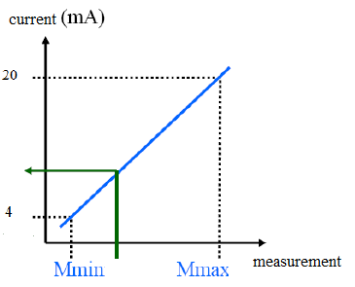
Figure : Ideal sensor response.

If a recorder needs to be added:
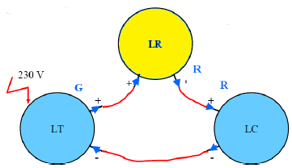

Figure: Current recorder
How to calculate the current as a function of the measurement (% of full scale)?
Example 1: Consider the functional diagram of the level
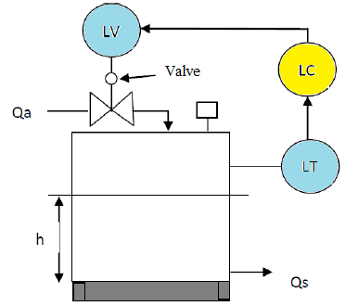
control loop with a tank that can hold between
2 and 8 meters of liquid.
Determine: for a liquid height of ℎ = 3m.
M : the measured value
i : the current of the level transmitter
Solution: Given:
Tank level range: ℎ min = 2m, h max =8m
Liquid height: h=3m
4–20 mA current loop
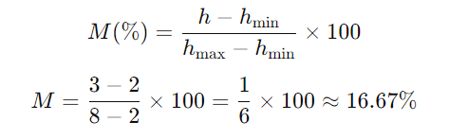
Step 1: Calculate % of full scale (M):

Step 2: Calculate transmitter current (i):
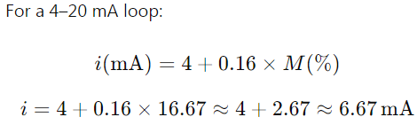

Answer:
M (measurement) ≈ 16.67 % of full scale
i (transmitter current) ≈ 6.67 mA
The controller reads this current and determines the percentage of the current span. Measuring this current (i=6.67mA) allows it to understand that the measurement M is equal to 16.7% of the sensor’s full-scale range.
Every instrument has at least one input and at least one output. For instruments with a linear response, the relationship between input and output is proportional:
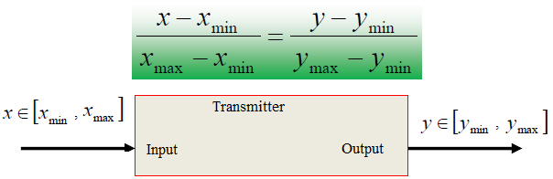

Transmitter inputs and outputs
Example 2:
A practical example of a pressure transmitter, in this case with an input range of 0 to 70 bar and an output of 4–20 mA.
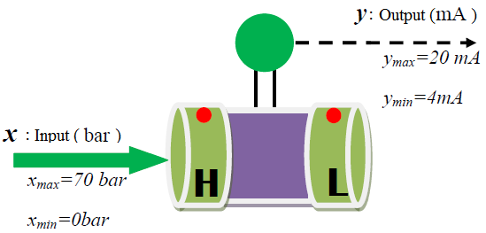

Pressure transmitter I/O
We have: $\frac{x - x_{min}}{x_{max}- x_{max}}→ \frac{x - 0}{70 - 0}=\frac{y - 4}{20 -4}→ \frac{x}{70}=\frac{y - 4}{16}$
If the output current measurement is y = 15 mA, The corresponding input pressure (x) is: 48.125 bar.
Question: Given an input pressure of 22 bar , calculate the transmitter’s output current?
5- Control system performance criteria.
The qualitative criteria to be imposed depend primarily on the nature of the process to be controlled.
In general, one aims for a short response time (T_{e}) and low damping. An overshoot of around 15% is generally considered an acceptable average value.
Control system performance can be evaluated from the response of the measured signal to a setpoint step, usually using quantitative criteria such as stability, accuracy, and response speed.
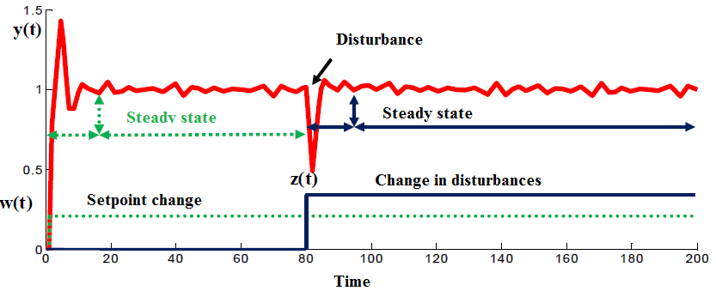

Figure: Control Performance criteria

- Stability
An essential and indispensable quality of a control system is its stability.
A process (system) is said to be naturally stable if a finite variation of the manipulated variable x (bounded input) produces a finite variation of the controlled variable (bounded output).
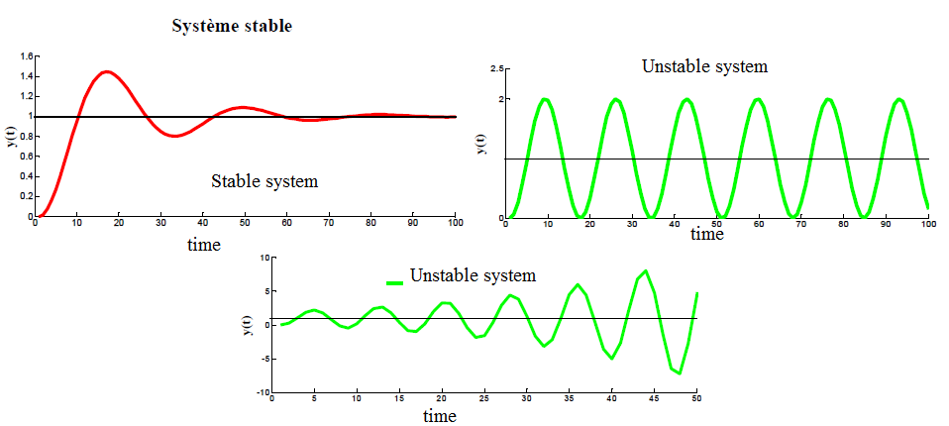

Figure: Stability performance criterion of the control system
Understanding the characteristic parameters (Static and dynamic characteristics) of a process facilitates the tuning of the control loop.
- Static characteristics: The graph of the output variable y versus the input variable 𝑥
y= f (t)
- Static gain: For a naturally stable system, the static gain 𝐾 is defined as the ratio of the change in the output variable y to the change in the input variable x. $K=\frac{Δy}{Δx}$ (Constant)
- Steady-state error: For a stable system, the steady-state (or position) error ε is defined as the difference between the setpoint W (step input) and the measured output 𝑦_{𝑚} in steady-state conditions. ε = W−y_{m}
​
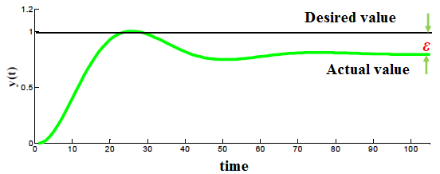

Figure: Steady-state error
- Dynamic characteristics of a process
- Response time (measure of speed): The response time is the ability of the system to follow variations of the manipulated variable. In the case of a step change in the manipulated variable, the rise of the controlled variable defines the different response times. In the example shown in the figure, the response time is measured at 20%, 10%, and 5%.
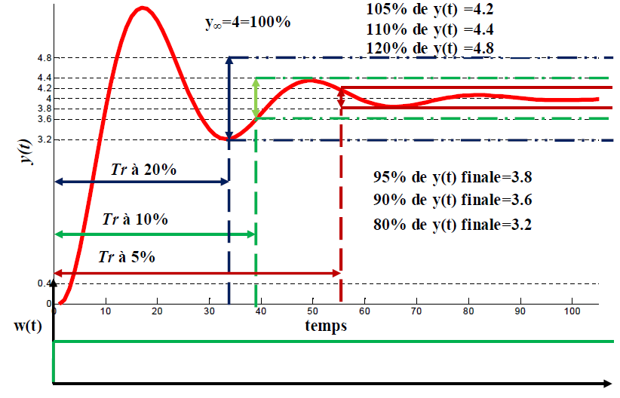

Response time example
- Overshoot: The initial overshoot is used to assess a system's stability. The greater the overshoot, the closer the system is to being unstable. In certain control applications, overshoot is not allowed.
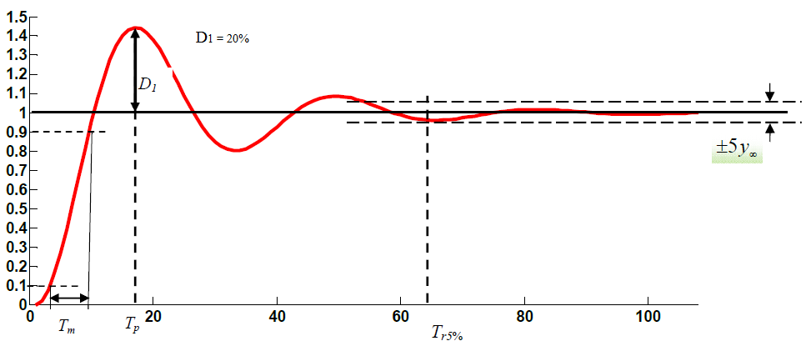

System dynamic and static characteristics
Rise time (𝑇_{𝑚}): The rise time is the time it takes for y to increase from 10% to 90% of its total variation.
Response time (Tr5%):The response time is the time needed for the system output to stay within ±5% of its final value.
Peak time (𝑇𝑝): The peak time is the time required for the system to reach the first peak of its overshoot.
First overshoot (D₁): The first overshoot is the difference between the maximum value reached by the system and its final steady-state value. It is sometimes expressed as a relative percentage of the final value.

