Exercise 1: Analysis of P&ID diagrams
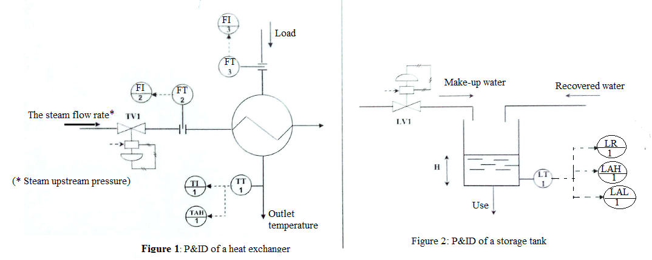
Consider the diagrams shown in the following figures,

Each of the two systems in Figure 1 and Figure 2 will be considered separately.
For each system:
- On the P&ID, provide the name corresponding to each symbol, both for process equipment and instruments, with as much detail as possible.
- Quickly analyze the operation of the process and specify the function of each instrument used in the system.
- Determine the controlled variable of the process. Identify the disturbance (input) variables and propose an appropriate manipulating variable for regulation.
- Establish the overall functional diagram and the detailed functional diagram of the system

Exercise 2:
Let us consider the same diagrams from the previous Exercise 1 to continue the analysis.
- Add instruments on the Figure 1 diagram to measure the inlet temperature of the load and record the measurements in the control room.
- Add to the diagram in Figure 2 an instrument to measure the usage flow rate (use an electromagnetic flow sensor) connected to a flow indicator in the control room.
- Add a sensor/transmitter for recovered water analysis, and log the data locally in the technical area.

