- Introduction :
Control engineering (regulation) refers to all the techniques used to control a physical quantity in an industrial process.
A physical quantity is any property that can be measured or calculated.
- The controlled variable is the physical quantity that we want to control. It gives its name to the control system.
- The setpoint is the value that the controlled variable must reach.
- The manipulated variable is the physical quantity of the process chosen to control the controlled variable. It is generally not of the same nature as the controlled variable.
- The disturbance variables are the physical quantities that influence the controlled variable. They are generally not of the same nature as the controlled variable.
- The control element (actuator) is the part of the process that modifies the manipulated variable.
industrial process
Disturbance
The set point
The controlled variable

Global functional block diagram
Example: We consider the preheating furnace shown below and identify the different control variables.
Product manufacturing generally requires proper conditioning of the various fluids involved in the chemical reaction. To ensure high reaction efficiency, the preheating furnace must heat the reactant to and maintain it at a constant temperature.
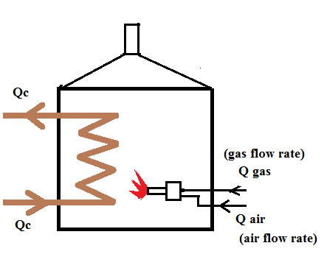

The preheating furnace
- Controlled variable: The temperature (To) of the product at the outlet of the preheating furnace.
- Disturbance variables: 1-Fuel flow rate (gas flow rate, Q gas).
2-Oxidizer (air) flow rate (Q air). 3-Product flow rate (Q c).
4-Upstream product temperature (Ti) at the inlet of the preheating furnace.
- Manipulated variable: The fuel flow rate (Q gas) used to control the furnace temperature.
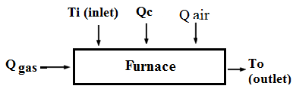

Global functional block diagram of the furnace
- Regulation system structure: There are two methods of control, Open-loop control and Closed-loop control.
- Open-loop control: It is a control system where its control action only depends on input signal and does not depend on its output response.
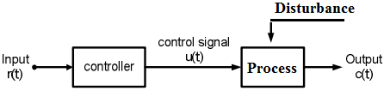

Open-loop control
- Closed-loop control: It is a control system where its control action depends on both of its input signal and output response.

Closed-loop control
Example: Control of a Preheating Furnace.
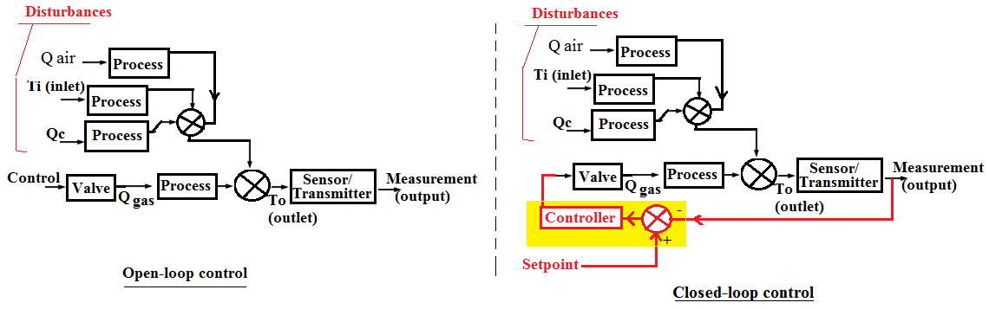

3- Technical drawings and plans
A Piping and Instrumentation Diagram (P&ID) defines the piping network and the components of a physical process.
- Installations: tanks, reactors, reservoirs, pipes
-The process fluids and their flow directions in the piping
- Actuators and control devices (pumps, control valves, etc.)
Example: P&ID of the preheating furnace
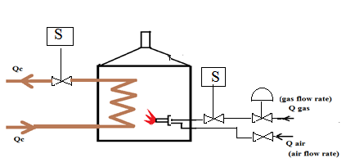

The P&ID also shows the measuring instruments. These instruments are represented as follows (for more information: https://www.instrumentationtoolbox.com/2016/12/instrument-abbreviations-used-in.html#google_vignette):
The first letter indicates the controlled variable, while the second letter and following letters denote the instrument’s function.
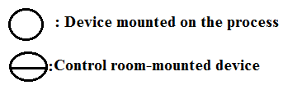

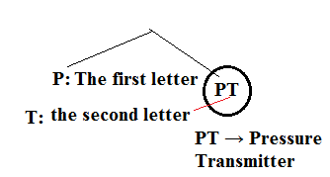

Example:
Lettre Signification Exemple
P Pressure (pression) PT → Pressure Transmitter
T Temperature (température) TT → Temperature Transmitter
F Flow (débit) FT → Flow Transmitter
L Level (niveau) LT → Level Transmitter
C Controller (contrôleur) LC → Level Controller
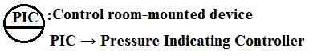
Example2:
Connection:
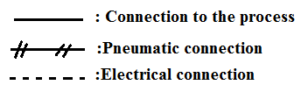

Example: Temperature control of the furnace
