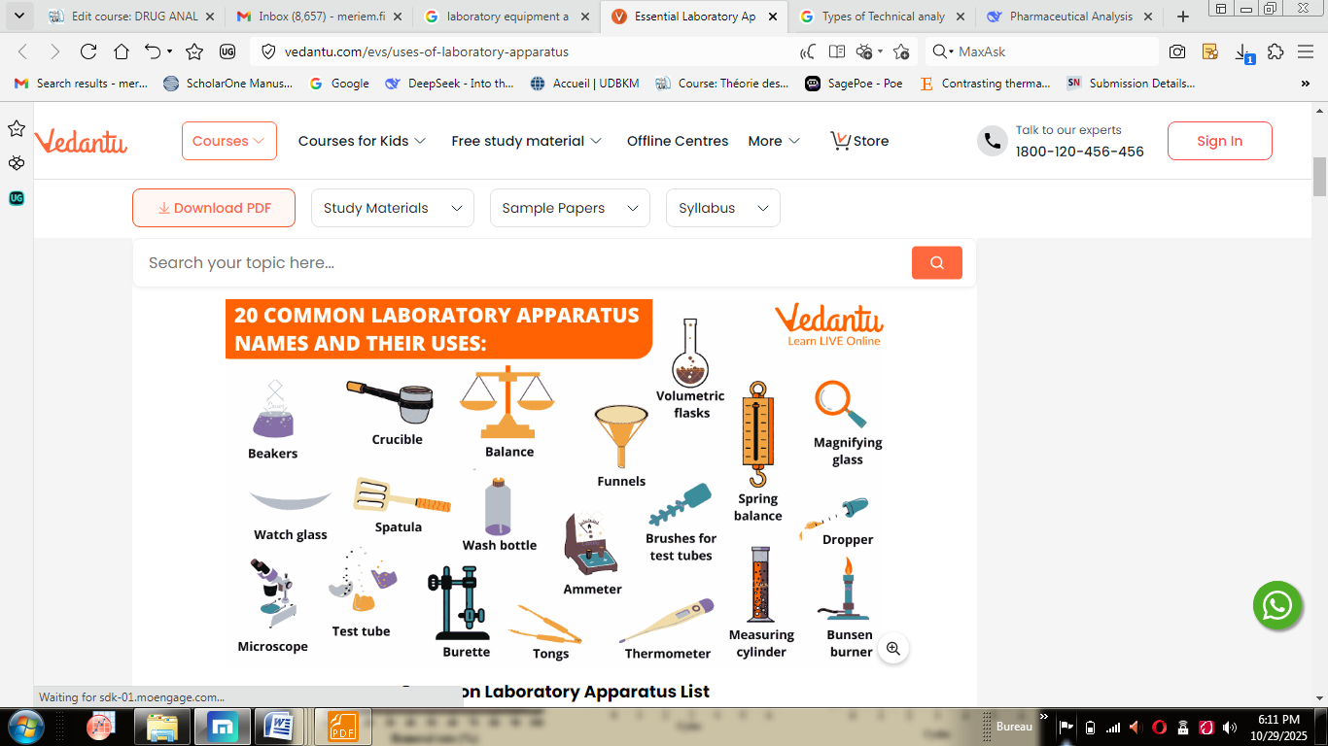

Laboratory Equipment list and uses
Laboratory equipment refers to the many devices of equipment used in a laboratory to carry out specific tasks. These tools are meant for use by scientists, students, professors, and medical professionals. Some scientific lab equipment is used for weighing materials, mixing and creating solutions, and cleaning containers.
Any experiment must be performed with care to prevent injury. To ensure safety and properly carry out an experiment, it is essential to understand the names and purposes of lab equipment

1. Microscope:
A microscope is a very basic and needed equipment in the biology laboratory. A simple light microscope (compound microscope) is the one, which is mostly used in colleges and it uses natural or artificial light and a series of magnifying lenses to observe a tiny specimen. Below is the schematic diagram of a compound microscope with details of its parts:
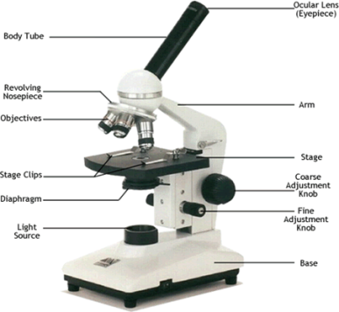
A microscope operates on the principles of refraction of light and takes advantage of how convex lenses bend light. There are generally two lenses – objective and oculus. The objective stays very close to the sample to be seen and makes a virtual large image of it. The oculus stays close to the eye and enlarges the previous image even further, and we see that.

2. Test tubes:
The next very common apparatus is the test tube. They are usually cylindrical pipes made up of glass, with a circular opening on one side and a rounded bottom on the other side. They come in different sizes but the most common standard size is 18*150 mm. Test tubes are one of the most important apparatus as they are functional from storing to mixing reagents in any chemical or biological reactions.
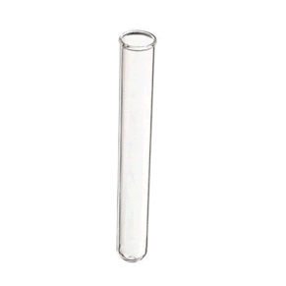

3. Beakers:
Beakers are another cylindrical utensil made up of glass, with a flat bottom and an upper opening, which may or may not have a spout. They are of varying sizes and are used to hold, heat, or mix substances with the proper measure. Beakers come in every size from tiny 20 ml cups to liter-sized buckets, and everything in between – but 250-500 ml beakers are most common.
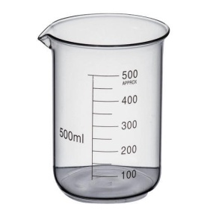
Beakers are very much favored in labs because of their ease of use. With the flat bottom and straight sides, they are very stable on most surfaces and best for boiling stuff safely; and with the large opening, you can pour things in or out of it, or stir the contents. However, that large opening also makes it unsuitable for storage purposes – use flasks for that.

4. Magnifying glass:
A magnifying glass is one of the first introduced lab equipment among the students. As the name suggests, it is used to view enlarged or magnified images of objects or read the small calibrations marked on many equipments. It has a convex lens for object enlargement and usually has a wooden handle to hold it.
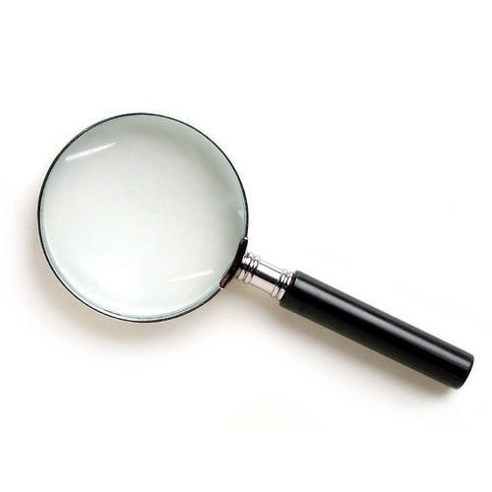

5. Volumetric flask:
This is one of the most important equipments of any lab, which is made up of glass and is calibrated to hold a precise volume of liquids at any precise temperature. Different sizes of volumetric flasks are available, each calibrated for the exact measurement of liquids and solutions. In chemistry labs, it is mostly used in the preparation of standard solutions.
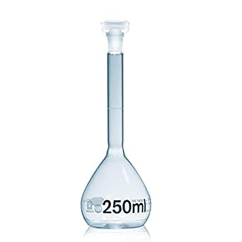
They are generally made of borosilicate glass, or hardened glass if you need to heat the contents to a higher temperature. You can also use volumetric flasks to store some liquid you made for a long time.

6. Bunsen burner:
This apparatus produces a single open flame and it is used for heating and sterilization purposes in the various experiments conducted in labs. A laboratory often needs a lot of things heated or boiled, and a bunsen burner was tailor-made for this purpose.
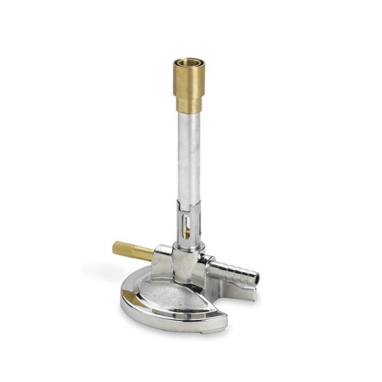

7. Dropper
The dropper, also known as Pasteur pipette, is a common small apparatus, usually made up of plastic or glass cylinder, having a small nozzle on one side and a rubber holder on the other. It is used to put the liquids or solutions in any medium dropwise, that is, one drop at a time, a piece of necessary equipment when any reagent is required in an extremely small amount in a solution.
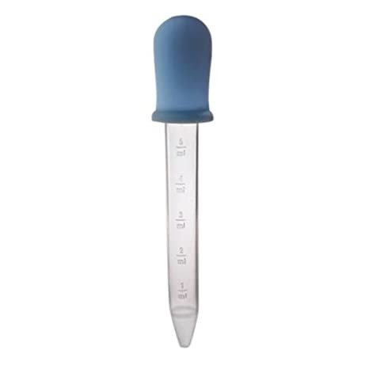
Pipettes are the big brothers of droppers and you can take up larger amounts of liquids in them. Both pipettes and droppers have special cleaning procedures, and you will need a bit of training before you can properly use them in a laboratory safely.

8. Thermometer:
Every lab is equipped with a basic thermometer as many times, certain chemical or biological reactions can be carried out in any particular temperature range only and so to proceed, the thermometer becomes very necessary to measure the temperature of the required solution before moving forward with further reaction procedure.
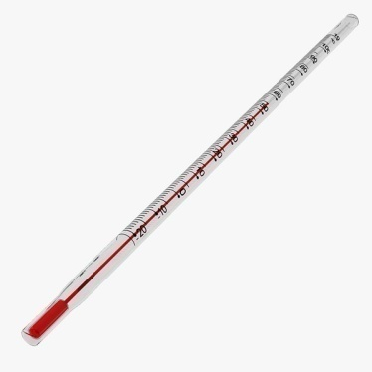

9. Tongs:
Tongs, though not much in use, are common and basic apparatus in any lab. They are used to grasp and lift hot vessels and harmful substances during any kind of reaction taking place in the lab. Many fingers have burned due to careless handling of hot or dangerous substances in labs. Therefore, make it a habit to handle things with tongs unless you are absolutely sure otherwise.
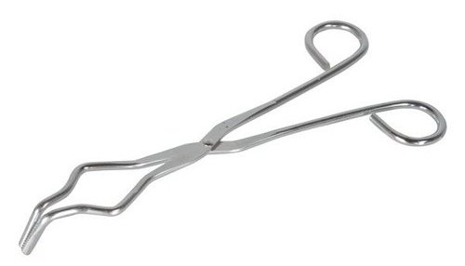
Strictly speaking, tongs are not exactly lab safety apparatus, but they indeed save you from a lot of harm. There are two kinds of tongs used in labs – larger ones with a hinge, and small tweezers. Both are coated with non-reactive material so that they can resist corrosion up to a certain extent.

10. Brushes:
Not many people know it, but cleaning things are one of the biggest portions of everyday lab life. Keeping glassware and apparatus clean is the first step to achieving precision and perfection. Brushes serve as the cleansing apparatus of the test tubes, as they are the only things that can get fit into the narrow-mouthed test tubes and other cylindrical and narrow objects.
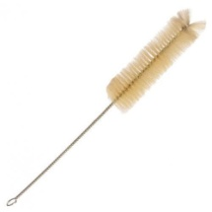

11. Weighing machines:
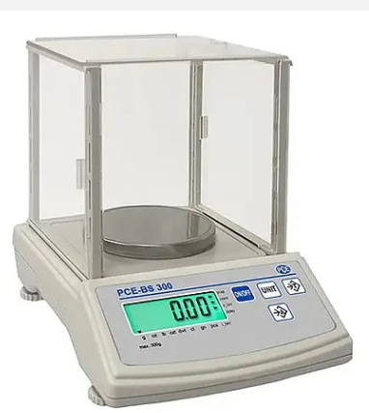
There are two kinds of lab weighing machines – precision balances and analytical balances. Precision balances are the most common and they can measure milligrams. Analytical balances are, however, so sensitive that even air currents can disturb them. This is why they have a glass box enclosure over the weighing plate. Analytical balances can measure parts of micrograms.

12. Wash bottles:
The wash bottles are laboratory consumables used for cleansing and sterilization purposes. These bottles are made up of plastic, which serves as a squeezy container with a long nozzle. They mostly contain distilled water, ethanol or deionized water.
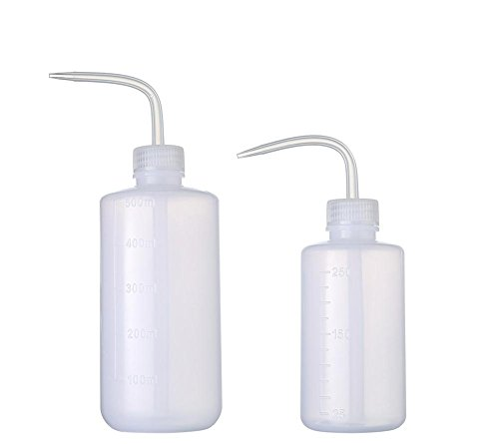

13. Spatula:
These laboratory spatulas are very much similar to the kitchen like spatulas found in our home but they are just very smaller in size in comparison. The spatulas are usually resistant to heat and acids, hence making them suitable for large range use in the laboratory experiments.
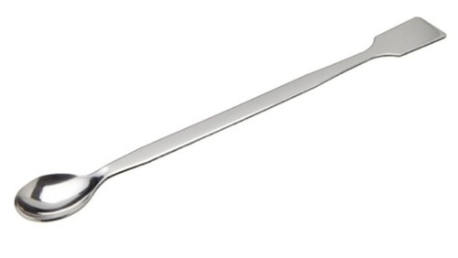

14. Litmus and filter papers:
These two cannot be called apparatus in a proper way, but they serve as one of the most important and basic things that will be required in any kind of laboratories. The litmus paper serves to identify the pH of any solution by changing colors whereas, the filter paper serves in the filtration process.

15. Burette:
Its mostly used in the titration reactions, and is handful in delivering a known volume of any substance to other equipment. This apparatus is a long-graduated tube, with a stopcock present at the lower end. It usually comes in the sizes of 10ml, 25ml or 50ml.
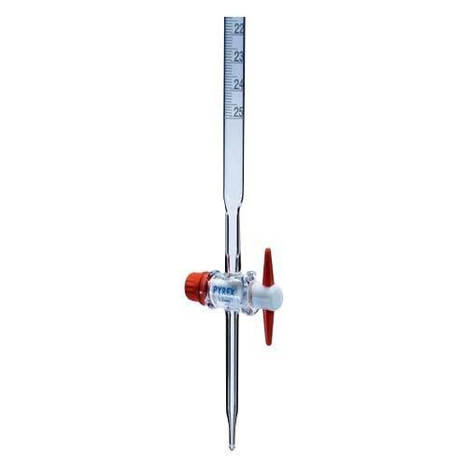

16. Watch glass:
This apparatus is more commonly found in chemistry laboratories and is made up of a concave piece of glass. It is normally used to hold solids, evaporate liquids, and heat small quantities of different substances as per the need of the experiment.
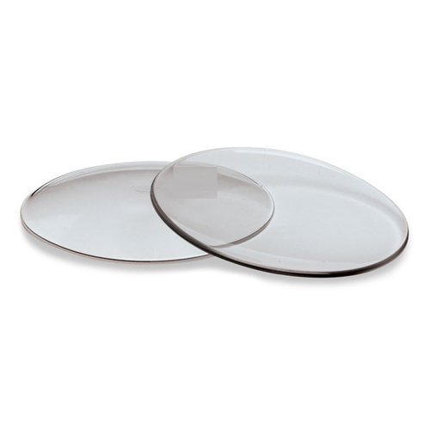

17. Funnels:
Funnels are necessary equipment to pour substances and solutions in narrow-mouthed test tubes and conical flasks. There is variety of its available, most common ones are filter, thistle, and dropping funnels.
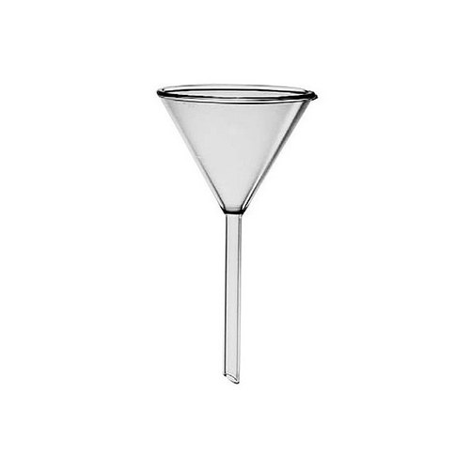

18. Stirring machine:

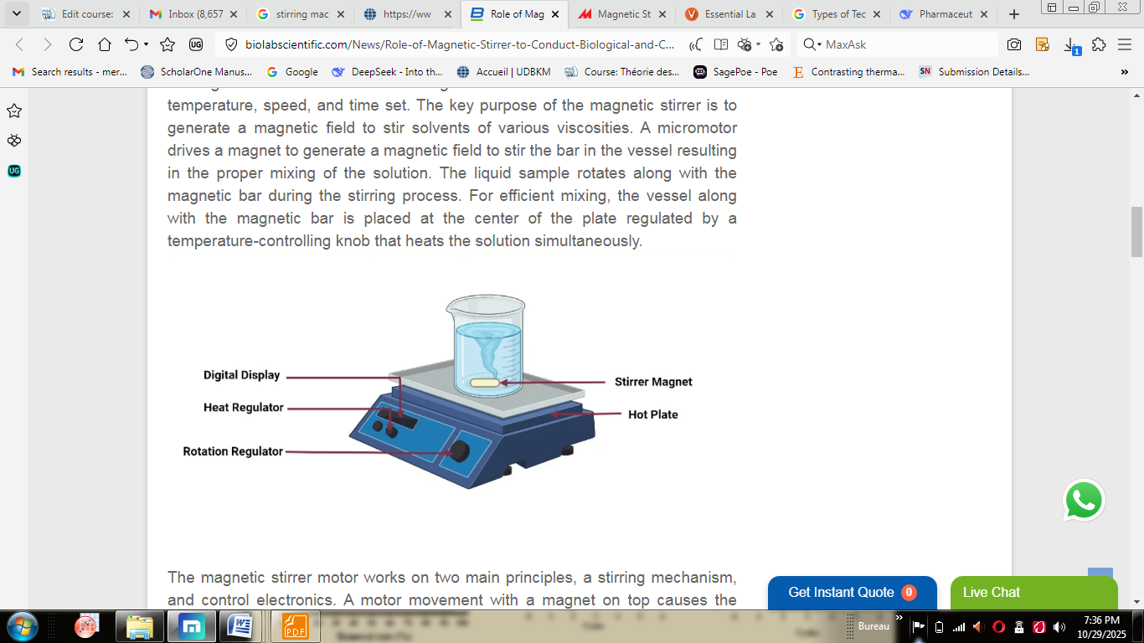
A stirring machine, or laboratory stirrer, is a piece of equipment used to mix, agitate, or disperse fluids.
Types of stirring machines
- Magnetic stirrer: Uses a rotating magnetic field to spin a coated magnetic stir bar placed in the liquid. It is silent, efficient, and often used with a heating element for solutions that need to be stirred and heated simultaneously.
- Mechanical stirrer: Consists of an electric motor, a drive shaft, and a blade or impeller at the end. These are often used for mixing larger volumes or more viscous liquids and provide more powerful mixing than magnetic stirrers.
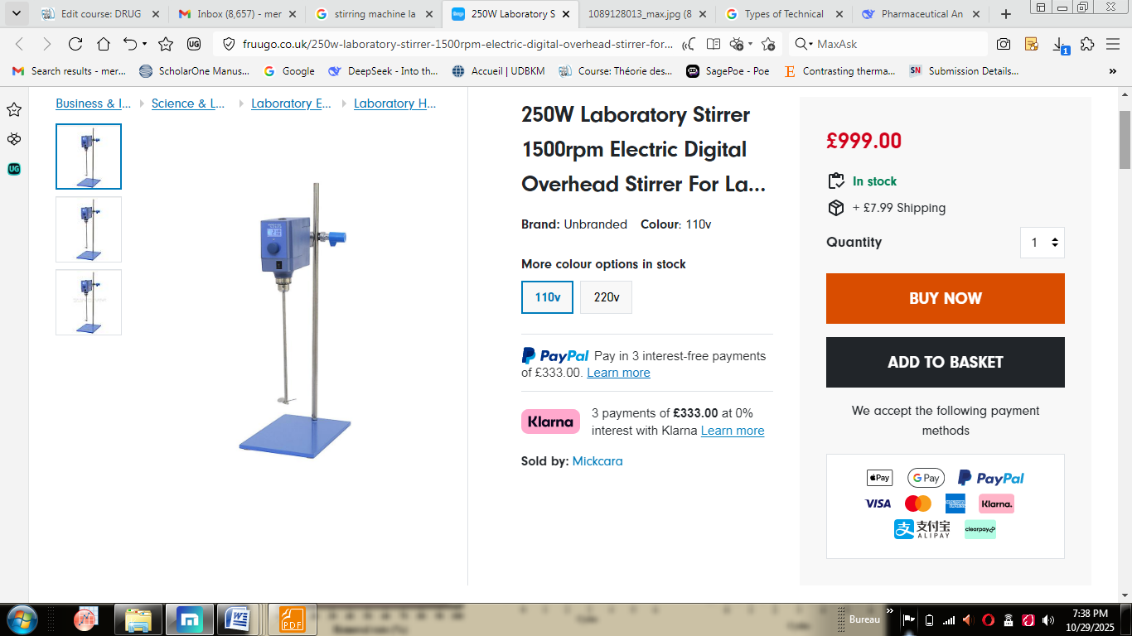

19. Crucible:
Crucibles are made up of porcelain and are used to store and heat substances when required to be heated at high temperatures since glassware are not always suitable for such high heat involving experiments.
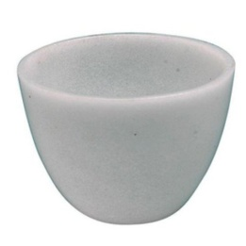

20. Measuring Cylinder:
This typical laboratory instrument is used to determine the volume of a liquid. It is calibrated, with each marker indicating the quantity of chemical used. This glassware is cylindrical and narrow, as the name indicates.
